Reading for Song of the Sea
Note: This isn’t the sort of reading I usually assign. The critical analysis below is written by a freelance blogger, not a professional film critic, so the writing is much less polished and less formal than what you’d find in either a newspaper or a journal catering to professional film scholars. Furthermore, it is just one writer’s thoughts, not a commentary written as part of a scholarly conversation. Still, it is well developed, well argued, and thoughtful, blending a keen eye for visual details with a sense of how symbols work across cultures. I would be very happy if your critical analysis papers were as thoughtful and well supported as this, though of course they will be shorter. I removed some of the illustrations to save space but left in the ones that seemed crucial to the argument.
Analysis of Song of the Sea: Salvation by Folklore By Noisewar posted March 24, 2015
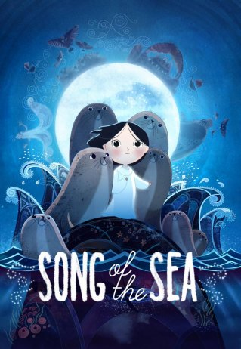 After just one stunning theater viewing, Cartoon Saloon’s Song of the Sea became one of my favorite animated films of all time. From an island nation with a daunting pound-for-pound cultural legacy, this fiercely Irish modern folktale embodies both the intellectualism born in their poet-king pubs, as well as the supernatural climes of their landscapes.
The comparisons to Miyazaki masterpiece Spirited Away have run a bit rampant; I’d like to expound on why this film, while indeed similar in tone, art style, and theme, is more than mere Celtic Miyazaki-esque.
In this article, I’ll discuss the visual and cultural themes of the movie, and explain its message for viewers today. Despite superficial similarities, it is these themes that make it quintessentially Irish. To quote the great Irish novelist John McGahern: “Everything that we inherit, the rain, the skies, the speech, and anybody who works in the English language in Ireland knows that there’s the dead ghost of Gaelic in the language we use and listen to and that those things will reflect our Irish identity.”
I’ll show that Song of the Sea (SotS) flavors well-known tropes with directed, intentional nuance that makes it more of a continuation of the worldview posited in The Secret of Kells (Moore’s first film). You could almost consider SotS to be a chronological sequel, diving deeper into the schism between spirit and human worlds that began in TSoK. Both reflect the Irish psyche that is the product of a transformation from the island’s Celtic paganism to its inevitable assimilation of Christianity. Where TSoK indulges in the intrigue of that transition, SotS grounds it in a modern story of loss, and offers folkloric lessons as an answer.
Plot SPOILERS BELOW!
Before we begin, I want you to take a moment and consider the single most important question to answer about SotS: Why does Saoirse choose to stay in the end? Answering this will reveal the meaning of this movie, and is the goal of this analysis, so you should have your own ideas before reading this.

NAME MEANINGS: To start this discussion, I will do my usual exercise of first examining names and their meanings. This gives us a useful insight to what the characters represent. Saoirse’s name means “freedom“, which she will come to embody with her existence. The father Conor’s name means “hound-lover“, which is appropriate as the family dog’s name is Cú, probably a reference to Cú Chulainn (“Culann’s Hound”) the great Irish hero of the Ulster Cycle. This reference is apt, as Cú is the most constant source of selfless courage in the film (notice who often overcomes Ben’s fears in the film).
The witch, Macha, is probably named for the many-aspected fertility goddess of the same name who, in one incarnation, famously cursed many Ulstermen with labour pains as she died in childbirth, a tale in itself. Mac Lir, the giant, is taken from another myth where he is a sea god, his name meaning “son of the sea” in Old Irish. The mother Brónach’s name means “sorrow“, and is probably also a reference to St. Patrick’s disciple, the matron saint of shipwrecked sailors (alluded to by their lighthouse home).
Most interesting is the main character Ben, whose name in Hebrew means “son“, often used in conjunction with other descriptors like Ben-jamin (“son of the south“) or, as Brónach’s child, Ben-oni (“son of sorrow“). What’s really interesting about the name Ben is that Biblically speaking, it is gender neutral, and can be used to refer to all scions, son or daughter. I doubt Moore knew this explicitly, but I use this point to launch you into thinking of Ben as an allegory for present day Irish people, the “sons” of the their history.
FROM BEN’S EYES This is important because this story is as much about Ben’s processing of his mother’s death through her stories as it is about the Irish processing the aforesaid history of transition from Gaelic to European peoples and the tragedies they’ve survived.
We see the real and the magical worlds strongly mirror each other. Ben is at the center of this duality or people and places. To start, look at some of these visual examples:
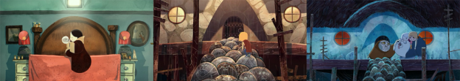
Gramma’s room referenced at Macha’s house.
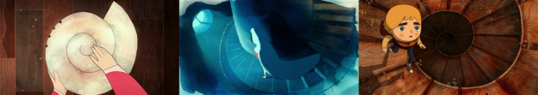
Familiar spirals.
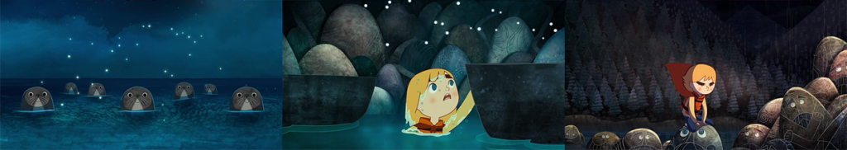
Seals, stones, and the sidhe.
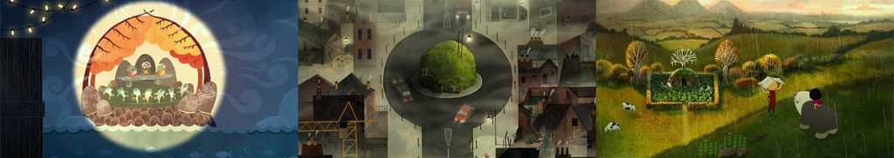
The bed mound in Ben’s room (with Irish phrase for “fort of foreigners”) is echoed in the sidhe fort and the holy well.
In the real world, Ben is sent to his Gramma’s place, somehow escapes, and finds his way back to his home with his sister in tow by following his handdrawn map. This is implied but not fully shown. In the magical world, where most of the onscreen story happens, he finds his way back by way of his quest to save his sick, kidnapped sister.
There appear to be two parallel worlds that Ben traverses between freely. For Ben, the magical world is his interpretation of the real world, so for him they are equally real. This is extremely important, and we’ll discuss this further later.
The characters Ben meets in the magical world have real world parallels. His father is Mac Lir, standing hunched in the same way, in the same shots, with the same story of tragic loss, crying in the sea. Ferry Dan, the ferryman between home and the city, is a dead ringer for Shanachie, the chthonic keeper of stories with his endless beard. The three sidhe he encounters are indistinguishable from trick-o-treaters. His mother’s image (and photo) is evocative of the many statuettes of the Virgin Mary found throughout the town and in the holy well, and in her final appearance, her spirit even appears to Ben in the form of an angel, Christian references that we’ll touch upon later.
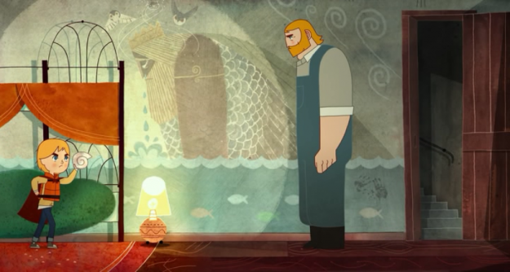
Conor mirroring Mac Lir.
Most evident of all is Macha, who is the magical counterpart of Ben’s gramma. Not only do they have a similar appearance, they are both overprotective of their sons’ sorrow. Gramma tells her Conor he’s “better off not thinking about that night”, while Macha literally bottles Mac Lir’s emotions. At the birthday party, Gramma says she wants to “capture the emotion of the day”. Funnily, Ferry Dan refers to her as a witch twice. Macha represents the desire to forget sorrow without confronting it- repression of memories and their feelings. This is what makes her the antagonist for Ben in both the real and the magical world.

LIVING IN MIRRORED WORLDS The magical world can be Ben’s metaphorical view of his real world, and of his personal tragedy, the loss of his mother. In this sense, the magical events he goes through are actually his internal experiences as he matures and overcomes that tragedy. If there are parallel plots of Ben’s real and his metaphorical world, they certainly interweave more and more until by the end they form a new magical reality. Let’s examine these plots as separate threads.
Most obviously, the story his mother told of Mac Lir and Macha mirror what real Ben sees of the man his father’s become. Like Mac Lir, Conor is a brooding, stone-faced giant. Gramma, who is always telling Conor to move on, is Macha. Gramma’s house is on the other side of Ferry Dan’s ferry service, just as Macha is on the other side of Shanachie’s underground passage.
The kidnap of his sister does not have to be a literal happening, but could represents his distance from her; we see his resentment of Saoirse many times. He feels this distance acutely, and in the magical events it manifests as her kidnapping and absence. In the real world, we see him tie her to his belt with a wire. In the magical world, he’s connected to her by a “wire” of Shanachei’s hair, which he follows until he finds her.
Saoirse’s sickness, then, represents his fear of losing her, just as he lost his mother. As Saoirse gets sicker, her hair gains an aged white stripe. Recall in his last memory of his mother: we see, in the flashback Shanachei gave Ben, her hair also taking on a stripe of white, the color of death. This sickness comes from not being near the sea that is the source of the selkie’s magical nature.

THE MEMORIES That last memory is extremely important to how Ben’s magical world is formed. Watch it again and pay attention to the colors and the location:
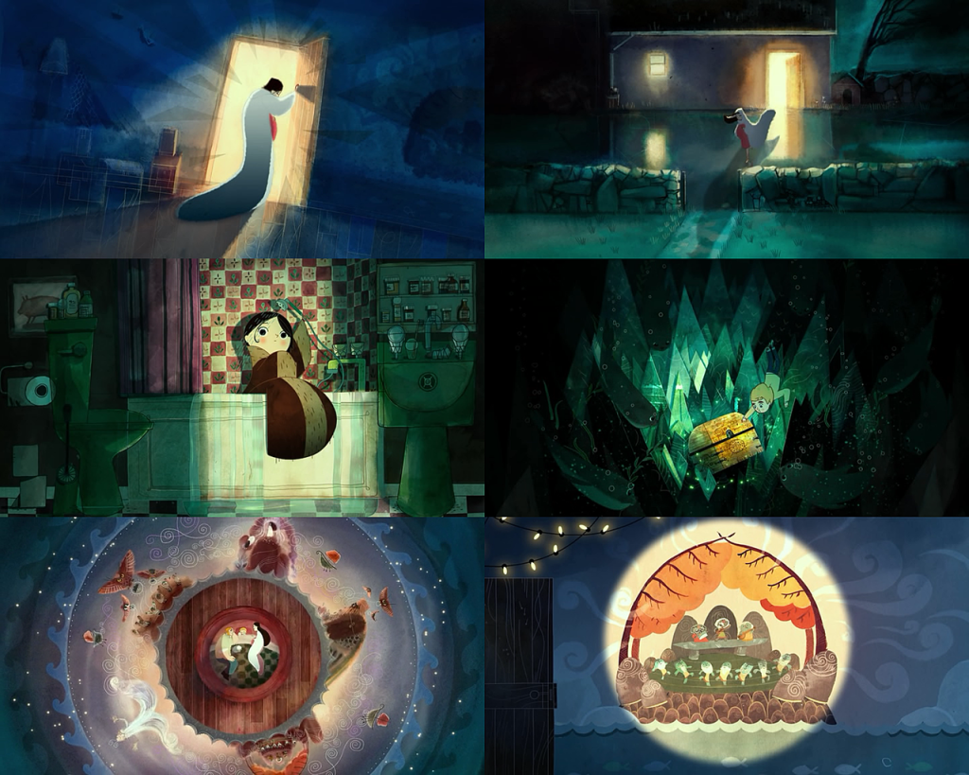
Notice the motif of warm surrounded by cool.
See a pattern? The warm colors of his room represent the comfort and sentimentality of his childhood, the golden glow of the light in his room imprinted in his self-consciousness. The range of warm colors (red, orange, gold) signify his past. When Brónach flees Ben, she escapes the warmth of his room and the house. She becomes the blues and greens of the ocean and the moon. Cool colors, especially blue, signify his memory of his mother, the color of guidance, wisdom, and spirit.
Whenever we see blue or moonlight, it can be understood as Brónach’s presence, watching and guiding, and often approving:
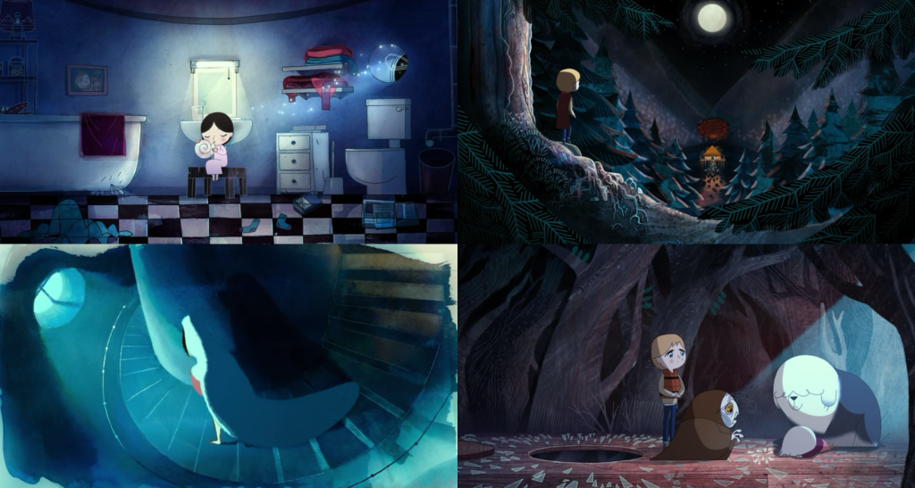
But something interesting happens with the warm colors. Through Ben’s journey, the warmest colors go from comforting (the beach, his home, the holy well) to sinister (Macha’s house). It becomes a color he must confront because it is also where the tragedy happened. Compare, for instance, the color of the chest that is the final challenge for Ben:
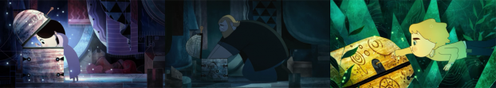
The motif of a warm center surrounded by cooler colors is repeated often, echoing that childhood memory. This is in stark contrast to the desaturated colors of the real world. This motif signifies that the memories of his mother continue to guide him to the answers he needs, answers found only by facing the memories of his childhood. Only after he overcomes his past do these colors mix where the golden energy (the past) frees the sidhe from stone, transforms Macha, and melds with the blue of the sky in lines that look like musical notation.
Ben must confront his past if he is to move on to the future and be free from his sorrow, and his gear shows the change in his heroism. He literally dons a pair of 3D glasses with a warm and cool lens, showing him both worlds, both memories. After resisting Macha’s attempt to subvert him, he gives up his red superhero cape, wrapping it around Saoirse. In his final challenge, to retrieve the chest, he sheds his orange lifesaver, never to wear it again. He sheds his child’s view of heroism by getting rid of his paraphrenalia, and finding real courage.

BRÓNACH’S GIFT So what does this all mean? Returning to our original question, why does Saoirse choose to stay with Ben and Conor? First, let’s understand why, where the story is primarily about Ben, its ending pivots on a choice by Saoirse. Remember that, as her name indicates, she represents “freedom”. She represents Ben’s ultimate objective- freedom from the weight of his past.
But freedom is not a choice he can make on his own, it must choose him, as a response to his deeds and his heart. To merely demand freedom from past sorrows is to try to wantonly forget, and that fails. This is the same mistake Conor makes trying to lock Brónach’s selkie coat away and hiding her portrait. It’s the same mistake Macha makes trying to just bottle Mac Lir’s feelings away. Only after Ben confront the obstacle to freedom, his sorrow, can freedom comes to him of its own free will. This is why Saoirse must make the choice.
But why does Saoirse choose Ben over Brónach? To gain Saoirse into his family, he needs to accept and love her as Brónach would have wanted (“you’re going to be the best big brother in the world”). But Ben was immature, and at some level blamed Saoirse for the tragedy. Over the course of his journey, he changes, and acts with the courage and love of a good brother. Saoirse’s choice to stay acknowleges that Ben has matured as a person. This is why Saoirse chooses Ben.
The gift of love, in this story, is a very specific thing. Brónach’s act of love for Ben was to empower him with her stories and her guidance. Before she died, she gave Ben a shell ocarina and the story of Mac Lir. These two things represent the rich Irish mythologies wherein lie valuable lessons. The stories give Ben the blueprint for understanding the sorrows of the past, both real (his last memory) or mythical (Macha and Mac Lir). When Ben begs her spirit to stay, she tells him: “My son, remember me in your stories and your songs. Know that I will always love you. Always.“
In other words, so long as you remember the stories from oral tradition, you will be cared for by generations past.
The shell is oral, evocated connection to that past. If you read the lyrics of the song it plays (in the soundtrack), it talks about love being “between the here, between the now, between the North, between the South” etc. While the lyrics refer to places in the film, the subtext is that the magical world exists between things normal things we take for granted. In the gray area between winds and waves, sand and shore, we must examine with our imagination, that is, we must want to know, and not merely to forget.
Ben comes full circle and understands his mother when he retrieves the selkie coat for Saorise. The coat represents the memory of Brónach that Saoirse doesn’t have (because she was born at Brónach’s death). Ben also teaches her Brónach’s song, giving her a voice so that she too may partake in the lineage of oral tradition. In Saoirse’s rebirth, Ben has transcended his childhood. This is why Saoirse’s choice completes Ben’s story.
The “Song of the Sea”, is a power gifted to the next generation to help them find love and courage. It tells us look with a new perspective “neither quiet nor calm”, and that is the path to happiness. I could write for days about how everything we know about happiness today proves this answer to be true, scientifically and psychologically, but alas this article is long enough already.

ON MAGICAL REALISM In Spirited Away, the protagonist Chihiro travels through a tunnel to reach an empty town. True to the Japanese shintoist concept of emptiness as non-emptiness, in that physical emptiness naturally fills with spirituality by its open and neutral nature, the town fills with gods that Chihiro must interact with. She leaves the small gods and their spiritual nexus by physically leaving the town through the tunnel, and her parents never remember their time there. The division between real and magical there symbolizes a transition between childhood and adulthood.
In contrast, in SotS there is no distinction to Ben (or any other character) as to which world is more real. This is true to the Western religious concept of mythological hierophany or (Christian sacrament), where the magical or divine manifests as riddle to solve or a miracle to behold, signifying enlightenment. The transition between real and magical worlds happens without self-consciousness, like tunnels or the magic pill Chihiro takes, which marks SotS as a work of magical realism. Unlike Spirited Away, in which there is a clear separation albeit co-existence of the real and magical worlds, SotS moves freely between them. Magic is “mundane”, even when magical.
For the Irish people, whose belief systems have changed hands from ancestors to ancestors, conquerors to conquerors, pagans to religious denominations, that is precisely the importance of being mundane. They have taken to heart all of the mysterious secrets of the world, and all traditions coexist in their collection consciousness simultaneously. This reminds me of the uniquely Irish literary feature of dindsenchas, a body of early lore that wove the etymologies and details of locations into epic poems, which Gaelic bards used to preserve and recall useful information. In their fashion, tall tales and truth become intertwined for the sake of oral tradition.
Note: A redditor pointed out to me that the words spoken at the start of the film are from W.B. Yeats’ poem The Stolen Child:
Come away, O human child!
To the waters and the wild
With a faery, hand in hand,
For the world’s more full of weeping than you can understand.
This is a perfect choice, not just for the meaning of the poem, but because Yeats straddled the movements of the Irish nationalism revival as both modernist and symbolist. His progression into Irish mysticism is a great example of literary hierophany. He literally believed in the creatures of the past, and of his obsession, the fairies, he called them “the gentle folk” (referenced by the sidhe trio in the movie). Yeats is a good convention for understanding a unique aspect of Irish consciousness.
Throughtout SotS, magic is never discussed as a force that needs to be understood or harnessed, it is simply the way things unfold. Not even Conor, an adult, questions when magical things happen before him in the finale. As the film climaxes, the two worlds mix mercilessly. Just as in Mulholland Drive, one of the best cinematic examples of magical realism (I know, odd reference, but surprisingly relevant!), the mundanity of magic is a gift, a connection to an infinity of stories that helps us process sorrow, confusion, and pain however we need, and does not respect a hierarchy versus reality. Instead, as a hierophany, the magical world is an event that teaches the sacred from the profane, or in Ben’s case, right from wrong.

CONCLUSION Like many pagan cultures, Celtic culture was one of oral tradition that took the form of storytelling (Brónach’s tales) and song (Brónach’s shell). What many people do not realize is that while Christian scholars are accused of appropriating pagan culture into Christian traditions like Xmas and Easter, we’d know nothing of pagan tradition if not for these same scholars. Almost all we know about the pagans today comes from the dutiful recordings of the monks, albeit through Christian eyes.
That was also the “secret” in The Secret of Kells… pagan or Christian, deep learnings from both have become embedded and intertwined throughout the long tradition of knowledge transference so long as they pass through the hands of brave men. These stories, quite simply, are tools we use to preserve our secrets for the ages, gifted forward. This is why folklore, now more than ever, must be cherished and spread.
Song of the Sea, while a gentle, beautiful, and deeply empathic film, is a call-to-arms for bringing wonder back into our waking lives. Its message is timely and urgent
Finally, I’ll end with director Tomm Moore’s own story (from an interview with Cartoon Brew) about his real life inspiration for Song of the Sea, and of the impact that losing folklore was having on the world:
“On holiday with my son, in the west of Ireland. We were sketching on the beach; it was pretty horrible. When we asked why there were so many dead seals on the beach, our landlady said local fisherman were killing them out of frustration with falling fishery stocks. She said it wouldn’t have happened years ago, when there was a belief system that deemed seals sacred because they were the souls of people lost at sea, or actual selkies. That started me thinking that folklore and superstitions serve functions beyond entertainment, or quaint stories for tourists. They bind people to the landscape, and that is being lost.”
http://warandnoise.com/analysis-of-song-of-the-sea-salvation-by-folkore/

