Timeline of Northern Ireland Troubles: from conflict to peace process

Following Prince Charles' historic meeting with Sinn Fein's Gerry Adams in Ireland today, we look back at some of the crucial moments of the province's troubled past

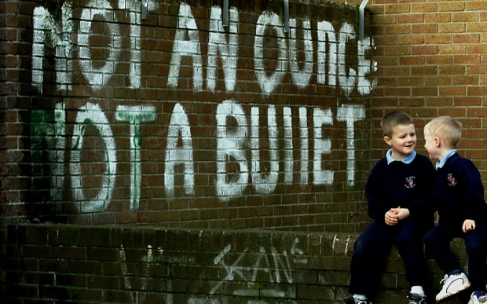
Catholic schoolchildren play near IRA graffiti in Belfast Photo: AP
By Tom Rowley 5:34PM BST 19 May 2015
Today's historic handshake between the Prince and the controversial republican figure comes after thirty years of bloody conflict and a protracted peace process started by the signing of the 1998 Good Friday Agreement.
ADVERTISING
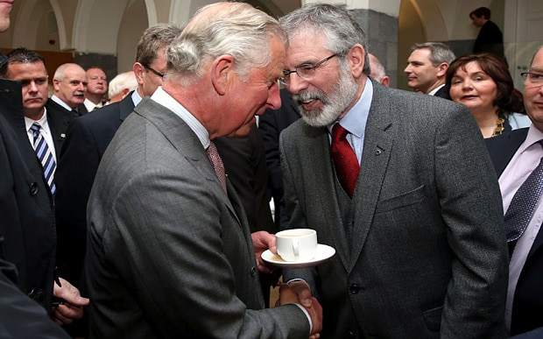
The Prince of Wales and Gerry Adams shake hands as they meet in Galway (Brian Lawless/PA)

Here we chart the key events in the Northern Ireland Troubles.
August 1969 The British Government first sends troops to Northern Ireland in what it describes as a “limited operation” to restore law and order after three days of violence in the predominantly Catholic Bogside area of Londonderry.

February 1971 Gunner Robert Curtis becomes the first British soldier to die when he is shot dead by the IRA.
January 1972 On “Bloody Sunday”, 30 January, 13 civilians are shot dead by the British Army during a civil rights march in Londonderry.
March 1972 The Stormont Government is dissolved and direct rule imposed by Westminster.
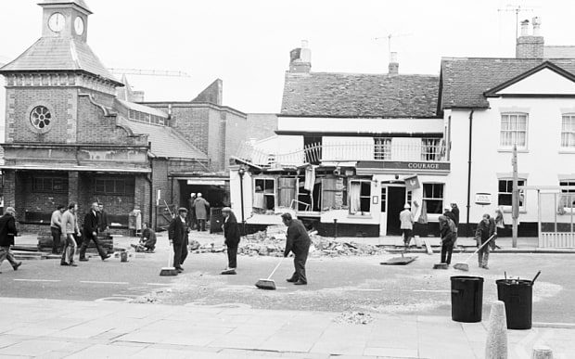
Workmen sweep away broken glass after the Guildford pub bombings
October 1974 Pubs are bombed in Guildford as the IRA expands its campaign to mainland Britain. A month later, there are more pub bombings in Birmingham, killing 21 people.
July 1976 Christopher Ewart Biggs, the British Ambassador to Ireland, is murdered by a car bomb in Dublin.
March 1979 Airey Neave, a confidant of Margaret Thatcher’s, is murdered by an Irish National Liberation Army car bomb which explodes as he leaves the Houses of Parliament.
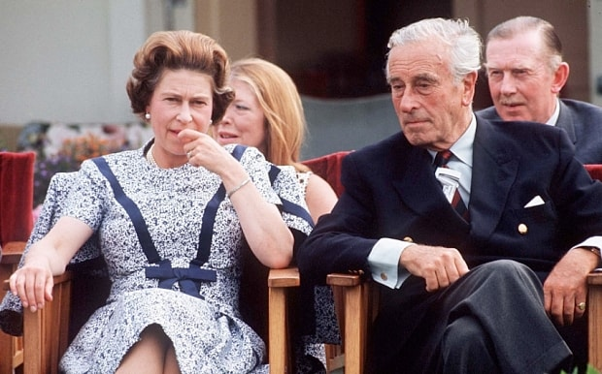
The Queen with Lord Mountbatten (Getty Images)

August 1979 Lord Mountbatten, the Queen’s cousin, dies when a bomb planted by the Provisional IRA explodes on his boat in Sligo.
April 1981 Bobby Sands, one of the republicans on hunger strike in the Maze prison, is elected to Parliament. He dies a month later.
October 1984 A bomb explodes at the Grand Hotel in Brighton, where Margaret Thatcher, the Prime Minister, is staying during the Conservative Party conference.
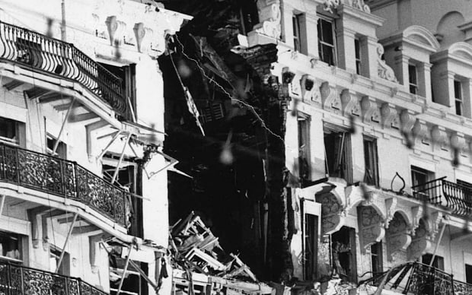The Brighton bomb ripped a hole through the Grand Hotel (Camera Press)
November 1985 Margaret Thatcher and Garret FitzGerald, the Irish Taoiseach, sign the Anglo-Irish Agreement, paving the way for co-operation between the two governments.
November 1987 11 civilians are killed by a Provisional IRA bomb at a Remembrance Day service in Enniskillen.
July 1990 Ian Gow, the Conservative MP, is assassinated by a Provisional IRA car bomb.
April 1998 The Good Friday Agreement is signed and is hailed as the end of the Troubles. It establishes the Northern Ireland assembly, with David Trimble as its first minister.
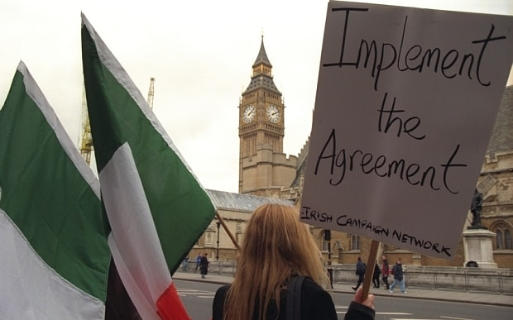Campaigning on the Good Friday Agreement (Jeff Gilbert)
August 1998 In the greatest single atrocity of the Troubles, 29 people are killed by a car bombing in Omagh planted by a dissident splinter group, the Real IRA.
October 2002 Sinn Fein’s offices at the Stormont parliament are raided by police investigating an alleged IRA spy ring. The Government says the peace process cannot go on with the IRA “half in, half out”.
August 2004 Gerry Adams, the Sinn Fein leader, says republicans must be prepared to see the IRA disbanded as part of a final settlement.
January 2005 Robert McCartney, a Catholic former bouncer, is killed outside a bar in Belfast by a gang including IRA members. His family’s campaign for justice focuses on the IRA’s criminal links.
September 2005 International monitors confirm the IRA has completed the disposal of its weapons.
November 2006 Michael Stone, the loyalist murderer, suspends the first meeting of Northern Ireland’s transitional assembly when he walks into the parliament building armed with a handgun, a knife, and a “viable” bomb.
May 2007 The Democratic Unionist Party enters a historic power-sharing government with Sinn Fein. Its leader, Ian Paisley, is first minister, with Sinn Fein’s Martin McGuinness as his deputy.
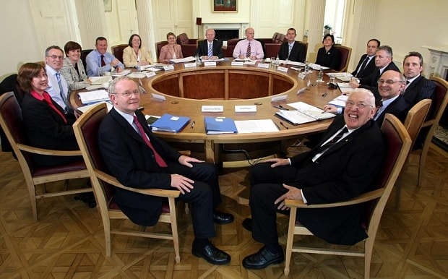
Martin McGuinness and Ian Paisley take power together (AP)
March 2009 Republican paramilitaries shoot dead two British soldiers at their barracks near Antrim and wound four other people.
May 2011 The Queen and the Duke of Edinburgh make a state visit to Ireland, the first since the 1911 tour by George V, Her Majesty’s grandfather.
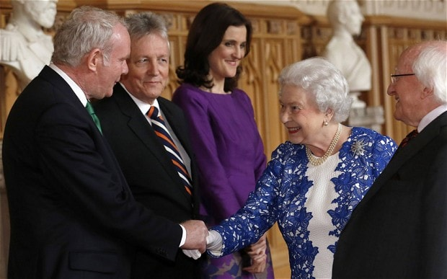
HM Queen shakes hands with Martin McGuinness at Windsor Castle (Reuters)
April 2014 Martin McGuinness, the former IRA commander, shakes hands with the Queen as he is invited to a state banquet at Windsor Castle.
May 2015 Six men are arrested in the Irish republic after police discover bomb-making equipment close to where the Prince of Wales and the Duchess of Cornwall are due to visit.

