English 1A Pathways 2015 Cross-Cultural Films for Film Clubs
These films were chosen for you on the basis of their themes and their high quality. They come from many diverse cultures and reflect many different value systems and ideas. Most focus on characters who are encountering people from different cultures or from different communities within the same culture trying to understand each other.

There is a separate category for films with the theme of optimism and progressivism, even if the people trying to make positive change don’t always have a happily-ever-after ending.

The list includes love stories, war stories, sports stories, comedies, dramas, and documentaries. Many involve journeys and coming-of-age stories. Some are pretty gritty, and many contain scenes of intense violence and/or sex, so do a little research and choose carefully according to what interests you and what you can manage. If you have one to suggest, let me know. The list will grow. Note: The descriptions below are from the Netflix website, in most cases shamelessly stolen word for word (though on some I did a bit of editing and added a few comments). I can do this because I’m the teacher (and because I’m acknowledging the usage here).

Africa and the Middle East

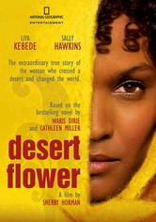
Desert Flower 2009R This drama tells the real-life story of Waris Dirie, a poor girl who flees an arranged marriage in Somalia, winds up in London and becomes one of the world's most recognizable supermodels -- who also speaks out against female genital mutilation. Film script based on a memoir written for Waris Dirie by a SJSU English professor.

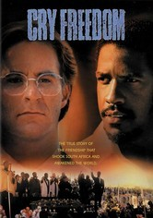
Cry Freedom In segregated 1970s South Africa, black nationalist Steven Biko (Denzel Washington) and white newspaper editor Donald Woods (Kevin Kline) are unlikely friends with a common goal -- ending apartheid -- in this true story based on Woods's books Biko and Asking for Trouble. When Biko's beliefs lead him to prison and a deadly fate, Woods rallies to expose the injustice. Director Richard Attenborough's film earned Washington his first Oscar nod.
Invictus (2009) This drama based on real-life events tells the story of what happened after the end of apartheid when newly elected President Nelson Mandela used the 1995 World Cup rugby matches to unite his people in South Africa. Morgan Freeman and Mat Damon star.
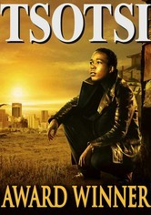
Tsotsi 2005R After shooting a woman and driving off in her car, a ruthless thug is surprised to discover he isn't alone, kept company by a crying infant in the backseat. But through his efforts to care for the baby, he slowly rediscovers his capacity to love. Academy award winner. (Set in South Africa)

The First Grader 2010PG-13 Based on a true story, this inspirational drama profiles the amazing determination of 84-year-old Kenyan Kimani N'gan'ga Maruge, a Mau Mau freedom fighter who wants to take advantage of a new universal education decree by learning how to read.

Cry, the Beloved Country Set in the dark days of apartheid, this film adaptation of South African author Alan Paton's novel tells the story of two men -- one black, one white -- who must cope with family tragedy in a climate of fierce government repression and violence. Rural minister Stephen Kumalo (James Earl Jones) travels to Johannesburg in search of his troubled son, while white landowner James Jarvis (Richard Harris) comes to the city to attend to his activist son's murder.
Nowhere in Africa2001R Shortly before the outbreak of World War II, a Jewish couple and their young daughter emigrate from Germany to Kenya to escape the Nazis, and are forced to come to terms with a new life on an unfamiliar continent.
Out of Africa Hoping to forge a better life, Denmark native Karen Blixen (Meryl Streep) enters into a marriage of convenience with a womanizing baron. But when the couple moves to Nairobi, Karen falls in love with a free-spirited hunter (Robert Redford) who can't be tied down. Director Sydney Pollack's lush period drama earned seven Academy Awards, including statues for Best Picture, Best Screenplay and Best Cinematography.
Lost Boys of Sudan2003UR As orphans living in the midst of civil war, Peter and Santino dealt with dangers like lion attacks and gunfire from militia. But even more daunting are the challenges they face in suburbia after they're chosen to start a new life in America. Megan Mylan and Jon Shenk direct this award-winning documentary that follows two Sudanese refugees throughout their intense journey from their native Africa to the United States. Note: Some of them ended up in the Bay Area, and a few at SJSU.
Persepolis Based on Marjane Satrapi's autobiographical graphic novel, this Oscar nominee for Best Animated Feature Film follows a young woman's childhood in repressive Iran, her adolescence in France and her return to Tehran as an adult.
Miral (2011) After rescuing children who survived a massacre in Jerusalem in 1948, a Palestinian woman establishes an orphanage that helps thousands of other children. But the success of her institution is tested when a pupil gets a taste of radical politics. Based on a true story.

Asia/ Pacific Islands
The Beautiful Country 2004R Looking to find a better life -- and his estranged American father -- a shy Vietnamese man in his 20s embarks on a personal journey with a beautiful young woman aboard a refugee ship bound for the United States.

Lagaan 2001PG In 1890s India, an arrogant British commander challenges the harshly taxed residents of Champaner to a high-stakes cricket match. If the villagers win, they'll avoid taxation for three years; if they lose, they'll pay the tax thrice over.

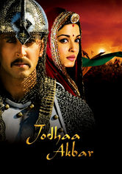
Jodhaa Akbar 2008NR What begins as a strategic alliance of two cultures becomes a genuine opportunity for true love between a mighty Mughal emperor and a Hindu princess in director Ashutosh Gowariker's epic romance set in 16th-century India.
The Wind Rises (2013) Master animator Hayao Miyazaki spins a decades-spanning tale inspired by the life of Jirô Horikoshi, designer of the World War II fighter plane the Zero. Too nearsighted to become a pilot, Jirô settles for building planes, with spectacular results.

Asoka 2001R Based on the life of the Mauryan dynasty's Prince Asoka, this elaborate Bollywood epic dramatizes one man's transformation from a vengeful and cunning warrior into a legendary leader and teacher of Buddhism. After ruthlessly vanquishing a neighboring province, the guilt-ridden ruler (Shahrukh Khan) exiles himself and seeks redemption in this historical drama packed with battle scenes, political intrigue and a star-crossed romance.
Dor 2006NR In this story of love, loss and redemption from director Nagesh Kukunoor, two Indian women from different walks of life are bound by tragedy when one of their husbands has a fatal accident and the other is accused of murdering him. When news of the events -- which occurred in far-off Saudi Arabia, where the men had been working -- reaches the women, one sets out to find the other, since she alone can save the accused from a death sentence.
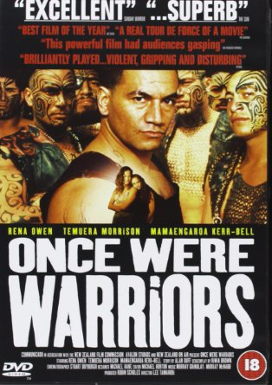
Once Were Warriors Director Lee Tamahori's powerful adaptation of author Alan Duff's best-selling novel centers on the troubled life of a Maori family crippled by poverty, bigotry, alcoholism and domestic violence. Rena Owen stars as Beth Heke, a beleaguered mother who struggles to care for her three children while battling the demons of her erratic, often violent husband, Jake (Temuera Morrison). Warning: this one is really brutal. (New Zealand)

Holly 2006R In this poignant drama, Holly (Thuy Nguyen), a young Vietnamese girl sold into prostitution by her family, tries to escape her dismal life by beginning a platonic relationship with a 40-year-old American named Patrick (Ron Livingston), a stolen-artifacts dealer. Twelve-year-old Holly has been smuggled into Cambodia, becoming one of countless children exploited in the sex trade; Patrick, who has his own troubles, may be her only hope.

Not One Less Master Chinese filmmaker Zhang Yimou turns his lens on the travails of modern China's peasants. When teacher Gao (Gao Enman) leaves town for a month, 13-year old Wei (Wei Minzhi) is pressed into serving as his substitute at the school from which she just graduated. If she keeps her class intact, she will receive a bonus. But when a student leaves for the city, she follows and strives relentlessly to bring him back.

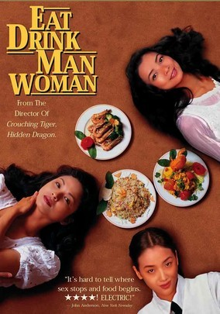
Eat Drink Man Woman Distracted by their complicated love lives and secret ambitions, three adult sisters reluctantly humor their widower father (Sihung Lung) by enduring the elaborate, traditional Taiwanese dinners he insists on having every Sunday. Ang Lee directs this charming tale that humorously examines the clash between modernity and tradition within the contemporary Taiwanese family. Yu-Wen Wang, Chien-lien Wu and Kuei-Mei Yang co-star.

Water 2005PG- After losing her husband to illness, 8-year-old Chuyia (Sarala) is forced to live out the rest of her days in a temple for Hindu widows, communing with 14 other women and a cruel headmistress who agrees to take her in. But it's through the trials of another widow, a beautiful prostitute named Kalyani (Lisa Ray) who's being courted by a man from a higher caste (John Abraham), that Chuyia learns the true restrictions of widowhood.

Ned Kelly 2004 R Fed up with being mistreated because of his heritage, Ned Kelly (Heath Ledger) and his brother (Laurence Kinlan) -- the sons of an Irish pig thief -- form a group of bandits called the Kelly Gang with two other men (Orlando Bloom and Philip Barantini) who share their ideals. Kelly's mob robs banks, evades the police and earns popular support from the people, much to the annoyance of the head lawman (Geoffrey Rush) trying to rein them in.

Rabbit-Proof Fence 2002PG Australia's aboriginal integration program of the 1930s broke countless hearts -- among them, those of young Molly (Evelyn Sampi), Gracie (Laura Monaghan) and Daisy (Tianna Sansbury), who were torn from their families and placed in an abusive orphanage. Without food or water, the girls resolve to make the 1,500-mile trek home. Meanwhile, a well-intentioned tracker is trying to return the girls to the authorities.

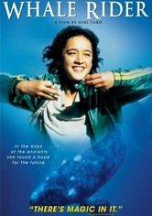
Whale Rider A Maori tribe must contend with the distinctly nontraditional concept of having a female leader when the intended heir to the throne dies during childbirth, leaving his twin sister, Paikea, to prove herself in this inspiring coming-of-age tale.

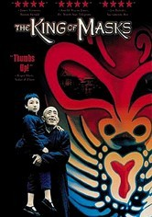
King of Masks Nearing the end of his life, Wang -- a locally renowned street performer and wizard of the venerable art of mask magic -- yearns to pass on his technique. But custom decrees that he can only hand down his craft to a male successor. Anxious to preserve his unique art, the heirless Wang buys an impoverished 8-year-old on the black market. But when the child divulges a dreaded secret, Wang faces a choice between filial love and societal tradition.

Europe

The Spanish Apartment When a French college student signs on to become an exchange student and learn Spanish so he can land a coveted job, he heads to Barcelona and moves in with a host of other young Europeans who help him discover how to enjoy life.
Wondrous Oblivion 2006PG When his new Jamaican neighbor, Dennis Samuels, offers to coach cricket-mad adolescent David Wiseman, the gesture sparks racial hostility in this coming-of-age tale set in 1960 London. David -- who lacks the skills to play the game -- eventually earns a spot on his school's cricket squad thanks to Dennis and learns a few lessons about bigotry in the process. Emily Woof and Stanley Townsend play David's parents.

Dirty Pretty Things 2002R Undocumented immigrants Okwe and Senay work at a posh London hotel and live in constant fear of deportation. One night, Okwe stumbles across evidence of a bizarre murder, setting off a series of events that could lead to disaster -- or freedom.
Bend It Like Beckham 2002PG-13 An ardent fan of British soccer sensation David Beckham, teenage Jess wants nothing more than to be on the field. But a proper Indian girl shouldn't be spending her time playing soccer, according to her traditional family.
Brick Lane 2007PG-13 Set in the 1980s, this cross-cultural drama follows young Nazneem (Tannishtha Chatterjee), a Bangladeshi woman who's immigrated to London for an arranged marriage to a middle-aged man, leaving her beloved family, including her sister Hasina, behind. While Hasina leads a life of adventure back home, Nazneem struggles to accept the isolation and unhappiness in her new life, until an unexpected visitor comes along and changes everything.

Solomon and Gaenor 2000R Two lovers from vastly different backgrounds try to stay together amid religious turmoil. In 1911, anti-Semitism runs rampant in Wales, so Solomon hides his Jewish heritage to make a living as a salesman. Gaenor, unaware of Solomon's ethnicity until she becomes pregnant, stands by him, but her family objects to the relationship. When riots erupt, the couple tries to escape persecution and save their unborn child in this Oscar-nominated romance. (warning, this has scenes of graphic sex and violence).

The Wind That Shakes the Barley2006NR As political tensions brew in early 1920s Ireland, brothers Damien and Teddy (Cillian Murphy and Padraic Delaney) abandon their civilian lives and take up arms to liberate their country from the oppressive "Black and Tan" squads of Britain. Winner of the Palme d'Or at the 2006 Cannes Film Festival, Ken Loach's provocative drama examines a microcosm of civil war in Cork, Ireland. Liam Cunningham co-stars.
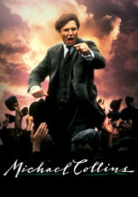
Michael Collins Neil Jordan directed this powerful biopic about the rise and fall of Michael Collins (Liam Neeson), the charismatic leader of Ireland's fight for independence. Collins and his companions de Valera (Alan Rickman), Broy (Stephen Rea), Boland (Aidan Quinn) and Kitty Kiernan (Julia Roberts) used guerilla warfare to attack the British empire, with historic results.
The Guard When FBI agent Wendell Everett invades an Irish village in pursuit of international drug dealers, wisecracking local copper Gerry Boyle (Brendan Gleason) does his best to annoy the American and get on with his life. But soon there's a murder. Hilarious dark comedy and crime drama from the gorgeous west coast of Ireland.
Before Sunrise This intoxicating film from director Richard Linklater stars Ethan Hawke as an American backpacker who strikes up a conversation with a lovely fellow traveler (Julie Delpy) on the train to Vienna and persuades her to spend his last day in Europe with him. Wandering the picturesque streets of the Austrian capital, the two share stories of their pasts and their dreams for the future, ultimately forging a bond that leads to love.
The Edukators Peter (Stipe Erceg), Jan (Daniel Brühl) and Jule (Julia Jentsch) -- a trio of anticapitalist radicals who call themselves the Edukators -- rankle Germany's elite by breaking into mansions, rearranging the possessions and leaving menacing messages that warn of an impending class war. But when Jule leaves her cell phone behind and they return to the scene to retrieve it, an unexpected visitor forces them to improvise.

North America

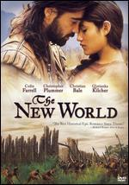
The New World2005PG-13 Set in 1607 at the founding of the Jamestown Settlement, Terrence Malick's epic adventure chronicles the extraordinary actions of explorer John Smith (Colin Farrell) and Native American princess Pocahontas (Q'Orianka Kilcher). As English settlers and Native Americans clash, Smith and Pocahontas find their worlds colliding and their hearts entwined, but ancestral loyalty may tear them apart. Christian Bale and Christopher Plummer co-star. Directed by Terrence Malick.
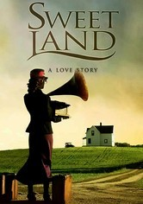
Sweet Land 2005PG Norwegian-American farmer Olaf Torvik and his rural Minnesota community must struggle to overcome years of anti-German propaganda and prejudice when he discovers that his mail-order bride, Inge, is not only a German but also an accidental Socialist. A gorgeous film with both drama and comedy. Stars Tim Gunee and Elizabeth Reaser from Grey’s Anatomy.

Smoke Signals On a Coeur d'Alene, Idaho, reservation, nothing ever changes -- until the estranged father of Victor Joseph (Adam Beach) bites the dust in Arizona, and Victor must go collect the cremated remains. The problem is, Victor can't afford the fare. But annoying nerd Thomas Builds-the-Fire (Evan Adams) will float Victor a loan ... if Thomas can tag along. This tender tale of self-discovery is based on acclaimed author Sherman Alexie's short stories.

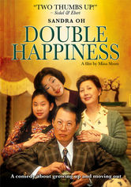
Double Happiness Old-fashioned values collide with the whims of youth in this modern romantic comedy about a dutiful Chinese-Canadian daughter who wants to please her parents without sacrificing part of herself when it comes to love. Deep down, Jade (Sandra Oh) knows her mother and father won't approve of her new boyfriend, a white college student named Mark (Callum Keith Rennie). But that doesn't stop her from hoping for "double happiness." The other plot line involves Jade’s ambition to be a “serious” actress, not a clerk in a dress shop—another desire her parents disapprove of.
Under the Same Moon2007PG-13 In this tale illuminating the plight of illegal aliens, Kate del Castillo plays Rosario, a woman working illegally in the United States to provide a better life for her son Carlitos (Adrian Alonso), who remains at home in Mexico. Longing for his mother, Carlitos stows away on a van that's headed for the border. But an already treacherous journey becomes even more so when Carlitos is separated from his smugglers (Jesse Garcia and America Ferrera).

Frozen River 2008R On a Mohawk reservation on the Canadian border, Ray Eddy teams with widowed tribe member Lila Littlewolf to smuggle illegal immigrants into the United States. Though the work provides the women with much-needed money, each trip puts them in peril.

Thousand Pieces of Gold In the late 19th century, Lalu (Rosalind Chao), a poor Chinese woman, is sold into marriage in America. She's sent to a tough Idaho mining town -- not to marry, but to work as a prostitute in a saloon run by fellow countryman Hong King (Michael Paul Chan). When Lalu refuses the job, her dignity proves irresistible to King's partner, Charlie (Chris Cooper). Based on a true story.

South and Central America

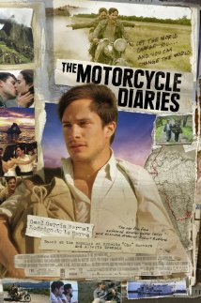
The Motorcycle Diaries2004 R This foreign-language drama tells the incredible true story of a 23-year-old medical student from Argentina -- future revolutionary Che Guevara (Gael Garcia Bernal) -- who motorcycled across South America with his friend Alberto Granado (Rodrigo de la Serna) beginning in 1951. Walter Salles's film is based on Guevara's diaries of the trek, a deeply personal odyssey that ultimately crystallized the young man's budding political beliefs.
Maria Full of Grace2004 R Maria Alvarez is a smart, independent 17-year-old from Colombia who agrees to smuggle a half-kilo of heroin into the United States for a shot at a normal existence in "El Norte" -- where she imagines the city streets are paved with gold.
Central Station Dora (Fernanda Montenegro), who writes letters for illiterate people at Rio de Janeiro's central railroad station, feels compelled to help 9-year-old Josué (Vinicius De Oliveira) locate his estranged father after the child's mother dies in a car accident. This Oscar-nominated drama follows the interplay between Dora and the boy during their journey to Brazil's remote Northeast region, their bond growing ever stronger with each mile logged.
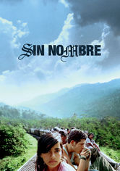
Sin Nombre2009R Fleeing retaliation from the violent Central American street gang he's deserted, a young hood boards a northbound train, where he takes refuge atop the moving freight cars and hopes for a fresh start in a new country. The other story line features a beautiful young girl he meets while riding the freight train, who is trying to reach relatives in the US.
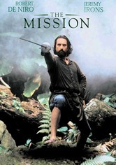
The Mission In the 18th century, a Jesuit missionary establishes a church in the hostile jungles of Brazil, but finds his work converting the indigenous Indians threatened by his superiors. Meanwhile, a slave hunter converts and joins the Father on his mission. Gorgeous film, great music, multiple award-winner, stars Robert De Niro, Jeremy Irons, Aidan Quinn.
Films about people trying to make the world a better place (includes documentaries and feature films)
Girl in the Café (2005) Sometimes high-level international politics works—but only if there’s passion firing up the negotiators. After meeting a beautiful Scotswoman named Gina (Kelly Macdonald) in a London café, lonely civil servant Lawrence (Bill Nighy) asks her to join him at the G8 Summit in Iceland. The shy outsiders hit it off, but their attraction is tested when Gina's personal convictions contradict Lawrence's professional duties. But someone has to speak truth to power. (UK / Iceland)
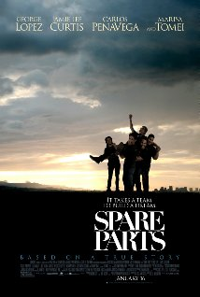
Spare Parts (2015) The journey of 4 undocumented Mexican-American high school students from Phoenix, AZ who form a robotics club and are led by their teacher with nothing but spare parts and a dream to compete against MIT in a National Underwater Robotics Competition. (George Lopez, Marissa Tomei, Carlos Pena, Jamie Lee Curtis star)
If You Build It (US) Hoping to renew the economic health of a rural North Carolina town, a designer and architect together create a new kind of high school design class. This documentary records their unique approach to the art of design and the positive results.

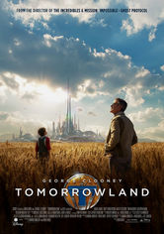
Tomorrowland (2015) Sharing the ability to perceive a utopian alternate dimension known as Tomorrowland, a reclusive inventor and a relentlessly curious teen begin a perilous quest to unlock the secrets of the magical world, which holds the promise of a brighter future. (George Clooney, Britt Robertson star)
Born into Brothels (2004) Documentarians Zana Briski and Ross Kauffman offer a humorous and heartfelt portrayal of the resilience of children and the magic of art to transform the lives of young people living in the brothels of Sonagchi, Calcutta. (India) Oscar Award-winner for best documentary.

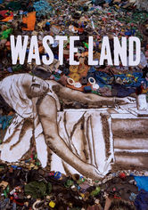
Waste Land (2010) Renowned artist Vik Muniz embarks on one of the most inspired collaborations of his career, joining creative forces with Brazilian garbage pickers who mine treasure from the trash heaps of Rio de Janeiro's Jardim Gramacho landfill. (Brazil)
Big Hero 6 (2014) Want to see brainy young techies—mostly college students—design cool new gadgets that could make the world a better place? In this animated adventure, genius robotics engineer Hiro Hamada finds himself enmeshed in a nefarious scheme to wipe out the city of San Fransokyo. Accompanied by his robot best friend, Hero joins a ragtag team intent on saving the City by the Bay.

