Jefferson Award: Martin Curiel
Shelah Moody, Chronicle Staff Writer Sunday, September 30, 2007
Martin Curiel, with his mother, Maria, at his graduation from Harvard University, worked in the fields with his parents until he was 19. Photo courtesy of Martin Curiel

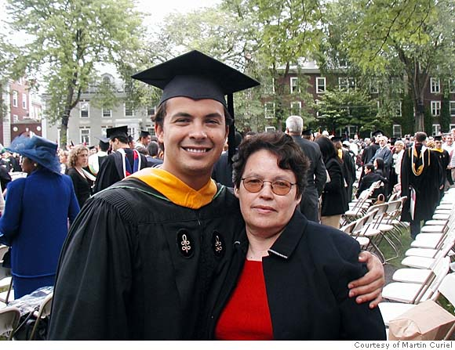

(09-28) 15:26 PDT -- Martin Curiel was born into a family of migrant farmworkers. He had his share of obstacles, hardships and tragedies, but he managed to achieve his dream of becoming a success in the business world and giving back to the community.
Curiel earned a master's in business from Harvard University and became vice president of marketing at Denali Advisors, a prominent investment firm in San Diego. Curiel is also founder and CEO of the Rising Farmworker Dream Fund, a nonprofit organization that empowers migrant laborers and their families.
The Rising Farmworker Dream Fund is based in Live Oak (Sutter County), where Curiel spent much of his childhood. The organization is composed of a group of business managers, investors, entrepreneurs, political leaders, educators and social advocates who invest in ventures that focus on improving the social conditions of U.S. farmworkers through business initiatives. Through the fund, farmworkers learn practical business skills such as saving, investing, how to start their own businesses and how to improve their lives through learning about management.
For Curiel, 32, the fund is a way to honor the spirit of labor activist César Chavez and recognize the contributions of his parents, Francisco and Maria Curiel. His father came to the United States from Guadalajara, Mexico, to work as a farm laborer, as did his mother later on, and they established their residency.
"Basically, what they did was come into this country somewhere around May of every year, and work the different crops," Curiel said. "They picked olives, peaches, cherries, walnuts, almonds, prunes and worked miscellaneous farmworker jobs until the end of November, when they would go back to Mexico. I have an older sister and a younger sister. We worked alongside them through their schedule every year until I was 19 years old."
Curiel worked 12 hours a day picking fruit in unbearable heat. As a child, he felt dirty, looked down on and ashamed to be a farmworker. He said he didn't understand why he could not watch "Scooby-Doo" on Saturday mornings like other children, or why his family drove an "ugly car." The worst part, he said, was that he attended school sporadically because the family moved around so often.
"We often would get independent study booklets to fill out through an organization called the Office of Migrant Education," said Curiel. "There was a big gap in a lot of my learning that, believe it or not, still affects me to this day. We'd go to Oregon in May through June and start summer school there and come back and start school in California near Sacramento, where our base was. Then, we would go and pick olives in Corning, California, (Tehama County) and start school there and then go to Mexico and start school there with the independent study from the state. It was quite challenging to complete your course work and to get the fundamentals."
At 16, Curiel realized that he needed to get out of the fields and get an education in order to become successful. His work ethic drove him to rise above his circumstances, although he was behind in school and his English was limited because he socialized mainly with the Spanish-speaking community of farmworkers.
"In the fields, I had developed the skill of doing something that I hated for long periods of time," Curiel said. "It took a lot of tolerance to do that. Even if I didn't like a class, even if it was difficult, even if it required a lot of time, I had the mind frame that I could work longer than most people without much trouble."
Curiel graduated from high school second in his class and was accepted into California Polytechnic State University San Luis Obispo. Curiel, who still worked in the fields, had just finished a harvest with his father in Oregon and had convinced him to drive back to California so he could make it back for his college orientation. Tragedy struck on the night of July 20, 1993, when the truck his father was driving was involved in an accident on the road. Because of the way he was positioned in the truck, Curiel survived, but his father, his uncle and three other workers, did not.
"I thought that my father had essentially died for my education, and the intensity quadrupled, as far as my desire to go to school and continue to be successful," Curiel said. "I didn't go to Cal Poly that year; I went to a community college and transferred into the engineering program a year later. I competed with some of the top engineering students in the state and was able to graduate cum laude with a 3.5 grade-point average."
While working as an engineer for what was then called ChevronTexaco in Bakersfield, Curiel returned to his roots and became involved with the plight of farmworkers in the community. Although he did well as an engineer, he realized that engineering was not his passion.
"I had the revelation that I had to ... help the farmworkers because of what happened to my father in 1993 and because of what I've experienced in my life," Curiel said. "Business was my vision of channeling resources into this community."
At Harvard, Curiel started the Rising Farmworker Dream Fund with a group of like-minded colleagues and peers. From 2004 to 2007, he worked as a management consultant for Deloitte Consulting in San Francisco. The company gave him money to provide scholarships for farmworkers and allowed him to use their facilities for a conference. Curiel currently donates 10 percent of his salary from Denali Advisors to the Rising Farmworker Dream Fund. (Curiel takes pride in the fact that Denali is the largest American Indian-owned investment-management firm in the United States and that the Rising Farmworker Dream Fund is now leveraging to help American Indian students). The fund has also received donations from Anheuser-Busch and other corporations.
To date, Curiel has helped seven former farmworkers start their own businesses, and 30 people have received scholarships. He said his focus is on the sons and daughters of farmworkers.
"What I found is that farmworkers, because they live in rural communities, are relatively invisible and, like my family, move around all the time," he said. "I see myself as the bridge between the business community that's very resourceful and powerful and the community of farmworkers. I'm trying to connect two worlds that most likely would never come in contact with each other."
For more information, visit www .risingfarmworkers.org. E-mail Shelah Moody at smoody@sfchronicle.com. This article appeared on page D - 2 of the San Francisco Chronicle

