Vivienne Harr's lemonade stand story a movie

Edward Guthmann Updated 5:25 pm, Monday, January 27, 2014
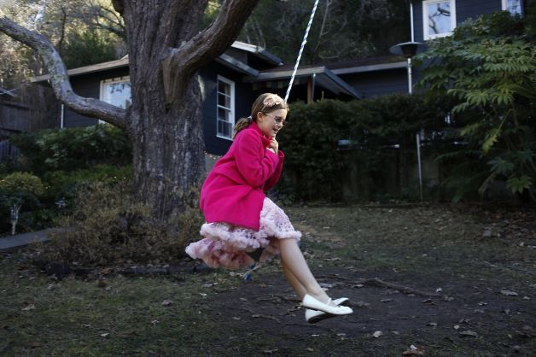
Vivienne Harr's lemonade stand to fight child slavery took in $101,320 over 173 consecutive days. Photo: Lacy Atkins, The Chronicle

(01-27) 17:19 PST FAIRFAX -- When Eric Harr was a kid, he made $9 one day from selling lemonade. He thought that was totally cool.
Thirty years later, his daughter Vivienne set up a lemonade stand in Fairfax and did considerably better. Over 173 consecutive days, she took in $101,320.
Vivienne, a 10-year-old with a penchant for bouncy princess dresses and the color pink, had a motive. Alarmed by photos she'd seen of Nepalese children hauling enormous rocks down a mountain, she decided in May 2012 to raise money to stop child slavery.
When people stopped at her lemonade stand to ask how much she was charging, Vivienne said, "Whatever's in your heart." She donated the $101,320 to Not for Sale, a nonprofit that works to eradicate human trafficking around the world. But she wasn't finished.
During the last year and a half, her campaign morphed into a corporation. Make a Stand Lemon-Aid, which her father oversees, sells fair-trade, organic lemonade at 137 stores and is expected to gross $2 million this year.
Along the way, Vivienne became a bit of a celebrity. In November, she joined "Star Trek" actor Patrick Stewart to ring the opening bell for Twitter's IPO at the New York Stock Exchange - a distinction bestowed because she and her dad, a social-media professional, had made extensive use of the microblogging service.

Larger context
In a new documentary, "#Standwithme," Portland, Ore., filmmakers Patrick Moreau and Grant Peelle show how Vivienne and her parents were drawn to their cause and set their story in a larger context of global efforts to halt human trafficking. The 66-minute film premieres Saturday at the Balboa Theatre and repeats Feb. 4 at the AMC Van Ness, Feb. 5 at the AMC Metreon and Feb. 6 at the Century Centre 9.
"This has really swept up our family," Harr said at his home in Fairfax. Slavery is "just so incomprehensible and so inexcusable, and we can't take another breath or live another day until we do something about this issue."
Thirty million people around the world are enslaved in a $32 billion-per-year industry. According to the U.S. Department of Health and Human Services, "after drug dealing, trafficking of humans is tied with arms dealing as the second-largest criminal industry in the world."
The large, airy home that Vivienne shares with her family couldn't be more removed from the brutal lives of child slaves. A wide, private front yard with two tree houses. A warm, roomy interior that reflects mom Alexandra's skills as an artist and designer.
Conversely, the documentary illustrates, a child slave works sunup to sundown for no pay, is fed rotten food and gets beaten if his or her work performance falters.
What drives an affluent Marin family to make a dramatic shift and devote themselves to ending child slavery? It started May 5, 2012, when Eric and Alexandra were in Sonoma. Strolling into an art gallery, they saw the work of Mill Valley photographer Lisa Kristine, including a heartbreaking image of two boys with large granite slabs strapped to their heads. The boys, roughly Vivienne's age, hold hands to comfort and balance each other.

'We didn't even know'
Alexandra started to shake and weep uncontrollably. When she and Eric walked outside, he says, their world had changed. "We were like, 'What are we doing?' We didn't even know this existed."
They bought a book of Kristine's photographs, took it home and showed it to Vivienne. "I looked at it, and I was super sad," Vivienne remembers. "More sad than all of them. And so we decided to make a stand as a family."
A month later, Vivienne started selling lemonade in Doc Edgar Park in Fairfax. She was 8 at the time.
For her interview, Vivienne is dressed in a pink pettiskirt and her parents in matching pink shirts - like backup singers. Her 4-year-old brother, Turner, wears a blazer and bow tie. You get the sense that the Harrs not only enjoy this playful dress-up and camaraderie, but find it necessary given the issue they're battling.
(Page 2 of 2)
"Vivienne is leading a charge, and we're really behind her," her father says. "I'd love to see this become a billion-dollar company, because if that happens, then we can really, really impact the issue." Eric left his job running the social-media agency Resonate Social in November.
"Now I have a 10-year-old boss, and I'm the CEO of Make a Stand," he says. Make a Stand is a B corporation, a new type of corporate entity that allows companies to make a profit and simultaneously donate a percentage of their revenue to a social-justice charity. Make a Stand has committed to giving 5 percent of its revenue to five organizations that work to end child slavery.

New book
There's also a new book, written by Vivienne and illustrated by Alexandra, called "Make a Stand - When Life Gives You Lemons, Change the World!" It's available on Amazon.
Moreau and Peelle, the directors of "#Standwithme," heard about Vivienne in a Huffington Post article last spring and filmed the Harr family over a five-month period. They also went to Ghana, Namibia, Nepal and the Dominican Republic to film child slaves at work.
"Originally, we thought we would make a five-minute piece," Moreau said by phone from Portland. "But after the first day (with the Harrs), we looked at each other and said, 'This is something so much bigger. If we can make a feature film exploring the issue of child slavery, we can create a much larger conversation.' "
Vivienne, who wanted to be an actress even before her lemonade fame, was such a natural on camera, Alexandra says, that "Patrick and Grant started calling her 'ham and cheese.' "
Fame and celebrity aren't conditions that 10-year-olds typically deal with. To keep their daughter grounded, Alexandra says, "She has homework. She has regular friends and playdates. She plays with dolls and has chores and consequences."
To keep it all in perspective, "We remind her that it 'really isn't all about you. It's this big thing and you're like the shining beacon, for sure. But you couldn't have come to this place without everyone behind you.' "
#Standwithme: 6 and 8:30 p.m. Saturday. Balboa Theatre. Next Tuesday. AMC Van Ness. Feb. 5. AMC Metreon. Feb. 6. Century Centre. www.standwithmemovie.com.
Edward Guthmann is a freelance writer. E-mail: datebookletters@sfchronicle.com
http://www.sfgate.com/default/article/Vivienne-Harr-s-lemonade-stand-story-a-movie-5179948.php#page-2

ONE CHILD, A FEW LEMONS, A WORLD WITHOUT SLAVERY.
SOME LEMONS DREAM BIG.

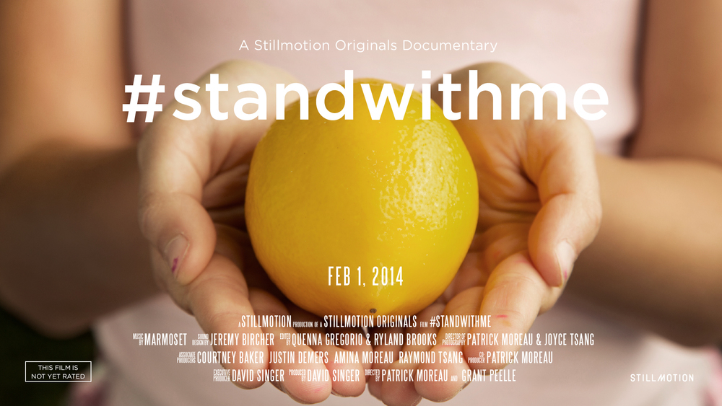
One child is enough to imagine a world without slavery. One child enslaved is too many. One child empowered a few lemons and a little bit of sugar with the light to mobilize a community into action.

Join Us By Attending A Premiere.

*A portion of all ticket sales will go towards helping keep children free and safe.
- February 1 - San Francisco, CA - SOLD OUT
- February 1 - San Francisco, CA - SOLD OUT
- *February 4 - San Francisco, CA at AMC Van Ness - Buy Tickets
- February 4 - Hollywood, CA - Attend Hollywood Premiere
- *February 5 - San Francisco, CA at AMC Metreon 16 - Buy Tickets
- *February 6 - San Francisco, CA at Century Centre 9 - Buy Tickets

