GMO Opponents Haven't A Scientific Leg To Stand On
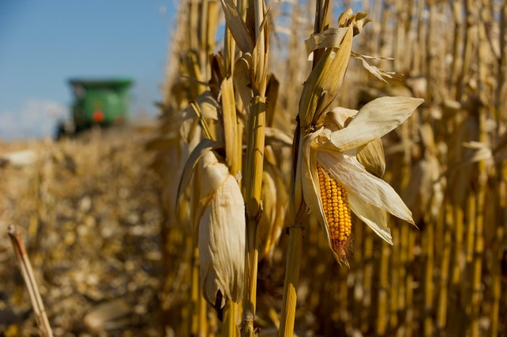
More than 85 percent of U.S. corn is genetically engineered, along with… (United Soybean Board / via…)
August 08, 2014|By BEAU KJERULF GREER | OP-ED
Connecticut, Maine and Vermont have all passed genetically modified organism labeling legislation despite no reputable evidence for health concerns. Unfortunately, New Englanders in both public and private sectors have revealed themselves to be no more enlightened than the anti-vaccine contingency by rejecting overwhelming scientific consensus with the publicizing of research misinterpretations and cries of conspiracy theory. Even popular magazine Scientific American's qualified and well-written defense of GMOs did little to move the needle of opinion.
It is no mystery as to why GMOs invoke a knee-jerk reaction. It frankly sounds scary that corn can be engineered to produce its own pesticide — well, at least until you know that a regular head of cabbage produces 49 different pesticides of its own. Creating a GMO is as simple as taking the gene that codes for one of those naturally occurring compounds and inserting it into a different food. Visions of corn producing chemicals sprayed in backyards to kill mosquitoes are understandable but completely inappropriate.
Consistency seems amusingly rare among the anti-GMO contingency. A pro-labeling friend who admirably admits to having no scientific knowledge on the subject recently lectured me about the perils of tinkering with nature all the while eating a muffin made of enriched wheat. That is wheat that has been stripped of its germ and bran, had synthetic vitamins added it to, and even in its "natural" state bore little resemblance to its botanical ancestors due to human-controlled breeding.
GMO Free CT, a GMO-labeling advocacy group with more conviction than education, is a notable source of misinformation and represents a case study in how an Internet education can be a dangerous thing. I often wonder what these pseudo-naturalists would say if they learned the vast majority of insulin used globally for diabetics is biosynthetic, and yet these individuals are fine despite injecting themselves multiple times per day.
In almost 20 years of research, there has been zero credible evidence that GMOs cause any detriment to human health. There are not even viable hypotheses as to why ingesting GMOs would be harmful. Popular Internet claims of heightened food allergies and elevated cancer risk have been repeatedly debunked. The World Health Organization, the U.S. National Academy of Sciences and the British Royal Society of Medicine have all formally stated there is no greater health risk with GMO-containing foods. The strict GMO regulation of the European Union is often misinterpreted by U.S. activists as a health-related decision as opposed to an economic one (GMOs are patented life forms that carry significant legal implications for farmers), for they too agree there are no health risks.
Last year in Italy, not exactly a country known for its fondness of GMOs, a team of biologists reviewed more than 1,700 published papers and concluded the same. In fact, there is far greater research consistency on the safety of GMOs than on the ability of human activity to affect climate change, the latter rightfully considered a non-negotiable truth by blue state progressives.
A "right to know" argument is a common tenet of pro-GMO labeling arguments, but it is often in the interest of public health that people are protected from their own acquired misinformation. Fat grams are not listed on baby foods because parents may restrict their infant's fat intake for perceived health effects, not understanding the necessity of high amounts of fat in the infant diet. And if the rationale for labeling is transparency for transparency's sake, why not direct our limited resources to labeling arsenic levels in rice, mercury levels in fish or other contamination that actually has documented potential for harm? And do we really want to increase food costs for the poor via labeling because the upper middle class currently enjoys playing the role of armchair nutritionist?
Considering the exploding global population, food and water shortages will be the most universally and immediately felt impact of rising mercury levels. Look to California's current epic drought to see the future of food. To deny scientific consensus on GMO safety is no more admirable or accurate than declaring global warming a hoax because it is snowing outside, and will only serve to delay progress in regard to cultivating adequate calories in a hotter and drier world.
Beau Kjerulf Greer is associate professor and the director of the exercise science and nutrition program at Sacred Heart University in Fairfield.
http://articles.courant.com/2014-08-08/news/hc-op-gmo-controversy-shows-illiteracy-in-science-20140808_1_gmos-health-risk-cancer-risk
from a newspaper based in Hartford, Connecticut.

