Op-Ed: No More Excuses—School Food Must Be Good Food

A middle-school teacher in New York speaks up about the reality of how kids eat in schools.
Comments
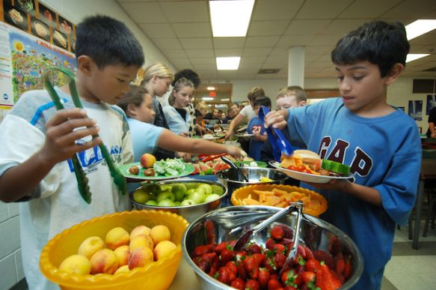
Too many kids are hungry during the school day. This teacher has some tips for teachers and schools. (Photo: Toronto Star via Getty Images)
April 10, 2013 By Lauren Prentiss
full bio
As a middle-school teacher I’m always amazed at the power of a granola bar. I find that on field trips the fix for a crabby kid is often a bite to eat. My husband can attest to the fact that my mood swings dramatically with my caloric intake. I’m resourceful and creative on a full stomach of quality food.
If as an adult I’m much more effective and focused on a full stomach, it must also make a massive difference for my students. Throw in the hormones and drama of middle school and food becomes a huge lever to student success—both socially and academically.
Countless studies have shown what a tumultuous time the middle-school years are for students. Even as adults we look back on these awkward, never-took-a-single-good-photo years, knowing they were tough. Adolescent children are dealing with changes in their bodies (sometime up to one-fourth inch of growth over night), maturing relationships, and the responsibilities that come with growing up.
Adolescence is hard. If we can eliminate one variable to make the challenges kids face more manageable, it could make a world of difference. We must feed our children with foods that support them as they face the challenges of adolescence.
At the middle school where I teach, approximately 95 percent of the student body is eligible to receive free meals. This includes breakfast and lunch daily as well as an afternoon snack. In reality only about ten percent of the student body takes advantage of the breakfast and 75 percent of students eat the school lunch daily.
I speculate students are more concerned with being social (the morning basketball game draws a big crowd) or sleeping in than eating a quick breakfast. By the time lunch hour arrives at 1 p.m., many of my students have not eaten since dinner the previous night. The impact on the class is palpable. In fact, multiple studies have shown the link between eating breakfast and learning.
To combat the difficulties students face as a result of not eating school breakfast, we serve special meals on important days such as when students are taking tests. Kids are invited in early for fresh bagels and orange juice to prepare their bodies and brains for a taxing day. It is unfortunate that this only happens a few days each year.
A friend of mine who works at a charter school in Brooklyn has breakfast with his students every day. It’s a time for teachers and students to come together, play brain games and get ready for the day. While it would be wonderful to provide this experience to every student, it’s currently not possible because of contracts and resources in most public schools. At my school, for example, while there is a culture of working well past dismissal (the majority of us leave around 6 p.m. and take work home) it’s unlikely teachers would come in earlier without compensation.
As much as I’d like to make meals mandatory for my students, it won’t be happening anytime soon. Being realistic, we must approach nutrition for our students from a few key angles.
1. Not all food is equal. There is no nutrition program at my school to teach students about how their body uses different types of food and how that food affects your body.
2. Food is your fuel. Students should be engaged in monitoring how different foods impact their daily energy levels, mood, and ability to focus. Often with working parents, adolescents are left alone for meals. We can’t expect them to make healthy choices if they haven’t been taught how.
3. School food must be good food. If we are expecting students to make positive choices with their own diets we need to provide a model of what healthy eating looks like. Revolution Foods is rapidly growing in this space and is serving healthy meals to kids all over the country.
The research is clear. The better students eat, the better they learn. As a teacher I want to do everything in my power to make my students successful. For me, that means keeping a drawer stocked with granola bars.

Related Stories on TakePart

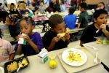

Op-Ed: Can We Please Stop Serving Moldy Food in Our Schools?

The School Breakfast Debate Rages on Despite the Number of Kids Coming to Class Hungry

Angry Moms Declare War on School Lunches

