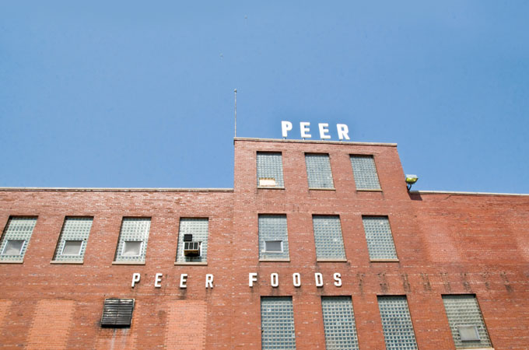
An Inside Job By Jennifer Cockrall-King June 6, 2012
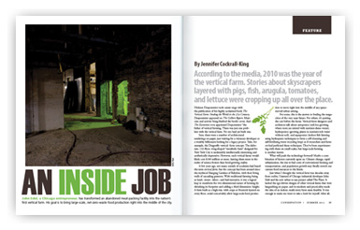
John Edel, a Chicago entrepreneur, has transformed an abandoned meat-packing facility into the nation’s first vertical farm. His goal is to bring large-scale, net-zero-waste food production right into the middle of the city.
According to the media, 2010 was the year of the vertical farm. Stories about skyscrapers layered with pigs, fish, arugula, tomatoes, and lettuce were cropping up all over the place. Dickson Despommier took center stage with the publication of his highly acclaimed book The Vertical Farm: Feeding the World in the 21st Century. Despommier appeared on The Colbert Report. Musician and activist Sting blurbed the book’s cover. And The Economist even appointed Despommier “the father of vertical farming. There was just one problem with the vertical farm. No one had yet built one.
Sure, there were a number of architectural renderings on paper, just waiting for a visionary developer or a wealthy billionaire looking for a legacy project. Take, for example, the Dragonfly vertical- farm concept. The elaborate, 132-floor, wing-shaped “metabolic farm” designed for New York City is undeniably intellectually interesting and aesthetically impressive. However, such vertical farms would likely cost $100 million or more, leaving them more in the realm of science fiction than food-growing reality.
A few years ago, not many outside of academia had heard the term vertical farm, but the concept has been around since the mythical Hanging Gardens of Babylon, with their living walls of cascading greenery. With traditional farming being so land-, water-, labor-, and fuel-intensive, it was a logical leap to transform the two-dimensional nature of farming by shrinking its footprint and adding a third dimension: height. A farm built as a high-rise, with crops or livestock layered on every floor, could conceivably allow large-scale food production to move right into the middle of any space-starved urban setting.
For some, this is the answer to feeding the megacities of the very near future. For others, it’s putting the cart before the horse. Vertical-farm designers and architects talk about aeroponics (soil-less growing, where roots are misted with nutrient-dense water), hydroponics (growing plants in nutrient-rich water without soil), and aquaponics (indoor fish farming using hydroponic techniques to form a self-cleansing and self-fertilizing water-recycling loop) as if researchers and farmers had perfected these techniques. They’ve been experimenting with them on small scales, but large-scale farming is another matter.
What will push the technology forward? Maybe a combination of factors currently upon us. Climate change, rapid urbanization, the rise in fuel costs of conventional farming and transportation, and population growth may finally stretch our current food resources to the limits.
Just when I thought the vertical farm was decades away from reality, I learned of Chicago industrial developer John Edel and his new urban re-use project called The Plant. It lacked the ego-driven designs of other vertical farms that were languishing on paper, and its modesty and practicality made the idea of an indoor, multi-story farm seem feasible. It was enough to make me want to take a look for myself. After all, if Edel could accomplish even a simple version of a vertical farm, it would be urban-agriculture history in the making. And so I made plans to visit Chicago to see The Plant in its early stages of becoming the world’s first, albeit four-story, vertical farm.
Edel cleared a few hours to show me around his “fixer-upper.” In July 2010, he bought the old Peer Foods Building for $5.50 per square foot. Built in 1925, the 93,500-square-feet former meat-packing plant was a late holdout of Chicago’s once-booming meatpacking industry.
I wasn’t prepared for how shockingly cold and dark it would be inside The Plant on that early January day I visited. It certainly wasn’t the natural light–flooded, ethereal skyscraper that the academic vertical-farming camp was known for; it wasn’t even the conventional greenhouse structure one associates with a covered growing space. There were high ceilings, which actually seemed to trap the chill, making it a few degrees cooler inside than it was outdoors.
I had somewhat naïvely assumed that Edel would have to “work around” the lack of natural light. Instead, he explained, the thick brick walls and lack of windows were a major benefit of The Plant. What currently functioned as windows—antique glass block—would, however, have to be replaced. “Glass block neither lets light in, nor does it keep heat in or out,” said Edel. One of the few outside purchases that the building would get was some new windows with high-efficiency glass.
However, high-efficiency glass is very limiting as well, explained Edel, holding up a sample of a high-efficiency window. “See how dark the glass is?” It was a smoky-gray color. High-efficiency glass, by its very nature, blocks those parts of the light spectrum that plants need for growing. And clear glass, which lets more of the light spectrum pass through, allows too much heat transfer. Edel then explained the problem of light at northern latitudes during the winter. “In the upper Midwest on a day like today,” he snorted, “you’ll get no usable light. In an ideal [summer] day, you might get light penetration of about 15 feet.
“That means you’ll be growing under artificial lights anyway. And the last thing you want is huge amounts of glass for that heat energy to escape through.” Any gains made by electrical savings in using natural light would be negated compared to the heating costs escaping out through glass. Besides, a well-insulated brick building such as The Plant will be very effective at trapping heat inside in the winter (the heat from the lights can go a long way if the building’s well enough insulated, Edel believes) and keeping it cooler in the summer. Heat, as I would learn that day, is as valuable an asset as anything else in an ultra-efficient vertical farm in a cold climate.
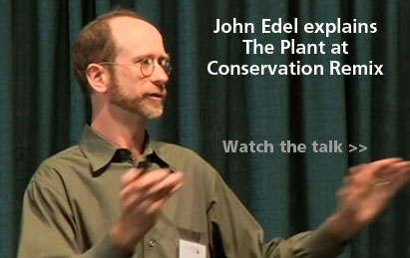But the great advantage to the cavernous nature of the building, Edel explained, is that “you can control the time of day.” This gives Edel the ability to “grow at night,” when electricity costs are a fraction of what they are during the day, when the demand is high. And plants need a period of darkness, just as they need a period of light, so it’s efficient to create night during the day, when energy costs are high. Edel figures he can cut the energy expenses in half by growing during nonpeak hours.
The other advantage, continued Edel, is that “you can create different time zones in various parts of the indoor system. You can flatten your nominal load so that you don’t have demand spikes.” Electrical-utility companies like to charge you at the peak daily rate for energy consumption. By “moving the time of day around” between a few growing zones, you can achieve a “flatter,” more consistent pattern of consumption and therefore save on utilities.
As we climbed the stairs to the second floor, the unmistakable and greasy aroma of bacon wrapped itself around me. “The smokers were in use 24/7 right up until the day Peer Foods moved out,” confirmed Edel.
Some of the smokers were new: huge, stainless-steel tanks about five feet high with what looked like ships’ portholes. The stainless steel was valuable, and Edel and crew had already started to hack it into panels for food-grade countertops and tables. Other panels would become the new bathroom stalls.
Edel has a real knack for finding low-cost creative uses for old industrial buildings and the materials within. After leaving a lucrative broadcast-television design job in 2002, he bought a paint factory that had been officially unoccupied since the 1960s and since become a derelict, biker gang–ridden building with shot-out windows. On a shoestring budget, Edel completely reformed the 24,000-square-feet building into the Chicago Sustainable Manufacturing Center. Better known as Bubbly Dynamics, it now turns a profit for Edel, the landlord. He’s following a similar model with his latest project, The Plant.
“Building a new building is a really inefficient thing to do!” said Edel. “Plants don’t care about columns, or taking a freight elevator to get out to a market. Really, an existing structure is the best possible situation.”
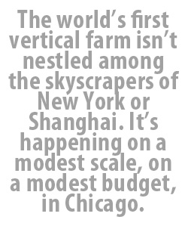Efficiency is part of Edel’s vision on multiple levels, from renting space to reusing waste from one business for another’s benefit. The stainless-steel smoke tanks were in the area designated to become the bakery—one of the food-based, business-incubator areas. Startups will be able to rent the space by the hour and still be in a completely 2,000-square-feet, food-grade, shared commercial kitchen—a major economic hurdle for most people getting into the food-production business, given the overhead on commercial space. Tenants can also rent plots on the rooftop garden and source other items, such as mushrooms, that will be grown in other parts of the building. “There’ll be a wood-fired oven in here,” enthused Edel. The heat from the bakery will be important for heating other parts of the building.
“All of these rooms were great forests of electrical wires, pipes, and everything else. There was meat-cutting equipment everywhere. We are keeping bits of it and reusing almost everything. The oldest wiring is only fifteen years old, fortunately.” There was even a certain beauty to the age-blackened iron rails formerly used to move the carcasses along from one worker to the next. Edel was planning to keep them suspended from the timber supports as a memento of the building’s past.
“This is the one mess I’m going to keep because it’s so out of control,” he laughed, pointing toward one particularly absurd tangle of meters, pipes, wiring, gauges, and switches. Edel quipped that this is where his art-school education will come into play. A floor-to-ceiling glass wall will be installed, with dramatic lighting focused on the “industrial found art”—a ready-made point of interest that will become a central art piece on the third floor. It can be seen from the conference room and the incubator office space rented out to small businesses that use The Plant’s commercial baking, brewing, and food-preparation facilities.
The New Chicago Brewing Company has signed on as a major keystone tenant, and there will even be a homebrew co-op operating out of The Plant. Brewing will not only produce a lot of heat; it will supply vast amounts of spent brewing mash to compost for the gardens and greenhouse or for the biodigester.
On my tour of the plant, I made it a point to talk to Blake Davis, a burly Chicagoan with a crew cut and a constant grin. Davis teaches urban agriculture at the Illinois Institute of Technology. He’s just one of several members of Edel’s team of highly skilled, sustainability-minded volunteers at The Plant, and he’s also studying the economic feasibility of the indoor farm. When I asked him how strong the demand was in Chicago for locally grown food, he replied that even drawing from a radius of 500 miles around the city, there aren’t enough farms for the markets and for the demand that already exists. Plus, being right in the city will be a huge advantage for restaurants willing to pay a premium for ultra-fresh product. “We’re about the only people who can say, ‘We’ll pick this for you at 9 a.m., have it to you by 10, and you can serve it for lunch.’”
The other factor favoring the viability of vertical farming in the city, according to Davis, is that Chicago’s public-school system now sets aside 20 percent of its school-lunch budget for local foods. Wholesale produce suppliers have also told Davis that they’ll take everything The Plant
can produce. So finding markets for the food will be the easy part.
In Davis’s opinion, however, Edel’s plan of having manufacturing tenants subsidize the food-growing spaces was a key element to turning The Plant into reality while other, more ambitious, “food-only” skyscrapers linger on paper. “We’ve been to almost every other urban-agriculture site within 500 miles, and we noticed that almost all of them are being run on job-training grants from foundations. We thought that this was probably not a good way to run this. That’s why I really jumped onto this project. It’s technically interesting, but it has a commitment to creating a business model that can be replicated. The problem with social services and 40-story urban farms is that you train a bunch of people, but there are no businesses out there to hire them.”
When I remarked that it’s somewhat surprising that the world’s first vertical farm won’t be nestled among skyscrapers in uptown Manhattan or in the anything-is-possible cities such as Shanghai and Dubai—that it will happen on a very modest scale, on a very modest budget, in Chicago—Davis just smiled.
“When Sam Walton [founder of Walmart] started, he didn’t try to build a 400,000-square-feet superstore. He took an old Kresge’s and said, ‘I’m going to figure out this business model in this relatively small space. If it’s successful, I’ll make another one.’ I think if you get good at urban agriculture and have a few technological breakthroughs, at some point you’ll need an architect to design an 80-story urban farm. Maybe your business model will be sound to do that. It’s just a bit premature right now.”
I asked whether the city was therefore giving The Plant any breaks or other type of help. “They’re not subsidizing it,” answered Davis. “But the most important thing in Chicago is that they’re letting us do it.”
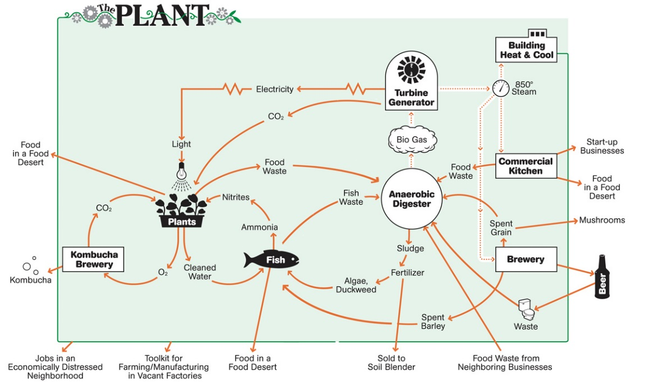
We descended into a dark, cavernous basement for the grand finale. We cautiously picked our way around and over scrap metal, spools of wiring, and curbs as though we were climbing through the innards of a submarine. Edel pointed out rooms that would soon be filled with mushroom beds. He had secured a former fighter-jet engine that would be put into use for electrical generation once the biodigester was built.
Edel yanked on a solid-steel door, and we passed from the submarine scenario into an immense, laboratory-white room bathed in a fuchsia light on one side with gurgling vats of tilapia-filled water on the other. The Plant Vertical Farm wasn’t just demolition and future scenarios: there was actual food growing in test systems in this basement room.
“This is Growing System Number One,” said Edel as we walked toward four square, 275-gallon, plastic tubs that were the fish tanks. This was the project that Davis’s students were working on, tweaking and perfecting it so that it could be implemented on a larger scale when The Plant ramped up its food ecosystem.
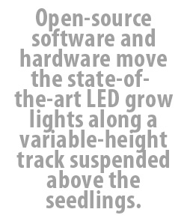Slivers of fingerling tilapia flashed around the tank; as soon as they saw us looming over them, they made for the surface. There were two more tanks attached to this chain of plastic vats and white plastic PVC pipes, and the nearby pump was noisily forcing water through the tanks. Sixty market-weight tilapia swirled in the final tank.
The water from the fish pens flowed into another water-filled tank with run-of-the-mill, hardware-store, black-plastic garden netting for filtering. Edel explained that the netting caused “the richer stuff” to fall to the bottom of the filter tank. When The Plant’s biodigester is ready, this solid fish waste will be used to produce methane gas, which will turn back into heat and electrical energy.
The next tank over had a black-plastic, honeycomb-like panel—a place to harbor the bacteria that turn the ammonia of the fish waste into nitrites and nitrates for fantastic plant fertilizer.
The pump then sent the water from the filters into shallow pans where foam rafts studded with tiny plant plugs floated on clear yet nitrogen-rich water. Each hole in the raft contained a small plastic basket filled with coconut husk to stabilize the roots of each tiny seedling of arugula, red lettuce, or whatever the team wants to grow. The nearly indestructible, coconut-husk fiber is porous enough not to restrict the rooting systems that dangle through the gaps in the baskets and into the water. As the plants take up nitrogen, they effectively clean the water—as they do in ecosystems in nature—allowing the water to be recycled back into the fish tanks for the waste-fertilizer loop to begin again.
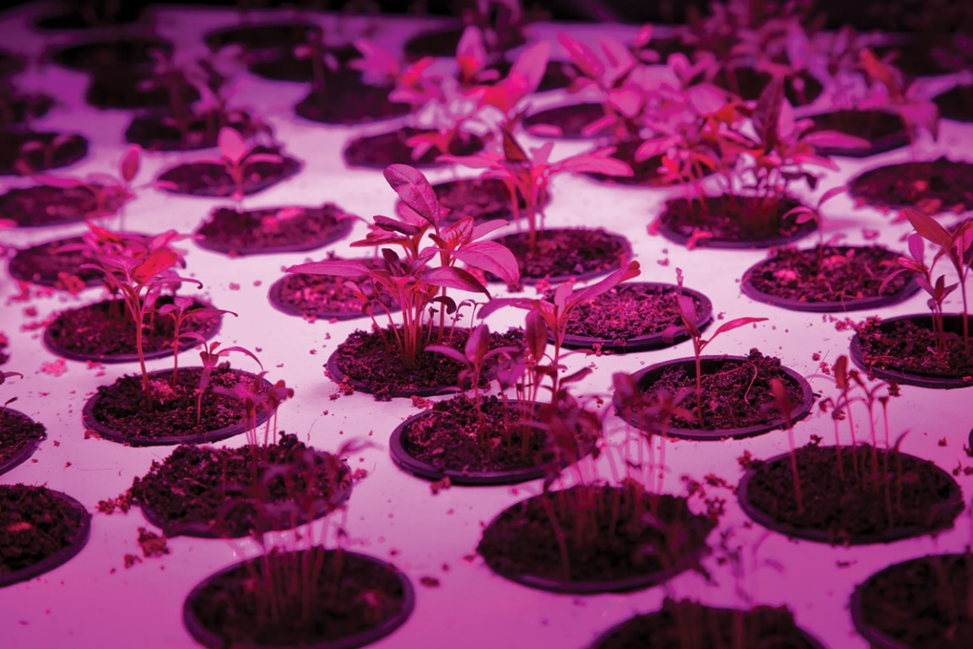
Bathed in the fuchsia light of the state-of-the-art LED grow lights, the plants looked very happy and healthy. “Plants can’t see green,” Edel explained, so you need only the red and blue lights. Edel, Davis, and some students are testing the LED lights, as these are relative newcomers to the market. If they work, they’ll be much more efficient than other grow lights commonly used. A computer engineer is working out the open-source software and hardware that will move the lights along a variable-height track suspended above the seedlings. The lights move slowly from one end of the beds to the other “so they don’t end up growing like this,” explained Edel, listing sharply to one side.
Edel’s ability to reinvigorate unwanted industrial space and make it beautiful, productive, and profitable seems like a reasonable antidote to the hefty price tags that have so far kept urban vertical farms confined to the drawing board. As Edel puts it, “You’ve got to sell a lot of rutabagas to pay for a 100-million-dollar building.”
If Edel and his team can figure out the right mix of elements that work synergistically, they will have built a viable physical and economic model for a vertical farm. Edel also intends that The Plant will serve as an open-source laboratory and catalyst for industrial reuse in a city that had no shortage of ready-built shells just waiting for a reason to remain standing.
There will be no single urban-agriculture solution that will work for every community and every city; each city will have to address its own limitations and needs. We won’t go back to living in the forests any sooner than we’ll be able to achieve total food security through urban farms
on each corner.
But if we learn to give space in our urban settings to food production and food producers, we’ll be healthier, happier, and more connected to the physical realities of our short existence because of it. Cities—or rather, those of us who live in cities—can no longer be just consumers of food and producers of waste. We’re realizing that it’s time to close the loop. ❧
Jennifer Cockrall-King, a freelance food writer based in Edmonton, Alberta, Canada, is author of the recently released Food and the City: Urban Agriculture and the New Food Revolution (Prometheus Books, February 2012), from which this article was adapted. Her work has appeared in the Chicago Sun-Times, the National Post, Canadian Geographic, Maclean’s, and other major publications. She blogs about food and her research trips at foodgirl.ca. You can also join her at facebook.com/FoodandtheCity and twitter.com/jennifer_ck.
Photos ©The Plant
See more photos of The Plant https://www.flickr.com/photos/plantchicago/
http://conservationmagazine.org/2012/06/an-inside-job/ (for the article)

