What does the rise of 'dark tourism' mean?
By Masako Fukui Wednesday 22 April 2015
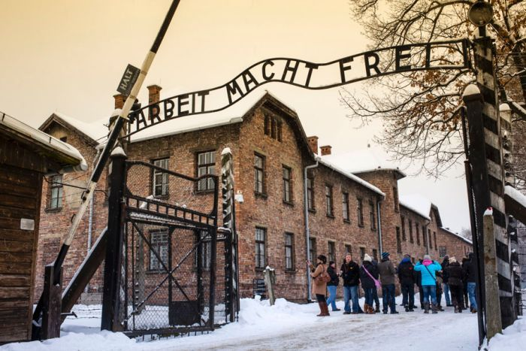Image: Tourists under the 'Arbeit Macht Frei' sign at Auschwitz Concentration Camp, Oswiecim near Krakow, Poland. (Lonely Planet/Getty Images)
Fancy a dose of death, disaster or suffering on your next holiday? It’s not as far fetched as you might think. Around the world, more and more tourists are heading to sites linked with murder, tragedy and even genocide. Is it thoughtful pilgrimage or voyeurism? Masako Fukui investigates.
Like the thousands of Australians now at Gallipoli, more and more people are travelling to places that you can describe as dark.
Dubbed dark tourism, holidaying to sites of grim commemoration is one of the fastest growing sectors in the international tourism market, and its popularity is raising new moral and ethical questions about the meaning of death and memorialisation.
Our memorials don’t rise up against injustice. We rise up against injustice. We shirk that responsibility when we go to a memorial instead of doing something.
James Young, University of Massachusetts Amherst
‘I really want to go to Auschwitz,’ says Irit Rosen, who wants to see the barracks where her mother Eva once slept. ‘I guess it’s making it real.’
Visiting the former Nazi concentration camp site in Poland is a form of pilgrimage for many Jews like Rosen. It’s also motivated by a desire to understand or to ‘make real’ the Holocaust, arguably 20th century’s greatest act of human evil.
Even for those who have no intimate connection to Jewish history, Auschwitz and other confronting destinations are now de rigueur on many holiday itineraries. Why this willingness to confront ourselves morally?
A myriad of destinations, from Elvis Presley’s Graceland to New York’s National September 11 Memorial and Rwanda’s sites of genocide fall within the dark tourism spectrum, so it’s difficult to generalise what motivates people to choose greyer shades of travel.
Richard Sharpley, professor of tourism and development at the University of Central Lancashire in the UK, suggests that in the increasingly secular west, people are replacing the void left by the rejection of structured religious practice with new forms of meaning making.
Dark tourism gives people the opportunity not only to grieve publicly, but also to explore their own responses to seemingly inexplicable human suffering, even unimaginable evil.
Of course, motives to travel to the conceptually dark can be just plain frivolous.
‘Some forms of tourism are undoubtedly driven by a degree of voyeurism and schadenfreude,’ says Sharpley.
The camera-toting tourists who descended upon the devastated Italian city of L’Aquila in the immediate aftermath of the 2009 earthquake, for example, are indeed a case of rampant voyeurism.
Mostly, however, our gawking is less consequential than people fear. That’s because most dark destinations—whether they’re ruins or memorials—resonate with the material palpability of the tragic events that they represent. It’s hard not to be moved.
‘Auschwitz is so powerfully present,’ says James Young, distinguished professor at University of Massachusetts Amherst in the US. ‘The ruins are very, very moving because they suggest themselves as extensions of what actually took place there.’
According to Young, the remnants of the barracks or the gas chamber tell the story of the Holocaust almost too well. Artefacts like bins of human hair, mountains of shoes or discarded eyeglasses that once belonged to prisoners are extremely powerful, but that power can be misleading.
‘Artefacts have always been used to endow a particular narrative with the naturalness of the artefact’s form,’ explains Young.
It’s easy to mistake the artefact for actual ‘living proof of whatever’s being explained there’.
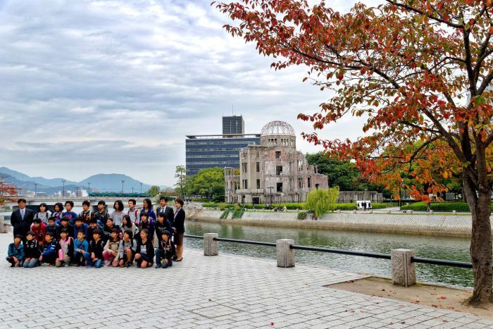Image: Hiroshima's A-Bomb Dome is the ruins of the building closest to the hypocenter of the nuclear bomb dropped on the city by the US at the end of WWII. (brian_ytsu; Flickr.com/CC/by-nc.nd/2.0)
The same goes for grandiose memorials and historical monuments. In the past 30 years a number of formidable edifices like Maya Lin’s Vietnam Veteran’s Memorial in Washington, Peter Eisenman’s Memorial to the Murdered Jews of Europe in Berlin or New York’s National September 11 Memorial have become regular tourist attractions.
Brimming with artistic intent, these memorials may provoke or console, but mostly they inspire awe for being aesthetically intriguing.
The almost deafening waterfalls at the September 11 Memorial, designed by architect Michael Arad, for example, are both disturbing and hopeful. Water is a symbol of life, explains Young, but the fact that the cascading waterfalls never actually fill the voids left by the twin towers suggests a profound loss that can never be filled. The sheer size of the waterfalls and the audacious vision of the memorial can be stirring.
Therein lies the problem of materiality. By externalising memory in material form, there’s always the danger that we relieve ourselves of the moral challenge of remembrance—that once we leave the memorial site, we allow ourselves to forget.
Young issues a warning ‘for visitors not to allow themselves to be overwhelmed by affect’ and miss out on historical explanations and meanings. In other words, as tourists to dark sites, what’s expected of us is not just empathy but a degree of critical historical consciousness. The burden of memory is on us.
That’s a considerable burden given memorials have very little to do with history, let alone historical authenticity. Sites of commemoration are expressions of collective memory, usually contemporary narrative concerns like mateship, heroism, victimhood or the loss of innocence.
Just listen to the narratives surrounding this year’s Anzac Day. History is merely the excuse to tell the stories of bravery, martyrdom, mateship and national pride.
Mythmaking is not the issue, however, the real problem with dark tourism, according to Young, is that we build memorials and visit sites of commemoration without doing anything about current, ongoing persecutions like genocide. Young alludes to the most important part of remembrance—future action.
‘Our memorials don’t rise up against injustice. We rise up against injustice. We shirk that responsibility when we go to a memorial instead of doing something,’ he says.
This particular challenge is left out of most travel brochures and guidebooks. As dark travel becomes more and more popular, there’s a possibility that it will become just another product we consume so we can vicariously experience the gravitas of dramatic events.
Perhaps then this Anzac Day, an idea might be for us to consider an addendum to the familiar ‘lest we forget’. ‘Lest we don’t act’ might not be catchy, but will the sentiment expressed catch on?
The original forum for this was Earshot, which says it is “about people, places, stories and ideas, in all their diversity.” From the “About” page: “RN exists to nurture the intellectual and cultural life of all Australians, and is as a vital and integral player in the development of a national conversation around the ideas that matter. Known for its specialist content across arts and culture; business and current affairs; health, science and technology; Indigenous culture and issues; and religion and ethics, thought-provoking analysis delivered on air and across digital platforms, RN is a dynamic and world-class production house where innovative content is commissioned and made.”
http://www.abc.net.au/radionational/programs/earshot/the-trouble-with-dark-tourism/6412726
From the comments section: One of the most well developed responses (though not entirely grammatical) on the comment board is pasted in below. I’ve resisted the impulse to add punctuation or capitalize letters.

Richard : 23 Apr 2015 10:25:41am Firstly, why does this need picking apart? Secondly, every single ruin or ancient greek or roman memorial would have to be considered "dark tourism". Where does this end? When do we no longer consider a memorial, memorable enough for tourism to it to be considered appropriate.
Next up, who is it to say what is appropriate tourism and what is not.
Last year, I visited the home of Anne Frank. Now, I'm sure that there are probably some people out there that would take nothing but sheer pleasure at it and some who would have absolutely no empathy or sympathy for the Frank family and their plight, not to mention, by extension, every other family in Europe at the time who suffered similar fates or who were not so fortunate (if one could say the Franks were fortunate). The people who would feel nothing, may just be in shock or they may be sociopaths who take a dark pleasure in visiting these sights. We can't close them down just because a few unstable people take pleasure in them.
The upshot of my visit to the house of Anne Frank was that at the end of it, I had to sit outside afterwards in the freezing cold for at least 20 minutes. I was in shock. I was in such a state of shock that I was crying, I could not stop crying. I grieved for Anne. I grieved for her family, for her father who never got to tell her how much he appreciated her and how proud she made him. I grieved for other families who went through similar things in the same period.
Next year I intend to visit Auschwitz. Not because it's grim, not because it's a "holiday". It's so that I can pay my respect to those who lost their lives in what was one of the worst wars that have ever happened in the world. It is a central place, that still exists. I single point on the globe that I can go to, not just to pay my respect to those who lost their lives there, but also to those who lost their lives throughout Europe between 1939-1945. The gay men who died at the hands of Nazis, the Jews, Gypsies, Communists, Socialists, Christians and anyone who dared to criticise these people. A central place where I can show my respect for some of my own extended family who originated from Germany, who lost their lives during the second world war, and even a few who lost their lives in the upheaval between the first and second world wars.
Your suggestion that some people may take a perverse pleasure in visiting these places, does not take away from those who visit them for noble reasons. And at the end of the day, what business is it of the Authors, or of anyone else's the motivation of those who visit memorials around the world.

Andy Betts : 23 Apr 2015 4:12:55pm Thanks Richard for your excellent and exact contribution. I personally visited Auschwitz in September 2000. I didn't make the visit because I am some mysterious supporter of 'dark tourism' but rather to pay my respects to all the people whom were murdered there. Facing those attrocities, in photos and physicality, first hand, and yes like visiting Gallipoli is to obtain understanding and closure.
I can say this. You don't have to have any connection to any of the people that died at Auschwitz nor Gallipoli. All you need to do is go there. I was completely and utterly moved by what I discovered there, and also what our guide relayed to us, of the utmost despair and the stories of incredible survival and hope.
All you need to be, is human. Dark tourism is the most stupid tag line I have ever heard. I have no fear of crazies who want to dance on people's graves at night and make what they will of going to these these places under some premise of their outspoken morbid facination. They have nothing on the people who committed something truly disgusting and abhorrent. Genocide. To wipe out, or ethnically cleanse an entire species or race, and what happened there, like experiments on wome and children demanded my attention and my respect.
Lest we forget.

