Book Review | Nonfiction

How to Raise a Mensch By JENNIFER BLEYERAUG. 22, 2016
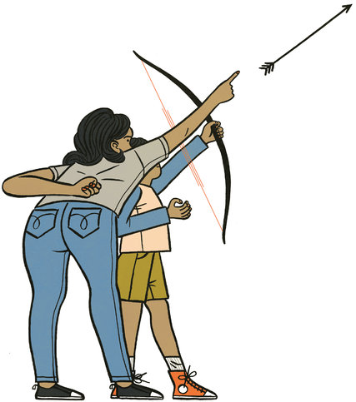Credit Hannah K. Lee
MAMALEH KNOWS BEST: What Jewish Mothers Do to Raise Successful, Creative, Empathetic, Independent Children By Marjorie Ingall 245 pp. Harmony Books. $25.
It’s hard to imagine that anyone except the most incessantly hovering, pathologically neurotic and culturally oblivious helicopter parent hasn’t clued in to the near-constant barrage of advice not to treat children like delicate butterflies who must be shielded from all forms of predation (nonorganic food, unsupervised play, mediocre grades, the feeling of sadness). For years now, social scientists have emphasized that what kids really need to become healthy adults is tenacity and self-reliance, flexibility and resilience. Among my parenting contemporaries, the lessons seem to have been drilled in so deeply that they’re invoked like a kind of mantra — Grit! Risk! Failure! We get it.
The premise of Marjorie Ingall’s rich, insightful book “Mamaleh Knows Best” is that these qualities are exactly what Jewish parents have aspired to instill in their kids for millenniums. Although similar to Amy Chua’s “Battle Hymn of the Tiger Mother” and Pamela Druckerman’s “Bringing Up Bébé,” Ingall’s Hebraic addition to the Here’s Our Cultural Secret subgenre of parenting guides lacks anything as scandalous as Chua’s sleepover bans or as astonishing as Druckerman’s depiction of French toddlers dutifully eating four-course meals. What it offers instead is a compilation of ideals that Ingall contends have long helped Jewish parents — and mothers in particular, as the historically dominant figures in their largely home-based religion — raise children who are, as the book’s subtitle says, successful, creative, empathetic and independent.
A writer for Tablet Magazine and a former parenting columnist for The Forward, Ingall starts by acknowledging that the popular image of a Jewish mother is typically something more cringeworthy than complimentary: She’s the clingy, kvetchy horror who douses her offspring in guilt and shovels kugel down their gullets. Ingall traces the image’s provenance to various elements of midcentury America, including, she concedes, a post-Holocaust anxiety — there’s nothing like living in the shadow of a genocide to make moms cleave to their kids a little tighter — as well as the ascent of male Jewish novelists, comedians and television writers who were desperate to assimilate into mainstream society and spewed their mommy issues across the page, stage and screen. (Poor Sophie Portnoy.)
After dissecting and mostly disposing of the moth-eaten stereotype, Ingall focuses each chapter on a different sensibility imparted by Jewish parents, marshaling evidence from history, culture and sacred texts, and leavening it with contemporary research, jaunty humor and personal stories from her experience as a mother of two daughters. On the value of independence, she points out that the ancient practice of a bar mitzvah at age 13 — whatever its glitzy evolution in the New World — is to publicly announce that a kid is not a “wee, unreliable, undependable, footloose-and-fancy-free child anymore. The family stands before the community saying, ‘Look! We have made an accountable human being!’ ” On the value of discipline, she explains that the Hebrew word for sin, chet, is an archery term that means “missing the mark,” and extrapolates that Jewish parenting has commonly been about warmly but firmly guiding children to gain the self-control, self-motivation and sense of responsibility they need to hit their marks, whatever they may be, and face the consequences when they don’t.
Less obvious but equally central values that Ingall highlights include having a healthy distrust of authority. Jews come from a vertiginously long tradition of “questioning, yammering, challenging and disputing,” she writes. “The Talmud, the compendium of Jewish law, is pretty much a bunch of dudes contradicting one another. Each page is a big box of text in the middle, and wrapped around it like a frame is lots of ‘Wait, you think what?’ ” Encouraging such chutzpah and sharp debate from a young age has not only helped the tiny religious minority survive centuries of persecution, she argues, but also made them creative freethinkers as well as humanitarians who stand up for what’s right. Likewise, on the value of education, she makes plain that Jews have customarily done well in this domain because of their love of learning, not for being “dutiful bubble-filler-inners.” And on the value of geekiness, she describes parents nurturing their kids’ natural enthusiasms no matter how uncool. “We’ve been taught not to be afraid to be passionate, focused dweebs,” Ingall writes.
Of course, though she doesn’t readily acknowledge it, the sensibilities she describes aren’t exclusive to Jews. And as she frets several times throughout the book, Jews aren’t always the best exemplars of their own received wisdom. Ingall worries that many modern American Jewish parents have fallen prey to the dominant culture’s devotion to personal happiness and achievement, and explains why being fixated on “me” before “we” is not only totally nonkosher but also a pretty sure way to create selfish, brittle, needy brats. Heading a section with “The Very Word ‘Self-Esteem’ Makes Me Want to Hurl,” she advises parents, Jewish or not, to “worry about building a kid who is good, not a kid who has good self-esteem.” If there’s one overarching lesson of the book, it’s that Jewish-style child rearing, at its best, is about raising a mensch — a person of true goodness and integrity — which is less of a discrete value than something like a master password that unlocks all the rest. Ingall holds this goal up as a guide star for all parents, regardless of their heritage. After all, she writes, paraphrasing the old slogan for Levy’s rye bread, “You don’t have to be Jewish to be a Jewish mother.”
Jennifer Bleyer is a senior editor at Psychology Today. (google NYTimes book review)

