ME 190 - Term Project Information Fall 2015
The term project is a chance for you to apply the skills you have learned thus far in mechatronics and will learn in ME 190, to design, build, and test a mechatronic system that incorporates a control system.
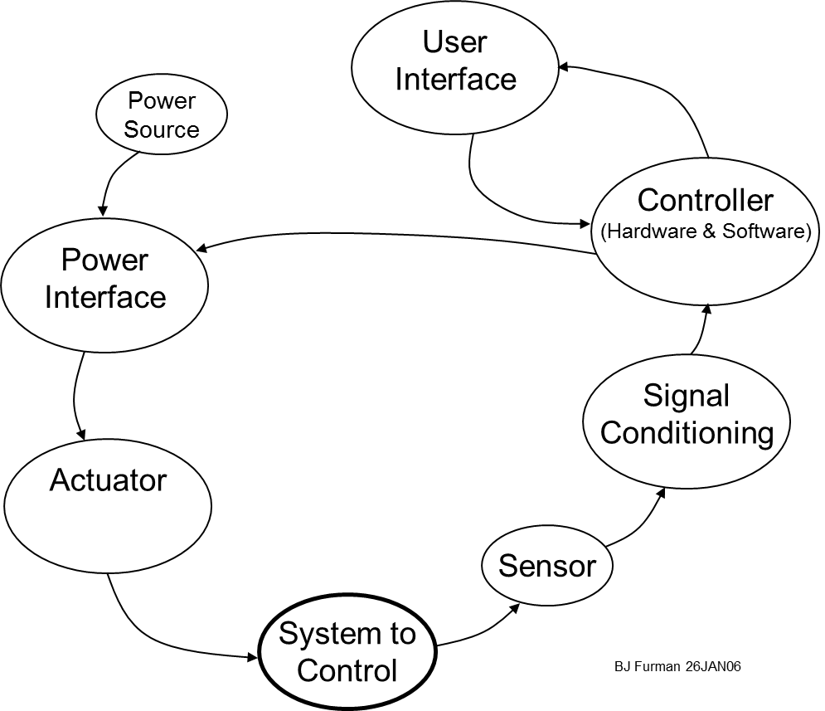
This semester you will define, design, build, and demonstrate a mechatronic system that fully integrates the elements of a mechatronic system and includes a control system. Remember from ME 106, that mechatronics is all about integrating the following elements:
So your system must involve all the elements of a mechatronic system, and implement a closed-loop control system in its operation
Special emphasis and extra-credit will be given to groups who,
- Contribute to the development of a suspended autonomous vehicle for the Spartan Superway project.
- Develop or refine a lab experiment that can be replicated and subsequently used in ME 190, particularly with SmartMotors or programmable logic controllers. (We have hardware on hand for at least one such system).
- Develop or refine a lab experiment for ME 285, particularly with the Cypress PSoC, Rasberry Pi, or BeagleBone Black controller platforms
(See Prof. Furman for more information about these three options!)
The project is intended to be a team effort of two to three people at most; however individual projects may be approved if and only if there are compelling reasons to do so. In any event, you must submit a proposal for your project and get approval for it and makeup of your group before diving into the project.
Grading of the project will be carried out using the following criteria:
- Concept (25%) Your device will be judged on its technical merits, including, innovation, appropriate use of hardware and software to produce a mechatronic system, application of physical and engineering principles in the design, and focus on the modeling an control system development.
- Implementation (25%) Your device will be judged on how well the concept was implemented in hardware. The focus here will be on the quality of workmanship and finished appearance.
- Performance (25%) Your device will be judged on how well it performed during the project evaluation session.
- Final Report and Project Videos (25%) This aspect focuses on the completeness and quality of your written documentation of the design of the system. A key feature will be, “How easy would it be for someone acquainted with Mechatronics to understand, reproduce, and/or modify this design as documented?” Part of your documentation will be two short videos posted to YouTube, one that describes the design and demonstrates its operation, and a second in which each member of the team describes his or her contribution to the project and what was learned in the process. (It is okay if you wish to combine these two parts into just one video, but be sure to address both elements in the video!)
[Individual contribution to the project will be assessed by each team member and will form a separate part of the overall course grade (see the section describing the Grading Policy in the syllabus). Your instructor will give you a form for this assessment]
You will present your project on Tuesday, 12/1 or Thursday, 12/3/15, beginning at 1330, and possibly extending through the lab period (1720) on 12/3/15. The presentation will take place in E135.
A hard copy and softcopy of your report will be due on or before Tuesday, December 8, 2015 at 5 pm. Turn in one hardcopy per team, and submit the softcopy to Canvas. The hardcopy of your report must have the individual performance evaluations attached to the report. This can be done in separate envelopes if desired, but all must be ATTACHED. Submit softcopy of the individual performance evaluations separately in Canvas.
Process for Completing the Term Project
- Form a team of two (preferred) to three classmates, and figure out when you can meet on a regular basis to work on the project.
- Prepare a proposal for your project. Submit your proposal by 10/1/15. Project proposals submitted early are likely to be approved earlier!
- Get approval and dive in!
- Prepare your video documentation and final report. Submit hardcopy to your instructor on the due date AND softcopy via Canvas.
Notes on the assignment:
- The Department may be able to provide some materials for this project. If not, visit http://www.engr.sjsu.edu/bjfurman/courses/ME106/componentinfo.htm for links to suppliers.
- Shop facilities are available in E123 at regular hours during the week for those who have successfully passed the ME/Tech 41 Shop Safety course and have received their access privilege from the MAE office. The shop manager will be happy to help you fabricate parts, but only if you have a sketch or engineering drawing (with dimensions) of your parts.
- Don’t procrastinate!
Key Dates Deliverables
Wk 7: 10/1 Deadline for submission of project proposal: group composition, subject of project, goals, and performance requirements. (Earlier is better than waiting to submit by the deadline, so you have more time to complete the project)
Wk 16: 12/1-3 Presentation of term projects in E 135 beginning at 1330
Wk 17: by 12/8 Term project report due and videos posted to YouTube (See below for how to write the report)
Guidelines for Term Project Report
- One report for your group
- A title page, at a minimum listing: the title of the project (descriptive and specific), the entity for which the report was written, i.e., San José State University, Department of Mechanical Engineering, ME 190 Mechatronic Systems Engineering, the names of the team members, the date of submission. The title page should be attractive and complete. The best reports typically have a nice, clear photograph or drawing of their solution as part of the title page.
- A Summary section that succinctly and specifically states: what you did, how you did it, what happened, and what was learned. This section should consist of approximately four paragraphs, and be about one or two pages long. Make sure that you include in this section a photograph or sketch of your device that provides a good visual summary of your project.
- An Introduction section that describes what the project was all about, first in general (by referring to this guideline to describe the general goal and design requirements of the project), but then specifically, giving background on the need and specific objectives that your design addresses. This section should be at least one page long. Make sure that you include sufficient sketches, drawings, and/or photographs and verbiage to clearly explain to someone unfamiliar with your project what it is all about and what your device is supposed to accomplish.
- A section that details the modeling and simulation of the system and the proposed controller.
- A section that describes your design in DETAIL. This section must have figures (i.e., drawings, photos, sketches all with annotation, see below) that document your design. In this section, you must have at LEAST an overall photograph, sketch, or drawing and a detailed schematic diagram of the circuits used in your design in this section. You might find it helpful to use Electronics Workbench software in the Mechatronics laboratory to draw the schematic. There is a freeware version of a program called CircuitMaker that you can get at: http://babbage.cs.qc.edu/courses/cs343/Circuit_Maker/ that you can use at home. There are also programs for designing printed circuit boards (PCB) that can facilitate drawing a schematic (DipTrace, http://www.diptrace.com/ and Eagle, http://www.cadsoftusa.com/ are two relatively popular PCB design programs). Follow the guidelines in http://www.engr.sjsu.edu/bjfurman/courses/ME120/me120pdf/ME120labreportguide.pdf for how to annotate your figures. This section must also have a system block diagram to clearly communicate what the major subsystems are and how they are integrated into the whole design. This section must also have analysis and description of how you verified that your design met the specifications. Also include a flowchart that outlines how the design and software operate. You will have achieved success in writing this section if a peer in the class could take what you have written, and referring to it alone, reproduce your device. Detailed drawings for any parts that you fabricated should be included in an Appendix and referred to in the body of the report.
- A section that addresses the outcome of the project: how well your modeling and simulation match the real performance, how well the control system worked or didn't work, what you would do if you had more time to improve the design, and what you learned. Please be specific about the performance of your device with respect to the design specifications, and give specific recommendations for improvements or further work. General blathering will not earn a good score on this section. Include reflections on your team’s process of problem solving, how effective it was, and what you would do differently if you had to do the project over again.
- A list of references used following the guidelines given in: http://www.engr.sjsu.edu/bjfurman/courses/ME120/me120pdf/ME120labreportguide.pdf.
- An Appendix that documents aspects of your project that are important, but that may be unwieldy or might otherwise disrupt the flow of the main body of the report. Examples include:
      - The source code of the program that operated your device. (Well commented!)
      - Detail drawings of any parts that you fabricated
      - Data sheets (or key excerpts if the full data sheet is too long to include in its entirety) of devices or sensors that you used
      - Bill of materials (BOM) for all the parts that comprise your design. If possible, also list in the BOM sources and costs for the parts.
      - Concepts for alternative designs and documentation of your selection process (such as a Pugh Chart)
      - Other items that might be helpful to someone who was attempting a similar project, but that don’t warrant inclusion in the main body of the report.
- Attach your individual performance evaluation forms (each team member must fill out a form) to your report. You may put your evaluation in a sealed envelope if you wish, but make sure that it is attached to your report.
*** IMPORTANT NOTE ***
Upload a softcopy version of your report to Canvas. See the Term Project Assignment there.
References
Design Specification. (2010, August 1). In Wikipedia, the free encyclopedia. Retrieved August 25, 2010, from http://en.wikipedia.org/wiki/Design_specification

