The Electronic Scale

Learning Objectives

By the end of this laboratory experiment, the experimenter should be able to:

1. Explain what an operational amplifier is and how it can be used in amplifying signal sources
2. Configure, build, and test several common amplifier types.
3. Explain what a Wheatstone bridge is, how it is commonly configured, and how it is used in measurement systems
4. Build a digital electronic scale using a force sensitive resistor, a voltage follower amplifier, and an Arduino.

Components

Qty. Item

1 Arduino with USB cable

1 Solderless breadboard

1 LM358 dual operational amplifier

1. Square force sensitive resistor, like the Interlink FSR 406 (https://www.adafruit.com/products/1075)

1 ea. 1 k resistor, 4.7 k resistor

2 ea. 10 kΩ resistors, 200 k resistors

Various lead weights

Introduction

Precise force sensing devices often use strain gages, which are essentially precisely calibrated resistors made from very thin metallic foils. Gages are usually bonded to a beam element, and when a load is applied to the beam, the foil stretches, which results in a change in the resistance of the gage. The gage is connected electrically in an arrangement using three other resistors of similar value called a Wheatstone bridge circuit. Because the change in resistance of the gage is relatively small, the voltage output from the bridge circuit needs to be amplified. This is commonly done with an instrumentation amplifier, which is a specially designed chip with several op-amps and precision trimmed resistors, which is designed to amplify the difference of two voltages. Figure 1 shows a fixture that used to be used in an earlier version of this experiment, which uses a short cantilever beam module with strain gages bonded to it. Figure 2 shows three types of Wheatstone bridge circuits that are commonly used with strain gages. The voltage labeled Vout is what an instrumentation amplifier would amplify.

A recent innovation in force sensing is the force sensitive resistor (FSR), which unlike the strain gage, changes its resistance in response to force applied to a low-cost thick-film polymer that in turn makes more or less contact on electrodes printed on a substrate. Figure 3 shows the construction of a FSR. We will use an FSR in this experiment to create a weight measurement system.

|  |  |
| --- | --- |
| Assembly_LoadCell |  |

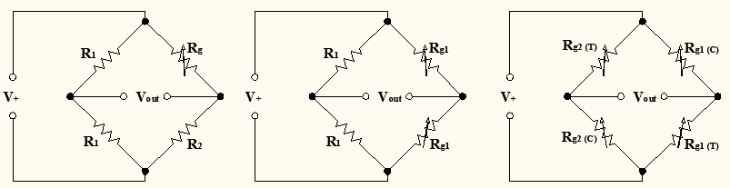Figure 1: Load Cell/Cantilever assembly. A short catilever beam instrumented with two strain gages forms the core of an electronic scale. When a force is applied to the right end of the beam, the lower strain gage is strained in compression and the upper gage is in tension. The compressive and tensile strains cause the resistance of the strain gages to change (lower for compressive and higher for tensile).

Figure 2. Common Wheatstone bridge configurations. The number of active gages (Rg) in the circuit determines the type of Wheatstone bridge. From left to right: The Quarter-Bridge has one active gage, the Half-Bridge has two active gages, and the Full-Bridge has all four resistors active. The letters ‘T’ and ‘C’ indicate tension and compression.

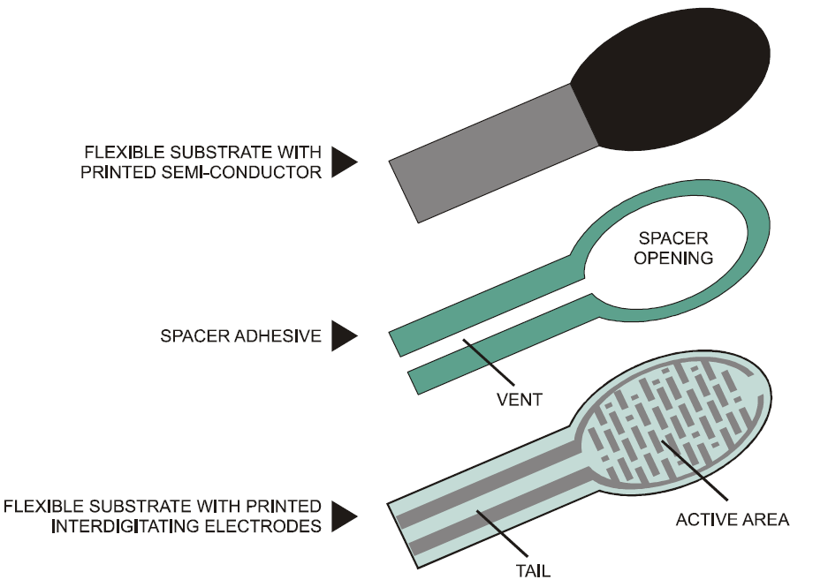

Figure 3. Construction of a force sensitive resistor (FSR). The resistance between the leads varies according to how much the flexible substrate is pushed against the electrodes. (source: <https://www.sparkfun.com/datasheets/Sensors/Pressure/fsrguide.pdf>)

Op-amps and Amplifier Circuits

Figure 4 shows two common packages for operational amplifiers. The single package on the left contains one operational amplifier. The LF741 was one of the earliest IC op-amps and is still widely used. There are many, many varieties of op-amps available today (see <http://focus.ti.com/lit/an/slod006b/slod006b.pdf> for example). In this lab we will be dealing with op-amps designed for small signal amplification. There are also power op-amps that are designed to source or sink relatively large currents at relatively high voltages. Small-signal single op-amp IC’s are usually pin-compatible with the ‘741, but one should always check the data sheets to be sure. The op-amp we will use in this lab experiment is the LF353. It contains two independent op-amps as shown. Some op-amps come in quad-packages that contain four independent op-amps.

Op-amps are active devices, which means they must be *powered* in order to function. The typical configuration for general purpose op-amps will use symmetrical positive and negative supply voltages (±VS) typically in the range between ±5 V and ±15 V. There are some op-amps that are designed to work with single-sided supplies, i.e., where –VS is ground, and +VS is typically +5 V to +15 V. There are other op-amps that can be operated at lower and higher supply voltages.

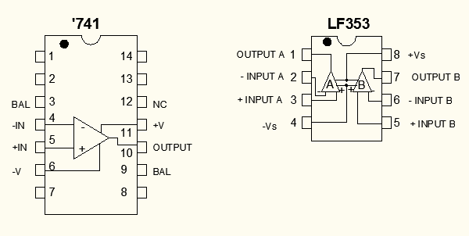

**Figure 4.** **Examples of single and dual op-amp IC packages.** The ‘741 was one of the earlier, but still very common, general purpose IC op-amps. Both the ‘741 and LF353 should be powered with symmetrical positive and negative power supplies (see their data sheets for maximum limits). We will use the LF353 dual op-amp in this experiment.

Procedure

1. Design and construct an inverting amplifier (see Figure 5) with a gain of -20. Use a 10k resistor for R1. This will save you time later). Note the minus sign on the gain. The output polarity is *inverted* from the input. This is why it is called an “inverting amplifier.” What must the resistance of R2 be? Set up the power supply for voltages of ±12 V ***before*** connecting the power supply to the op-amp. Turn off the power supply before you wire it to the op-amp. ***It is always a good idea to do whatever wiring you need with all power to the circuit turned off.***

Scope ground clips. If you remember from the first lab, because the circuit uses a *common ground*, we can attach the ground clips anywhere in the circuit. Actually, we only need to attach one of the ground clips to get a stable trace. Make sure that if you attach both ground clips, you attach them to the ***same point*** in the circuit. If you attach them to points at different voltages, you essentially create a short-circuit to earth ground through your circuit and the ‘scope. Such a condition will likely toast your circuit and damage the ‘scope, so always think carefully when using the ‘scope. For this experiment, it is recommended that you attach one of the ground clips to COM somewhere in your circuit.

To test your circuit, first, set up the function generator with high-Z termination to output a **2 kHz** ***sine wave*** with an amplitude of 100 mV peak-to-peak (p-p). Check the output of the function generator with the ‘scope first before you connect it to the amplifier. Then, connect the ‘scope probe from Channel 1 to the input of your amplifier circuit and the ‘scope probe from Channel 2 to the output of the amplifier. Where should the ground clips of the scope probe be clipped? Before you attach the clips, turn to the last page to check your answer.



**Figure 5.** **An inverting amplifier.** The gain of the amplifier is -R2/R1. It is always a good idea to keep the leads to the inputs of the op-amp and the feedback loop short to minimize noise pickup.

Now apply power to the circuit, and connect the function generator to the input of the amplifier. Compare the signals from Channel 1 and 2 displayed on the screen. **Do the voltage peaks appear to be opposite each other? Does the amplitude of the output signal agree with your gain calculation?** Increase the function generator amplitude until the op amp output appears to be chopped off at the peaks (also called, ‘clipped’). At what input amplitude is the output clipped? **Explain why the output is clipped.**

1. Using the other op-amp on the LF353, construct a non-inverting amplifier with a gain of 50 as shown in Figure 6. Let R1=1k, and use a 100 k trim pot for R2. The gain of this circuit is (R1+R2)/R1.



**Figure 6.** A non-inverting amplifier. The gain of the amplifier is (R1+R2)/R1.

**Test this circuit in the same manner as before**, then input a **10 kHz *square-wave*** with an amplitude of ***0.5V p-p***. Compare the two signals displayed on the screen. **Are the voltage peaks synchronized? With a square-wave, how would you tell if the voltage peaks were being chopped off? Most importantly, what is the gain of this circuit?**

1. Modify the non-inverting amplifier to make a *voltage follower* amplifier. (Do you remember the configuration for the voltage follower, where the output is simply fed back to the inverting terminal, and the signal is applied to the non-inverting terminal?) Test this circuit in the same manner as in step 1. **How does the output signal compare to the input signal? Does this agree with what you expect?**
2. Obtain a force sensitive resistor (FSR) from your instructor (Figure 7). Handle it gently, so as not to knock off the short tube that has been mounted at the center of the FSR. Insert the pins into the solderless breadboard as shown in the right side of Figure 7.
3. Measure the resistance of the FSR with nothing loading it. Then, using something to support it underneath (like a book), press *gently* on the center, and measure the resistance. **How much did it change**? Try applying the same pressure elsewhere on the FSR. **Do you get the same resistance**?

|  |  |
| --- | --- |
| 1075 LRG |  |

**Figure 7.** **Force sensitive resistor.** The short length of tubing in the middle of the FSR will be used to support a load, so that the load will be applied consistently in the same location. (Photo sources: <https://blog.adafruit.com/2012/10/19/new-product-square-force-sensitive-resistor-fsr-interlink-406/> and <https://histrumentation.wikispaces.com/EDT307T+Lab2_OLD>)

1. Build the circuit shown in Figure 8, where RM = 10 kΩ and V+ = 5 V. Before you connect the voltage follower, measure the voltage at node A, and see that it varies with the force you apply to the center of FSR. Gentle force only, please! Once you are satisfied that you are seeing a change in voltage, connect the voltage follower, and verify that Vout is what you expect.

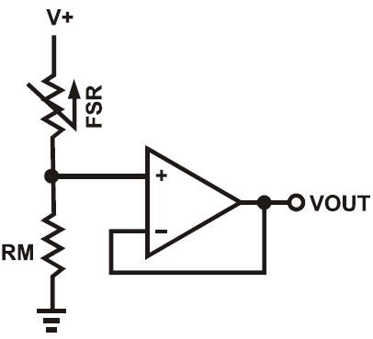

**Figure 8.** **FSR circuit.** The short length of tubing will be used to support a load, so that the load will be applied consistently in the same location. (Photo sources: <https://blog.adafruit.com/2012/10/19/new-product-square-force-sensitive-resistor-fsr-interlink-406/> and <https://histrumentation.wikispaces.com/EDT307T+Lab2_OLD>)

1. Use some of the lead weights that you will get from your lab instructor to develop a *calibration curve* for your electronic scale. In other words record and plot Vout vs. weight. **Is the curve linear**? Repeat your collection of Vout vs. weight using the same weight values. **How closely do the values repeat? What happens to Vout if you leave the weight on for a minute or two? Is it stable?**

Interfacing the Electronic Scale to the Arduino

1. Connect the electronic scale to Analog pin 2 of the Arduino, view the analog output through the serial monitor, and note the average value being displayed. The Arduino has a 10-bit analog-to-digital (ADC) converter. This means that the ADC has a resolution equal to the reference voltage, Vref = 5 V, divided by 210. For example, if the output from the scale circuit, Vout = 2.51 V, then the converted 10-bit result will be 514. What is the smallest voltage that can be detected by the Arduino’s ADC?
2. Apply weight to the scale, and note the corresponding serial monitor value. Now, **write a function that will display the weight of any object on the scale.** Once you have done this, get an unknown valued weight from your lab instructor, and see if you can determine its weight using your calibrated scale.

Extra-Credit

Modify your program to also include a calibration routine. The calibration routine would prompt the user to enter a set of weights, so that the calibration for any FSR could be determined upon initialization or through a user input, like a button press. Test that your program works by using a different FSR (which will have slightly different calibration than the one you worked with). See how close you can get to determining the unknown weight using a different FSR and your modified program.