San José State University
College of Health & Human Science
Department of Justice Studies
JS144, Criminal Law, Section 1, Spring 2019
Instructor: | Harold W. Peterson, JD
Office Location: | MacQuarrie Hall, Room 508
Telephone: | (408) 924-2754 (voice mail)
Email: | harold.peterson@sjsu.edu
Office Hours: | Tuesday/Thursday 4:14 p.m. to 5:15 p.m.
Class Days/Time: | Tuesday/Thursday 10:30 am to 11:45 am
Classroom: | MacQuarrie Hall 520
JS Competency Area: | C: Critical Inquiries

Course Catalog Description
Historical development of philosophy of law and constitutional provisions, legal definitions, classifications of crime, case law, methodology and concepts of criminal as a social force.

Instructor’s Course Description
From property crimes to homicide, this course will explore the fundamental elements to crimes in the United States, their historical progression, constitutional limitations as well as the specific defenses to them. In addition, the course will survey the general principles of criminal liability including the ideas of mens rea and actus reas. Moreover, students will learn the various degrees of criminal liability including intentional, reckless and negligent conduct its concurrence and causation as well as conspiracy and the concepts of vicarious and strict liability.

The course will explore crimes against persons, including general and sexual assault, aggravated assault and homicide as well as crimes against the public order, including disorderly conduct, vagrancy, panhandling, gang activity and certain victimless crimes. In addition, the course will examine the elements associated with property crimes, including burglary, larceny, theft, vandalism and fraud. Finally, the course will look at various crimes against the government, including treason, sedition, sabotage, espionage and terrorism.

- Historical Perspective: The course will survey the historical components to specific crimes in the United States as well as a chronological review of statutory and case law associated with such crimes.
- Legal Analysis: The course will provide an analytical review of the basic elements of specific crimes pursuant to federal and state statutes and the common law, specifically the evolution and interpretation of such law by the US Supreme Court and the state courts. In addition, the analysis will include an in-depth look at the reasons and justifications that shape the court’s opinions and how these opinions ultimately define criminal law in the United States.
- Discussion: The course will facilitate discussion of issues concerning criminal law, crimes and the development of such law within the criminal justice system.

Course Goals and Course Learning Outcomes
Upon successful completion of this course, students will be able to:
CLO 1 - Articulate the nature and limits of criminal law in the United States.
CLO 2 - Understand the Constitutional limitations regarding criminal law such as the void-for-vagueness and Equal Protections doctrines.
CLO 3 - Understand concepts of mens rea and actus reas.
CLO 4 - Apply the principles of causation, concurrence and vicarious liability to certain fact situations.
CLO 5 - Master the elements of specific crimes against persons and property as well as defenses to such crimes.
CLO 6 - Brief cases from the textbook in a format that identifies the facts, legal issues, holdings and the court’s findings.

Course Requirements
Success in this course is based on the expectation that students will spend, for each unit of credit, a minimum of forty- five hours over the length of the course (normally 3 hours per unit per week with 1 of the hours used for lecture) for instruction or preparation/studying or course related activities including but not limited to internships, labs, clinical practica. Other course structures will have equivalent workload expectations as described in the syllabus.

Students are expected to complete all reading assignments before their discussion in class. In addition, students are responsible for the individual cases contained in textbook and when called upon are required to recite the specific case in class. Students shall receive a maximum of 50 points for their initial case recitation and a maximum of 25 points for each additional case for a maximum of 100 points towards their participation grade. Student may also receive additional participation points for various exercises identified in class by the instructor. THESE EXERCISES ARE NOT EXTRA CREDIT BUT SHALL ONLY COUNT TOWARDS A STUDENT’S PARTICIPATION GRADE.

Textbook:
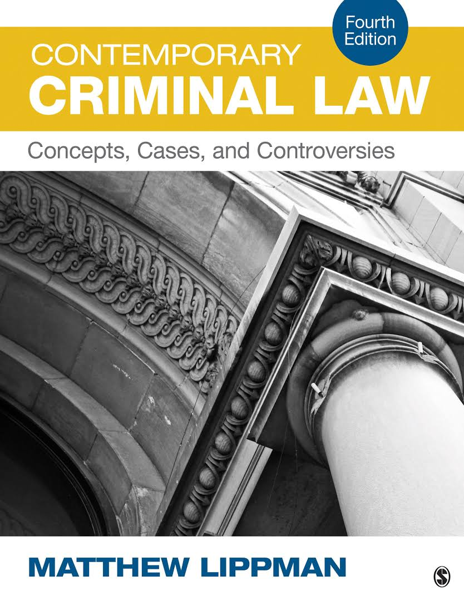
Lippman, M. R. (2013) (4th ed). Contemporary Criminal Law, Concepts, Cases and Controversies. Thousand Oaks, CA: Sage Publications Inc. The text is available at the campus bookstore. Supplemental readings assigned by topic and held on e-reserve at the library. ISBN-13: 978-1483379364

Justice Studies Reading and Writing Philosophy: The Department of Justice Studies is committed to scholarly excellence. Therefore, the Department promotes academic, critical, and creative engagement with language (i.e., reading and writing) throughout its curriculum. A sustained and intensive exploration of language prepares students to think critically and to act meaningfully in interrelated areas of their lives–personal, professional, economic, social, political, ethical, and cultural. Graduates of the Department of Justice Studies leave San José State University prepared to enter a range of careers and for advanced study in a variety of fields; they are prepared to more effectively identify and ameliorate injustice in their personal, professional and civic lives. Indeed, the impact of literacy is evident not only within the span of a specific course, semester, or academic program but also over the span of a lifetime.

Classroom Protocol: This is a time to open your minds to new ideas, to explore new concepts, so please take advantage of this opportunity. Further, please be respectful of others and show them common courtesy. Students may enrich the learning process by discussion. Respect and professionalism are the guiding principles of this class. Tardiness will not be tolerated, if you are late, do not disturb class—wait until break to enter the classroom.

Electronic Devices: Please turn off all cell phones, pages, PDA’s or any other electronic device that “make noise”. No text messaging in class, please turn off these devices, as they are disruptive. Students may take hand written notes during class; however, students may not use computer and/or other recording devices without instructor’s permission.

Assignments and Grading Policy

Written Assignments: All writing assignments must adhere to the 10 Rules of Formal Writing and the instruction and description found on the Canvas website. Written Assignments not conforming to these rules will receive a significant reduction in grade.
Examination and Evaluation: A student’s final evaluation shall consist of two (2) midterm examinations (one in-class and one take-home, three (3) short essay assignments and a final examination. Each assignment/examination shall consist of 100 point and is weighted as follows:

Grade Item | Weight
First Midterm Examination (CLO’s 1-3, 5) | 20%
Second Midterm Examination (CLO’s 1-5) | 20%
3 Short Essay Assignments (CLO 6) | 20%
Class Participation/Case Recital (CLO’s 1-3, 5,6) | 10%
Final Examination (CLO’s 1-6) | 30%
Total | 100%

Examinations consist of multiple choice, short answer and essay questions derived from the reading assignments and class lecture. Missed exams or assignments may only be made-up with proper documentation of illness, incapacity and/or prior and valid notification and reason for absence.

Presentation/Recitation Assignments: Students must present/recite at least two (2) cases from the text. As there are a limited number of cases, students are encouraged to volunteer early in the semester. Instructor requires students to summarize the facts, assess the issues and reflect on the possible outcomes. Students must also be prepared to answer questions from the instructor and the class.

More details can be found from University Syllabus Policy S16-9.

Examinations consist of multiple choice, short answer and essay questions derived from the reading assignments and class lecture. The second midterm will be take-home. Missed exams or assignments may only be made-up with proper documentation of illness, incapacity and/or prior and valid notification and reason for absence.

- University Syllabus Policy S16-9 (http://www.sjsu.edu/senate/docs/S16-9.pdf)
- University Policy F15-12 (http://www.sjsu.edu/senate/docs/F15-12.pdf)

+/- Grading: This course will be using the +/- system on final grades based on the following percentages:

93-100: A 74-76: C
90-93: A- 70-73: C-
87-89: B+ 67-69: D+
84-86: B 64-66: D
80-83: B- 60-63: D-
77-79: C+ 0-59: F

Please note, a “C” or higher is required to receive credit for this course toward a Justice Studies or Forensic Science Major.

Students must submit all assignments online at the Canvas website.

Dropping and Adding
Students are responsible for understanding the policies and procedures about add/drops, academic renewal, etc.
https://slisweb.sjsu.edu/current-students/registration-and-enrollment/adding-and-dropping-classes
Students should be aware of the current deadlines for dropping and adding classes. http://www.sjsu.edu/provost/docs/1314aycalendar.pdf

Required University Policies Statement
Per University Policy S16-9, university-wide policy information relevant to all courses, such as academic integrity, accommodations, etc. will be available on Office of Graduate and Undergraduate Programs’ Syllabus Information web page

Academic Integrity:
www.sjsu.edu/studentconduct/docs/Academic_Integrity_Policy_S07-2.pdf
Your own commitment to learning, as evidenced by your enrollment at San Jose State University and the University’s integrity policy, require you to be honest in all your academic course work. Faculty members are required to report all infractions to the office of Student Conduct and Ethical Development.
The University will not tolerate instances of academic dishonesty. Cheating on exams or plagiarism (presenting the work of another as your own, or the use of another person’s ideas without giving proper credit) will result in a failing grade and sanctions by the University. Students must complete all assignments unless otherwise specified. If you would like to include in your assignment any material you have submitted, or plan to submit for another class, please note that the SJSU Academic Policy F06-1 requires approval of instructors.

Campus Policy in Compliance with the American Disabilities Act: If you need course adaptations or accommodations because of a disability, or if you need to make special arrangements in case of building evacuation, please make an appointment with me as soon as possible, or see me during office hours. Presidential Directive 97-03 requires that students with disabilities requesting accommodations must register with the AEC (Accessible Education Center) to establish a record of their disability. For more information call their office at 408-924-6000 (v) or 408-924-5990 (TTY).

Accommodation to Students' Religious Holidays: San José State University shall provide accommodation on any graded class work or activities for students wishing to observe religious holidays when such observances require students to be absent from class. It is the responsibility of the student to inform the instructor, in writing, about such holidays before the add deadline at the start of each semester. If such holidays occur before the add deadline, the student must notify the instructor, in writing, at least three days before the date that he/she will be absent. It is the responsibility of the instructor to make every reasonable effort to honor the student request without penalty, and of the student to make up the work missed. See University Policy S14-7at http://www.sjsu.edu/senate/docs/S14-7.pdf.
Expectations of Students’ Effort: “Success in this course is based on the expectation that students will spend, for each unit of credit, a minimum of forty-five hours over the length of the course (normally 3 hours per unit per week with 1 of the hours used for lecture) for instruction or preparation/studying or course related activities including but not limited to internships, labs, clinical practica. Other course structures will have equivalent workload expectations as described in the syllabus.”

Student Resources

Library Liaison: Silke Higgins Assistant Librarian, University Library, San Jose State University
Email: silke.higgins@sjsu.edu

Student Technology Resources: Computer labs for student use are available in the Academic Success Center located on the 1st floor of Clark Hall and on the 2nd floor of the Student Union. Additional computer labs may be available in your department/college. Computers are also available in the Martin Luther King Library. A wide variety of audio-visual equipment is available for student checkout from Media Services located in IRC 112. These items include digital and VHS camcorders, VHS and Beta video players, 16 mm, slide, overhead, DVD, CD, and audiotape players, sound systems, wireless microphones, projection screens and monitors.

Peer (Mentoring) Connections: Peer Connections offers free mentoring and tutoring services to undergraduate SJSU students. http://peerconnections.sjsu.edu
Peer Connections has four locations on the SJSU main campus:
- Student Services Center (SSC) 600, on the corner of 10th and San Fernando (inside the 10th Street parking garage building)
- Martin Luther King, Jr. Main Library in room LL 67, just off of the elevator lobby on the lower level
- Academic Success Center in Clark Hall, on the first floor next to the Computer Lab
- The Living Learning Center (LLC) in Campus Village B.
SJSU Writing Center: The SJSU Writing Center located in Room 126 in Clark Hall offers a variety of resources to help students become better writers, including one-on-one tutoring sessions and numerous writing workshops. All of the services are free for SJSU students. http://www.sjsu.edu/writingcenter/

CASA Student Success Center: The Student Success Center in the College of Applied Sciences and Arts (CASA) provides advising for undergraduate students majoring or wanting to major in programs offered in CASA Departments and Schools. All CASA students and students who would like to be in CASA are invited to stop by the Center for general education advising, help with changing majors, academic policy related questions, meeting with peer advisors, and/or attending various regularly scheduled presentations and workshops. If you are looking for academic advice or even tips about how to navigate your way around SJSU, check out the CASA Student Success Center. Location: MacQuarrie Hall (MQH) 533 - top floor of MacQuarrie Hall. Contact information: 408.924.2910. Website: http://www.sjsu.edu/casa/ssc/. The CASA Student Success Center also provides study space and laptops for checkout.

Week | Day | Readings, Assignments & Deadlines
1 | Thursday  1/24 | Reading: Lippman: Chapter 1 – Criminal Law: Nature, Purpose & Function of Criminal Law  Lecture & Discussion: Introduction; Syllabus; Class Mechanics; The Nature of Criminal Law, Criminal vs. Civil Law, The Purpose of Criminal Law; The Principals of Criminal Law
2 | Tuesday  1/29 | Reading: Lippman: Chapter 1 – Criminal Law: Nature, Purpose & Function of Criminal Law (continued)  Lecture & Discussion: Categories of Crime (felonies & misdemeanors, mala in se and mala prohibita, subject matter); Sources of Law
 | Thursday  1/31 | Reading: Lippman: Chapter 2 – Constitutional Limitations  Lecture & Discussion: Rule of legality; Bills of Attainder and Ex Post Facto Laws; Statutory Clarity;
3 | Tuesday  2/5 | Reading: Lippman: Chapter 2 – Constitutional Limitations (continued)  Lecture & Discussion: Equal Protection (levels of scrutiny); Freedom of Speech; Privacy; Right to Bear Arms
 | Thursday  2/7 | Reading: Lippman: Chapter 3 – Punishment and Sentencing  Lecture & Discussion: Retribution; Deterrence; Rehabilitation; Incapacitation; Restoration; evaluating sentencing; approaches to sentencing; sentencing guidelines; truth in sentencing; victims’ rights; cruel and unusual punishment
4 | Tuesday  2/12 | Reading: Lippman: Chapter 4 – Actus Reus  Lecture & Discussion: criminal acts (a voluntary criminal act); status offenses; omissions (American/European bystander rules); the duty to intervene; possession
 | Thursday  2/14 | Reading: Lippman: Chapter 5 – Mens Rea, Concurrence, Causation  Lecture & Discussion: mens rea (evidentiary standard and model penal code); purposely; knowingly; recklessly; negligently; strict liability
5 | Tuesday  2/19 | Reading: Lippman: Chapter 5 – Mens Rea, Concurrence, Causation (continued)  Lecture & Discussion: causation (cause in fact, legal or proximate cause, intervening cause, coincidental intervening acts, responsive intervening acts, the model penal code)
 | Thursday  2/21 | Reading: Lippman: Chapter 6 – Parties to Crime and Vicarious Liability  Lecture & Discussion: parties to crime (actus reus and mens rea – accomplice liability); accessory after the fact (common law, elements of accessory after the fact); vicarious liability (corporate, public policy, automobiles, parents
6 | Tuesday  2/26 | Reading: Lippman: Chapter 7 – Attempt, Conspiracy and Solicitation Liability  Lecture & Discussion: attempt (history, public policy, elements, mens rea, actus reus, legal tests, physical proximity and substantial test); impossibility; abandonment
 | Thursday  2/28 | Reading: Lippman: Chapter 7 – Attempt, Conspiracy and Solicitation (continued)  Lecture & Discussion: conspiracy (actus Reus, overt act, mens rea, parties); the structure of conspiracy; criminal objectives; conspiracy prosecutions; solicitation (public policy, the crime)  Due: Short Essay 1 “Death to the Dead”
7 | Tuesday  3/5 | First Midterm Examination Review
 | Thursday  3/7 | First Midterm Examination
8 | Tuesday  3/12 | Reading: Lippman: Chapter 8 – Justification  Lecture & Discussion: mitigating circumstances; self-defense; defense of others; defense of home; execution of public duties; resisting unlawful arrests; necessity; consent
 | Thursday  3/14 | Reading: Lippman: Chapter 9 – Excuses  Lecture & Discussion: the insanity defense (right-wrong test, irresistible impulse test, the Durham product test, substantial capacity test, burden of proof, the future of the insanity defense)
9 | Tuesday  3/19 | Reading: Lippman: Chapter 9 – Excuses (continued)  Lecture & Discussion: diminished capacity; intoxication (voluntary/involuntary); age; duress (elements, duress and correctional institutions, the defense of duress); entrapment (the law, the subjective test, the objective test, due process, the defense); new defenses (new/cultural defense)
 | Thursday  3/21 | Reading: Lippman: Chapter 10 – Homicide  Lecture & Discussion: types of criminal homicide; actus reus; the beginning of human life; the end of human life; mens rea; murder (first-degree murder, capital and aggravated first degree murder, second-degree murder, depraved heart murder, felony murder, corporate murder)
10 | Tuesday  3/26 | Reading: Lippman: Chapter 10 – Homicide  Lecture & Discussion: types of criminal homicide; actus reus; the beginning of human life; the end of human life; mens rea; murder (first-degree murder, capital and aggravated first degree murder, second-degree murder, depraved heart murder, felony murder, corporate murder)
 | Thursday  3/28 | Reading: Lippman: Chapter 10 – Homicide (continued)  Lecture & Discussion: manslaughter (voluntary/involuntary); negligent manslaughter; misdemeanor manslaughter
11 | Tuesday  4/2 | No Class – Spring Break
 | Thursday  4/4 | No Class – Spring Break
12 | Tuesday  4/9 | Reading: Lippman: Chapter 11 – Criminal Sexual Conduct, Assault & Battery, Kidnapping and False Imprisonment  Lecture & Discussion: rape (common law elements, rape reform, the impact of rape reform, punishment and sexual assault, actus reus of modern rape); statutory rape; rape shield laws
 | Thursday  4/11 | Reading: Lippman: Chapter 11 – Criminal Sexual Conduct, Assault & Battery, Kidnapping and False Imprisonment (continued)  Lecture & Discussion: assault & battery (elements of battery, simple/aggravated battery, assault, aggravated assault, elements of assault); kidnapping; false imprisonment  Due: Short Essay 2 “A Lesson in Manners”
13 | Tuesday  4/16 | Reading: Lippman: Chapter 11 – Criminal Sexual Conduct, Assault & Battery, Kidnapping and False Imprisonment (continued)  Lecture & Discussion: kidnapping; false imprisonment  Second Midterm Examination Assigned (open)
 | Thursday  4/18 | Reading: Lippman: Chapter 12 – Burglary, Trespass, Arson and Mischief  Lecture & Discussion: burglary (breaking, entry, dwelling house, dwelling of another, nighttime, intent); trespass; arson (burning, dwelling, dwelling of another, willful and malicious, grading); criminal mischief (actus reus & mens rea)
14 | Tuesday  4/23 | Reading: Lippman: Chapter 13 – Crimes Against Property  Lecture & Discussion: larceny (trespassory taking, asportation, property of another, mens rea, grades of larceny)  Second Midterm Examination Due
 | Thursday  4/25 | Reading: Lippman: Chapter 13 – Crimes Against Property (continued)  Lecture & Discussion: larceny by trick; embezzlement; false pretenses; theft; identity theft; computer crime; receiving stolen property; forgery and uttering; robbery; carjacking; extortion
15 | Tuesday  5/2 | Reading: Lippman: Chapter 15 – Crimes Against Public Order and Morality  Lecture & Discussion: disorderly conduct; public indecencies (quality of life crimes, vagrancy and loitering, homelessness); gangs; the overreach of criminal law (prostitution and solicitation); obscenity; cruelty to animals  Due: Short Essay 3 - “Oliver Twisted”
 | Thursday  5/4 | Reading: Lippman: Chapter 15 – Crimes Against Public Order and Morality (continued)  Lecture & Discussion: gangs; the overreach of criminal law (prostitution and solicitation); obscenity; cruelty to animals
16 | Tuesday  5/7 | Reading: Lippman: Chapter 16 – Crimes Against The State  Lecture & Discussion: treason; sedition; sabotage; espionage; terrorism; international criminal law
 | Thursday  5/19 | Final Examination Review
 | Thursday  5/16 | Final Examination: (9:45 am to 12:00 pm)

