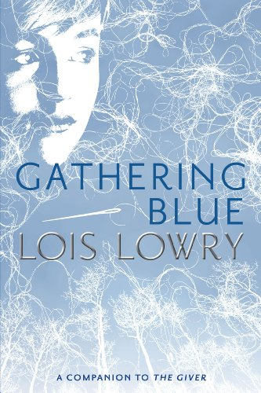
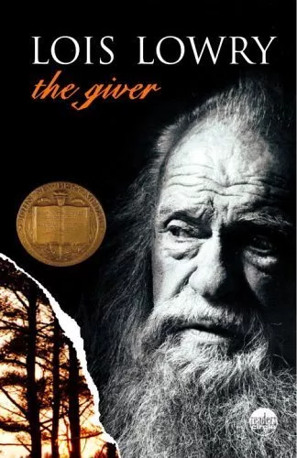

Author Biography
Author’s Website: http://www.loislowry.com/
Lois Lowry spent a few years of her childhood living on a military housing complex in Japan where her father was stationed after World War II. Wanting to experience authentic Japanese society, she would ride her bike to go explore Shibuya against her mother’s wishes; these experiences were one of her inspirations for The Giver.

Book Summaries
The Giver
A young boy named Jonas is lives in a colorless commune that finds peace in “Sameness.” He is chosen to inherit memories of difference, both joyful and painful, from “The Giver” and begins to see with his own eyes just what lengths his community goes to in order to preserve “Sameness.” He must eventually decide whether peace is worth sacrificing individuality and freedom.

Gathering Blue
A girl named Kira is born with a twisted leg in a society that leaves the weak and ill to lie among the dead in “the Field.” Orphaned, she has nobody left to defend her right to continue living in the community until she is chosen by the Council of Guardians to work as a weaver due to her talents. She discovers the value and power of art, and begins to uncover the secrets behind a society that controls its people through fear.
Significant Quotes
The Giver

Pedaling rapidly down the path, Jonas felt oddly proud to have joined those who took the pills. For a moment, though, he remembered the dream again. The dream had felt pleasurable. Though the feelings were confused, he thought that he had liked the feelings that his mother called Stirrings. He remembered that upon waking, he had wanted to feel the Stirrings again. Then, in the same way that his own dwelling slipped away behind him as he rounded a corner on his bicycle, the dream slipped away from his thoughts. Very briefly, a little guiltily, he tried to grasp it back. But the feelings had disappeared. The Stirrings were gone. (pages 36-37)

This passage illustrates how emotionally repressed the people of the “Community” are in its description of Jonas taking pills in order to eliminate perfectly natural sexual urges that are beginning to arise from puberty. Though prior to this we see that the people of the Community are extremely controlled in their behavior, the pills are even more extreme in that they entirely remove emotions from the people taking them.

He had never, within his memory, been tempted to lie. Asher did not lie. Lily did not lie. His parents did not lie. No one did. Unless… Now Jonas had a thought that he had never had before. This new thought was frightening. What if others – adults – had, upon becoming Twelves received in their instructions the same terrifying sentence? What if they had all been instructed: You may lie? (pages 67-68)

This passage shows how naive and complacent the residents of the Community are. People are expected to always be truthful, which is not necessarily alarming itself, but the ease with which it is accepted that nobody else lies shows how little the Community actual worries about their surroundings and the actions of others. The extent to which this scares Jonas shows how much doubt this puts upon his entire world and upbringing.

“Well...’ Jonas had to stop and think it through. “If everything’s the same, then there aren’t any choices! I want to wake up in the morning and decide things! A blue tunic, or a red one?” He looked down at himself, at the colorless fabric of his clothing. “But it’s all the same, always.” Then he laughed a little. “I know it’s not important, what you wear, it doesn’t matter. But – “It’s the choosing that’s important, isn’t it?” The Giver asked him. (pages 93-94)

This passage illustrates the importance of freedom, though Jonas has trouble understanding his frustration at lacking freedom due to never having known it. This passage would be a good place to start a discussion on the freedom of choice and the value of freedom for freedom’s sake.
Gathering Blue

“I heared them talking at the well. I be picking up wood chippies from the refuse, and them didn’t even notice me listening. But they want your space. They want where your cott was. They aim to build a pen there, to keep the tykes and the fowls enclosed so they don’t be having to chase them all the time.” Kira stared at him. It was terrifying, almost unbelievable, the casualness of the cruelty. In order to pen their disobedient toddlers and chickens, the women would turn her out of the village to be devoured by the beasts that waited in the woods to forage the Field. (page 9)

This passage sets the tone of the novel’s setting and makes it very clear that the society being depicted is one of conflict and lacking in empathy for the weak. This contrasts heavily with the collectivist society of the Community in The Giver and shows just how much danger Kira’s physical handicap actually presents to her.

Matt heard him and looked up toward Kira in dismay. “No. Me and Branch, we be going now.” he said. Then with an expression of concern, he asked, “You don’t be captive here, do you?” “No, she’s not a captive,” Jamison reassured Matt. “Why would you think that?” (page 53)

This passage foreshadows the nature of Kira’s employment by the Council of Guardians and cues the reader to question how much freedom Kira actually has. It also shows how Matt’s contentment with his life of squalor has left him with a more objective look at Kira’s situation, rather than being taken in by the glamour of the situation.

The woman turned back, her mouth full. “Further down,” she said, chewing noisily. The infant in her arms grabbed at the bitten apple, and she shoved its hands away. She gestured with her head. “There will be a busted tree in front.” Kira nodded. “And please, one more thing,” she pleaded. “What can you tell us about a tyke named Jo?” The woman’s face changed and Kira found it hard to interpret the look. For a moment, a brief flicker of joy had washed across the thin, embittered face. Then hopeless replaced it. “The little singing girl,” the woman said, her voice a hoarse whisper. “She be tooken. They tooken her away.” She turned away abruptly and disappeared into the shadowed interior of the cott. Her children began to cry and to claw at her for food. (page 136)

This passage shows the suffering of the bottom of society as well as how extremely a philosophy of survival of the fittest can go, with a mother keeping food for herself even as her infant child tries to grab for it. This passage also makes for a good comparison with the collectivist society of The Giver and could make for a discussion about the nature of the two dystopian societies.

Using the Book for Teaching
The Giver and Gathering Blue both go beyond understanding and studying the individual or the self, and comment on societies as a whole. Though the journeys of Jonas and Kira are both also very individual, the challenges they face come from societies that must be understood as well as the characters themselves. The book should be assigned to students who are old enough to appreciate and understand the dystopian settings of the two novels. It is still suitable for young adults of course, and is not so complex as to require an extremely deep understanding of political science and sociology (a person educated in such fields would probably not find the novels particularly groundbreaking from as far as social commentary goes). However, it is a fantastic introduction for young adults to begin thinking about society and how humans live and interact with one another. The Giver provides an accessible depiction of a society that has become obsessed with the greater collective good of its people at the cost of individual freedom and rights, while Gathering Blue provides a similarly accessible exploration of the importance of art, freedom of expression, and the responsibility that comes with holding power over others in human society.
The novels would fit most under the category of “Allegory, Fantasy, Myth, and Parable” in both their use of fantastical elements (the way memories function in The Giver and the way art seems to peer into the future in Gathering Blue) and the dystopian societies that the two novels take place in are allegories for human society in the real world.

Text Complexity
The quantitative complexity of The Giver and Gathering Blue are fairly low, with the latter being lower than the former. The Giver has an ATOS measurement of 5.7 and a Lexile measurement of 760L, placing it within the upper end of the Common Core band for 2nd to 3rd grade and the lower end of the Common Core band for 4th to 5th grade. Gathering Blue has an ATOS measurement of 5.0 and a Lexile measurement of 680L, a Lexile measurement that does not even make it into the 4th to 5th grade Common Core band and an ATOS measurement that only barely makes it above the minimum 4.97 ATOS score to be within the Common Core band for 4th to 5th grade.
Though the technical complexity of the text makes the book readable by children in middle school, I do not believe that the actual themes and meanings of the text can be understood by such young readers. For example, in The Giver Jonas at one point suffers from something described in the novel as the “Stirrings,” which are the sexual desires that begin arising as he starts to go through puberty. The actual nature of the “Stirrings,” the erotic dream that Jason has which makes his parents realize he’s beginning to experience the “Stirrings,” as well as the significance of the fact his community would seek to suppress such “Stirrings” through medication are all concepts that would be lost on a middle school age reader even if they could comprehend the technical meaning of the text. Gathering Blue is similar in that much meaning is lost if the reader can only understand the surface meaning of the text, such as how the novel only implies that the Guardians are committing murder to maintain their control over their society rather than explicitly stating it. Due to the complexity of the two novels when going beyond just the difficulty of the language and sentence structure, I would instead recommend that the novels be taught to students starting high school and that the teacher make sure that students actually comprehend the deeper implications of the novel as opposed to only understanding the surface of the plot.

