Kaitlyn Dean
Dr. Mary Warner
ENGL112B
Preservation Through Hardship and its Universality
Rationale:
When I was in the 4th grade I purchased the book Weedflower—mainly because it had a Japanese girl on the cover—and until that point I had never read a book with an Asian protagonist. This novel takes place right before the bombing of Pearl Harbor occurs and throughout World War II. The story follows a young Japanese American girl who lives through the tribulation of the war. There is a scene that I remember reading in the middle of the night, tucked under the covers of my bed. In the scene, the protagonist, Sumiko is invited to one of her classmate’s birthday parties. She is, however, not allowed into the house by a parent because she is Japanese. I recall reading this and for the first time I cried while reading a book. Sumiko is closed to my age when I read this, she is Japanese and she is isolated by her peers. Upon first reading this novel I figured my tears were sourced from my empathy for this twelve year old Japanese girl. I understand now—later in life—that the reason I cried was because I related to the hardship of alienation Sumiko experiences in the novel.
Hardship is a concept that comes in various shapes and forms. Therefore, to focus a unit on this topic would be beneficial for students to acknowledge the diversity in hardship. It also would be good for them to see how it is possible to persevere through the trials in life. The canonical work I have chosen to center the unit on is Lorraine Hansberry’s A Raisin in the Sun. This is a play about an African-American family—the Youngers—living in a poor neighborhood on the South side of Chicago in the 1950s. The family faces many road blocks and clash with one another. However, it is at the end of the play that they learn to appreciate the hardships they experience and see the optimistic side of their situation. Raisins are dried up grapes which has a bad connotation to it but in actuality raisins are sweet. The Youngers struggle with their means, which dries up their grapes, however by appreciating each other and their home they find the sweetness of the raisins they have.
The way this work could connect to the YA Literature sources I have chosen is through the diverse nature of hardship. I would want to emphasize this to my class, thus, I would pick novels that not only focus on racial discrimination but other forms of hardship. For example, Eleanor and Park deals with issues with self-image or The Fault in Our Stars deals with fatal disease. Other novels that highlights racial discrimination I would use are The Book Thief, Weedflower, and The Hate U Give. These are only a few of the examples of the books I would use in this unit to accentuate the universal characteristic of hardship.
Launching the Unit:
- Into-Strategy: A strategy I can use to introduce the theme of the unit—preservation through hardship—is by having the students identify a common thread between different songs. The students will be able to relate and personalize the theme more by sourcing songs that they know and have grown up with. This will engage the students instantly and start a conversation about the theme of over-coming obstacles, relevant to A Raisin in the Sun.
- “What doesn’t kill you makes you stronger.” “Stronger”- Kelly Clarkson
- “I’ve got all my life to live and I’ve got all my love to give and I’ll survive.” “I Will Survive”- Gloria Gaynor
- “N-now th-that that don’t kill me. Can only make me stronger.” “Stronger”- Kanye West
- “I will find my way, if I can be strong. I know every mile, will be worth my while. When I go the distance, I’ll be right where I belong.” “Go the Distance”- Michael Bolton (Hercules)
- Diving Deeper into the Diversity of Hardship: Once the students determine the similarity between all of the songs then I would segue way into reading the students the Oxford dictionary definition of hardship. The Oxford dictionary reads that hardship is, “severe suffering or privation.” Based off this definition I would ask the students if they can think of any groups of people whom experienced or experience hardship. This discussion would lead to how hardship is universal through all races, sexes and so on. Later in the unit, this would tie into the inclusion of the different YA sources because they show various examples of hardship. However, the most important facet to the theme of the unit is the concept of persevering through hardship. A Raisin in the Sun presents an example of this.
The Unit: 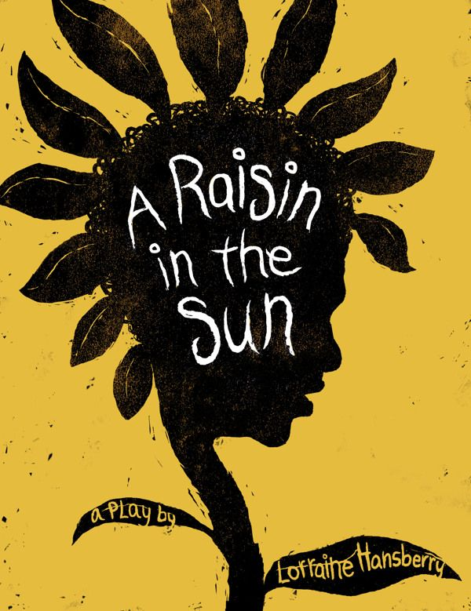 https://www.pinterest.com/pin/458804280761309962/
- Canonical Work: The classic at the center of my unit is A Raisin in the Sun by Lorraine Hansberry. This play follows the Youngers, a struggling family from the south side of Chicago. The Youngers are about to receive and insurance check for 10,000 and all the family members have different opinions on how they should spend the money. This causes the family to go into a disarray—and they fall apart—even though to survive they need each other. The family struggles with not only their financial situation but their racial identity. All of the family members want to assimilate into white culture, except for the daughter Beneatha. The hardship they experience is not privy to their financial status. They also encounter racism, for example, when their new neighbors try to pay them to not move into the neighborhood. The grapes they had was the insurance money but the oldest son Walter, who dreams of being rich, is scammed by a friend and loses everything. Thus, their grapes dry into raisins. In the end, it is left up to Walter whether they take the money and not move into the new neighborhood. By not taking the money and choosing his family’s integrity over his dream of being rich the family is able to taste the sweetness of their raisins. They may have lost the money and did not take the money to stay away from the new neighborhood but they finally have each other. Those hardships are what has brought them together as a family. Therefore, they are able to persevere out of their hardships because they have one another.
- In between each scene I would also have the students do a hashtag summary. To further explain, a hashtag summary would be one word or a short phrase that encapsulates what occurred in the scene. If I were teaching Romeo and Juliet, for example, and we had just read the balcony scene where Romeo and Juliet decide to get married a hashtag could be “#movingtoofast”.
  - This would be a useful tool for students to comprehend what happened in each scene. Teenagers use hashtags in social media to describe photos they post online. Therefore, this would open their mind more to A Raisin in the Sun.
- The Voices of Hardship: While reading the play and other YA novels in this unit there can also be a supplementation of poetry to the unit, specifically spoken-word. To start this lesson, I would first have the class do an in-class reading of Maya Angelou’s “The Mask”. This poem provides an insightful example of persevering through slavery and racism. After reading this poem I would show Maya Angelou’s reading of the poem prior to discussing the contents of the poem. The spoken-word format of her poem will give the students a visual representation of Angelou’s “mask” and the “mask” her ancestors wore so that she could live a better life. The mask she describes is a smile that hides pain, sorrow, and anger. During the discussion of this poem we can explore other spoken-word poetry that covers themes of hardship (poverty, racism, self-image issues, family dynamic, and more). There are various videos on YouTube of young adults and adults delivering spoken-word poetry on many topics. For example, “Beach Bodies” by David Fasanya and Gabriel Barralaga. This could also open students to the idea of poetry.
- “The Mask” by Maya Angelou
https://www.youtube.com/watch?v=CN9DN_PImy8&frags=pl%2Cwn
- “Beach Bodies” by David Fasanya and Gabriel Barralaga https://www.youtube.com/watch?v=nVnPQw0f8Qc&frags=pl%2Cwn
- Supplementary YA Novels: The other novels I could include in this unit for the students to read are All the Bright Places, The Hate U Give, The Fault in Our Stars, The Book Thief, Forgive Me, Leonard Peacock, Weedflower, Eleanor and Park, and Letters to the Dead. All of these novels exemplify different forms of hardship. All the Bright Places and The Fault in Our Stars entail hardship with disease and death. The Hate U Give, The Book Thief, and Weedflower deals with the hardship in prejudice and war-time. Then Forgive Me, Leonard Peacock, Eleanor and Park, and Letters to the Dead has hardship in the form of bullying, self-image, and the repercussions of sexual assault. This is a vast list of novels for the students to read and I know that to have them read all of these would be unrealistic. Thus, I would have them choose one of these novels provided to read. Then they would write a comparison essay of the book they chose and A Raisin in the Sun. In their essay, they would answer questions such as:
- Are there any similarities in the hardships the characters experience in both novels? If they struggle with different hardships then how are they different?
- How do the characters from both works respond to their circumstances? How are their reactions similar or different? Is one method of persevering through hardship better?
- How do the works further your understanding of hardship as a universal experience?
The goal of this activity would be to not only deepen the students’ comprehension of the characters and stories they read. This would also aid them in realizing that hardship is experienced by everyone in some manner and perhaps the students can relate to the stories they read. If that is the case, then the best result would be that they have the epiphany that they can persevere through their own tribulations by reading stories about how other characters do.
- Conclusion of the Unit: At the end of the unit I would show my students the play A Raisin in the Sun during class time. This is so they can see the stage directions, set, lighting, and more. This will also help the students identify visually the themes and symbolism present in the play. For example, in the play the living space of the Youngers is used as a visual symbol of their bleak lives, caged in by their hardships. The wallpaper appears as chain link fences, which adds to the Youngers meager situation. This creates an idea that the family is fenced in by their poverty and race. After watching the play, I would have the students do a brief in-class writing of comparing the play as a novel and a film. The writing wouldn’t be in a formal essay format. The formal essay would be their comparison of A Raisin in the Sun and the YA novel of their choice. In this activity, I would have the students do a silent writing after the viewing of the play and answer these questions:
- Between the play as a novel and a film, which do you prefer and why? Furthermore, which mode of the story did you find more insightful to the theme of preservation through hardship?
- What are the Pros and Cons of both modes?
Once the students complete their silent writing, I would open the class to a discussion. Each student would discuss one or more of the points they made in their writing. This would establish dialogue for the class to have in regard to the story A Raisin in the Sun as a whole. The goal of this would be to solidify the theme of the work for the students—preservation through hardship.
- Final Activity: As a final activity, I would provide the students with a 3x5 notecard and have them write on there a hardship they have experienced in their life. The notecard would not be addressed and remain anonymous to not only the students but me as well. This would establish a comfortable space for the students to be open and not feel judged. After collecting and shuffling the cards I would have the students discuss with a seat partner their final thoughts on the story. Meanwhile, I would peruse through the notecards and get a brief understanding of what the students wrote so I can decide how to properly address them. Once I have done that then I would read the notes back to the students. The anonymous nature of the notes would remain. This would be a final activity to conclude the unit in a more personal perspective for the students.

Works Cited
“Beach Bodies (in Spoken Word) - David Fasanya and Gabriel Barralaga.” Performance by Gabriel Barralaga, and David Fasanya, YouTube, TED-Ed, 27 Feb. 2013, www.youtube.com/watch?v=nVnPQw0f8Qc&frags=pl,wn.
Bolton, Michael. “Go the Distance.” Alan Menken, 27 May 1997.
Clarkson, Kelly. “Stronger.” Greg Kurstin, Echo Studio, CA, Feb. 2011.
Gaynor, Gloria. “I Will Survive.” Dino Fekaris, Mom & Pop's Company Store, CA, 1978.
“Maya Angelou - The Mask (1987).” Performance by Maya Angelou, YouTube, Pogmog, 10 Aug. 2016, www.youtube.com/watch?v=CN9DN_PImy8&frags=pl,wn.
West, Kanye. “Stronger.” Stronger, Kanye West, Sony Music Studios, NY, 2007.

