Miriam Malca
Dr. Mary Warner
ENGL 112B: Literature for Young Adults
05 December 2017
Our Obsession with Bleak Futures: A Look at Why Dystopian Literature is so Important
Rationale:
I have had an interest in dystopian literature since I was a teenager. I have always been interested in the totalitarian governments found in dystopian literature and the vast struggles that the protagonists must face to fight against these regimes, often to no avail. The fighting spirit of a dystopian protagonist is something that people from all cultures and countries can get behind: someone who keeps fighting to do the right thing, regardless of the consequences, which are pronounced and terrible. My first encounter with dystopian literature was in the seventh grade. We had read The Giver the year before, but no one had ever explained what the genre of dystopian literature was, and what the word “dystopia” meant. I liked The Giver; it was good, but strange. Then, in the seventh grade as I was rummaging through my parents’ books I found a small novel called Brave New World. I brought it to my dad, and he gave me the basics of dystopian literature. I decided that reading about a depressing future world would be fun, and blazed through the book! I loved it, but in the seventh grade, I didn’t really connect what I was reading to the world around me. Then in high school, we read 1984 and everything I didn’t quite understand in Brave New World made sense. I could take these two great novels and apply the warnings within them to our recent history and our current situation. I was effectively hooked on the dystopian genre.
I took IB in high school, and the combination of my HL English, HL History, and Theory of Knowledge classes helped me to better understand and digest the messages in dystopian fiction. This crossover between classes was extremely helpful, and is part of what makes the IB programme great. Our teachers encouraged us to make connections between literature, history, philosophy, and politics in order to gain a deeper understanding of the works we read in class. Later, as a psychology major at my previous university, I studied the effects of mortality salience on humans’ willingness to engage in risky behaviours. This brought to light a whole new aspect of dystopian literature: our motivation to read depressing, scary books about totalitarian futures. My studies showed me that people love to be scared and to experience frightening situations in controlled environments. This is why horror films are so popular, and why so many people are picking up dystopian novels. We want to have dangerous experiences without actually engaging in risky behaviours, and reading dystopian fiction satisfies that need.
I was excited to observe classes at San Jose High School, as they use the IB curriculum, too. This means that they encourage the crossover between different classes, focusing on how students can take the information that they learn in class and apply it to their lives and the global society in which they live. Dystopian fiction starts conversations about types of government, personal freedoms, heroic behaviours, and cultural differences. And, discussing the demographics and the writers of dystopian literature, students can see the reasons behind the writing and make connections to the content and the authors. Dystopian literature is also a great way to discuss the importance of language, which is a key factor in any English class. The totalitarian nature of dystopian governments and the total control that they possess allow students to see how language can influence thought and action, as it does in 1984. We can use young adult literature like The Hunger Games, Where I Live Now, Noughts and Crosses, and The Maze Runner to open up discussions on class systems and problematic governments, making connections to both historical and current events. I think it’s important for students to be able to connect their own experiences to the things that they read in class. For example, speaking from my own cultural experience, I could talk about the horrors of the Marcos dictatorship in the Philippines or the Nazi regime in Germany. I could discuss why the current Philippine president, Rodrigo Duterte, scares me and what socio-political connections I can see between the Philippines and the United States. I could even discuss why most writers of dystopian fiction come from developed countries. I could discuss why authors in developing countries don’t write dystopian fiction, and why readers in developing countries don’t really feel the need to read dystopian fiction.
The great thing about dystopian fiction is that the basic idea never changes: a small group of people fight against the large, faceless government, with varying degrees of success. As a result, we can make straightforward comparisons and connections between classic and contemporary dystopian literature. The concerns of Katniss Everdeen are very similar to the concerns of Winston Smith; the class and racial divides in Noughts and Crosses can be seen in Brave New World. There are many activities that classes can do to gain a deeper understanding of some of the complex issues presented in dystopian literature. The importance of language in 1984 can be illustrated in a group activity wherein students must try to define a complex concept without the use of vocabulary related to that concept -- take a concept like “freedom”, and see how hard it is to explain it without using words like “liberty”, “rights”, “free speech”, “enslavement”, etc. Teachers could tie in a Theory of Knowledge/philosophy class with their English class by doing a dystopian themed thought experiment, as in the film, The Philosophers. This genre allows teachers to be creative with the explanations they give and the connections they make.
Launching the Unit:
- Writing Prompts: I believe that writing prompts are a wonderful way to prime the student’s thinking to get them into the mentality that you want when analysing and discussing literature. It also serves the double duty of getting students to practice their writing style and form a little bit everyday! I would employ the use of a different prompt at the beginning of every class in order to get the students ready to discuss dystopian literature. Listed below is one week (or 5 classes) worth of possible writing prompts.
- “I see humans, but no humanity.” (See Appendix A).
  - This would get the students to start thinking about the human side of dystopian literature. All too often, students reading dystopian literature focus on the authoritative force, when in fact this genre’s main focus is on humanity. By using this prompt to launch the unit, the teacher can make sure that the students are focusing on the human piece while they are reading. This would be a simple and straightforward way to model for the students that their primary focus should be on how the government in the dystopian society affects the characters, rather than only focusing on the mechanics on the government.
  - Some guiding questions for this could be: How do we define humanity? Can Humanity be taken away and how? What would a society with no humanity look like?
- What does the future look like to you? Is it utopian or dystopian? Why?
  - This question would be useful to allow the students to apply their knowledge of utopias and dystopias to what they see happening in their own lives and societies. It will get them thinking about how literature relates to the real world, and could help them to start developing a more global worldview. This is also a great question to practice working facts and evidence into the students’ writing, as they must give specific evidence as to why they believe the future will be a utopian or a dystopian world.
- Why are we so fascinated by dystopian literature? Why do we prefer to read or watch a story like District 9 or The Hunger Games rather than something uplifting like The Jetsons?
  - This question will hep students to think about why authors write what they write, and why consumers read the media that these writers produce. It is important in literature not only to read the pieces assigned, but to understand the context under which they were written.
- Think about the society of Oceania in George Orwell’s 1984. Are there any similarities to our own society?
  - This prompt combines prompts 1 and 2 in that it guides students to make connections between the material learned in class with their pre-existing knowledge of the world around them.
- Responses to the Quora question, “Why don’t more Filipinos write dystopian fiction?” (See Appendix B).
  - The students will be shown the images in Appendix B and must respond to them. These images show the answers to the Quora.com question “Why don’t more Filipinos write dystopian fiction?” The responses state that in order to have a demand for dystopian literature, a society must first experience the luxuries that are taken away in the dystopian society of the fictional works. This could open up discussions about privilege, the differences between developed and developing countries, and the motivation that authors have in writing dystopian literature.
- New Speak Activity: Working off of my centrepiece work, George Orwell’s 1984, I would present this activity to my students to get them thinking about the importance of language in our society. This would illustrate the point that language is a vital aspect of freedom and that censorship is detrimental to the formation of complex thoughts and ideas. In this activity, students would be given a short list of complex concepts. A bank of related words would accompany these concepts (see Appendix C). Students would form into groups, then each group would pick one concept. The students would have 5 minutes to write a brief (1-2 sentences) definition of the concept that they chose, but are not allowed to use the words in the related words bank. At the end of the 5 minutes, a representative from each group will present their definition, and the rest of the class will try to guess which concept they chose.
The Unit:
- Centrepiece Work: The centrepiece for my unit is 1894 by George Orwell. I chose this because it is a book commonly read in high schools around the world. Even though I believe that the society in Brave New World has more in common with today’s society, 1984 is so universally important in terms of the issues that it presents. The language aspect is just one important facet of this novel. The intrusion of the government into everyday life in Winston Smith’s society is so terrifying it resonates profoundly with many people, particularly after the NSA scandal a few years ago, and several accusations of wire tapping that seem to come to light in recent years. With the advent of new technologies comes the possible limiting of personal freedoms. This is seen in 1984 as well as in the news, as net neutrality may be coming to an end. The forced compliance by the thought police and Winston Smith’s eventual acceptance of the “2+2=5” dogma through torturous indoctrination can be seen as a warning against totalitarian dictatorships. Students can link any number of themes and events in 1984 to the current events and history of our world, both in the USA and abroad. It also opens up discussions about philosophy and morality.
- Supplementary Text(s): The students would be provided with a list of other dystopian texts (see Appendix D). These are either classic literature, young adult literature, novels, short stories, films, or television shows. The student must pick at least one item from this list (or have their teacher pre-approve a text that is not listed), and must read or watch it on their own time. This will feature into their final assessment: an essay comparing and contrasting the supplementary text(s) that they chose with the centrepiece work, 1984. The student will have to do a short presentation of 5-10 minutes in front of the class detailing why they have chosen their supplementary text(s). The purpose of the presentation is to use the global perspective with regards to dystopian literature that we have practiced in class to show that they can make these connections.
- Final Assessment: This will be a comparative essay between the student’s chosen supplementary text(s) and the centrepiece work, 1984. They can choose any aspect of the texts to compare and contrast. The purpose of this final assessment is to display the student’s writing competency and comparative competency. The student should not only write the essay with fluidity and proper formatting, but should demonstrate his/her ability to create a well-rounded argument. This paper should be roughly 1,500 words long.
The Connection to the IB Programme:
As outlined on the IB Programme’s website, the goal of the IB Programme is to make sure that students develop:
- a personal appreciation of language and literature,
- skills in literary criticism using a range of texts from different periods, styles, and genres,
- an understanding of the formal, stylistic, and aesthetic qualities of texts,
- strong powers of expression, both written and oral,
- an appreciation of cultural differences in perspective,
- an understanding of how language challenges and sustains ways of thinking. (“Language and literature course”).

In this unit, the students will be able to achieve these developmental goals by illustrating the connections that they make with other subjects and with current events. Dystopian literature is wonderful for helping students to make connections to other subjects because it often encompasses many different topics. This genre can be connected to history, philosophy (specifically, the Theory of Knowledge class that is required in the IB Programme), economics, journalism, religious studies (if the school should have such a class), and so on. In terms of current events, dystopian literature is concerned with themes that can be connected to all manner of current events: political dictatorships, freedom of speech, oppression, government control, consumerism, classism, and so on. Likewise, for students to gain a deeper understanding of the text, they would be encouraged to make connections with their own lives and personal experiences.

Works Cited
“Language and literature course.” International Baccalaureate, www.ibo.org/programmes/diploma-programme/curriculum/language-and-literature/.
Images for Appendices A and B retrieved from:
https://pics.me.me/i-see-humans-but-no-humanity-kuro-11172417.png
https://www.quora.com/Why-dont-more-Filipinos-write-dystopian-fiction

Appendix A. Image for Writing Prompt 1
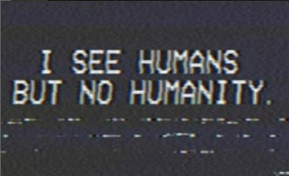

Appendix B. Images for Writing Prompt 5
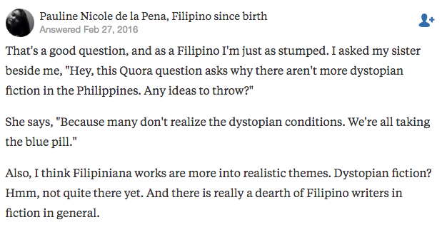

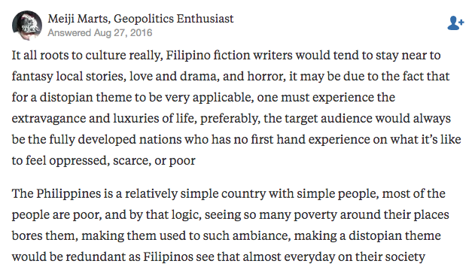

Appendix C. List of Complex Concepts and Related Words for the Newspeak Activity
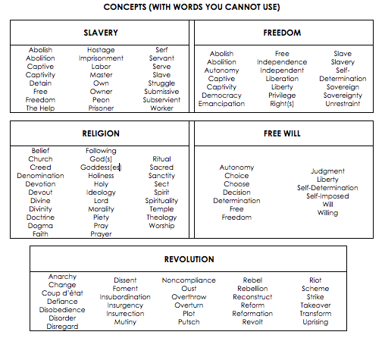

Appendix D. Supplementary Texts: Literature and Film Resources
LITERATURE

CLASSICAL/CANONICAL WORKS |  | YOUNG ADULT WORKS
Title | Author | Title | Author
A Clockwork Orange | Anthony Burgess | Borne | Jeff VanderMeer
A Handmaid’s Tale | Margaret Atwood | Feed | M.T. Anderson
All Summer in a Day | Ray Bradury | How I Live Now | Meg Rosoff
Brave New World | Aldous Huxley | Ready Player One | Ernest Cline
Children of Men | P.D. James | Shade’s Children | Garth Nix
Cloud Atlas excerpts (specifically “An Orison of Sonmi-451” and “Sloosha’s Crossin’”) | David Mitchell | The Across the Universe Series | Beth Revis
Fahrenheit 451 | Ray Bradbury | The Book of Joan | Lidia Yuknavitch
HaDerech L’Ein Harod | Amos Kenan | The Brave New Girl series | Rachel Vincent
It Can’t Happen Here | Sinclair Lewis | The Divergent series | Veronica Roth
Limes inferior | Janusz Zajdel | The Ender Quintet | Orson Scott Card
Moscow 2042 | Vladimir Voinovich | The Giver Quintet | Lois Lowry
Never Let Me Go | Kazuo Ishiguro | The Hunger Games series | Suzanne Collins
Oryx and Crake | Margaret Atwood | The Hungry Plague series | M.R. Carey
The Lord of the Flies | William Golding | The Imperial Radch series | Ann Leckie
The Lottery | Shirley Jackson | The Maze Runner series | James Dashner
The Machine Stops | E.M. Forster | The 100 series | Kass Morgan
The Road | Cormac McCarthy | White Fox | Jane Yolen
The Third | Yishai Sarid | Z for Zachariah | Robert C. O’Brien
We | Yevgeny Zamyatin
OTHER MEDIA

FILM |  | TELEVISION
1984 |  | 3%
12 Monkeys |  | Battlestar Galactica
A Clockwork Orange |  | Black Mirror
A.I. |  | Doctor Who
Akira |  | Dollhouse
Blade Runner |  | Falling Skies
Children of Men |  | Firefly
Die Welle |  | Humans
District 9 |  | Orphan Black
Gattaca |  | Samurai Jack
Ghost in the Shell |  | The 100
Idiocracy |  | The Handmaid’s Tale
Logan’s Run |  | The Last Man on Earth
Mad Max |  | The Last Ship
Serenity |  | The Man in the High Castle
Snow Piercer |  | The Stand
Terminator |  | The Twilight Zone
The Fifth Element |  | The Walking Dead
WALL-E |  | Westworld
 |  | You, Me, and the Apocalypse

