Yvette Ackerman
ENGL 112B
Professor Warner
November 30th, 2020
The Importance of a Fantastic Journey
Genre and Topic Explanation
The fantasy subgenre of young adult literature is often seen as a childish and nugatory genre. The fantastic characteristics that tend to cause people to second guess the important and valid messages that these young adult works offer because they are seen as separate from or inconsequential to the real world. These assumptions tend to misdirect people, which causes them to discredit the powerful resources that the fantasy subgenre can give to youths. What is vastly overlooked are the ways that the fantasy subgenre of young adult literature can help youths process their emotions, work through struggles, and learn more about themselves. Part of the reason the fantasy genre can be such an effective tool for young adults’ development is because oftentimes the protagonists in the novels are also young adults who are embarking on their own journey of self-discovery.
As protagonists trek through their own obstacles and struggles, the readers can follow along and learn through the protagonist’s experiences. Oftentimes, the protagonists of fantasy young adult literature are a part of a bildungsroman narrative that can prove effective in helping young adult readers navigate their own experiences and emotions. The addition of a fantastic world, in any degree, to these life lessons allows for the reader to dream of and think creatively about themselves in settings removed from a potentially less appealing real world. It challenges readers to think objectively about scenarios that may or may not be achievable in their own lives, pushes them to explore ideas or possibilities that they may want for the future, and reassures them that, regardless of whether the world is fictitious or not, their emotions are valid and that they aren’t alone in their experiences. It provides both an escape from reality as well as an outlet for young adults’ minds to ask the creative and developmental questions, “What if?” and “How?” as they follow along with protagonists on their own journey of self-discovery.
Identity is a difficult thing for young adults to navigate alone. They are constantly being influenced by their peers, their family, their community, and the larger world around them; identifying where they belong or who they are isn’t an easy task. Young adults begin to toe the line between youth and adult— a boundary that presents a lot of confusion, insecurity, and the unknown. Venturing into the world and figuring out the meaning of identity takes courage, strength, and curiosity. Self-discovery, which is the overarching theme of my selected works, is a reoccurring and vital theme in the fantasy young adult genre. As readers follow along with the protagonist on their respective journeys of self-discovery, readers are learning more about themselves and how they would or would not respond to similar events that the characters go through. Along with the questions of, “What if?” and “How?” comes the ever-evolving question of, “Who am I?”. With so much external influence young adults can become lost on their way to answering these questions.
The protagonists of the fantasy subgenre become beacons of guidance for young adults on their journeys. In the real world, heroes are obscured in everyday life; in the fantastic world, a hero can immerge from under the cupboard under the stairs and can be an 11-year-old child. A reader can find familiarity and recognize themselves in role models achieving the unimaginable or improbable. Fantasy makes the improbable possible and the mundane an adventure. As is stated by Donelson and Nilsen’s book, Literature for Today’s Young Adult, “Fantasy sings of our need for heroes, for the good, and for the success in our eternal fight against evil or the unknown” (Ch. 7, Donelson and Nilsen).
Annotated Bibliography
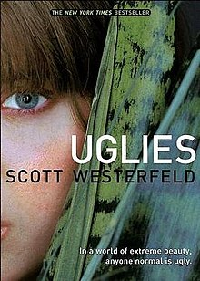
- Uglies by Scott Westerfeld (Have Read)
Summary
Set in a dystopian world where, by default, everyone is considered ugly unless they get extreme cosmetic surgery when they turn 16 years old. Tally Youngblood lives a life where monumental, life altering change is the norm in her society. Initially, she is excited for her chance to become pretty to finally arrive. However, Tally begins to rebel against conforming to society’s view of what is acceptable or desired after she witnesses the negative impact becoming pretty has.
Evaluation
This novel focuses on making difficult, off-the-beaten path decisions. Through Tally’s character, the novel advocates for choosing what you think is right, while also exploring the challenges that come with making those decisions. There is heavy emphasis on the implications of change, standing up for what you believe is right, and resisting societal pressures. The duality of good versus evil, one of the more prominent qualities associated with the fantasy genre as mentioned in LfTYA, can teach readers a lot about what to do when faced with injustice. In this particular novel, evil is personified through the enforcers of the “pretty” standard. Tally’s character and the choices she makes on her journey of self-discovery because she teaches the reader to value and trust themselves as they go against the grain to choose to do what is right. This novel exemplifies the Exeter Qualities 2 (exciting plots that include secrecy, surprise, etc.), 4 (characters who go beyond typical experiences), and 7 (themes that allow the possibility of emotional and intellectual growth).
Westerfeld, Scott. Uglies. Simon Pulse, 2005.
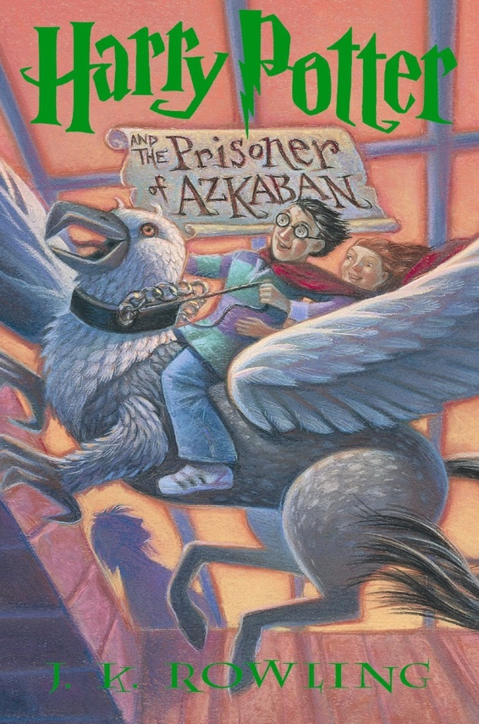
- Harry Potter and the Prisoner of Azkaban by J.K. Rowling (Have Read)
Summary
Not only is Harry Potter struggling with the news that an escaped mass-murderer is hunting him down, but he also has to grapple with the new restrictions that require him to miss out on fun new experiences with friends. He faces bullying, embarrassment, and judgement. Yet Harry’s biggest challenge is seeking the truth regardless of what the majority of people think and taking courageous action to correct others past mistakes.
Evaluation
For starters, this whole series is a valuable resource for young adults because the protagonist starts off as very relatable, but then transforms into someone extraordinary as he embarks on his own journey of self-discovery. What Harry is able to accomplish despite cataclysmic obstacles that arise exemplifies the importance of community, bravery, and honesty. While Harry has some level of extraordinary abilities, he mostly relies on help from those around him and he admits to the mistakes he makes along the way. This practical approach to learned bravery is an excellent example for the average young adult reader because Harry’s strength isn’t due to his magical abilities, but due to his openness and honesty. Additionally, Harry must learn to trust and discern information objectively in order to make fast decisions that can result in the righting of wrongs. Just like in LfTYA as it says, “seeking the good and being tempted by the evil that we know we must ultimately fight,” Harry knows and shows that he must fight till his last breath against evil, even if the odds are stacked against him. Harry has to navigate his complex emotions as he deals with Sirius being his godfather, come to terms with his embarrassment about his reaction to the dementors, and determine for himself who to trust. These are all difficult things that readers can learn a lot from. Lastly, this novel also showcases Hermione’s extraordinary capabilities and intelligence; the events wouldn’t have succeeded without her and this is a great example of a strong female character. This novel exemplifies the Exeter Qualities 2 (exciting plots that include secrecy, surprise, etc.), 3 (characters who reflect experiences of teen readers), 4 (characters who go beyond typical experiences), and 7 (themes that allow the possibility of emotional and intellectual growth).
Rowling, J.K. Harry Potter and the Prisoner of Azkaban. Scholastic Inc., 2004.
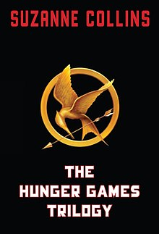
- The Hunger Games by Suzanne Collins (Have Read)
Summary
Katniss Everdeen lives a difficult life full of scarcity and scraping by. The Capitol is cruel and forces each district to send a boy and a girl between the ages of 12 and 18 to participate in the Hunger Games, which is a fight to the death for entertainment. Katniss understands it’s a death sentence because the likelihood of survival is low, so she volunteers to take her sisters place when her name is called. Suddenly faced with the reality of being a contender, Katniss must weight her own life’s value against the value of other people’s lives.
Evaluation
Katniss has to come to terms with the injustice of her world and the specifically structured society that she is a part of. Facing life or death, Katniss has to make compromises to keep herself alive, even if it means choosing to work with people she wouldn’t otherwise work with. This compromise leads to trust, and this trust leads to a fundamental understanding of humanity. Katniss befriends people she had previously viewed as her enemies, which shows the value in cooperation and compassion. Even though she’s tempted by the monumental evil, Katniss persists and therefore exemplifies the importance of perseverance to achieve justice. The fantastic world that this is set in shows an extreme world scenario that isn’t entirely impossible, although it is improbable. It encourages readers to imagine and think about themselves going through the struggles that Katniss goes through, regardless of them having not experienced those events. This novel exemplifies the Exeter Qualities 2 (exciting plots that include secrecy, surprise, etc.), 3 (characters who reflect experiences of teen readers/strong female protagonist), 4 (characters who go beyond typical experiences), and 7 (themes that allow the possibility of emotional and intellectual growth).
Collins, Suzanne. The Hunger Games. Scholastic Press, 2008.
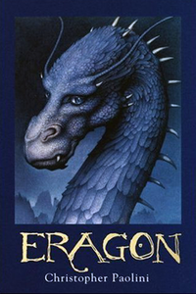
- Eragon by Christopher Paolini (Have Read)
Summary
Eragon is a normal farm boy who finds a strange stone in the mountains and it’s revealed that the stone is, in fact, a dragon egg. After finding out about the egg, the evil King Galbatorix sends people out to retrieve the egg and Eragon is forced to flee with Saphira, the dragon that hatches from the egg, and another character named Brom. It turns out that Brom is a Dragon Rider, an extinct group, and he teaches Eragon how to be a Dragon Rider. Suddenly with his simple life in shambles, Eragon is thrown into a dangerous new world filled with magic and battles for power.
Evaluation
This is a classic coming of age story, or bildungsroman, that has the main character experience an altering life event that causes a series of new obstacles that challenge the protagonist and require them to learn from the world they’re in. At the beginning of the novel, the reader knows very little about Eragon because he knows very little about himself. As he continues through the story, he realizes that he is a dragon rider and finds his identity. He starts to question his parentage and his place in the world, which is something young adult readers can relate to as they emerge from childhood into a broader world where they’re unsure of their identity. As Eragon ventures through his own self-discovery journey, readers can learn from his bravery as he resists ruthless rulers and evil to protect others. This novel exemplifies the Exeter Qualities 2 (exciting plots that include secrecy, surprise, etc.), 4 (characters who go beyond typical experiences), and 7 (themes that allow the possibility of emotional and intellectual growth).
Paolini, Christopher. Eragon. Paolini LLC, 2002.
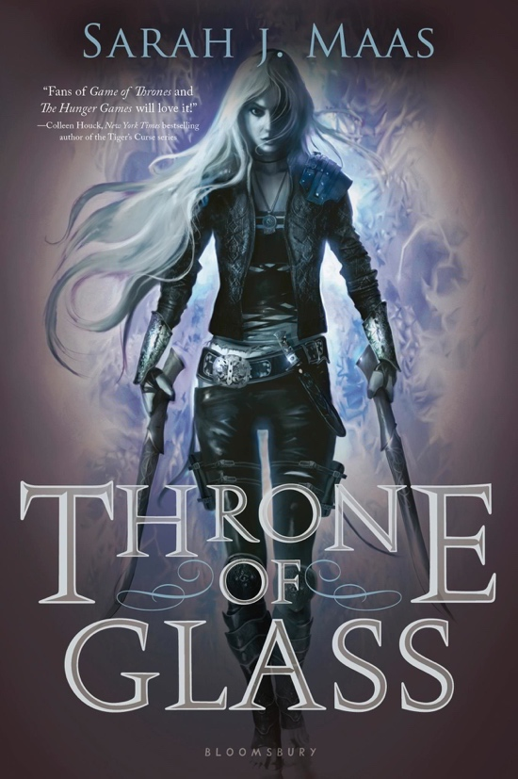
- Throne of Glass by Sarah J. Maas (Have Read)
Summary
Celaena Sardothien is an 18-year old assassin that is enslaved for her crimes in a horrifying slave camp called Endovier. Her reputation makes its rounds and soon she is asked to participate in a competition between other thieves and assassins to win the opportunity of serving as the King’s Champion. Success for Celaena means a fresh start and freedom after 4 years of servitude, but her hopes are put on hold as she is drawn into a conspiracy that uncovers secrets about the kingdom and that threaten to reveal more than she’d like about herself.
Evaluation
The battle between good and evil, as well as the blurred lines that separate the two, is a reoccurring theme in this novel. Celaena begins as a morally questionable individual, but she sides with good in order to survive and battle the evil that threatens others. Additionally, Celaena is a strong female protagonist who prides herself on her ability to be self-sufficient, to overcome great obstacles, and to admit that she is talented. She is a flawed, but very capable, main character that readers can learn from as they channel their own inner strength and confidence. This novel also highlights the dangers of power-hungry individuals who only take and rarely give, which can show young adults the dangers of self-absorption and negligence. Celaena allows for this novel to be a good option for young adult readers who are looking for a narrative with strong female characters. This novel exemplifies the Exeter Qualities 2 (exciting plots that include secrecy, surprise, etc.), 3 (characters who reflect experiences of teen readers/strong female protagonist), 4 (characters who go beyond typical experiences), and 7 (themes that allow the possibility of emotional and intellectual growth).
Maas, Sarah J. Throne of Glass. Bloomsbury USA Children’s, 2012.
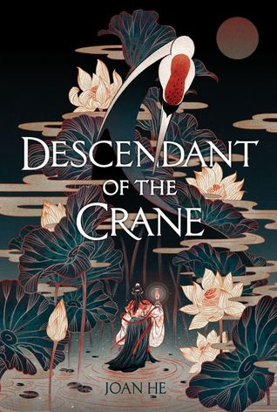
- Descendant of the Crane by Joan He (Have Not Read)
Summary
Princess Hesina of Yan doesn’t want anything to do with bearing the crown, but she is handed the responsibility after her father is murdered. Suddenly faced with the daunting task of being queen of an unstable kingdom, Hesina is desperate to find justice for her father and to get answers regardless of the things she has to do to get them.
Evaluation
I haven’t read this novel, but I gathered by information from Joan He’s website. The protagonist, Hesina, has to face the emotions that come with losing a father, the reality that she now has the greatest responsibility in the kingdom, and decipher the mysteries that she never knew her kingdom had. This novel is also inspired by Chinese culture, so it’s a narrative with more diversity in the fantasy subgenre. It touches on the complex emotions of someone struggling to cope with the loss of a family member and provides the reader with a protagonist who has flaws. Hesina struggles to find out who she is, what her role is as queen and as Hesina, and what to do with power now that she has it. Hesina is a strong female protagonist, so it’s a great way for readers who are looking for that type of narrative as well. This novel exemplifies the Exeter Qualities 2 (exciting plots that include secrecy, surprise, etc.), 3 (characters who reflect experiences of teen readers/strong female protagonist), 4 (characters who go beyond typical experiences), and 7 (themes that allow the possibility of emotional and intellectual growth).
He, Joan. Descendant of the Crane. Albert Whitman & Company, 2019.
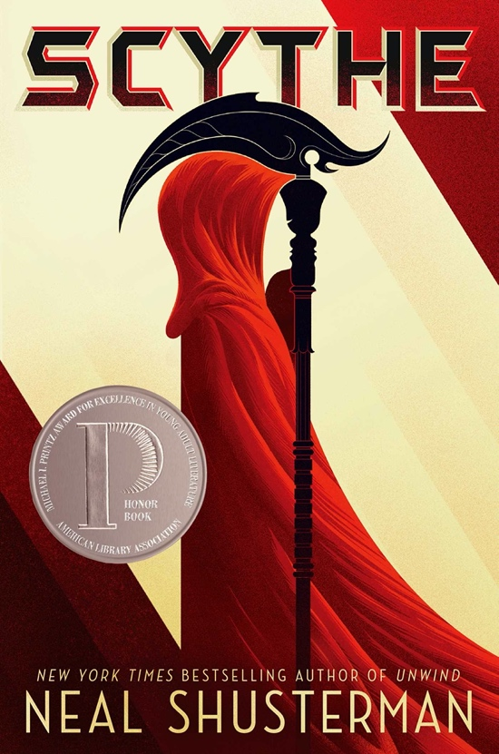
- Scythe by Neal Shusterman (Have Not Read; Jacob Stewart)

Summary
In a world where disease, hunger, and war are no issue, humanity has officially conquered everything up to death. An artificial intelligence called Thunderhead, who is unable to make mistakes or have regrets, rules over humanity. Scythes are dealers of death and the only ones who are permitted to end a life. This is a mandatory position for society to maintain its population control. Two characters, Citra and Rowan, are assigned to apprentice under a scythe even though it’s not something either of them wants to do. Failure to master the skill of killing could mean death for both of them.
Evaluation
This is yet another book I haven’t read, but Jacob Stewart from our 112 class has read it and I was inspired to use this novel because of his Book Talk. Even though they technically live in a utopia, things aren’t easy for Citra and Rowan. This story coming of age narrative takes place far into the future, but it presents readers with an alternative and unconventional way of becoming an “adult”. Citra and Rowan’s quest to become scythes gives them purpose, goals, and a unique experience that separates them from their peers who didn’t end up on this path. The novel offers readers a different way of thinking about self-discovery as scythes are denied the usual markers of aging, such as marriage, kids, etc., and teaches readers that they should find their purpose or calling in order to develop emotionally. The novel also challenges the reader to consider what being alive really means and gives scenarios that demonstrate how vital passion, purpose, and desire are for really living. This novel exemplifies the Exeter Qualities 3 (characters who reflect experiences of teen readers/strong female protagonist), 4 (characters who go beyond typical experiences), and 7 (themes that allow the possibility of emotional and intellectual growth).
Shusterman, Neal. Scythe. Simon Schuster Books for Young Readers, 2016.
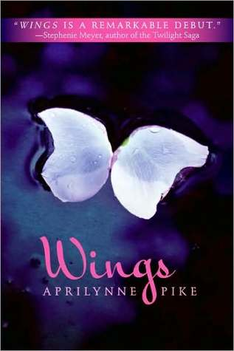
- Wings by Aprilynne Pike (Have Not Read)
Summary
Laurel has spent most of her life homeschooled by her parents and roaming the redwood forests, but one day she has to move with her parents away from her home and to a new school. She seems to adjust well enough, until she notices that a small bump is forming on her back. Her and her new friend, David, are investigating the bump on her back when she begins to blossom wings. Laurel then discovers that she is a faerie made of plant cells and that her destiny is to protect the gate to Avalon, the faerie world.
Evaluation
I haven’t read this novel, but from the information I’ve gathered I can reflect on the contents. Laurel’s identity has suddenly been ripped from her as she realizes that she isn’t just different—she isn’t even human. Through Laurel’s exploration of her biology, she finds that she has unique genes, and she begins to question her parentage as well as her birth. This could be a useful resource for young adult readers who are interested in or questioning how their genes may cause them to be different. This novel also teaches readers that it’s okay to wonder about your identity and that the road to self-discovery isn’t always straight forward or clean cut—there are a lot of unseen factors that can drastically shift your perspective on who you are or who you want to be. Laurel is a strong female character who seeks to help others, so she proves to be a protagonist who can stand as a role model for some readers. This novel exemplifies the Exeter Qualities 2 (exciting plots that include secrecy, surprise, etc.), 3 (characters who reflect experiences of teen readers/strong female protagonist), 4 (characters who go beyond typical experiences), and 7 (themes that allow the possibility of emotional and intellectual growth).
Pike, Aprilynne. Wings. HarperTeen, 2009.
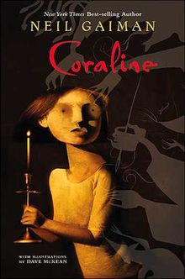
- Coraline by Neil Gaiman (Have Not Read)
Summary
Coraline lives in a home with loving parents. Angsty from her recent move and desiring more attention from her parents than they are able to immediately give, Coraline seeks out adventure through a crawlspace that she is advised not to go through. She tumbles through a magical portal where the Other Parents reside. At first, these Other Parents seem perfect and far better than her original parents. However, things go wrong quickly and Coraline must learn fast that things aren’t always what they seem—danger looms ahead.
Evaluation
Although I haven’t read the novel, I’ve done enough research to give a proper evaluation of the novel’s themes and messages. Coraline is a curious and intelligent adventurer. She is frequently upset when people—particularly adults— don’t take her seriously because of her age and size. This is something that young adult readers may relate to as they become more settled in who they are and find others don’t give them the respect that they deserve merely because of their age. Identity is at the core of this novel. Coraline is an adventurer and an explorer that finds herself trapped in a boring world with a boring family. As she embarks on her journey of self-discovery, Coraline is forced to reflect on her own strengths and weaknesses in order to remedy mistakes she makes. She learns about herself and she begins to see the identities of the other people in her life as well. These are great lessons for young adults to learn about accepting their flaws and nurturing their relationships. This novel exemplifies the Exeter Qualities 3 (characters who reflect experiences of teen readers/strong female protagonist), and 7 (themes that allow the possibility of emotional and intellectual growth).
Gaiman, Neil. Coraline. William Marrow Paperbacks, 2006.
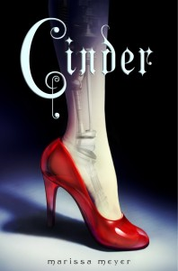
- Cinder by Marissa Meyer (Have Not Read)
Summary
Cinder is a talented and reputable mechanic in New Beijing. Despite her talents, she is discriminated against because she is a cyborg. After her adoptive sister falls ill with the deadly lunar disease, letumosis, her cruel adoptive mother volunteers Cinder to participate in plague research that no one ever survives from. However, once she is injected with the disease, it’s discovered that she is immune to the disease and this discovery leads to Dr. Erland researching Cinder’s life prior to becoming a cyborg. As more is revealed, Cinder becomes caught in the center of a dangerous intergalactic power struggle and Cinder must find the truth about herself in order to protect her world.
Evaluation
I haven’t read this novel, but I know enough form online sources to comment on the novel. For the most part, Cinder’s adoptive family is cruel to her and society shuns her. This causes cinder to crave family, affection, and a sense of belonging. She is different from others and suffers for that, so she must struggle on her journey of self-discovery in order to find true connection with herself and with others. Cinder finds courage and shows immense bravery as she stands up for herself despite what others think and despite how others treat her—Cinder always chooses to see the good. Not only is Cinder a strong female role model, but she is a protagonist who has suffered bullying and discrimination, which a lot of young adult readers can relate to. This novel has a lot of messages about bravery, identity, and loyalty that readers can learn from. This novel exemplifies the Exeter Qualities 2 (exciting plots that include secrecy, surprise, etc.), 3 (characters who reflect experiences of teen readers/strong female protagonist), 4 (characters who go beyond typical experiences), and 7 (themes that allow the possibility of emotional and intellectual growth).
Meyer, Marissa. Cinder. Feiwel & Friends, 2012.

Works Cited

“Coraline by: Neil Gaiman.” Sparknotes.com, SparkNotes, https://www.sparknotes.com/lit/Coraline/.
Donelson, Kenneth L., and Alleen Pace Nilsen. Literature for Today's Young Adults, 8th ed., Pearson, 2008.
Gerster, (c) Gaby. “Scythe.” Book by Neal Shusterman | Official Publisher Page | Simon &
Schuster, Simon & Schuster Books for Young Readers,
www.simonandschuster.com/books/Scythe/Neal-Shusterman/Arc-of-a-Scythe/9781442472433.
He, Joan. “Descendant of the Crane.” Joan He, www.joanhewrites.com/dotc/.
Meyer, Marissa. “Wings.” Marissa Meyer, www.marissameyer.com/books/cinder/.
“Wings (Pike Novel).” Wikipedia, Wikimedia Foundation, 25 Nov. 2020,
en.wikipedia.org/wiki/Wings_(Pike_novel).

URLs for Novel Cover Photos
https://www.marissameyer.com/books/cinder/
https://en.wikipedia.org/wiki/Coraline
https://www.goodreads.com/book/show/5056084-wings
https://www.ecosia.org/images?q=scythe%20neal%20shusterman#id=6F19F976B7C3F207D6282DAD5F71E66F1DE4AA8C
https://www.goodreads.com/book/show/41219451-descendant-of-the-crane
https://www.ecosia.org/images?q=throne%20of%20glass#id=EC7BBF0014B2D28509817936AE42534E4B2FD6BA
https://www.ecosia.org/images?q=harry%20potter%20and%20the%20prisoner%20of%20azkaban%20book#id=6E3A48C70CE9ACA43F7A95F529A12AFF3E030A53
https://en.wikipedia.org/wiki/The_Hunger_Games
https://www.ecosia.org/images?q=uglies#id=19C16EAD71486E7FE457823EF4F7112C58D33BFC

