Ivy Moore
Professor Warner
English 112B
7 December 2020
Unit of Study: Generational Curses
Rationale:
Generational curses are not the first topic that is usually up for up discussion, but that does not mean there are students who do not suffer from them. Unfortunately, these familial curses can impact the lives of students, leading to depression or self-destruction because that person may or may not be able to handle what comes their way. Generational curses are not necessarily actual “curses” but more so toxic tendencies that families tend to throw under the rug. Some people learn from them and attempt to fix them while others succumb to the pressure and may continue them. Most high schools are very diverse, and with this diversity comes many different ethnic backgrounds and diverse family structures. By familiarizing students with texts that provides examples of generational curses, students may be able to examine their own and learn from them. I want my students to learn more about themselves and set expectations on how they would want their futures to differ from their current situations.
For my unit of study, I will be focusing on the play Fences by August Wilson. This two-act play focuses on a man (father) named Troy who overcomes his own obstacles but only does what is best for him, not his family. He has a son named Cory who wants to go to college and play football, but because he did not make it to pro ball, he pulls his son from playing football causing them to be at odds. He feels as if, because he provides for his son that he should do as he says but that is not the case. We also find out that Troy has an affair and a baby out of wedlock, as well as putting his disabled brother into a mental hospital to collect his disability check. This play is a perfect example of what generational curses could be like and how it affects the next generation to come.
Introduction to the Unit:
I decided to take the idea that I have observed from my field experience observations. My students will start the unit off with a “Musical Journal”. I will play the song “Family Business” by Kanye West about three times which allows the students almost 15 minutes to write. They will be writing about if they feel accepted by their family or live up to their standards. After writing their musical journal, I will give my students the opportunity to share theirs out loud if they would like. By doing this I am hoping to create a safe space environment where students feel they can express themselves willingly with no judgment.
Song Link: https://www.youtube.com/watch?v=JwAjANmjajc
After their musical journal, we will begin to read the play. I will assign my student’s different characters for each scene, so everyone has a chance to read and participate. Since we are reading a play, I am hoping that my students will get into character and make something that is educational fun. Whoever is not reading will be required to write a 5-7 sentence paragraph on what they have observed in that scene regarding how Troy’s treats his family.
Within the text
Another activity that I will have my students complete is simple reading comprehension quizzes with no more than 5 questions. Those questions will focus on the major themes within the scenes of each act. I will be assigning the quizzes because I want to keep up with how my students are understanding the play and to recognize where they may be struggling. After the quizzes, I will offer two bonus questions that will be slightly more difficult, so that way my students have a chance to gain extra points.
In addition to the quizzes, I will have my students get into groups of 3 or 4 and discuss their opinions on how they feel about the play. They will have discussions questions such as:
- Who is your favorite character so far?
- What themes are you starting to notice?
- How do you think Troy’s behavior affects his family?
- Why is the setting of the play important?
- What is the hidden metaphor within the play?
Finally, with the same discussion groups, I will have students create a poster of their own version of fences. This activity will allow them to come up with their own creative ideas and voice their thoughts on the play. Plus, this could be a fun Friday activity to close out the readings of the play. If there is time and depending on the behavior of the class throughout the unit as a reward, we could watch the film. Of course, while watching the film I will have them create a chart stating the similarities and differences between the film and the written play.
Beyond the text
Hopefully, my students will show interest in the genre of this play with it being a drama. I will introduce both drama plays and novels, that express generational curses (family traumas) and reveals how the children overcome them.
- A Child Called “It” by Dave Pelzer
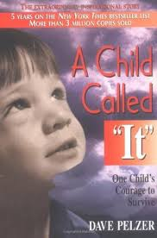 This novel is about a young boy by the name of Dave who is abused consistently by his mother. She has forced to him to inhale ammonia, eat feces, get whipped with chains, and much more. Although he endures both physical and verbal abuse, he still finds a way to make it out. He creates a successful future for himself.
- Little Fires Everywhere by Celeste Ng
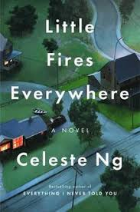 Little Fires Everywhere, touches on many different themes from motherhood, manipulation, and identity. There is a young girl by the name of Pearl who constantly moves around, and she finally settles in Shaker, Ohio with her mother Mia. Events then start to unravel, and she finds out many family secrets and lies that forces her mother to tell her the truth.
- A Raisin in the Sun by Lorraine Hansberry
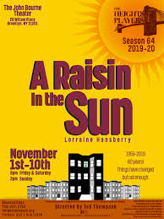 This play focuses on the themes of family, fighting racial discrimination, and the value and purpose of your dreams. This book focuses on breaking the generational curses and exceeding the expectations that society has for you. Instead, to make your own path and successful life.
Works Cited
Hutchinson, Emily, and Lorraine Hansberry. A Raisin in the Sun. Globe Fearon Educational Publisher, 2000.
Kane, Joe, et al. Fences. Tinkan Press, 1984.
Ng, Celeste. Little Fires Everywhere. Abacus, 2020.
Pelzer, David J. A Child Called 'It'. Seven Dials, 1995.

