Sophia Knauer
25 November 2019
4th Credit Enhancement
Have read
New to me
Annotated Bibliography
Rationale
The dystopian subgenre of YA literature has a practical application in the idea that it has the potential to teach concepts like critical thinking to readers that they may apply to reality and the world around them. The ability to adequately question and reach a proper conclusion about the world is crucial in dystopias as much as it is for our own reality. A common theme found in dystopian literature is truth, the plot typically structures around the concept of a hidden truth or lies the hero is told. The process of uncovering the truth, however, is what matters in the course of the hero’s journey. Even in the smallest circumstances facing a lie or uncovering something for these characters is never easy, they have to face fears and find strength throughout their development. As well as the hero finding strength and courage, he or she must work to bring their world back to order and this can only be done by bringing the truth to light.
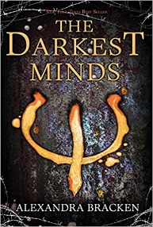
Going into a closer study of dystopian YA literature is beneficial to creative writing studies as it gives a pinpoint view of character development and conflict in a way that seems to parallel reality at the same time that it dramatizes and exaggerates what may occur in the real world. Dystopias can create a stronger connection between the readers and the main characters on a personal level. The ability to write characters with identities readers can relate to is important but the concept of representation is even more so critical; it changes the way the plot is received and who it resonates with. Representations of multiple cultures and communities make the difference between flat characters and vivid characters with strong identities that impact their development.

Bracken, Alexandra. The Darkest Minds. Hyperion, 2018.
- A story about a world in which teens and children have developed certain powers after surviving and illness; the main character Ruby provides a personal narrative. Ruby meets three other people in the same situation as her and runs with them from the government and organizations that would either use them for their ability or kill them for it. As the story goes on, the four realize that they have no choice but to find others like them and fight against the system that keeps them in fear.
- This novel is valuable in multiple ways, because it features a group of four as main characters there is a team aspect. Although the four do not always get along and split up in the end, in crucial moments they learn teamwork and how to survive and depend on one another. When they finally uncover the truth about just how bad the government has treated them, and the plans it has for runaways like them they are forced to find strength in an impossible situation; this can prove invaluable to teens reading it that may be in a toxic circumstance, whether it be a family problem, or interpersonal social relationship, there is inspiration to stand up for themselves to be found in The Darkest Minds.

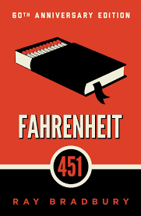

Bradbury, Ray. Fahrenheit 451. Simon & Schuster Paperbacks, 2012.
- A story about a society in which books are forbidden and illegal, a man with the job of burning any books found makes the decision to save some. Upon reading those books he is criminalized and has to live that part of his life in secrecy but as he begins questioning the world around him it becomes more dangerous.
- The concept of questioning is crucial to uncovering truth in this novel. The main character, Guy, can only begin to grow as a human being and learn if he questions the society he takes part in. Although knowledge and growth can bring trials and troubles, in this case becoming a criminal, there are positives to understanding the system’s flaws. When one understands the flaws of the world there is an opening to try and improve upon these flaws.
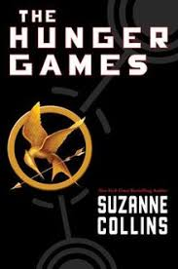

Collins, Suzanne. The Hunger Games. Scholastic, 2012.
- A teenage girl faced with the impossible task of protecting her sister by volunteering in her place to participate in a tournament to the death, an event put on by the Capitol (government). As she survives while others die, she finds a companion in her male counterpart from her district, eventually ending the games with a suicide pact unless they could live.
- The concepts Katniss takes to heart throughout the novel can be applied in the lives of readers as well, she learns what it means to stand and fight for what she believes in regardless of the trauma she has faced throughout the games. It can help victims of trauma find their own strength to fight such emotional battles as the ones in the story. The 6th Exeter quality ties into the novel as it strongly encourages the topic of finding truth and making a change on a larger scale.

Condie, Ally, and Allyson Braithwaite. Condie. Matched. Dutton Childrens Books, 2010.
- A 17 year old girl is forced by society into a “match”, essentially a world in which 17 year olds are unable to choose who they spend their life with and their lifelong partners are chosen for them, Cassia must decide whether to follow as she has been taught or to follow what she feels instead.
- The theme of choice in Matched in crucial to teach younger ages and teenagers living in a world where everything seems decided for them; the encouragement to choose their own path is the first step to teenagers becoming independent enough to think critically about their surroundings and how they relate to the world around them. Cassia’s choices and how they impact her life serve as a lesson to readers to think more on the consequences—good or bad—of their own decisions.
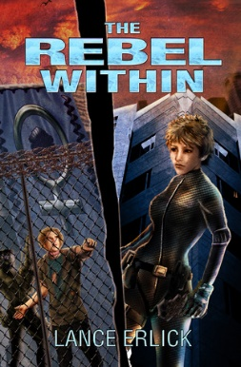

Erlick, Lance. The Rebel Within. Finlee Augare Books, 2013.
- In a dystopian future, Annabelle joins the military to escape a punishment when she is caught and would otherwise be sent to prison. She must then face how to keep her own identity in a society that would beat it out of her.
- Because I have not read this one, I can only go off of comments, however, many make a statement of how the story is centered around the theme of freedom. Freedom can mean quite a bit in a situation where many feel the pressure to conform and some—especially LGBT+ related youth—need the reminder that the courage to stick out and be oneself is life-changing and can influence others in a positive manner.
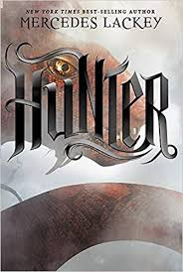

Lackey, Mercedes. Hunter. Scholastic Inc., 2017.
- Hunter Joy Charmand is a disciplined member of Apex, perhaps the only one to strive for the purpose of defending others and making them feel protected. With her otherworldly hounds at her side, she has the advantage of a sort of magic to aid her in her fight.
- The themes of courage and fear go hand-in-hand for this novel, as Joy faces her fears, she realizes the importance of bravery and courage for the sake of those around her. For teenagers to learn that fear does not necessarily limit the amount of courage one is capable of is a necessity, it can change their outlook on life and how they choose to face said fears.
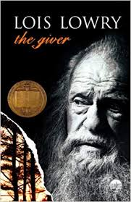

LOWRY, LOIS. GIVER. HOUGHTON MIFFLIN HARCOURT, 2020.
- A boy named Jonas is chosen to receive memories and knowledge kept secret from the rest of society and discovers life in its most vivid sense. However, he is tasked with keeping this secret in a world where everything has its designated job and place in the order of things.
- The 4th Exeter quality is ever present as Jonas experiences what it means to make a major decision for himself yet at the same time debating whether or not he should, his ability to critically think about the systemic society and how he must act to change it serves as a lesson to readers looking to change the world in their eyes. The ability to think critically is the first move in understanding how things work and how things are flawed and can open the door to change.
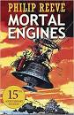

Reeve, Philip. Mortal Engines. Paw Prints, 2012.
- In a time of “city-eat-city”, four characters must work simultaneously from different parts of the world to uncover the truth about the past and use the information they discover to save people. The main characters, Tom and Hester, fight to keep others safe while Bevis and Kate fight for the truth.
- As much as Tom and Hester’s fight is important Kate’s character development can encourage readers to seek out the truth a well, despite the pain it may initially cause. The lesson in this story and through Kate serves as a reminder that it is better to know terrible things rather than be ignorant. Only once one knows these things can they begin to make a change.

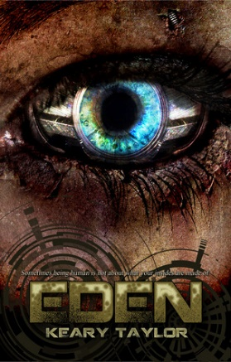

Taylor, Keary. Eden. Published by Keary Taylor through CreateSpace, 2011.
- A cybernetic disease walks the earth in the form of creatures known as the Bane, and it is left to the remaining human colonies to survive and fight for their ability to live. Eve experiences this time period differently from others, finding within herself an ability to feel love on a new level.
- Although I did not read this one, I do not feel the need to, comments from other readers suggest that there is not anything to actually learn from this novel except how not to write a dystopian YA book. The flat characters and evidently repetitive depictions of Eve’s thoughts and emotions serve very little purpose instructionally. However, in a creative writing setting it sounds like a good example to use in demonstrating how to structure a critique and give constructive criticism in response to a story.
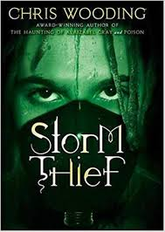

Wooding, Chris. Storm Thief. Scholastic, 2013.
- A government system entraps unfortunate and “undesirables” in a cycle of poverty as two characters living a life of thieving for a crime boss stumble across a new device that allows them to change their future
- The theme of chosen family in Storm Thief offers a truth often not taught to younger teens; the idea that the family one chooses is the one to make the most profound impact on a life. Readers see how Moa finds the people that care and support her more than anyone related to her by blood as encouragement. For some the validation that just because they are related to someone does not make them family can be critical and the ability to move on and find people they can call family is life changing.

Works Cited
“Eden (The Eden Trilogy, #1) by Keary Taylor.” Goodreads, Goodreads, 6 Mar. 2011, https://www.goodreads.com/book/show/9635325-eden.
“The Rebel Within (Rebel #1) by Lance Erlick.” Goodreads, Goodreads, 25 Mar. 2013, https://www.goodreads.com/book/show/17724228-the-rebel-within.

