Sabino Brooks
Professor Warner
English 112B, Section 01
2 December 2019
The Journey of Self-Discovery in Fantasy Literature
Rationale of Genre and Topic
The genre of fantasy is often stigmatized as literature that is preposterous, far-fetched, and frivolous; such qualities appear unsuitable for a subgenre of young adult literature. Yet, the truth is that fantasy and young adult literature are not remotely incompatible. These epithets that are attributed to the fantasy genre shroud the likeness between characters of fantasy novels and young adults. The relationship between young adults and these fictious beings is captured by the journey of self-discovery. Foremost, in embarking on this journey—like real life—many protagonists of fantasy novels are young adults. Young adulthood is a period in which humans are still developing and lack complete knowledge of their character and their ability to outgrow their problems. Be that as it may, young adulthood is also a period in which humans realize their intellectual freedom and opportunity to discover more about themselves. Fantasy novels pick up on this insight.
For young adults in the real world, the journey of self-discovery is a process. This process is encapsulated by a series of events that an individual undergoes; meanwhile, the individual experiences maturation as each event passes. The accumulation of these events is underscored by one single substantial event that generates satisfaction of the individual’s desires. Once the individual overcomes the pivotal event, the person attains awareness of one’s own character, needs, and motives. The scholar is both real and exemplary of the journey of self-discovery. The passing of high school and introductory college courses serve as minor events; the scholar develops and begins to tackle the question of “Who am I?” Upper division college courses aid in the scholar’s pursuit for answering this question. Finally, the attainment of the diploma acts as the essential event that fulfills the scholar’s search for self-discovery—in this case, the scholar’s motives for acquiring an education.
Fantasy novels convey the journey of self-discovery through the convention of the quest. Acclaimed authors, Alleen Pace Nilsen and Kenneth L. Donelson write that the quest the protagonist undertakes is an expression of “the desire to accomplish a thing fraught with difficulty and danger; the central figure grows in stature as the quest evolves” (Literature for Today’s Young Adults). In other words, the knight of an Arthurian fantasy shares the same hunt as typical young adult scholars. For instance, the prerequisite of spending a night in an enchanted forest functions as a minor event; the knight succeeds and grows in bravery. Other events like the onslaught of ferocious goblins test the knight’s courage. Finally, the pivotal event occurs when the knight slays the dragon. When the knight prevails over the dragon, the journey of self-discovery is fulfilled; the knight becomes aware of his valorous character.
Characters of fantasy novels and young adults take on the same journey of self-discovery; fantasy novels just employ an imaginative term for this journey. Fantasy exists as a genre that contextualizes the quest of learning about one’s self. If the fantasy genre is interpreted in this manner, then the genre is indispensable to our understanding of a very real quest. Above all, the characters of the fantasy genre always attain self-discovery by the end of the story; in reading fantasy novels, young adults are encouraged to not give up on their own journeys of self-discovery.

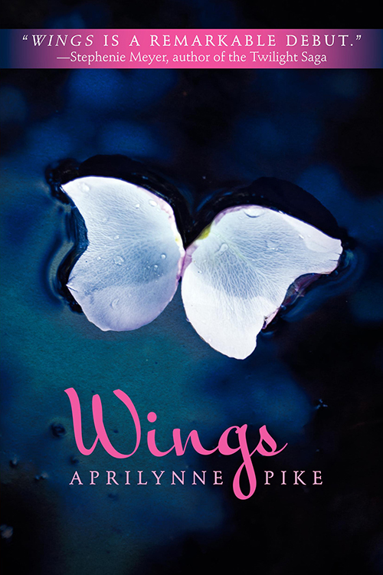
Annotated Bibliography
- Wings by Aprilynne Pike
Summary
Initially, the common change of moving cities, attending public school, and making friends are the only new challenges of Laurel Sewell’s life. However, once Laurel notices that the lump on her back is budding; she realizes that she is not ordinary. In a search for answers, Laurel discovers that she is not a human but a faerie who is dispatched among the human
(Have Read) realm; her situation is exacerbated by her newfound
responsibility of protecting the gate to Avalon.
Pike, Aprilynne. Wings. HarperTeen, 2009.
Evaluation
In a great segue from Arthurian knights, this novel explores the fantasy of faeries. Laurel’s journey of self-discovery relates to her origins. Her developing wings suggest that she is genetically unique and prompts Laurel to learn more about her birth. This novel is valuable read for young adults who also share the same questions regarding their identity. More importantly, this novel teaches young adults that the journey of self-discovery is not always predictable. Along the way, you might discover something that is unexpected. This novel also epitomizes romance fantasy and incorporates the convention of a love triangle between three featured characters. Wings best exemplifies Exeter qualities 2 (exciting plots) and 4 (characters who go beyond typical experiences).

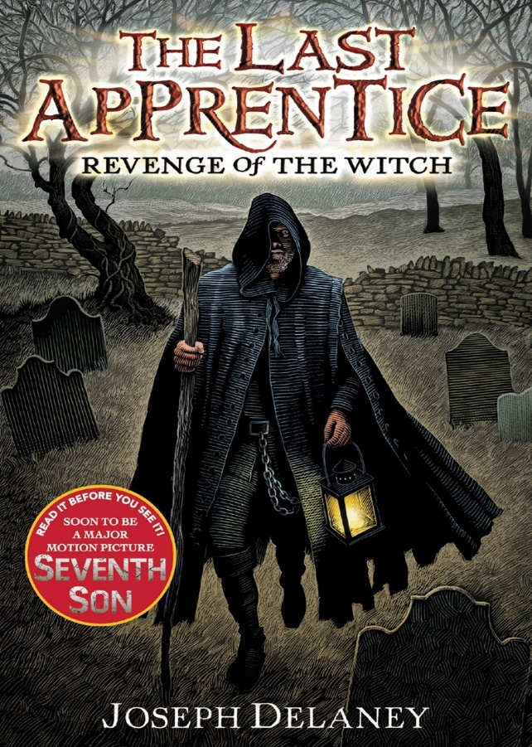
2- The Last Apprentice: Revenge of The Witch by Joseph Delaney
Summary
From the outer perspective, Tom Ward is merely a typical farm boy; however, his birth gives him a rare designation as the seventh son of a seventh son. Due to this uniqueness, Tom can observe supernatural beings walk the Earth and cause mischief. Under the tutelage of a Spook,
(Have Read) Tom learns how to banish these irksome creatures;
In doing so, Tom gains insight on how a Spook
overcomes evil.
Delaney, Joseph. The Last Apprentice: Revenge of the Witch. Greenwillow Books, 2006.
Evaluation
This novel is a great representation of archetypes. Tom Ward fits in the role of the archetypal seeker; his parents send him off to be the apprentice of the Spook because of his inherent ability to see the supernatural. While working alongside his mentor, Tom attempts to discover how he belongs in the world of a Spook and if he can engage in a Spook’s livelihood. This archetype complements Tom’s journey of self-discovery. The Spook fits in the role of the sage. The Spook advises Tom on how evil exists outside of the supernatural realm, and these evils are more difficult to eliminate then boggarts and ghosts. The Spook guides Tom through the truths of reality and the truths of the extramundane entities they face.
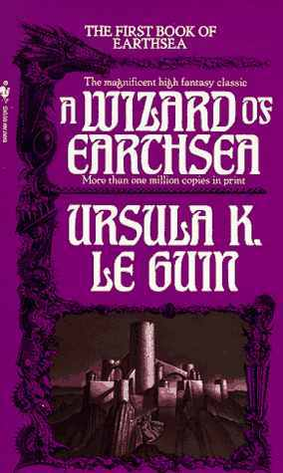
3- A Wizard of Earthsea by Ursula K. Le Guin
Summary
In the island of Gont, a young boy named Duny saves his village from an attack by the Kargad Empire. He utilizes spell casting to achieve this victory. The wizard Ogion hears of Duny’s deed and decides to become his mentor. Ogion bestows upon Duny his true name, “Ged”. As Ged’s magical abilities develop, he grows tiresome of
(Have Read) following Ogion. Ogion, sensing Ged’s fervor
for more advanced magic, dispatches Ged to a
school of wizardry.
Le Guin, Ursula K. A Wizard of Earthsea. Houghton Mifflin Harcourt, 1968.
Evaluation
Le Guin’s novel is perfect for educating young adults on the reward of self-discovery. The antagonist of this novel is a shadow. Throughout the novel, Ged is constantly looking for ways to kill, subdue, or avoid this shadow; however, he does not conquer this enemy until he realizes that the shadow is his own. In discovering that the darkness is a part of him, Ged becomes “a man: who knowing his whole true self, cannot be used or possessed by any power other than himself” (214). Le Guin’s words exposes the relationship between control and self-discovery. This novel demonstrates Exeter qualities 2 (exciting plots), 4 (characters who go beyond typical experiences), 5 (lively, varied and imaginative language) and 7 (themes that allow possibility of emotional and intellectual growth).
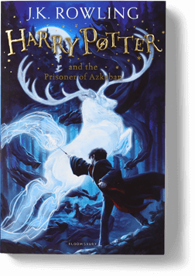
4- Harry Potter and the Prisoner of Azkaban by J.K. Rowling
Summary
Harry Potter is now in his teens and beginning his third year at Hogwarts. Once more, problems arise for the renowned protagonist. Panic is amongst the residents of Hogwarts as Sirius Black manages to escape from the intimidating Azkaban, a prison for
(Have Read) convicted criminals. It is assumed that Black’s
target will be Harry. Yet, Harry is even more
perturbed by the guards of Azkaban and his
supposed protectors, creatures that bear the name “dementors”; These creatures are vile, decayed, grey, and ghoulish—more importantly, they suck the happiness from their victims. In discovering the truth, Harry realizes that Black is misrepresented as the enemy.
Rowling, J.K. Harry Potter and the Prisoner of Azkaban. Scholastic Inc., 2013.
Evaluation
In relation to the journey of self-discovery, Harry discovers the truth regarding his parents’ murder and the framing of Sirius Black. As a result, Harry gains a mature insight regarding truth and how the person who appears to be the villain might not be the villain. In acquiring the truth, one must not be distracted by the impressions, whispers, and accusations of other people. Rowling’s novel teaches young adults to have good discernment when judging people. This book exemplifies Exeter qualities 2 (exciting plots), 4 (characters who go beyond typical experiences) and 7 (themes that allow possibility of emotional and intellectual growth).
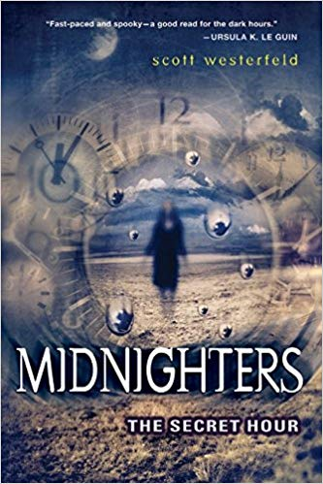
5- The Secret Hour by Scott Westerfeld
Summary
High schooler Jessica Day experiences a strange night unlike any other shortly after she and her family move to Bixby, Oklahoma. The abnormality occurs just after midnight. Jessica can freely roam, but everything else in the world is frozen. She does not share the 25th hour alone however. Darklings reside in the secret
(Have Read) hour and they despise the presence of
humans. Luckily for Jessica, a faction of
humans known as “The Midnighters” take
her under their wing.
Westerfeld, Scott. The Secret Hour. EOS Books, 2004.
Evaluation
The Mightnighters are capable extraordinary powers to combat the darklings during the secret hour. The novel centers around Jessica’s journey of self-discovery in finding out what her super power is. The darklings, who normally keep away from humans, are driven to murder Jessica; it all makes sense when Jessica’s power is revealed as the bringer of flame. This novel teaches young adults that in acquiring self-discovery, often we are rewarded light to our darkness. In becoming aware of one’s self, the individual is stronger and less likely to succumb to evil. Another important aspect of the novel is the narration. Each chapter differs in the perspective of one of The Midnighters. This work displays Exeter qualities 1 (imaginative and well-structured plots, including time shifts and different perspectives), 3 (strong female protagonist), 4 (characters who go beyond typical experiences) and 7 (themes that allow possibility of emotional and intellectual growth).
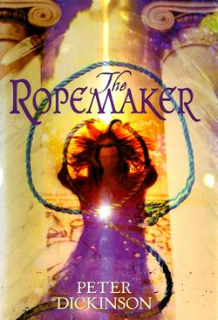
6- The Ropemaker by Peter Dickinson
Summary
Tilja’s home in the tranquil Valley becomes threatened once the enchanted forest’s magical barrier dwindles. With the barrier being exposed, the Empire can invade and strip Tilja and many other villagers of their homes. Tilja volunteers, along with her grandmother and two northern villagers, to infiltrate the Empire in search for a
(Have Read) magician who can restore the lifespan of the magic
barrier.
Dickinson, Peter. The Ropemaker. Delacorte Books for Young Readers, 2003.
Evaluation
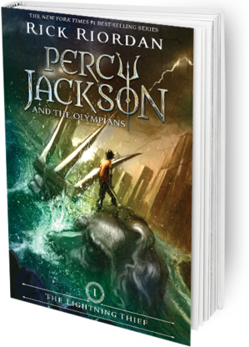
Tilja Urlahdaughter’s family has a rich history. Long ago, one of her ancestors aided in protecting the Valley from an invasion by the Empire; the ancestor was a woman with innate skill in magic. The remnants of this woman’s magic are continuously passed down among the women of Tilja’s family. All Urlahdaughter ancestry can talk to trees. However, this magical capability skips Tilja. The journey to the Empire is very much akin to Tilja’s journey of self-discovery. Along the way, Tilja discovers that she can use magic; her abilities are just different from the rest of the Urlahdaughter women. This book informs young adults that not everyone acquires the same knowledge in the shared journey of self-discovery. People’s needs, characters, and motives are different. This novel demonstrates Exeter qualities 2 (exciting plots), 3 (strong female protagonist) and 4 (characters who go beyond typical experiences).
7- The Lighting Thief by Rick Riordan
Summary
Life is not too kind to Percy Jackson. He struggles in school and is dubbed a trouble-maker. To make matters worse, he has no idea of who his father is or his whereabouts. Perhaps this life is easier compared to the new life he attains once he learns that he is demigod—son of Poseidon and his mortal mother, Sally. In another turn (Have Read) of screw, Percy’s mother is abducted, and his father is blamed for stealing Zeus’s lighting bolt. With the help of his friends from Camp Half-Blood, Percy embarks on a quest to retrieve the lighting bolt and rescue his mother.
Riordan, Rick. The Lightning Thief. Disney-Hyperion, 2006.
Evaluation
Percy’s journey of self-discovery is linked to his condition of being both mortal and god. In the beginning of the novel, it appears as if Percy does not belong to ether group. He faces difficulty in the moral world as a student with dyslexia. His godly father abandons him as well, leaving him unaware of his status as a demigod. However, as the novel progresses Percy finds his place among the “half-bloods” or other children that share the same familial background. This novel teaches young adults that the journey of self-discovery is aligned with finding out where you belong. Percy is also a great model for the orphan archetype. This novel best exemplifies Exeter qualities 2 (exciting plots), 4 (characters who go beyond typical experiences) and 7 (themes that allow possibility of emotional and intellectual growth).

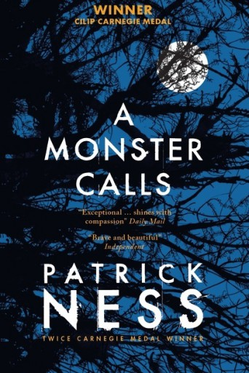
8- A Monster Calls by Patrick Ness
Summary
Conor O’ Malley cannot cope with the thought of letting go of his terminally-ill mother. In fact, the action of letting go haunts his dreams. One night at 12:07, Conor experiences a different nightmare. A monster, in the form of a yew tree, grabs him and declares that it will tell Conor three stories; after the stories are told, Conor must tell the monster his own—the truth. In
(Have Read) Conor’s time with the monster and listening of
its stories, he deals with his overwhelming
emotions regarding his mother’s inevitable
demise.
Ness, Patrick. A Monster Calls. Candlewick Press, 2011.
Evaluation
I have attained an insight regarding stories at the beginning of the semester in my ENGL 100W course. Professor Stork comments on how stories are divided into two plots: “a person goes on a journey, or a stranger comes to town”. A Monster Calls is a great novel that incorporates a magical figure into the role of the stranger. The monster enters Conor’s life and his emotions are aroused. The journey of self-discovery is still present in this novel however. The monster acts as an agent that imposes this journey onto Conor. This novel enlightens young adults that sometimes the journey of self-discovery is forced upon as a necessity. For Conor, self-discovery is necessary to survive; he needs to be aware that letting go of his mother does not change his love for her. In Adolescents in the Search for Meaning: Tapping the Powerful Resource of Story, Chapters 4 (books about real-life experiences) and 5 (books about facing death and loss) complement this novel.
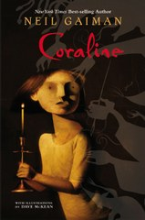
9- Coraline by Neil Gaiman
Summary
Inside her new residency, Coraline Jones comes across an enticing secret door. In entering the doorway, Coraline is lead into a counterpart world dubbed, “The Otherworld”. She is greeted by parents that resemble her own; although, these other parents are more attentive, attractive, and fun. The delight does not last long as Coraline discovers that the Otherworld is weird. She temporarily escapes, but her real
(Have Not Read) family is kidnapped by the Other Mother and
Coraline must journey back to save them.
Gaiman, Neil. Coraline. HarperCollins Publishers L.L.C., 2002.
Evaluation
While I have not read this novel, I can comment on Coraline’s journey of self-discovery as it pertains to her relationship with her family. The characters of the Other Mother and Other Father have qualities that Coraline wishes she could see in her real-life parents. They are not always busy with work and pay attention to her. Even though Coraline leaves the Otherworld, she discovers her need for a closer bond with her actual parents. She is determined to obtain this type of connection, even if that means she must defeat the Other Mother to retrieve her parents. Due to this, this novel can teach young adults the importance of salvaging relationships.
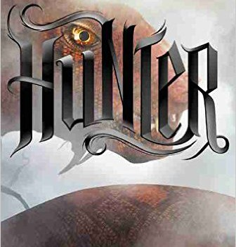
10- Hunter by Mercedes Lackey
Summary
The world is in chaos as monstrous creatures of the Otherworld prowl about. Joyeaux Charmand, a distinguished Hunter, is intent on protecting all Cits who cannot fight back. In becoming a member of the Apex, Joy is assigned the task of protecting the high-ranked of Apex City; However, she discovers that
(Have Not Read) these supposed leaders have no concern for
the safety of the Cits. The Cits are given a false narrative regarding their security; meanwhile, more monsters are bypassing the barrier between two worlds. Joy must act quickly and with no fear.
Lackey, Mercedes. Hunter. Disney-Hyperion, 2015.
Evaluation
Although I have not read this novel, I see a resemblance between Joy and my opening example of the Arthurian knight. Joy’s journey of self-discovery concerns her awareness of being brave in the face of danger. Joy is willing to protect the Cits at all cost; to do so, she must overcome her fears and display valor as she battles the monsters of the Otherworld. Similarly, young adults must conquer their fears every day. In Adolescents in the Search for Meaning: Tapping the Powerful Resource of Story, Chapter 7 (books about courage and survival) complements this novel.

Works Cited
Donelson, Kenneth L., and Alleen Pace Nilsen. Literature for Today's Young Adults, 8th ed., Pearson, 2008.
Lackey, Mercedes. “Hunter.” Mercedeslackey.com, SketchThemes, 2016, http://www.mercedeslackey.com/books/hunter/.
Warner, Mary L. Adolescents in the Search for Meaning: Tapping the Powerful Resource of Story. Scarecrow Press, 2006.
“Coraline by: Neil Gaiman.” Sparknotes.com, SparkNotes, https://www.sparknotes.com/lit/Coraline/.

URL Links for Book Photos
http://aprilynnepike.com/index.php/wings
https://josephdelaneyauthor.com/spooksworld/books-us/the-last-apprentice-series/revenge-of-the-witch/
https://www.ursulakleguin.com/a-wizard-of-earthsea
https://www.jkrowling.com/book/harry-potter-prisoner-azkaban/
http://scottwesterfeld.com/midnighters/hour.htm
https://www.peterdickinson.com/books/ropemaker/
http://rickriordan.com/book/the-lightning-thief/
https://patrickness.com/book/a-monster-calls-non-illustrated-edition/
https://neilgaiman.com/works/Books/Coraline/
http://www.mercedeslackey.com/books/hunter/

