Presley Lugo
T 4:30 ENGL112B
Dr. Warner
Unit Of Study: Revision
12.10.19
Humanity Versus the Individual
A Dystopian Unit of Study of Lord of The Flies
Rationale:
In the current age of technology, infinite information is in our pockets, and access to the entire world is at our fingertips. With the rise in technology also came an increase in individuality. Individuals can connect with people across the globe via tiny screens. Personal profiles can depict every particular trait, habit, characteristic, and facial feature. Phone applications can find favorite places to shop, desired content based on algorithms, and where you are at every moment of the day. Navigation apps can predetermine where you’re going based on driving habits. Although it seems we are being watched, individuality is heavily advocated, therefore individuals are willing to comply with new social media technology. Individuals are eager to place private information because it is a new way of connecting to others and at the same time, being unique. Being able to form a connection with others has never been easier, yet there is still a disconnect in human relationships. Amongst the vast individuality spectrum on social media apps, some hierarchies determine individual statuses and social groups. Therefore, many must navigate how they play a role within today’s elaborate social compass.
Similar themes and connections are seen in William Golding’s Lord of the Flies, in which a group of young boys are deserted on an island and struggle to survive with no food, no shelter, no grownups, and no rules. These boys have the luxury of living without adults, but soon learn that in order to be rescued, roles and groups need to be formed. Though these groups are formed initially as a ways to collaborate and survive, they soon find that it leads to chaos and disorder. All innocence is lost when boys are turned into hunters. Golding’s novel paves the way for today’s popular dystopian theme and introduces a genre that questions the meaning of civilization.
Combining Lord of the Flies into a Dystopian unit of study will help students make connections to current issues that concern how the individual connects to the rest of humanity. Students will be able to analyze how their role in their community, helps shape that community. Students will be open to how the most innocent beings resort to means of harsh survival. Students will learn themes of power, control, respect, and abuse, and the overall theme of humanity versus the individual. The outcome of this unit will be that students will be more aware and engaged in human nature and the issues that we face today. Students would be able to see how a dystopia can hinder their voice or can give them one.

Launching the Unit:
This unit starts by asking students what their perfect world would look like and how do they perceive themselves in that world. I would ask Students to either talk briefly in groups or give a short journal response to this question. Lord of the Flies by William Golding, is an essential text to be introduced to students because Golding paved the way for post-apocalyptic scenarios long before, novels that students might recognize were introduced. By implementing themes of “the individual versus humanity” and how important individuality is in our modern democracy, teaches students that their voices matter.
Before introducing the text to students, dystopia and Utopia will be defined. This will be done via PowerPoint and accompanied by a vocabulary sheet where students will be asked to rewrite the definitions of the unit, in their own words. Students will further their understanding of dystopia by learning about the characteristics of a dystopian society. This would be achieved by making a PowerPoint about what can be found in a dystopian society, and students will continue to fill out this information on their vocabulary sheet. Vocabulary words will be added to posters across the room that illustrate characteristics within a dystopia, and that can be found in dystopian narratives. The terms and characteristics would be propaganda, conformity, worshipped figurehead, restricted freedom, citizens under constant surveillance, and the illusion of Utopia.

1. Video & Reflection: This unit will continue to be introduced by showing students “YouTube” videos that illustrate examples of a Dystopian Society. This video idea is taken from Doreen Trenholm’s 11th grade honors English class. Ms. Trenholm showed students a YouTube video entitled “Children.” The dark, short, animated film illuminates how dystopian characteristics might be seen in a classroom setting, making it relevant to students. The short film shows students conforming to a system that favors uniformity and equality. Although the movie depicts an ideal world for students shows, where everyone receives A’s for trying, the students in the film are unhappy. The short film illustrates that the students are silenced and are unable to show emotion. Their mouths are literally zipped shut and they cannot voice any type of individual thoughts. After students view the film, they will be asked to respond to reflection questions as a class. Students will be asked what dystopian characteristics they noticed in the short film. In Ms. Trenholm’s class, students point out the color of the film, the somber music, the teacher wearing a smiling mask, and the conformity of the students.
https://www.youtube.com/watch?v=BE4oz2u6OHY

2. Media Examples & Reflection: I will assign a short journal activity to students where students will answer a series of questions. They will find examples in media, where they have seen a dystopia being portrayed. Some examples can be taken in television shows or movies such as Disney’s “WALL-E,” “Black Mirror,” and “The Twilight Zone.” I will introduce this segment of the unit by presenting another short video entitled, “DYSTOPIA [sic] Common Characteristics & Examples in Popular Culture.” This short film shows relevance to students as they see popular video games such as “Fallout,” “Borderlands,” “Bioshock,” and “Far Cry” and films like Gary Ross’s The Hunger Games, being depicted. Students would then be put into groups and will choose a video game, movie, or show where they see a dystopia being depicted. As a group, they will answer the following questions:
a. How is propaganda demonstrated in your example that controls the citizens of that society?
b. What or who is the figurehead that is worshiped in that society?
- Are citizens under constant surveillance? How and why are the citizens watched?
- Are the citizens perceived to be in fear of the outside world?
- Is there conformity to these citizens, and what are some examples? Do citizens comply with the expectations of the society? Do citizens have freedom of speech?
- What are some examples that dystopian society is an illusion of a Utopian society?
- Is there is a protagonist who rebels against conformity?
This activity will allow students to identify the characteristic of dystopia and how individuality is ignored. I will then introduce the novel Lord of the Flies that will be read during class. https://www.youtube.com/watch?v=489al7lGy0I

Through Activities:
As we being the novel in class, students will dive deeper into a dystopia by completing in-class assignments that focus on the themes of humanity versus the individual.

1. Classroom Collaboration Posters: As mentioned previously in “Launching the Unit,” posters would be placed in the classroom throughout the dystopian Lord of the Flies unit. During the in-class readings, students would be asked to add quotes directly onto the poster that represent the dystopian characteristics: Propaganda, conformity, worshipped figurehead, restricted freedom, citizens under constant surveillance, and the illusion of Utopia. This assignment allows students to analyze the text and also see how other students have interpreted the reading.

2. Agree or Disagree Assignment: An idea that was inspired by an assignment taken from Doreen Trenholm’s 11th-grade honors class would be a would have students agree or disagree with a series of statements. This assignment will focus on why specific rules or laws are created and ask students to analyze the importance of having said regulations or laws. Students will be asked to a pick statement they feel is most controversial. Within their group, they must analyze these statements and answer why they agree or disagree.
- Laws are always written to be broken.
- Some books are evil and should be destroyed.
- It is impossible to be close friends with people who think differently than you.
- Schools are places where teens are subject to dress codes, have few free speech rights, are always under surveillance.
- Surveillance keeps us safe. The only people who need to worry about it are criminals.
- Surveillance is a violation of privacy and personal freedom.
- Fear is necessary for society. Without fear of punishment, most people would not follow society’s rules.
- Some things are so vital that they are worth risking your life to protect.
- In today’s world, writers and artists are not as important to society as scientists and engineers.
3. Found Poem: Students will create a “found poem” using chapters from Lord of the Flies that they are currently reading (Romano 95). A “found poem” is a poem created by lines taken from within a text. Student’s are not writing their own unique piece, but instead taking parts of the book to create a poem. This activity allows students to find new meaning within the text and “cues students to look for poems hidden within the prose of the […] novel” (Romano 95). Students will then share their “found poems” in class. Creating a poem using the text will also help students see different perspectives within Lord of the Flies. This is an example of a “found poem” from a student named Kayla found on Teenink Magazine. This poem illustrates the tone and mood of Lord of the Flies.
A stain in the darkness (Found Poem, Lord Of The Flies)
Untold terrors in the dark
Gazing, bewildering at the thought
Full of the unknown, giant, dangerous
A maze of darkness through out the night

Frightened?
There were eyes, teeth, claws
Sneaking, slinking, following
Quiet, hide here, maybe the beast wont come near

Silence, voices whispering like the wind
The dense blue horizon encircling them
Shadows, so big, making a ring, moving in
Scared of the beast who fell from the sky

Running for their lives, exaggerating with lies
Too bitter, too daunting, blinded with tears
Powerless, desperate, small devils of fear
Hiding in the shadows of the night.

4. Poem Analysis, Discussion, and Reflection: Selected poems will be read aloud to the class, and then the class will either work in groups or individually, depending on time, to analyze the poems’ overall themes. The assigned poem will be accompanied by discussion or reflection questions, depending on if this is a group or individual project, and each team or individual must respond to each question. These poems have similar themes in Lord of the Flies. Analyzing poems will improve students’ critical thinking skills as they continue to read the novel. The overall goal of the assignment is to help students see and better understand the themes of a broken civilization that are present in Lord of the Flies. Some ideas for the discussion questions are:
- What do these poems say about civilization?
- What is the overall theme of the poem?
- Are there any common themes you see in the poem and The Lord of the Flies?
The Shell
By: James Stephens

And then I pressed the shell
Close to my ear,
And listened well.

And straightaway, like a bell,
Came low and clear
The slow, sad murmur of far distant seas,
Whipped by an icy breeze
Upon a shore.
Wind-swept and desolate.

It was a sunless strand that never bore
The footprint of a man,
Nor felt the weight

Since time began
Of any human quality or stir,
Save what the dreary winds and wave incur.

And in the hush of waters was the sound
Of pebbles, rolling round:
Forever rolling, with a hollow sound:
And bubbling seaweeds, as the waters go,
Swish to and fro
Their long cold tentacles of slimy grey;
There was no day;

Nor ever came a night
Setting the stars alight
To wonder at the moon;
Was twilight only, and the frightened croon;
Smitten to whimpers, of the dreary wind

And waves that journeyed blind…
And then I loosed my ear—O it was sweet
To hear a cart go jolting down the street.

This poem focuses on the loneliness of the speaker and how he desires companionship. Students will be able to see how the theme of isolation presented in the poem connects to Lord of the Flies.

I Stood Upon A High Place
By: Stephen Crane

I stood upon a high place,
And saw, below, many devils
Running, leaping,
and carousing in sin.
One looked up, grinning,
And said, “Comrade! Brother!”

This poem is from the point of view of the speaker who is viewing a scene below. The poem suggests that the speaker views himself as Godlike and those below him as savages. This theme is similar to Lord of the Flies and connects the ideas of savagery.

Huntress
By: H.D.

Come, blunt your spear with us,
our pace is hot
and our bare heels
in the heel-prints—
we stand tense—do you see—
are you already beaten
by the chase?
We lead the pace
for the wind on the hills,
the low hill is spattered
with loose earth—
our feet cut into the crust
as with spears.
We climbed the ploughed land,
dragged the seed from the clefts,
broke the clods with our heels,
whirled with a parched cry
into the woods:
Can you come,
can you come,
can you follow the hound trail,
can you trample the hot froth?
Spring up—sway forward—
follow the quickest one,
aye, though you leave the trail
and drop exhausted at our feet

This poem is from the point of view of hunters who are asking the reader to join them in a hunt. There are themes of hunting and violence that are in Lord of the Flies.

We Wear the Mask
By: Paul Laurence Dunbar

We wear the mask that grins and lies,
It hides our cheeks and shades our eyes,—
This debt we pay to human guile;
With torn and bleeding hearts we smile,
And mouth with myriad subtleties.

Why should the world be over-wise,
In counting all our tears and sighs?
Nay, let them only see us, while
We wear the mask.

We smile, but, O great Christ, our cries
To thee from tortured souls arise.
We sing, but oh the clay is vile
Beneath our feet, and long the mile;
But let the world dream otherwise,
We wear the mask!

This poem is about lies and deceit. It is also about human suffering and correlates to the themes of suffering and loss found in Lord of the Flies.

5. Character Poster—A “Low Stakes” Assignment: This assignment idea was taken from Doreen Trenholm’s 11th grade Honors English Class. Students would be put into assigned groups and be given a specific character from Lord of the Flies. Each group will be given poster paper and markers. Each group must then draw their assigned character using textual evidence to support their drawing. Along with the actual drawing students must find a quote, from the chapters that have already been read in class, that the students best feel represent the character. Students will also be encouraged to add words they feel represent their character. For example, for Piggy, students might choose to write “loyal” next to the portrait. Once completed, each poster will be placed in the classroom. The overall goal is to have each group analyze a different character so that there will be visual representation of the characters that class can refer to while continuing to read the novel. Students can refer back to the posters to see how and why each characters plays a specific role within a dystopia. Students who have been assigned Piggy might draw him holding a conch to symbolize how he values order and the rational side of humanity. When speaking to Ms. Trenholm about this assignment, she informed me that students love this assignment because it is a “low stakes” assignment. She stated, “They know I don’t grade heavily on this assignment, so they are free to depict the character however they want without feeling like they’re wrong and at the same time they’re learning how to find textual evidence.” Peter Elbow, in his article, “Writing for Learning—Not Just for Demonstrating,” explains how incorporating “low stakes writing” assignments in the unit allows students to learn the process of writing, and writing for themselves rather than for an assignment. Giving students the chance to experience that not all writing assignments are graded and need to be heavily securitized. This “low stakes” assignment’s goal is to allow students to connect with the novel and bond with the characters. Each character will be better understood, and students will be able to analyze better how the character’s identity portrays within the dystopia.

6. Reflection Journals: Students will also keep a reflection journal to answer questions about the chapters that are reading during class. The discussion questions asked are to make sure that students are following along with the readings and are understanding themes, motifs, symbolism, and characters of Lord of the Flies. Ideas for discussion questions are:
a. Why do you think Piggy wants to join the expedition?
b. Why do you believe Piggy feels hesitate to vote for Ralph to be chief?
c. What is the importance of the boys stripping after they landed on the island?
d. What does the conch shell symbolize?
e. What are examples of foreshadowing? e.g., the fire.
f. Are there various groups that exist in school? What are some characteristics of each group? Do individuals behave differently in the group versus when they are alone? Does this group have a leader?
g. Have students pick a quote to respond to and reflect on:
- “We’ve got to have rules and obey them. After all, we’re not savages.” (Golding 42)
- “The thing is–fear can’t hurt you any more than a dream.” (Golding 82)
- “As long as there’s light we’re brave enough. But then?” (Golding 125)
- “He’s a proper chief, isn’t he?” (Golding 159)
- “I expect the beast disguised itself.” (Golding 161)
- “A semicircle of little boys, their bodies streaked with colored clay, sharp sticks in their hands, were standing on the beach making no noise at all. ‘Fun and games,’ said the officer” (Golding 200).

7. Outside Assignments:
These outside assignments allow students to make deeper connections to the characters and allows them to see the character in a more social setting versus a deserted island.
a. Students will create a “tweet” from the perspective of one of the characters of Lord of the Flies textual evidence and character analysis to determine what the character will say. For example, if a student decides to make a “tweet” from the perspective of Ralph, they might write, “Being barbaric is kind of exhilarating! Might unleash this beast in me more often!”
b. Students can create a Facebook profile of one of the characters. This allows students to analyze characters, make new connections, and engage with their classmates in a safe environment.
c. Choose three songs that represent one of the characters and explain your reasoning. For example, a song that one might choose for the character of Ralph is Under Pressure by Queen because Ralph is sometimes pressured by being a leader.

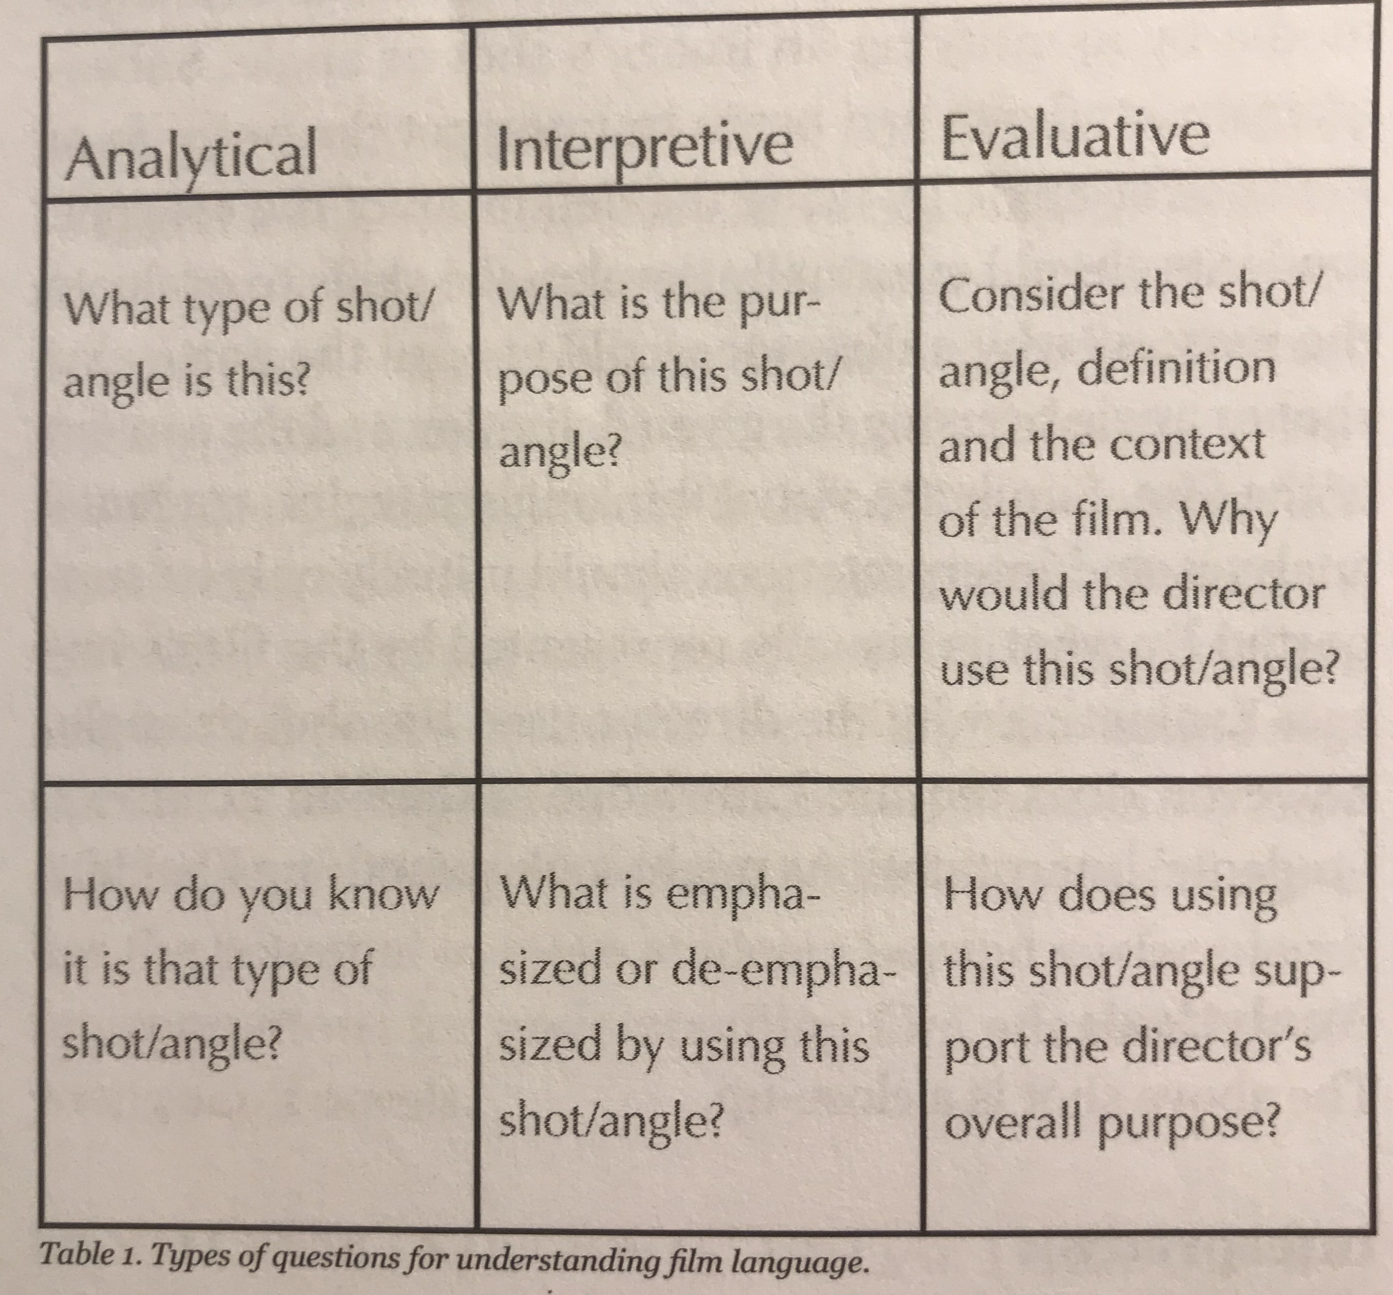
Taking it further:
1. Book to Film: Incorporating the film adaptation of the novel continues to allow students to see the theme of humanity versus the individual visually. Students will learn how social constructs interpret characters and how these build and societal norms play into the theme of the unit. This assignment also helps develop a student’s media literacy. A film vocabulary sheet will be provided so that students can have a reference to film terminology. According to Kathy Garland, who wrote an article in the SIGNAL Journal entitled, “Re-Viewing Popular Film Adaptations of Young Adult Literature Using Three Contemporary Literacy Strategies,” students need to gain “visual thinking strategies” to support “students’ interpretations” (20). The questions that visual thinking strategies allow students to ask see the directors purpose compared to the authors and why this is significant (Garland 21). Students will be provided with a table that allows them to analyze, interpret, and evaluate the camera angles and how the camera angles show different aspects of the novel that would have been difficult to visualize without that visual. For example, for students how does the director convey Ralphs dream and vision? How the director convey the tone and mood of the characters. Bryan Gill, who also wrote an article in the SIGNAL Journal entitled “Connecting YA Literature and Film.” states, “Mood and tone in fiction are controlled primarily through narration.” For students, this might be difficult to grasp. However, using film, Gills states that lighting, angles, and sound allow students to visually see the characters mood and the tone the author is trying to convey (9). “This method for teaching students film language provides them with tools for ‘reading’ popular culture films” (21). This project aims to allow students to improve their visual analysis skills. It is a more refined version from the beginning of the unit where students practiced using visual analysis skills to analyze the YouTube videos.
Table 1. Kathy Garland SIGNAL Journal p.22

2. Literary Analysis: Students would expand on their understanding of the individual in a dystopia by reading one paired novel of their choice. These novels share similar themes to the book of Lord of the Flies.

The Hunger Games by Suzanne Collins: This novel follows a strong and independent 16-year-old girl named Katniss Everdeen. Katniss must use her hunting and survival skills as she participates in the annual “Hunger Games.” A televised event where one boy and one girl, called Tributes, are taken from each of the twelve districts and must fight for their life. Within the Hunger Games Katniss must decide between survival is worth her loss of innocence and control. As Katniss switches from one community to another, she learns to adapt to her surroundings. Students will determine how Katniss’s role changes in different settings and how that affects her outcome in the Hunger Games.

Divergent by Veronica Roth: Beatrice Prior lives in the dystopian world of Chicago. Society divides into five factions that are devoted to particular virtues. All sixteen-year-olds must be appointed to a faction and spend the rest of the lives on it. Beatrice must decide if she wants to stay with her family or be who she truly is. Beatrice must undergo extreme changes, like her name, which she changes to Tris. Tris is faced with challenges as she struggles with the choice she made. Students will see how there is no freedom of individuality in this dystopian world. Students will analyze how Tris navigates as an individual through this strict world.
Synopsis paraphrased from Veronica Roth’s website:
https://veronicarothbooks.com/books/divergent/

The House of Scorpion by Nancy Farmer: Matt is a young boy who is confined in a cottage on the estate of El Patró n’s, a 146-year-old drug lord. This estate lays on a land, known as Opium, the main product, between the U.S.A. and Aztlán, a place that was once called Mexico. Matt finds out that he is a clone of El Patrón and is his body are parts are used for El Patrón’s survival. With the help of Matt’s bodyguard, Matt escapes from Opium, but these troubles continue as he imprisoned by a brutal labor camp for orphaned boys. However, that is not the end of Matt’s troubles. He is imprisoned in a brutal labor camp for orphaned boys. The themes that this novel illustrates allows students to see how humanity effects certain characters like El Patrón and Matt. El Patrón desires to live forever, but students will analyze why El Patrón feels this way. Students will analyze how Matt’s individualism is sacrificed.
Synopsis paraphrased from Nancy Farmer’s website:
https://www.nancyfarmerwebsite.com/house-of-scorpion.html

The Giver by Lowis Lowry: A boy named Jonas lives in a somewhat sheltered community with his father, mother, and his younger sister. This community regards age as extremely important, tracking each boy and girl with various labels based on their age. At age twelve, Jonas is given the job of a “Receiver,” a prestigious position that must learn and keep the memories of the past. He begins training with the previous “Receiver,” known as the “Giver.” The “Giver” transfers memories to Jonas by touch, and Jonas starts experiencing different emotions and experiences that are absent from his community. These emotions and experiences trouble Jonas. Not knowing what to do with this knowledge, Jonas decided to take a newborn and run away from his community. Jonas finds a society that has elements of a Utopia.
Synopsis paraphrased from Lowis Lowry’s website:
http://www.loislowry.com/index.php?option=com_djcatalog2&view=item&id=17:the-giver&cid=4:the-quartet&Itemid=185

Scar Island by Dan Gemeinhart: I have not read this novel, but it was introduced to me by Dr. Warner. This novel follows a group of boys that are left alone at a Reformatory school for troubled boys. Without the supervision of adults, the boys are free to run rampant on an entire island. But this freedom also comes with danger. Jonathan Grisby, who is the newest arrival, is left to save the boys from destruction. This novel is similar to Lord of the Flies, and students can use these similarities to analyze how the small community on the island creates a society.
Synopsis paraphrased from Dan Gemeinhart’s website:
http://dangemeinhart.com/scar-island/

Closing Activity: After the unit is complete, the overall goal is that students will have new insights into their current society. They will be able to see how their individuality and own characteristics shape how they fit within their community. Students will also be able to see how a dystopian society is not too different from their current community, and the themes presented in William Golding’s Lord of the Flies can be seen in current issues today.

1. Students will write a brief reflection essay on which character they related to the most in Lord of the Flies. They will determine if they fit the role of a leader like Ralph or jack or if they fit the role of a lieutenant like Piggy or Roger. After the class will share with everyone why they feel like their part is essential in their world.

Works Cited
Bioshock. 2K Boston, PlayStation 3, 2018.
Bowie, David and Queen. “Under Pressure.” Soul Brother, Mountain Studios, 1981.
Brooker, Charlie, creator. Black Mirror. Zeppotron Productions, 2011. Netflix.
Borderlands. Gearbox Software, PlayStation 3, 2019.
Collins, Suzanne. The Hunger Games. NY: Scholastic, 2008.
Crane, Stephen. “I Stood Upon A High Place.” http://famouspoetsandpoems.com/poets/stephen_crane/poems/13293. Accessed 21 Nov. 2019.
Dunbar, Paul L. “We Wear the Mask.” https://www.poetryfoundation.org/poems/44203/we-wear-the-mask. Accessed 21 Nov. 2019.
Elbow, P. (1994). “Writing for learning--not just for demonstrating learning.” University of Massachusetts, Amherst, 1-4. National Teaching and Learning Forum. http://www.ntlf.com/html/lib/bib/writing.htm
Farmer, Nancy. The House of the Scorpion. Atheneum Books for Young Readers, 2013.
Garland, Kathy. “Re-Viewing Popular Film Adaptations.” SIGNAL Journal, vol. 34, no. 2, 2011, pp. 19-24.
Gemeinhart, Dan. Scar Island. Scholastic Press, 2018.
Gills, Bryan. “Connecting YA Literature and Film.” SIGNAL Journal, vol. 34, no. 2, 2011, pp. 7-12.
Golding, William. Lord of the Flies. Spark Publishing, 2014.
Graham, Jake. “DYSTOPIA. Common Characteristics & Examples in Popular Culture.” YouTube, 2 Dec. 2016, https://www.youtube.com/watch?v=489al7lGy0I
H.D. “Huntress.” https://poets.org/poem/huntress. Accessed 21 Nov. 2019.
Kayla, “A stain in the darkness (Found Poem, Lord Of The Flies).” Teenink Magazine, 25 Mar. 2010. http://www.teenink.com/poetry/all/article/194078/A-stain-in-the-darkness-Found-Poem-Lord-Of-The-Flies/
Lowry, Lois. The Giver. Houghton Mifflin, 1993.
Okada, Takuya. “Children.” YouTube, 30 Jun. 2011, https://www.youtube.com/watch?v=BE4oz2u6OHY
Romano, Tom. Blending Genre, Altering Style: Writing Multigenre Papers. Boynton/Cook, 2000.
Roth, Veronica. Divergent. HarperCollins Publishers, 2016.
Serling, Rob, creator. The Twilight Zone. Cayuga Productions, Inc. and CBS Productions, 1959.
Stephens, James. “The Shell.” http://www.poetryexplorer.net/poem.php?id=10031393. Accessed 21 Nov. 2019.
Trenholm, Doreen. Classroom Observation. 6 Nov. 2019, and 12 Nov. 2019.
WALL-E. Directed by Andrew Stanton, Jim Morris, John Lasseter, and Pete Docter, Walt Disney Pictures, 2008.
.

