Katherine Eleogo
ENGL 112B
Dr. Mary Warner
November 25th, 2019

History and History Makers: Of People and Places
Rationale of Genre
World history, despite being a fundamental subject in the American Education System, is greatly overlooked by in the perspective of a young middle or high school student. It is easy to disregard events of the past and find trouble in the appeal of repetitive discussion about the ways our nation has developed and succeed over time. However, through my own experience of reading diverse historical fiction, I have learned that visualizing a character in a particular historical setting provides a more solid memory of that time in history, while simultaneously allowing a greater perspective as to how environmental, societal and cultural factors in that era play a significant role in the storyline. Personally through my undergraduate studies at San Jose State University, learning history through literature helps cement the vastly differing experiences of what it was like for oppressed individuals or communities living under a particular political regime or specific cultural history. Historical fiction and non-fiction also allows readers to challenge initial beliefs taught about the development of America, and establish their own personal interpretation of both the beautiful and ugly events often overlooked in history that also contributed to early America’s success and economic prosperity.
When a specific setting is integral to the story, the actions, thoughts or beliefs of a character can be better understood and analyzed. Readers of historical fiction novels are challenged to dissociate themselves from the comfortability of their present-setting and delve off into a time far away, where life and people function differently in concordance to values and beliefs that fulfil purposes unfamiliar to them. American author, Valerie Tripp, writes that historical fiction is more effective in engaging students with history because “it uses emotion to make the facts matter” (“Vitamins in Chocolate Cake: Why Use Historical Fiction in the Classroom?”, 2011). Through historical fiction, readers are able to develop empathy, compassion, and connection with others who are significantly alike or even harrowingly dissimilar. In a time where discrimination and societal and cultural indifferences deluge human equality, historical fiction exists in part to remind us that although history is bound to repeat itself, we must look back on times of struggle, discrimination, loss, death or any other historical malady and work together to do better than our previous populations and encourage peace and equality in order to thrive as a nation.

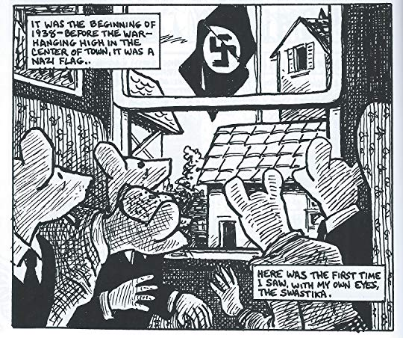
Annotated Bibliographies
1) MAUS by Art Spiegelman

Summary:
MAUS is about an aspiring cartoonist by the name of Art, who interviews his father, Vladek, about his experience as a Jew during the Holocaust. Through Vladek’s stories, Art realizes the physical and psychological effects of the war on both of his parents and the legacy of survivor’s guilt throughout their family’s generations.

Evaluation:
Because the graphic novel provides a greater, more personal understanding of how much Jews suffered and lost during the Holocaust despite temporal distance, the book demonstrates Exeter Quality 6. As Art begins to understand the justifications behind Vladek’s eccentric behaviors, he realizes his father’s frugalness, urgency and constant irritability and awareness are a manifestation of the ongoing war that exists within Vladek. The graphics, in addition to the text, further depict the struggle of mending the emotional and historical disconnect between Art, Vladek and his mother Anya, and exemplifies overcoming significant death and loss, violence, discrimination and abuse during the Holocaust.

Spiegelman, Art. MAUS, vol. 1-2. Pantheon Books, 1980-1991.

2) Drown by Junot Diaz
Summary:
Drown is a collection of short stories about an immigrant family from Dominica struggling to assimilate in America in the 1980s. The narrator varies with each short story, however the main narrator is the now-older Yunior de la Casas looking back on his time as a teenager in America, after his absent father succeeds in bringing his mother Virta, brother Rafa, and sister Madai to New York from Santo Domingo. Despite leaving the Dominican Republic to create a life full of success, wealth and familial prosperity, the stories depict the different forms of familial, emotional, individual and socio economic hardships the characters face each day.
Evaluation:
Through the stories depicted in Drown, the pursuit of security for oneself and their families comes at a significant cost if you weren’t born in America. Familial, financial and even psychological struggles are exponentially heightened for immigrants as they try to integrate into a society that only functions to exploit their desirability for a better life and take advantage of their limitations. Furthermore, As Yunior looks back on his personal development in his adolescence, he finds that the misogyny, aggression, abuse, hyper sexuality and poverty he’s seen and experienced as a teen were fundamental to the making of his own individual identity, mirroring Exeter Quality 7. This novel also reflects Exeter Quality 1 because although the main focus is on the de la Casas family, the varying narrators with each short story illustrates the idea that many immigrant families in real life experience similar personal and economic obstacles as Ramon, Yunior, Rafa and Virta. In a time where immigrants are being targeted and heavily discriminated against, the novel provides an inside perspective on the lives of immigrants who sacrifice their lives and families to become part of the American workforce and hope for a better life.
Diaz, Junot. Drown. Riverhead Books, 1996.

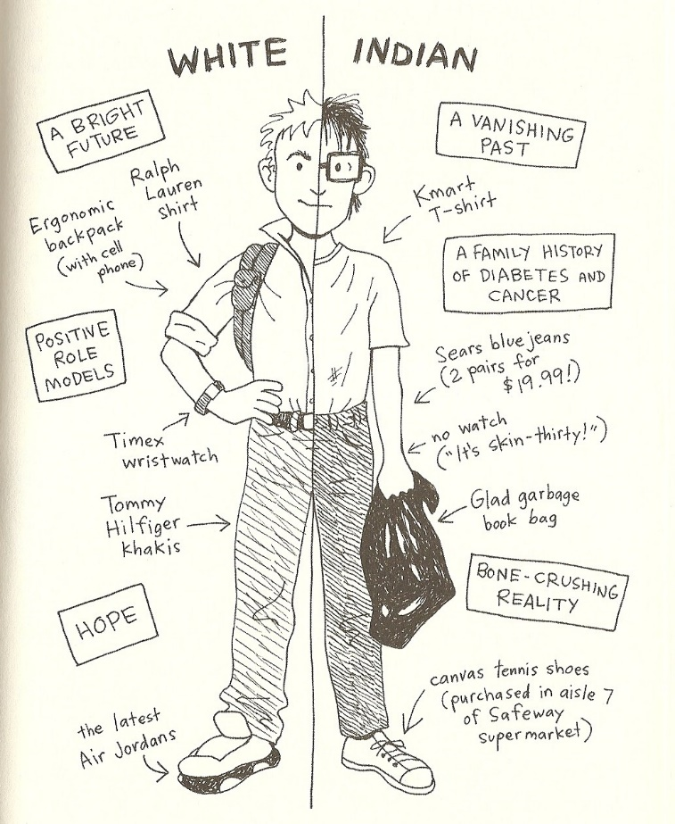
3) The Absolutely True Diary of a Part-Time Indian by Sherman Alexie
Summary:
The Absolutely True Diary of a Part-Time Indian is about a young boy named Arnold Spirit Jr., Junior for short, who lives in the Spokane Indian Reservation in Washington. Complications from hydrocephalus as a baby isolate Junior from the rest of the Indians on the reservation, and after being told by his teacher that there is no life or hope staying in the “Rez,” he decides to go to a school in Reardan in an all-white town twenty-two miles away. The novel depicts Junior’s struggle with balancing a dualism of two very different lifestyles; in the Rez, Junior is friendless and lonely, but in Reardan, he is a popular strong, outgoing and well-respected basketball player.
Evaluation:
The Absolutely True Diary of a Part-Time Indian provides an integration of life on a Native American Reservation and its contributions to one’s own bildungsroman. Exemplified through outdated Western films and biased history, Indians have always been portrayed as an underdeveloped nation, living and looking primitively even in contemporary settings. However, the history behind Indian socioeconomic disparity is directly linked to the perpetual oppression and lack of aid from the American government. Junior’s humorous depictions of the immense poverty, alcoholism and depression illustrated within the Spokane Reservation reflects an important spiritual function in Native American Literature, while accurately portraying Reservations in real life. And as Junior navigates his childhood around the limitations on the Reservation, he grapples with vacillating between two different identities, illustrating Exeter Quality 7.
Sherman, Alexie. The Absolutely True Diary of a Part-Time Indian. Little, Brown and Company,
2007.

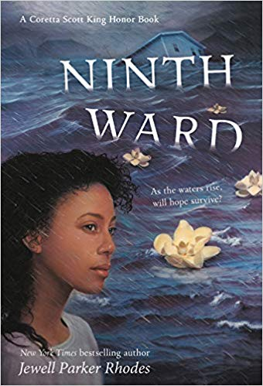
4) Ninth Ward by Jewell Parker Rhodes

Summary:
Ninth Ward follows twelve-year-old Lanesha living in a historically impoverished section of New Orleans when Hurricane Katrina hit Louisiana. Living only with her ill grandmother, Mama Ya-Ya, the story follows Mama Ya-Ya and Lanesha’s harrowing struggles for survival when the levee breaks and Hurricane Katrina floods the Ninth Ward. As her home and neighborhood floods, Lanesha and her friend TaShon fight for their lives. The spirit of Lanesha’s dead grandmother and mother ultimately help save Lanesha and TaShon when they are forced to break out the roof, but drown when they untie a boat from a tree. After retrieving the boat, Lanesha and TaShon row until they reach the Martin Luther King Bridge, where a rescue team is waiting to help survivors.

Evaluation:
Told through the perspective of young Lanesha, Ninth Ward provides significant imagery that is representational of what Hurricane Katrina was like for the poorer communities when the levee broke in 2005. Lanesha not only deals with the loss of both her mother and grandmother, she is forced to make quick life-or-death decisions during one of the most significant natural disasters in American history. Utilizing what she learned in school when faced with urgency is significantly applicable to Exeter Quality 4. Furthermore, the use of magical realism to foreshadow the hurricane and Lanesha’s rescue is a great example of Exeter Quality 5 and 6.

Parker Rhodes, Jewell. Ninth Ward. Little, Brown and Company, 2010.

5) Nervous Conditions by Tsitsi Dangarembga

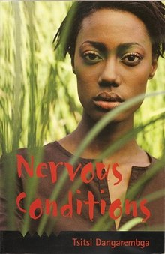
Summary:
After the death of her brother, Nhamo, Tambu is able to attend a missionary school in Zimbabwe and receive the elite education she’s always dreamt about. Coming from an exceptionally conservative lifestyle, the new school and her uncle’s younger and English-educated children constantly challenge the traditional values of Shona culture. Throughout the novel, Tambu is faced with establishing where her identity lies within the indigenous customs that oppress her individuality and the Westernized society that provides her the opportunity and freedom she longs for.

Evaluation:
Nervous Conditions displays Tambu’s struggle to assimilate in a time where Africans seldom received any type of education and are heavily discriminated against by white Europeans. The major conflict that Tambu has when trying to navigate obtaining an exemplary education and preserving her native culture during colonialism in Africa mirrors Exeter Quality 7, and provides insight into the gender and cultural inequalities occurring in Africa during the 1960s and 1970s wherein Shona women never worked outside of their domestic roles and even elite and educated Africans were treated poorly.

Dangarembga, Tsitsi. Nervous Conditions. The Women’s Press, 1988.

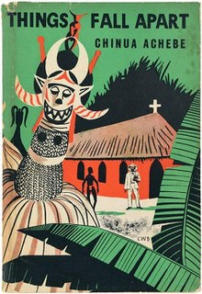
6) Things Fall Apart by Chinua Achebe

Summary:
Things Fall Apart is a novel about Umuofia village leader named Okonkwo, famous among his people for his strength and manliness, who is exiled for the murder of a villager’s daughter. During his exile, Okonkwo learns that Christianity and British missionaries are slowly taking control of his people and aim to diminish his culture. Okonkwo returns to his village in hopes to establish a mutiny and inspire the Igbo people to resist. However, Okonkwo realizes The Igbo’s indifference to revolt against the British and ultimately commits suicide, forever exiling him from the Igbo culture.

Evaluation:
Although Okonkwo is a fictional character, Things Fall Apart provides an extremely accurate history behind the true decline of the Igbo people in Africa during colonialism. The novel provides diversity within literature and also allows a perspective into the difficulty of resistance in African villages under oppression, displaying Exeter Quality 6. The novel also illustrates identity issues for Africans during a time of transition and massive discrimination. Furthermore, the books reveals psychological effects of colonialism and slavery in African diaspora and foreshadows the legacy of trauma inherited by its descendants.

Achebe, Chinua. Things Fall Apart. Heinemann Ltd., 1958.

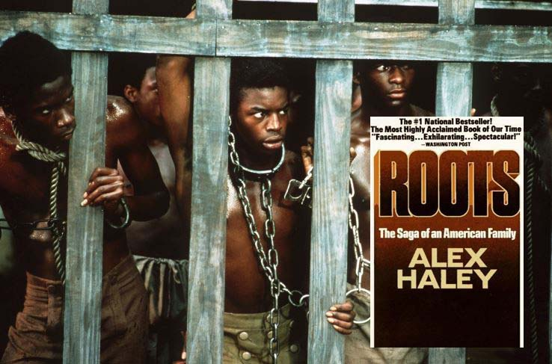
7) Roots: The Saga of an American Family by Alex Haley

Summary:
Roots follows Kunta Kinte, later named Toby by plantation slave owners, who is stolen from his home in Gambia at seventeen and is sold as part of the Trans-Atlantic Slave Trade. The book follows Kinte and the lives of his descendants in the United States all the way down until its lineage connects to Alex Haley, author of the book.

Evaluation:
Through the family reunion of Alex Haley to Kunta Kinte, Roots connects the bridge between slavery in Africa, overseas, through time and into contemporary America. In addition to the reader’s knowledge of the history of slavery from the early 1600s to the nineteenth century, the story of Kunta Kinte’s generational line provides readers with a figure to visualize the expansive powers of the Trans-Atlantic Slave Trade and its horrific and detrimental ramifications to black people in America throughout history, mirroring Exeter Quality 1. The novel portrays genocide, rape, and the dehumanization of slaves, however sheds light on a very dark and disturbing, yet sadly foundational, aspect of a history that is deeply rooted into the development of America.

Haley, Alex. Roots: The Saga of an American Family. Doubleday, 1976.

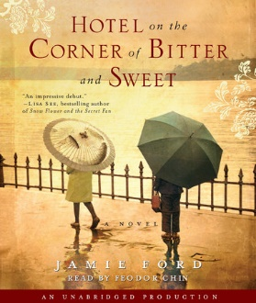
8) Hotel on the Corner of Bitter and Sweet by Jamie Ford
Summary:
Hotel on the Corner of Bitter and Sweet is about a Chinese-American man named Henry Lee, who during WWII, loses contact with his first love and best friend, Keiko, after she is shipped off to Japanese internment camps. Now older, Henry sees on TV that an old hotel in Seattle discovers it is hoarding possessions left behind of Japanese families who were evacuated during the war. Immediately thinking of Keiko after all those years and remembering the difficulty it was to be a Chinese-American in WWII, Henry his son and fiancé work to reunite Keiko and Henry together and pick up where they left off as children.
Evaluation:
The novel reflects Exeter Quality 1 as it is told through a difference of two timelines -- one when Henry is older and widowed, and another where Henry is young and in love with Keiko in a time where they are both discriminated against due to their appearances. Through Keiko’s immediate detachment from Henry, the novel symbolizes the effect of WWII and how discrimination towards Japanese people resulted in a quick dissolution of friendships and love. The love story of Henry and Keiko represent overcoming loss, discrimination and illustrate the importance of family and peer relationships to young children.
Ford, Jamie. Hotel on the Corner of Bitter and Sweet. Ballantine Books, 2009.
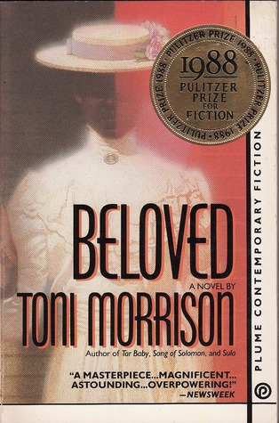
9) Beloved by Toni Morrison
Summary:
The novel follows a mother named Sethe, a former slave, and her daughter Denver after they flee to the Free State Ohio in 1873. Sethe and her family believe they are being haunted by a ghost whom they name Beloved, supposedly Sethe’s eldest daughter who she previously killed during her recapture to prevent her daughter from being enslaved. The presence of Beloved taunts Sethe and her family and results in Sethe’s ultimate depletion for life after Beloved disappears.

Evaluation:
Beloved provides an inside lens on the traumatic and psychological effects of slavery, even after they are freed, allowing the book to fall into Exeter Quality 6. The idea that Sethe becomes delusional upon Beloved’s arrival, and Denver integrating her identity with her dead sister is representational of the massive loss of identity experienced by slaves after years of torture, dehumanization and learned worthlessness. The novel demonstrates topics surrounding identity issues, loss, and death.
Morrison, Toni. Beloved. Alfred A. Knopf Inc., 1987.

10) The Boy in the Striped Pyjamas by John Boyne
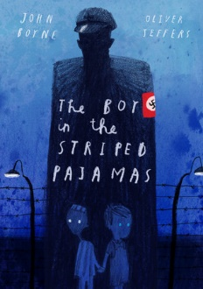
Summary:
The Boy in the Striped Pyjamas follows the friendship of Bruno, the son of a Nazi Commandant, and Shmuel, a young boy in a Jewish concentration camp. After meeting by a barbed wire fence and becoming close friends, Shmuel and Bruno agree to sneak Bruno into the concentration camp to help Shmuel find his mother with whom he’s separates from upon arriving to Auschwitz. Bruno and Shmuel unknowingly walk into a gas chamber, and a year after his disappearance, Bruno’s father pieces together the reason for his son’s disappearance.
Evaluation:
The novel is extremely important when it comes to the basis of racism and discrimination. In a time where Bruno and Shmuel are meant to hate and oppose each other, they become each other’s best friend, signifying that one’s prejudices and bias beliefs are taught and not innate. The story of Bruno and Shmuel’s friendship above the normalities of their social expectations are a great illustration of Exeter Qualities 6 and 7. The deaths of Bruno and Shmuel are indicative of an era where death and loss were executed in masses, without due diligence or sympathy. The disheartening novel navigates around topics of discrimination, loss, innocence, child-like courage and love in the face of war and death.
Boyne, John. The Boy in the Striped Pyjamas. David Flicking Books, 2007.

Works Cited
Tripp, Valerie. “Vitamins in Chocolate Cake: Why Use Historical Fiction in the Classroom?” Teachinghistory.org, Apr. 2011, teachinghistory.org/nhec-blog/24679.

URL links for book photos:
https://www.goodreads.com/book/show/15195.The_Complete_Maus
https://bookmarks.reviews/transfiguring-disorder-in-junot-diazs-drown/
https://storysailor.wordpress.com/tag/the-absolutely-true-diary-of-a-part-time-indian/
https://www.amazon.com/Ninth-Ward-Jewell-Parker-Rhodes/dp/0316043087
https://en.wikipedia.org/wiki/Nervous_Conditions
https://en.wikipedia.org/wiki/Things_Fall_Apart
https://newswithattitude.com/blog/day-history-alex-haley-awarded-pulitzer-prize-roots/
https://www.penguinrandomhouse.com/books/54454/hotel-on-the-corner-of-bitter-and-sweet-by-jamie-ford/
https://www.goodreads.com/book/show/6149.Beloved
https://www.penguinrandomhouse.com/books/545545/the-boy-in-the-striped-pajamas-deluxe-illustrated-edition-by-john-boyne-illustrated-by-oliver-jeffers/

