Marie Holley
English 112B
Dr. Warner
3 December 2018
Using The Outsiders to Help Teens Better Understand Outsiders
Rationale-
Of all the problems that teenagers face, I believe one of the most common is the fear of not belonging. From the isolated teen who feels excluded and suicidal, to the popular princess who is secretly starving herself in order to fit in with the pretty girls, it’s all the same problem - not wanting to be on the outside. I want to create a unit that explores how different people experience the same problem in order to increase kindness and inclusion among teenagers. I believe that realistic stories, be they books, films, songs or other mediums, can help people develop empathy for others. It is said that we fear the unknown, and hate can come from fear. However, if we get to know the unfamiliar, we can grow to like it and then fear and hate can dissipate. This is how storytelling contributes to the world. This is what matters to me.
This topic has a particularly personal hook for me. First, there’s my son, who is autistic and is often excluded. Whether the exclusion is unintended or malicious, it hurts just the same. My son gets hurt, I hurt for him, and the ones who exclude him are missing out on his awesomeness, so everyone loses in that scenario.
As for my personal connection to this topic, I didn’t have it much easier than my son when I was a kid. Growing up in LA, I was too White and American for the Hispanic kids around me. In Orange County, I was too Hispanic. In Argentina, I was too American. I was almost always too broke no matter where I was. But, my goodness, I sure do have some deep empathy for people who feel like they’re on the outside!
I’ve chosen S. E. Hinton’s The Outsiders as my centerpiece book. There are all sorts of reasons for people to be excluded, whether it’s racism, sexism, homophobia, or other. The problem in The Outsiders is classism, which is very real but not talked about as much. The novel is short and an easy read. The Lexile level says it’s appropriate for ages 12-16. I was 12 the first time I read it and it gripped me tightly. I cried for days and days after reading it. I used to sneak it into my math class and hide it in my lap to read it. My heart broke for all those boys. Last year I read it with the 8th graders in my book circle and they loved it, too. I found it just as moving, if not more so now that I can see if from adult eyes. The film has an amazing cast and would be a great compliment to the unit.
Briefly, the story is about two groups of teenagers who live in the same town and go to the same school. They also all seem to be mostly the same race. The problem is socio-economic status. The Socs, (pronounced soh-shez) short for Sociables, are the more affluent kids who seem to have everything. The Greasers, called so because of the hair products they use to slick back their hair, are the kids who struggle to make a living. Some of them don’t have parents, some of them are abused. The two groups clash and real drama ensues.
Because of how easy it is to read this book and how likeable the characters are, this book would work well in a Unit of Study anywhere from seventh grade through tenth grade. The factors that would determine grade level would be the difficulty and rigor expected from the accompanying activities and the choice of supplemental materials. I will present this unit as if I were teaching a tenth grade class.
Introducing the Unit-
I would not introduce this unit until after the the class had been meeting for at least a few weeks and some relationships and trust had been established. I would first show Alessia Cara’s music video “Scars to Your Beautiful.” https://www.youtube.com/watch?v=MWASeaYuHZo I would explain that we’re looking for the types of problems that each featured person in the video may have. I’d ask if the problems are always obvious, hopefully getting to the point that even people who seem perfect on the outside struggle with something. I’d have students do a 5 minute quick write in their writing journals about the secret hurts that people hide, whether they be the students’ personal hurts or those of others. They could address whether they see people in their school or family who suffer from these issues. Then I’d have table groups discuss some of the things they came up with for another 5 minutes, without obligating them to say anything too personal to each other. I’d then lead a class discussion in which groups share some of the issues they came up with. We’d then expand the concept a little and ask how it would affect an entire group or community if some of those issues affected them as a whole, such as living in a less affluent part of the neighborhood within the school boundaries, or looking a certain way based on race or religious clothing.
Now I can introduce The Outsiders. I would give them some background on the story and setting and explain the expression about being “from the wrong side of the tracks.” The teacher I observed, Susan Leftwich, taught Of Mice and Men in her 8th grade class. I really liked her whole unit, so I want to make mine similar. She had her students read the book aloud, as our class did with Witness. Ever since I was in high school, I’ve always believed that I would have my students read aloud if I ever had my own class. This would help me identify who may have slipped through the cracks versus who is extremely adept at functioning at a lower reading level and hiding it. I also feel that reading aloud increases student engagement. In my own high school experience, I witnessed several people who had slipped through those cracks. Maybe it was the type of school I went to, maybe these things don’t happen so much anymore, but it’s an idea that’s always been with me. Likewise, I saw several students blossom and break out of their shyness when they were able to act from their seats in a class, students who would never audition for the school play but who love reading out loud. Mrs. Leftwich had the same students keep the same character roles throughout the entire book, but I think I would have them rotate the roles in order to spread out the opportunity a little more evenly.
Since the book is short and easy to read, we would read the whole thing in class, out loud. I had already planned on showing the film The Outsiders when I saw Mrs. Leftwich show Of Mice and Men in little bits as the class read the book. I thought this was pretty great because it spoiled neither the book nor the movie since they were doing the two together. However, she had a block schedule and I don’t know how this would work if I only had the kids for 50 minutes at a time. If it’s possible, I would prefer to show the film in small sections.
At the start of each new day during the unit, I would ask the students to do a quick write in their journals based on the previous day’s reading. Some questions might be, “What are some of the similarities that you find between the novel and things that you’ve experienced in your own life?“ “Which lines stand out for you and why?“ “Discuss anything that any particular character has said or done that bothered you? Why?” “Name any similarities between this novel that is set in the 1960s and things that are happening in your world today?” Again, table groups could discuss their thoughts. Then we would read until the next good stopping point, where we would then watch that section of the film. This would continue until we concluded both the book and the film.
During the reading and watching of The Outsiders, other activities would be inserted into the unit.
- One of the activities I saw during my observations was symbolic posters that the small groups made. Each group picked a character from the story. They chose key words and props to describe something about that character. This activity would appeal to the artistic, visual learner.
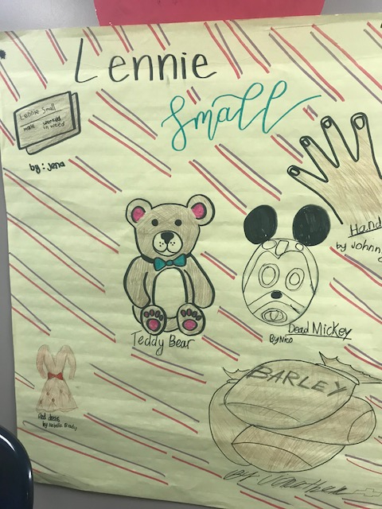 | 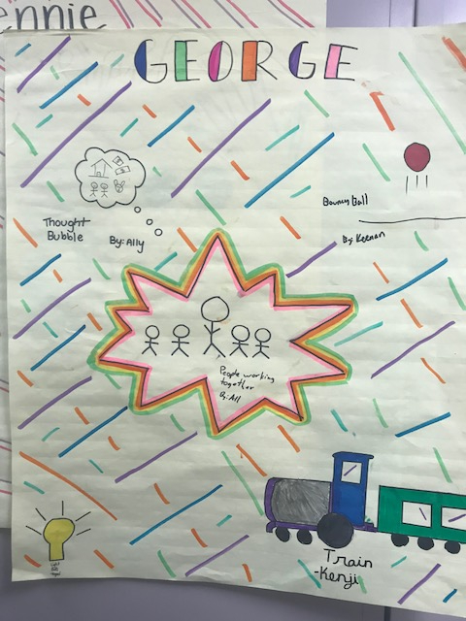 | 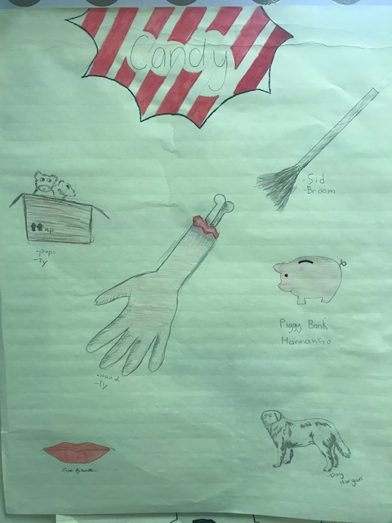 | 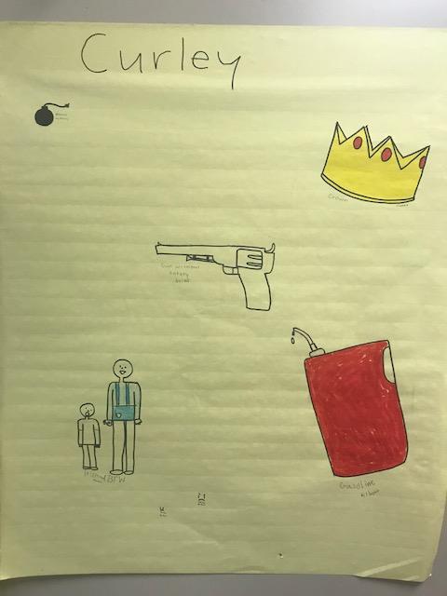 | 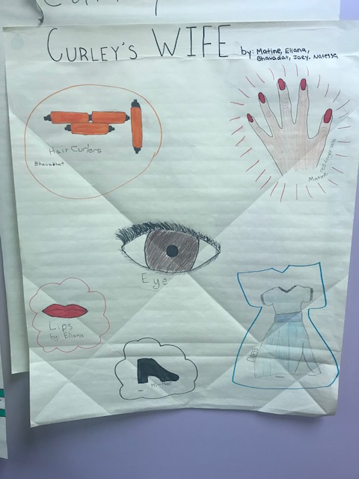
- Another activity could occur just after the part of the book that features Robert Frost’s poem, “Nothing Gold Can Stay.” The students could write an “I Am” poem about themselves, then another ”I AM” poem in the voice of one of the characters from the book.
- In lieu of the “I AM” poem, the more daring students could write a monologue for one of the characters and perform it. These activities would serve those with linguistic, existential and inter and intrapersonal intelligences.
- Another option could be to have the students create a musical playlist for one of the characters, or even write a song for or about the character. Performing the song would be going the extra mile. This would stimulate the musical as well as the linguistic intelligences, not just of the student who performs the song, but also everyone who hears it.
- Of course, at some point near the end several members of the class would act out a few key scenes from the book. This would satisfy the kinesthetic and spatial intelligences, and even the naturalist intelligence if the scene takes place in nature.
- After the class finishes reading and viewing the story, I’d like to have them do a type of press interview activity, where some students are the reporters and the rest form a panel as the characters. This would put the students on their toes and have them thinking improvisationally. (Kaplan, Jeffrey. “Acting Up Across the Curriculum: Using Creative Dramatics To Explore Adolescent Literature.” ALAN Review. Spring 1997 Volume 24.3 (1997) 42-46)
In a perfect world, there would be a production of West Side Story playing somewhere locally and I would take the students on a field trip to see it. It would be even better if the school’s drama program were performing it, and even more exciting if some of my students were in it. But if those options are not available, I would have the class watch the film and then do a comparison of the two works, first with a Venn Diagram and then a short paper. Even though West Side Story is based on Romeo and Juliet, by William Shakespeare, I would not have the class read Romeo and Juliet at that time. Firstly, the students will most likely have to read the play at some point in their school careers if they haven’t already. But more to the point, in Romeo and Juliet, both Montague and Capulet families appear to be distinguished and well off, whereas the Jets in West Side Story are akin to the Socs and the Sharks could be the Puerto Rican cousins of the Greasers.
After reading The Outsiders, I would introduce a few other books that fit into my topic of increasing empathy through understanding. I would have the students split into small groups based on which book they choose and have them work together to create a presentation for the class about that book. The presentation would be a book talk that includes performances of key scenes by the students. The groups would need to include discussion and clips or quotes from at least two of the following three options - one song, one poem and one film or play (not based on the book they read) which connects to their book choice and helps the rest of the class understand the book a little better.

Book Pairings
Mexican White Boy, by Matt de la Peña  Danny’s brown. Half-Mexican brown. And growing up in San Diego that close to the border means everyone else knows exactly who he is before he even opens his mouth. Before they find out he can’t speak Spanish, and before they realize his mom has blonde hair and blue eyes, they’ve got him pegged.  Danny’s convinced it’s his whiteness that sent his father back to Mexico. And that’s why he’s spending the summer with his dad’s family. Only, to find himself, he might just have to face the demons he refuses to see right in front of his face. And open up to a friendship he never saw coming. | http://mattdelapena.com/books/mexican-whiteboy/ Lexile 680L Ages 13-17
Nineteen Minutes, by Jodi Picoult  In nineteen minutes, you can mow the front lawn, color your hair, watch a third of a hockey game ...In nineteen minutes, you can get revenge. Sterling is a small, ordinary New Hampshire town (whose) complacency is shattered by a shocking act of violence. For them, the lines between truth and fiction, right and wrong, insider and outsider have been obscured forever. What does it mean to be different in our society? Is it ever okay for a victim to strike back? And who -- if anyone -- has the right to judge someone else?  (*Could be triggering for some.) | 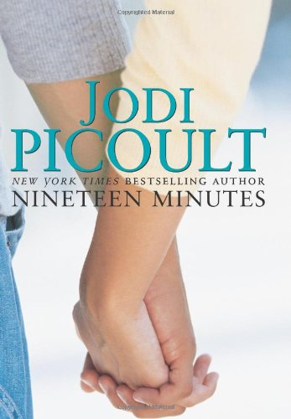https://fab.lexile.com/book/details/9780743496728/ Lexile 840L Ages 14-18+
Whale Talk, by Chris Crutcher  A group of misfits brought together by T. J. struggle to find their places in a school that has no place for them… The bus on which the Mermen travel to swim meets soon becomes the space where they gradually allow themselves to talk, to fit, to grow. Together they'll fight for dignity in a world where tragedy and comedy dance side by side, where a moment's inattention can bring lifelong heartache, and where true acceptance is the only prescription for what ails us. | 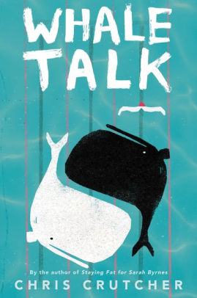https://www.goodreads.com/book/show/49746.Whale_Talk  Lexile 1000L
The Curious Incident of the Dog in the Nighttime, by Mark Haddon  Although gifted with a superbly logical brain, for fifteen-year-old Christopher everyday interactions and admonishments have little meaning. He lives on patterns, rules, and a diagram kept in his pocket. Then one day, a neighbor's dog, Wellington, is killed and his carefully constructive universe is threatened. Christopher sets out to solve the murder in the style of his favourite (logical) detective, Sherlock Holmes. What follows makes for a novel that is funny, poignant and fascinating in its portrayal of a person whose curse and blessing are a mind that perceives the world entirely literally. | https://www.goodreads.com/book/show/1618.The_Curious_Incident_of_the_Dog_in_the_Night_Time?ac=1&from_search=true  Lexile 1090L Ages 14-17
The Hate U Give, by Angie Thomas  16-year-old Starr Carter moves between two worlds: the poor neighborhood where she lives and the fancy suburban prep school she attends. The uneasy balance between these worlds is shattered when Starr witnesses the fatal shooting of her childhood best friend Khalil at the hands of a police officer. Khalil was unarmed.  What everyone wants to know is: what really went down that night? And the only person alive who can answer that is Starr.  But what Starr does — or does not — say could upend her community. It could also endanger her life. | 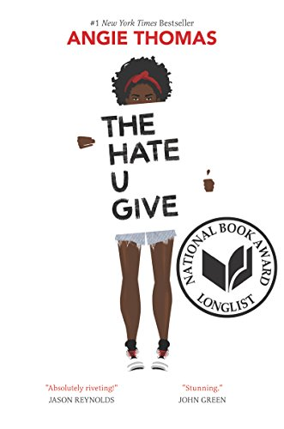  https://www.bookbub.com/blog/2018/02/15/books-like-the-outsiders-by-se-hinton  Lexile HL590L Ages 14-17
The Miseducation of Cameron Post,  by Emily M. Danforth  When Cameron Post's parents die suddenly in a car crash, her shocking first thought is relief. Relief they'll never know that, hours earlier, she had been kissing a girl.  But that relief doesn't last, and Cam is soon forced to move in with her conservative aunt Ruth and her well-intentioned but hopelessly old-fashioned grandmother. She knows that from this point on, her life will forever be different.  The Miseducation of Cameron Post is a stunning and unforgettable literary debut about discovering who you are and finding the courage to live life according to your own rules. | 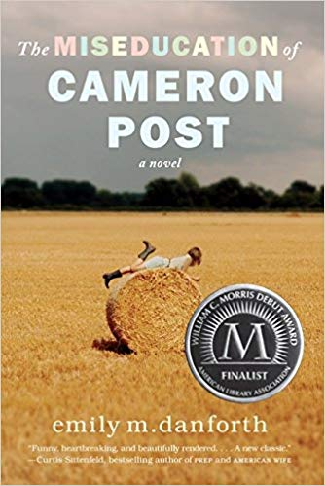https://www.amazon.com/Miseducation-Cameron-Post-emily-danforth/dp/0062020579  Lexile 1120L Ages 14-17

Honorable mention for other pairings:
The following list is part of my brainstorming for this project. Some of the books would be perfect for this unit in a middle school grade. Others, such as The House On Mango Street, will probably be required reading in a different class at some point. If time allowed, some of the other films and songs could also be shared with the students. Some of the songs I didn’t feature contain harsher language, or some of the music videos and some TV shows contained some more sensitive scenes, such as suicide and sexual content. Still, I’ve seen some of these work beautifully in classroom settings with the proper supervision. Perhaps the students themselves will discover and share some of these references during their own reports. This is just a tiny sample of all that is out there and all of the ideas I looked at.

Books  13 Reasons Why - Jay Asher  Out of My Mind - Sharon Draper  The Revealers - Doug Wilhelm  Wonder - R.J. Palacio  Staying Fat for Sarah Byrnes - Chris Crutcher  House on Mango Street - Sandra Cisneros  Stargirl - Jerry Spinelli  The Diary of a Young Girl - Anne Frank  Bronx Masquerade - Nikki Grimes  Prisoner of Tehran: A Memoir - Marina Nemat | Poems  “Buen Joven” - Armando Ayala (definitely use this together with We Were Here)  “She Only Wanted To Be Happy” Ecem Y  https://www.familyfriendpoems.com/poem/she-only-wanted-to-be-happy
Music  “What It’s Like” - Everlast  “I Will Buy You a New Life” Everclear  “Message in a Bottle” The Police  “I Dreamed a Dream” - Les Miserables  “Somewhere Over the Rainbow/What a Beautiful World” - IZ’s version  “Perfect” (radio and video version) - P!nk https://www.youtube.com/watch?v=K3GkSo3ujSY | Film  The Breakfast Club - John Hughes  Stand By Me - Rob Reiner  Edward Scissorhands - Tim Burton  Moonrise Kingdom - Wes Anderson  Sierra Burgess Is a Loser - Ian Samuels  Boyz in the Hood - John Singleton  Eighth Grade - Bo Burnham
TV  American Vandal Season 2 (Fruit Ninja) - Netflix  13 Reasons Why - Netflix | Plays  Les Miserables - Schönberg, Kretzmer, Nunn, Caird, Fenton
Comic Books/Graphic Novels  X-Men -Stan Lee  Spiderman - Stan Lee  Superman - Jerry Siegel, Joe Shuster | Other  Gang member interviews from jail on the web: https://news.streetroots.org/2016/05/05/youths-and-gang-life-their-stories-their-words

