Jonathon Cabello
12/01/18
YA Lit
Warner
Unit of Study: The Great American Novel
The Great Gatsby
Rationale
The Great American novel incorporates what it’s like to live in America during a certain period of time in our nation's history. Whether it’s Huckleberry Finn (set during the Civil War) or Catcher in the Rye (set post WWII) the main idea is that the essence of the American lifestyle is captured. John William DeForest defines the Great American Novel as, “the picture of the ordinary emotions and manner of American existence”. Certain novels in a way represent all of American society and represent all the complexities of such a nation. These novels provide insight on the culture of the United States during a specific point in our country’s history. Being able to make connections between what you’ve read and the history of the world around you dramatically changes how the story resonates with you.
Using The Great Gatsby as an example of the Great American Novel gives students an opportunity to bask in life during the Roaring 20’s. Universal themes are present throughout the story such as love and various types of power. It also weaves in relevant themes such as prohibition, changing position of women, etc. Introducing a novel of this caliber enables me to launch a discussion explaining what literary criticisms are to the students. I would spend a little extra time focusing on the historical criticism as that’s the one the kid’s will be using the most.
The Roaring 20’s was one of the most exciting periods in American history. The 1920’s was a period of economic prosperity in the United States. Productivity rose dramatically as assembly lines became more common. New industries in electronics and chemicals began popping up thus providing new products and more jobs. Companies were creating new labor saving devices like toasters and washers. This allowed Americans more time for leisure activities such as baseball games and dances. The Great Gatsby does an amazing job illustrating life during that era, putting emphasis on the American Dream. By the end of the unit I’m hoping for the students to leave with new literary terms, how to link history with literature, and a better understanding of the 20’s according to F. Scott Fitzgerald. Even though im taking the historical route the book is still very much a love story filled with internal battles. In chapter 8 of Literature for Today's Young Adults books on the topic of historical fiction in the United States are introduced. Some qualities that these category of books have include, “An author who is so thoroughly steeped in the history of the period that he or she can be comfortably creative without making mistakes. Also Believable characters with whom young readers can identify”(LfTYA, Ch.8).
Launching the unit
I would introduce the unit by first showing the class John Green’s “CrashCourse: The Roaring 20’s”. This super fun and interesting video that’s found on youtube basically gives a quick but detailed rundown in about 9 minutes. This would be great to start the unit with because the main focus of this unit is to find which ways history connects itself within the literature. So if the students already have a good understanding of the Roarin’ 20’s they should have an easier time finding connections between the book and history. To also get the students into the “20’s mindset” I will pass out two seperate sheets of paper. One is titled “The Jazz Age Glossary” and has a bunch of different words that they used in those times, which are now obviously out of date. Words like bronx cheer which is a loud derisive noise from an audience, and giggle water which is an alcoholic beverage. The next paper the students will receive is titled “1920 Slang Expression” and this paper is a collection of slang terms and their definitions. At this point I would have the students take out a sheet of paper and come up with 5 disses using 1920 slang. Then students 2 at a time will go in front of the class and have a diss off. From there we’ll see who used the slang in the most creative way. Before we start reading the story I will have the students first read a biography on F. Scott Fitzgerald and annotate it. As they’re doing that I would have them think about what the “American Dream” means to them. Before they leave I will hand out an article for homework titled, “F. Scott Fitzgerald and the Age of Excess” by Gilderlehrman and have them annotate it.
Centerpiece
The book we would be focusing on is The Great Gatsby by F. Scott Fitzgerald. The homework I would assign to the students would involve reading a few chapters a night and writing in a notebook any thoughts or themes you saw in the chapter. Then the following class day we will spend a nice amount of time talking about the chapters. I’ll also distribute a glossary of literary lenses and once a week they’ll need to write a paragraph on how a specific lens can be used in the story. We will discuss characters and their motives and what they’re saying about American Culture in the 1920’s. As we’re nearing the end of the book we will start answering some questions that require more thought. Some examples are:
Compare and contrast Gatsby’s social class with that of Tom and Daisy Buchanan. How does geography contribute to the definition of social class in The Great Gatsby?
Fitzgerald wrote, “You don’t write because you want to say something, you write because you have something to say.” What did he have to say in The Great Gatsby?
Expanding the Unit
After we’re done with reading the book we’ll have one more major discussion then watch the movie. To make sure the kids are paying attention i’m going to be handing out sheets of paper that says, “Things done well” on one side and, “Things done wrong” on the other. On the final discussion day we will discuss the following prompts:
(1) Go back and re-read the brief biography on Fitzgerald. Ask yourself what connections can I make between the author's life and the novel? What life experiences/people may have influenced his writing?
(2) Symbols are an essential element in this novel. How have they been used and in your opinion was it successful?
-The green light at the end of Daisy’s dock
-Gatsby’s shirts
-Owl eyes
(3) Do you think Jay Gatsby represents the American Dream? What do you think Fitzgerald is saying about the American Dream in the 1920’s? Is the novel a bad representation of the American Dream? Or did Fitzgerald defend it? Support your position with evidence.
They’ll also need to write a paper on how the American Dream was portrayed in The Great Gatsby and if it’s an accurate representation or not. As well as a few new things they learned about the Roaring 20’s.The last thing I will show my class is a song by Benjamin Gibbard titled “It’s Bigger Than Love”. This is a song that Mr.Gibbard had wrote inspired by Zelda and Fitzgerald’s relationship. This would be a super cool way of closing the unit up.

Additional Readings
The books mentioned in additional readings have to do with the 20’s and anything falling in that era.
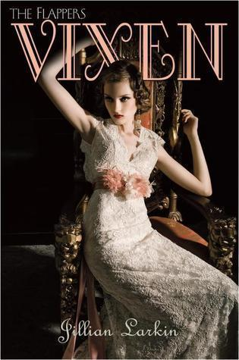
Just like every other girl her age 17 year old Gloria Carmody wants to live the flapper lifestyle. She gets engaged to a member of Chicago's most powerful family and has to put her flapper lifestyle on hold. While that's happening her good girl cousin Clara is home to help her with the wedding, but she’s up to no good despite her facade. Nothing is ever going to be the same in this funny, edgy, romantic read.
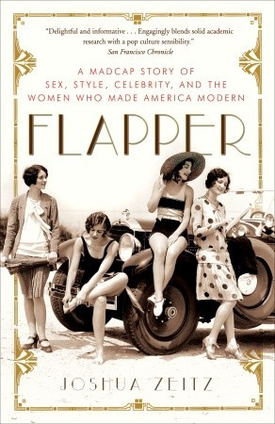
The women of the 1920’s controlled their own destiny, secured liberties, and had a newfound freedom. This is a story about a diverse group of men and women who made the flappers. The first sexual revolution and the right to pursue happiness, these women did it all for themselves. Flapper is a glance at the women who started the first truly modern decade.

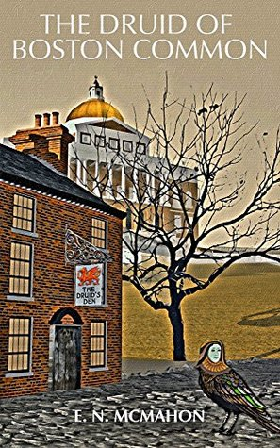
We’re in Boston 1924, era of prohibition, gangsters, and speakeasies. But these gangs don't use guns, they use magic. For 90 years Owen the Unimpeachable has kept peace in the land. But now he’s passed and it’s become a war zone. We have Al Costa who has a bunch of stolen munitions and a banshee wail that gives him the magic upperhand. We have Governor Channing Cox trying to restore the old ways of thinking. There’s only one man, Ben, who can bring back the peace, but he’s left the city long ago and was never gonna return.. Or so he thought.

Works Cited
Fitzgerald, F. Scott. The Great Gatsby. Charles Scribner’s Sons. 1925. Print.
Larkin, Jillian. Vixen. Delacorte Books for Young Readers. 2010. Print.
McMahon, E.N. The Druid Boston Common. Nick de Blegny Publishing. 2015. Print.
Zeitz, Joshua. Flapper: A Madcap Story of Sex, Style, Celebrity, and the Women Who Made America Modern. Broadway Books. 2007. Print.

