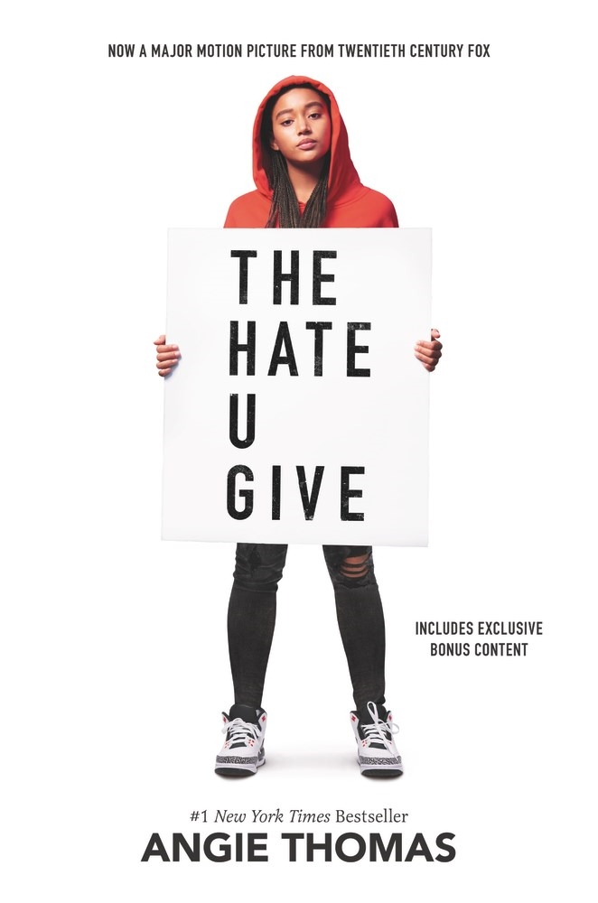Connie Nguyen
112B FALL ‘19
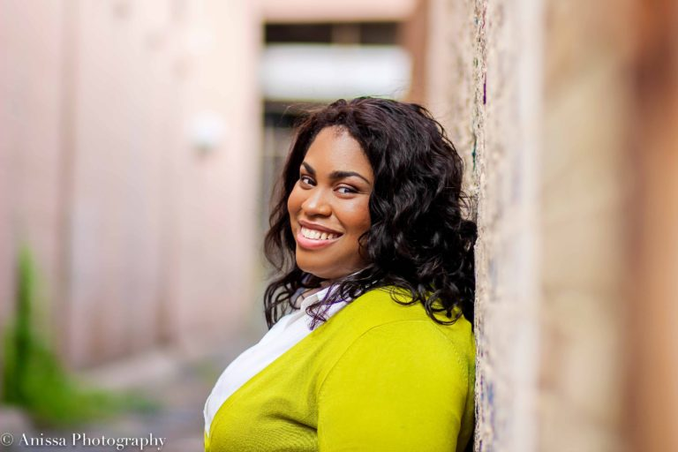
ANGIE THOMAS
- She is a former teen rapper whose greatest accomplishment was an article about her in Right-On Magazine with a picture included.
- Her award-winning, acclaimed debut novel, The Hate U Give, is a #1 New York Times bestseller and major motion picture from Fox 2000, starring Amandla Stenberg and directed by George Tillman, Jr.

https://angiethomas.com/

Significant Quotes

“I get out of the car. For at least seven hours I don't have to talk about One-Fifteen. I don’t have to think about Khalil. I just have to be normal Starr at normal Williamson and have a normal day. That means flipping the switch in my brain so I’m Williamson Starr. Williamson Starr doesn’t use slang - if a rapper would say it, she doesn’t say it, even if her white friends do. Slang makes them cool. Slang makes her “hood.” Williamson Starr holds her tongue when people piss her off so nobody will think she’s the “angry black girl.” Williamson Starr doesn’t give anyone a reason to call her ghetto. (71)”

- This quote is significant because it articulates the dichotomy of Starr’s origins and her perceived persona. She is extremely aware of the hypocrisy of her classmates’ attitudes and herself, and she understands that she is unable to act the way they act because she would be conforming to stereotypes. She has to put on a mask whenever she is at Williamson, because she knows her true self is not accepted.

“ ‘Brian’s a good boy,’ he says, in tears, ‘He only wanted to get home to his family and people are making him out to be a monster.’
That’s all Khalil and I wanted, and you’re making us out to be monsters.
I can’t breathe, like I’m drowning in the tears I refuse to shed. I won’t give One-Fifteen or his father the satisfaction of crying. Tonight, they shot me too, more than once, and killed a part of me. Unfortunately for them, it’s the part that felt any hesitation about speaking out.
‘How’s your son’s life changed since this happened?’ the interviewer asks.
‘All of our lives have been hell, honestly,’ his father claims. ‘Brian’s a people person, but now he’s afraid to go out in public, even for something as simple as getting a gallon of milk. There have been threats on his life, our family’s lives. His wife had to quit her job. He’s even been attacked by fellow officers.’ (247)”

- This quote happens when a news segment about the officer is played on TV. The officer’s father expresses how unfortunate the situation is, because his son, Brian is a good guy. The situation has made his wife quit his job, and caused fear and anxiety of the public. But Starr is quick to point out that Khalil has been demonized by the media from the beginning, and the news segment sparks her desire to speak for justice.

“When my eyes aren’t closed I see what my neighborhood has become. More tanks, more cops in riot gear, more smoke. Businesses ransacked. Streetlights are out, and fires keep everything from being in complete darkness. People run out of the Walmart and carry armfuls of items, looking like ants rushing from an anthill. The untouched businesses have boarded up windows and graffiti that says, “black owned.” (416)
- The aftermath of the jury’s decision causes an enormous riot in her neighborhood. This scene shows exactly how deeply affected the community is. The neighborhood is terrorized in response due to the community’s rage against society’s failure of justice. It is obvious that the rage is against white privilege, since only black owned businesses are safe.
I sacrifice my world to a world that ignore me
Black man in therapy, 'cause white terror don't sleep
-WALE

Literary Analysis/Ways to Teach it

The book itself is frank in its language. Starr writes plainly, but in her plain use of language, she is also very decisive. Her language is sharp, and it cuts through to comment on societal faults and character flaws. The majority of the story comes through her perspective, which keeps the scope of the novel very limited to herself, her family, and friends. The societal impact of the trial is discussed towards the final pages of the novel, and the ending feels incomplete but in a purposeful way. Starr’s future as an activist seems certain, she vows to never stop being a voice for the victims of white terror.
The movie does a better job of presenting her story through the lens of society, since her inner monologues don’t play a major role in the story. Instead, the physical representation of tragic scenes hit heavily to the audience. Scenes like the actual shooting, her father’s confrontation with police, and media coverage are visually impacting because it offers the reaction of every character as opposed to just Starr’s. The movie rearranges some minor scenes but it doesn’t detract from the overall message. The movie also erases an important character, DeVante, from the storyline. The ending of the movie, however, is SO powerful, it’s extremely worth the watch.
The book is very long, over 400 pages, so in order to teach it in a short time frame, it would be most beneficial to carve out the chapters of most importance and have students read those. Watching the movie would offer the whole story in a two hour sitting, as well as a visual representation of different aspects of the story. There are some chapters of the book essential for reading, especially ones with DeVante because it offers an inside perspective on Khalil and King’s business.

Rationale
The Hate U Give offers a survivor's account through aftermath of an unwarranted shooting of a young black teenager by a white police officer. Starr’s narrative details her own struggles; finding balance between her origin and her perceived persona, and finding a voice through tragedy. As she begins to solidify herself in who she is, she begins to seek justice for Khalil, ensuring through her resources that his image becomes more than just a “drug-dealer” shot by the police. Her narrative is interesting because it intertwines various different elements of society, white perspective through the awareness of her masquerades and their hypocrisy. Her narrative articulates media and its deliberate portrayal of stereotypes, as well as the societal impact of justice denied.

Quantitative
Lexile Score:
HL590L
Age Range: 14 to 17
ATOS Book Level: 3.9
Interest Level: Upper Grades (UG 9-12)
- The book itself is easy to read due to the simplicity of the language. The context of it aligns more with high school age, hence the reasoning for the age ranges. High schoolers are more aware of society, and the content of the book is more relatable since the narrator herself is going through high school and struggling to find her place within society.

Qualitative
Exeter qualities
3. Characters who reflect experiences of teen readers, something that is not found in much of the literary canon, especially when it comes to strong female protagonists.
6. Themes that inform truthfully about the wider world so as to allow readers to engage with difficult and challenging issues relating to immediate interests and global concerns.
7. Themes that allow the possibility of emotional and intellectual growth through engagement with personal issues.

