Jessica Caton
Dr. Mary Warner
English 112b
17 May 2021
Literature Confronting Racial Bias Post-Emancipation
This unit of study is primarily focused on pieces that confront racial bias post-emancipation. It is my firm belief that as a woman of privilege, it is my responsibility to educate younger audiences on the horrors of slavery and the blatant discrimination that followed it after being “freed.” Initially, I wanted my centerpiece work to be Charles W. Chesnutt’s The Marrow of Tradition. It was written by an African-American author and depicts an accurate account of the “race riots” present in North Carolina. Still, unfortunately, it is not considered a “canonical” text and is primarily recommended for older audiences. That being said, I turned to an old classic — To Kill a Mockingbird. Harper Lee’s novel was the first piece of literature that I, and most students at the time, interacted with that dealt with prejudice in America. While, in my opinion, TKAM is not the best representation of “anti-racist” rhetoric, given that all disenfranchised characters are not given a voice and is from the perspective of a naive child, it provides an excellent opportunity for students to think critically and decide for themselves whether Lee’s novel promotes racial equality.
In addition to cementing America’s racist beginnings, reading books such as TKAM is essential today more than ever as institutionalized racism and police brutality inspire further racial divide. It is unfortunate to say, but the truth is that kids will see and experience these scenarios in their lives repeatedly. As English teachers, there is not much we can do to take away the pain, but we can try and soothe the ache by providing our students with characters they can relate to and affirm that the scenarios they encounter are wrong. On a more personal note, I will be moving out to Mississippi, one of the most conservative states in the United States, on June 20th. That being said, spreading awareness about racial inequality is vital to me — especially in a state where you can find confederate flags on almost every front porch and, until recently, the state flag. Through this unit, I hope to remind my students of the atrocities that occurred before us and encourage them to support one another in these trying times. Reflecting on history is not to cast blame or guilt onto newer generations but to inspire them to learn from these mistakes and bring justice to those still disenfranchised.

Introduction to the Unit
I. Establishing Vocabulary
Before we begin this unit, I want to establish a few key vocabulary words that will aid in students’ comprehension of the text and the history that inspired it. Because this is a sensitive topic that will undoubtedly bring uneasiness to the classroom, it is essential to create a thoughtful and mature atmosphere. I want to reassure students that while the language used in this unit is severe, they are necessary to understand the racial divide. On a piece of paper, I would have the students write down each of the following terms and number them 1-8, like so:
- Lynching
- Discrimination
- Racism
- Emancipation
- Abolitionist
- Reconstruction
- Racial Identity
- Marginalization
Then, going one by one, I would invite the class to share their thoughts on what the definition might be. After a few students share, I would give a definitive explanation of the term and move on to the next. By the end, the class should have a vocabulary list they can refer to if they should need it for their writing or as a quick refresher. Additionally, throughout the unit, I would encourage that if a student comes across a word that they do not know that they share with the class so we may add it to our vocabulary list.

II. Song Activity
From my own observations of unit introductions, I have found that starting the unit off with a song can leave quite an emotional impact on students and prepare them for the topic ahead. The Reconstruction Era is a gruesome one — racism did not disappear overnight after Emancipation, and many people felt they had the right to express this hatred through extreme violence. The song “Strange Fruit,” written by Abel Meeropol and performed by Billie Holiday, is a harrowing piece that highlights just how disturbing these attacks were. Before listening to the song, I would have the lyrics printed and passed out to the class. Then I would ask for volunteers to read two lines at a time (seeing that the song is written in couplets). There will be seven volunteers in total. After reading, I will ask the students a series of questions:
- What images are we seeing contrasted? How do they affect the piece?
- Are there any metaphors present?
- What tone does this piece have? Why?
- What (if any) lyrics stand out to you?
After our discussion, I will play Billie Holiday’s cover of the song twice — once to experience the music as a whole and a second time to read along while Holiday sings. I will then have them discuss the difference between reading the poem and hearing it sung.
- How does hearing the poem affect you?
- What do you think Holiday’s intention was in singing this song?
- Does the song have a different tone when sung? Why or why not?
The Main Text: To Kill a Mockingbird
I. Setting the Scene
Before assigning any readings, I would take a moment to explain the history of how To Kill a Mockingbird came to be and what the world was like when Harper Lee wrote it. Before reading any literature, especially ones written over a century ago, I like to be aware of what keystone events were occurring and what historical events the author may have lived through. Learning one’s history is incredibly important because it shapes us into the people we are now. When writing a novel, an author’s biases are bound to seep in, whether intentionally or subconsciously, and as an educator, it is my job to communicate this. That being said, I would dedicate one class period to set the historical stage for To Kill a Mockingbird, including Emancipation, criminalization, racial violence, and the movement for civil rights.

II. Readings
Lee’s novel consists of 31 chapters, so I will have students read a chapter every day (with two chapters assigned for the weekend). In order to encourage reading, there will be reading quizzes at the beginning of every class. These exams will not be included in the grade book and serve primarily for my own reference of the class’s progress. They will be short answers, and if completed with 100% accuracy, I will award students up to three extra credit points. I do not want to punish kids for not reading, not everyone is at the same reading level, and sometimes kids are overwhelmed. I do, however, want to give a small reward to the kids who do the work I ask of them.

III. Class Discussion
I was inspired by my classmate Emily Greulich’s idea to have students discuss and reflect on their thoughts regarding the assigned text each class. Like the SSW’s we have completed in Dr. Warner’s class, students would be given 5-10 minutes before class to write informally about the text. This could include their like or dislike of the text so far, quotes that particularly stuck out to them, or characters they might have related to. This activity is beneficial for students because they not only will have a chance to reflect on what they have read, but it gives them easy participation points just by writing a paragraph or two.
Following this writing activity, I would encourage students to share what they have written and posit the following recurring questions:
- What is Harper Lee’s intention in writing this novel?
- How does having primarily white narrators affect the themes of the novel?
- Is this novel anti-racist? Why or why not?
By repeating this question at the start of every class, I want to ingrain the idea of actively reading and questioning the text. The idea is that over the course of reading To Kill a Mockingbird, students will have the opportunity to change their minds (or not) and give an explanation with evidence. I want to use this activity to reassure students that our opinions may change while reading, and that is totally okay! Even during the writing process, we may realize we do not actually agree with our argument. What matters is identifying why one believes something and having the evidence to support that claim.

IV. Group Activities
In order to prepare students for the unit’s concluding essay, I will utilize a series of activities throughout the unit that will hopefully inspire them to make more concise arguable claims and collect evidence simultaneously. While racial discrimination is the primary focus of this unit, I want students to have the option to write about other characters they may relate to more. That being said, the first activity is...
- Marginalized Character Profiles
For this project, I will hand out a worksheet (Fig.1) and split the class into four groups. Each group is responsible for one marginalized character: Tom Robinson, Boo Radley, Mayella Ewell, and Aunt Alexandra. The groups will then fill out the worksheet answering the following questions concerning their assigned character:
- How is this character marginalized? Use specific references from the text and page numbers.
- Why are they marginalized?
- What is the effect of their marginalization on the rest of the community?
Once completed, the group will elect a speaker who will present their ideas to the class. Their peers will then have the chance to fill out the remainder of the worksheet on the back so that everyone has the same information on all the characters.

- Dinner Party Activity
I was fortunate enough to observe this activity from the teacher I observed at University Preparatory Academy two years ago. This activity aims to let students practice concision and elaboration instead of relying on surface-level ideas for their essay topics. First, students will be placed in randomized groups of three, assigned a surface-level topic, and given a large piece of poster paper. Each group will then elect a “host” who will act as the expert on the group’s topic and write their ideas on the poster. After discussion, groups will move from table to table, leaving behind the host to catch new groups up to speed. New groups will take personal notes on the topic and collaborate with the host to form new ideas. By the end of the activity, the poster should be filled with meaningful additions. See Fig. 2 for an example of a completed poster.
This activity is significant because it pushes students to dig deeper into their analysis, as with each rotation, the more apparent answers are gone. Additionally, this activity encourages collaboration among students as they must rely on one another to come up with new ideas.

Working Beyond the Text
If I had all the time in the world to teach this subject, I would love to include these works. This selection comprises short stories, poems, novels, and even a documentary that all express the constant struggle for equality in America. Poetry and short stories are incredibly moving in that they can be further analyzed through their use of figurative language. Additionally, poetry is a great example of using creative writing as a form of protest. Depending on how much time is available, a shorter piece could be chosen, such as Gwendolyn Brooks’ “The Last Quatrain of the Ballad of Emmett Till,” or a longer modern piece, I’m Not Dying With You Tonight by Kimberly Jones and Gilly Segal. Any of these would make a great addition to learning about post-emancipation literature.
- “Désirée’s Baby” - Kate Chopin
  - Although Chopin’s short story takes place prior to the Civil War/Emancipation, it was published in 1893 when anti-miscegenation laws were rampant in the U.S. The story follows the lives of Désirée and Armand Aubigny as they are struck by the sudden revelation that their child is dark-skinned. Because of Désirée’s ambiguous family history, Armand immediately blames her for their son’s “impurity.” This piece divulges the arbitrariness of race and the irrational hatred towards darker complexions through a surprise ending.
- “The Last Quatrain of the Ballad of Emmett Till” - Gwendolyn Brooks
  - Although relatively simple, Brooks’ poem conveys the emptiness and utter sorrow that followed the brutal murder of Emmett Till, an African American youth who was lynched for allegedly flirting with a white woman. This piece would be a great addition to the unit as students can analyze how Brooks utilizes figurative language to express so much agony in so few words and insight into the horrifying history that inspired it.
- “If We Must Die” - Claude Mckay
  - Written in 1919, “If We Must Die” is a response to the abhorrent amounts of anti-black violence in America. Through this piece, Mckay inspires his fellow African Americans to resist against their oppressors proudly and aggressively — even “if [they] must die” in the process. Additionally, Mckay speaks out on how their oppressors will only ever see them as animals if they do not resist through the frequent animal imagery present throughout the poem. This piece would be great for an additional poetry unit on Black History and how poets used their creative voices to inspire change in a severely anti-black society.
- A Lesson Before Dying - Ernest J. Gaines (racial bias/criminalization)
  - A Lesson Before Dying is an incredibly heartbreaking and moving piece about racial bias and the unfair criminalization of Black Americans. This novel takes place in 1940’s Louisiana and follows the story of Grant Wiggins, a highly educated young man who, like many of the residents of his hometown, is stuck in an antebellum state of mind. However, an unusual request from Grant’s grandmother places him outside the prison bars of Jefferson, an innocent Black man sentenced to death for the murder of a white shopkeeper.
- I’m Not Dying With You Tonight - Kimberly Jones & Gilly Segal
  - This novel follows the lives of two teenage girls — one black and the other white — as they must join forces in order to survive an intense race riot. Although I have not personally read this novel, I believe that it would be an excellent piece for students to read in conjunction with or for an independent piece as it deals with racial tensions that occur in a modern scene. Additionally, in order to create a more authentic piece, the novel was written cooperatively between a Black (Jones) and White (Segal) woman for each girl’s perspective.
- 13th (2016) - Ava DuVernay
  - An intensive and shocking account of the injustices many Black citizens face today, primarily the use of institutional racism in our justice system to keep Black Americans incarcerated and benefiting from their prison labor. This documentary explores the idea of “the new jim crow,” which was coined by Michelle Alexander, and highlights how Black Americans still struggle to be free in modern America.

Concluding the Unit
I. Final Essay Assignment
To conclude this unit on racial bias post-emancipation, I will have my students write an essay based on one of the following prompts:
- Is Harper Lee’s novel To Kill a Mockingbird an adequate representation of anti-racist literature? Use specific examples to support your claim.
- While Tom Robinson and Boo Radley are alike in being considered marginalized characters, they are also similar in a few other ways. Citing specific examples from the text compare and contrast the two.
- What does Lee say about gender roles and stereotyping through her characterization of Miss Maudie and Aunt Alexandra?
Something I am adamant about when it comes to essay writing is having a “third time’s a charm” revision policy. After submitting an essay and receiving my feedback, students will have two additional opportunities to revise and resubmit their essays for a chance at a better score.

Fig. 1 (Front)

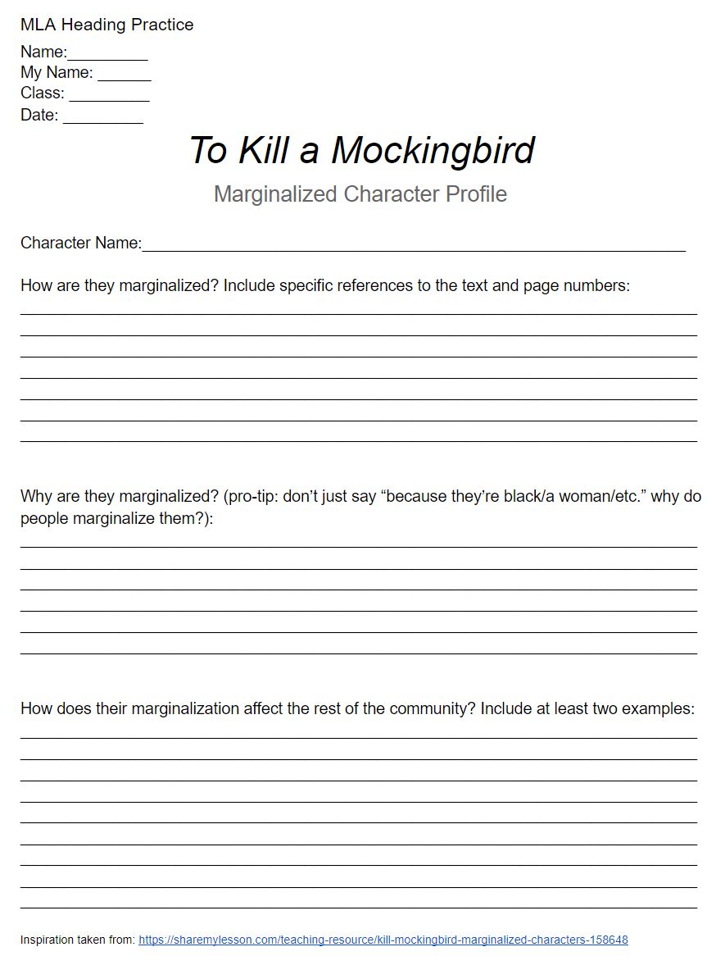

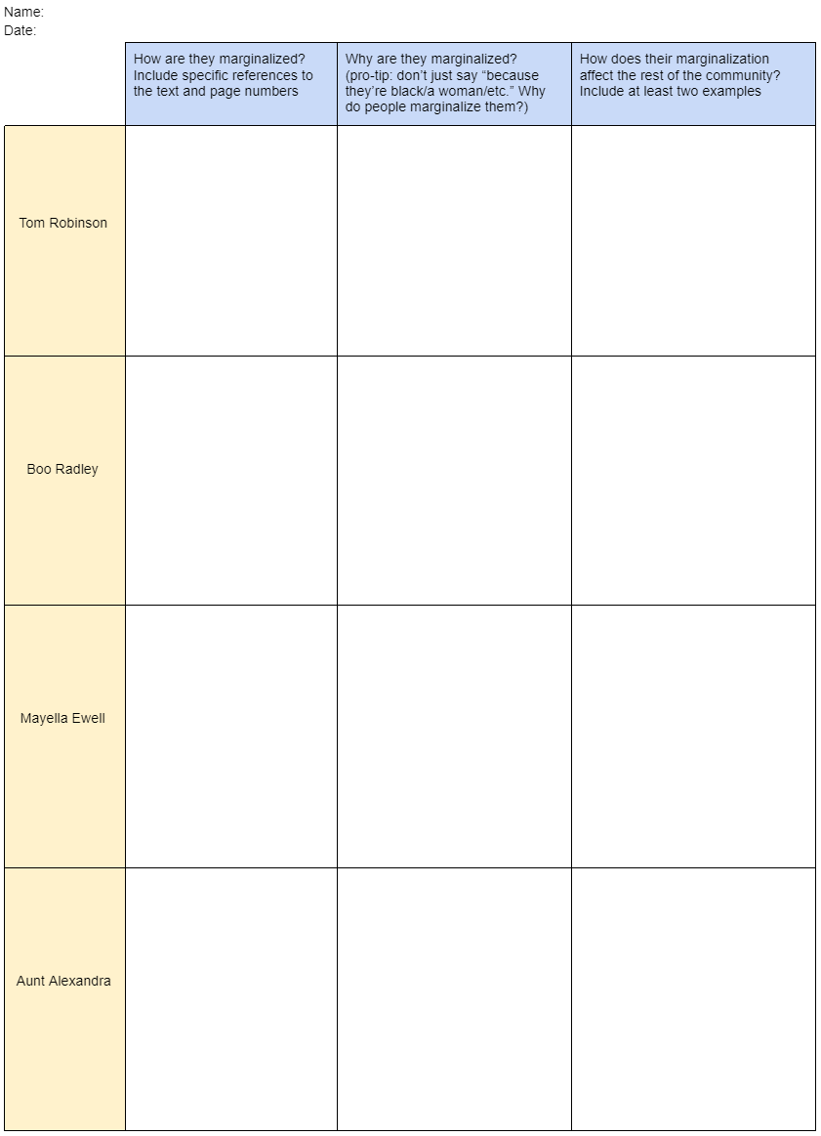
Fig. 1 (Back)

Fig. 2

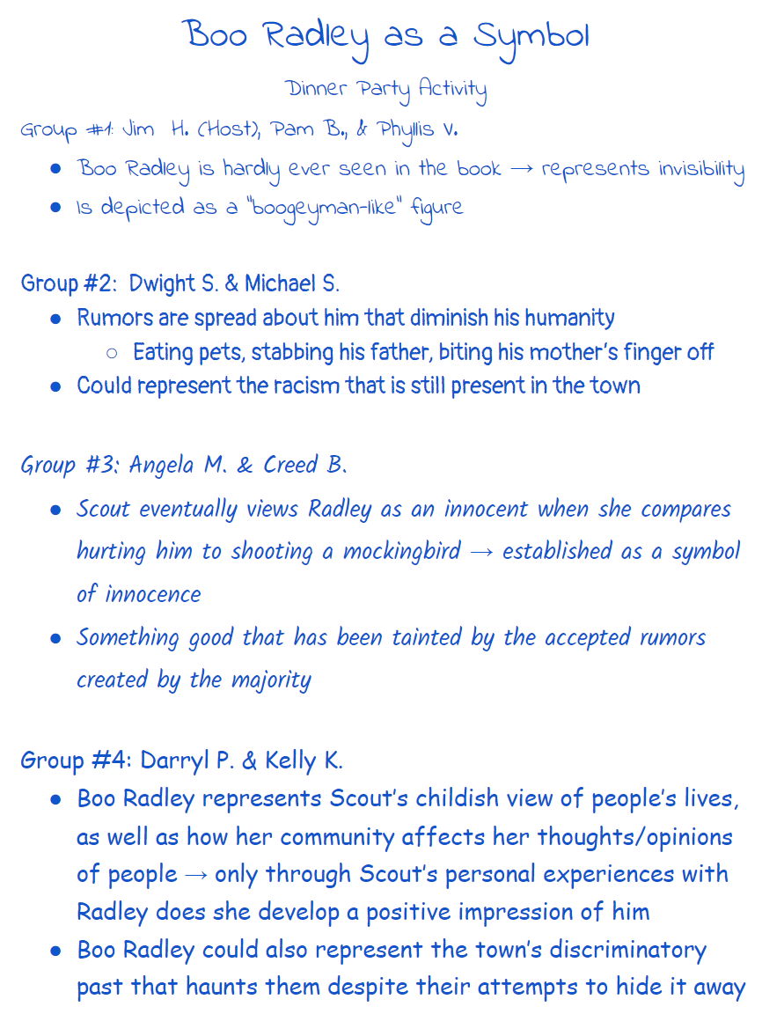

Works Cited
13th. Directed by Ava DuVernay, Netflix Studios, 2016. Netflix, www.netflix.com/watch/80091741?trackId=13752289&tctx=0%2C1%2C.
Brooks, Gwendolyn. “The Last Quatrain of the Ballad of Emmett Till.” The World of Gwendolyn Brooks. New York: Harper & Row, 1971. 324.
Chopin, Kate. The Awakening, With a Selection of Short Stories. New York: Bantam Classic , 2003.
ELA Team. “To Kill a Mockingbird Marginalized Characters.” Share My Lesson, 30 Sept. 2019, sharemylesson.com/teaching-resource/kill-mockingbird-marginalized-characters-158648.
Gaines, Ernest J. A Lesson Before Dying. 1994. Print.
Jones, Kimberly, and Gilly Segal. I'm Not Dying With You Tonight. Sourcebooks Fire, an Imprint of Sourcebooks, 2020.
Lee, Harper. To Kill a Mockingbird. New York: Harper Perennial Modern Classics, 2006.
McKay, Claude. “If We Must Die.” Poetry Foundation, www.poetryfoundation.org/poems/44694/if-we-must-die.

