Fareed Shayek
Dr. Warner
English 112B
4/7/2021
Mirage by Somaiya Daud
Author info
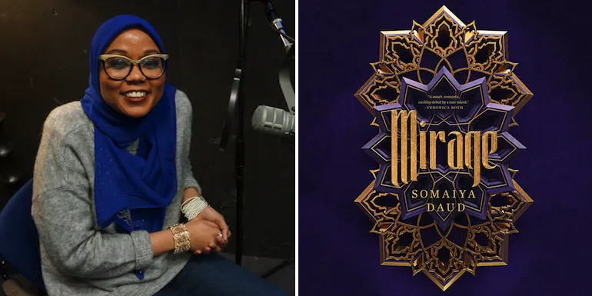
Author website: https://somaiyaonline.tumblr.com/
Goodreads: https://www.goodreads.com/author/show/15179415.Somaiya_Daud

- She’s Moroccan American
- She has a degree in medieval and early modern English literature
- While working on her master’s degree, she worked children’s department of Politics and Prose in DC.

Summary
Mirage by Somaiya Daud is a science-fantasy story set on the planet of Andala and its two moons which are under the colonial rule of the Vathek Empire. The story follows Imani, a young farm girl from the moon of Cadiz. The story begins on the night of a coming of age ceremony for Imani and several other young women from her village. The celebration is interrupted when Vathek droids enter the building and abduct Imani, severely injuring her best friend and brother in the process. Imani is then taken to Andala, where she is forced to be a body double for Maram, the cruel Vathek princes. The rest of the story follows Imani as she struggles to survive Vathek court politics and attempts on the princes’ life.

Quotes
- “I crept into my parents’ room often when I was small, always to peek into the box. And its mystique only increased in my eyes when my mother began to hide it from me. The feather fascinated me. A five-year-old had no use for a ring or a flower or fabric. But the feather of a magical, extinct bird? Like all things from the old order, it called to me.
The feather was black, made up of a hundred dark, jewel shades. When I held it up to the light it rippled with blues and greens and reds, like magic reacting to some unseen hand, roiling to the surface. It had belonged to a tesleet bird, my mother said, birds once thought to be messengers of Dihya.
When Dihya wanted to give you a sign He slipped the feather into your hand. When He wanted to command you to a calling, to take action, He sent the bird itself. It was a holy and high calling, and not to be taken lightly. War, pilgrimage, the fate of nations: this was what the tesleet called a person for.
There were no tesleet left on Cadiz or our mother planet, Andala. Like many things from my mother’s childhood, they had left, or been spent, or were extinguished.”
— Mirage: A Novel by Somaiya Daud (pg 7-8)
Colonialism and what is lost because of it are common themes throughout the story, as is the image of the tesleet. Furthermore, Imani’s borderline obsession with her people’s past comes up throat the text, sometimes as a boon and other times as a curse. This passage contains the first glimpses of the world and Imani’s character that the reader is given.

- My heart thundered in my chest. I could hear them murmuring with each other—Nadine and one of the royal household. There weren’t very many members. The Vathek king, King Mathis, had only had one child with his Andalaan bride: Princess Maram, who was rumored to be as cruel and Vathek as her father, despite being half Kushaila. King Mathis’s queen had died of illness during the Purge—the systematic extermination of the Salihis, the most powerful Andalaan family, who had resisted the Vathek takeover.
“Kneel,” Nadine said from behind me.
I sank to my knees clumsily.
“Well, your work is quite cut out for you, isn’t it?” a second voice said. It was cultured and sharp, as though the speaker were used to cutting people down with it.
I could feel her eyes burning holes into the back of my skull, and then the sound of swaying skirts and jewelry chiming as she made her way in a large circle around me. The bottom of her skirt was a dark red, embroidered, and shot through with black. Hanging from the gold belt around her waist were several long, thin chains that swayed and hit against one another as she came into view.
My eyes met hers, and I made a sound that was both a sob and a laugh. Looking at the girl in front of me was like looking into a mirror: it was my mouth on her face, the same dark eyes as mine, though they were lined in kohl. The same chin and cheeks—though hers were fuller, rounded with wealth.
No one on Cadiz had seen an image of the princess, not for a long time—her father had kept her hidden away on Luna-Vaxor, the Vathek homeworld, out of danger and out of view. But now I knew that standing in front of me was Maram vak Mathis, Her Royal Highness, High Princess of the Vath.
And she looked exactly like me.
(pp. 36-37).

This section gives the reader a chance to see why Imany was taken while also giving them the first impression of Maram. The princess is immediately made to seem intimidating when her voice. The revelation serves to deepen Imani’s despair and make the reader feel for her. Furthermore, this excerpt gives the reader information about the history of the world.

- At every turn in her life, Massinia took control of the narrative. She escaped her slavers, she found her love even if she couldn’t save him, she united the tribes. And at the end of her life, when she’d had enough, she’d simply stepped out of the story and up into the sky.
My life had been a series of events happening to me, and I wanted so desperately to be able to exert the control Massinia managed on my own life. To see my family, to see Husnain, again. To have her power, her determination, her faith.
(p. 123).
Imani compares her life to the of Massinia, a key figure in Imani’s religion. Throughout the text, the reader is told that Imani has an abnormally strong love for Massinia. Imani’s lack of control is emphasized because when she has this thought she is on an assignment disguised as Maram.

Teaching Information
Categories from Adolescents in the Search for Meaning:
- Books about Identity, Discrimination, and Struggles with Decisions
- Books about Courage and Survival
- Books on Allegory, Fantasy, Myth, and Parable

This text would probably work best with sophomores, juniors, and seniors because it contains some gruesome descriptions, and older teens would have an easier time relating to the protagonist. Given the subject matter, it could be paired with any text about colonialism or captivity. Though most students will be younger than Imani, they will likely be familiar with a similar, though hopefully less extreme sense, of confinement.

Why give this book to a teen?
- Because we live in a colonialist country and they need to understand the harm that it causes.
- Because Arab and North African students deserve to read about heroes who look, talk, and eat like them.
- Because they should see the importance of standing up for what they believe.
Text complexity
- Qualitative: Lexel gave Mirage a rating of HL780L, meaning it is best suited for teens from 14-17. Despite being a sci-fi novel, Mirage avoids overloading its readers with jargon. The text does rely heavily on Arabic words and names, which may prove difficult for some readers.
- Reader task: After Imani is captured and her training begins in earnest; the story moves at a relatively low pace which might cause some to lose interest. Despite the heavy use of Arabic, the novel provides enough context clues that help the reader to decipher the meaning.
- Implicit: Mirage deals with some darker themes like colonialism and captivity. Throat the text, Imani is physically and emotionally abused by Maram and her aid Nadine. Imani’s face and body are forcibly altered to match Maram better; this process involves removing tattoos which are of great importance to Imani’s culture.

