Caitlin Small
Dr. Warner
ENGL 112B
May 16, 2021
Can Love Really Make You Stronger in Dystopian Fiction?
There will always be the same theme in nearly every book, not just in young adult, but in adult fiction, too. That theme is relationships. Relationships are important for every main character in order to grow and be three-dimensional, regardless of the type of relationship, be it romantic, platonic, or familial. As a teen, romantic relationships might be something to look forward to when reading, to help guide your way through your own life, hormones, and having a new boyfriend/girlfriend. Dystopian novels, however, play romantic relationships to a different level. As a main character, once you fall in love, you basically do two things: risk everything for this one person, even if it means betraying the other people in your life (or everyone in general) and constantly making bad decisions. As a dystopian main character, is it possible to make good decisions without risking the lives of others? There is a cliche saying that “love makes you stronger”, but what I have seen in dystopian novels, is that love makes you make bad decisions, in which the consequences you must then overcome is what which actually makes you stronger.
Most dystopian novels are set in a futuristic setting, where governments have taken over and control children to different extents, depending on the overall theme. Some include children adopting some sort of powers, therefore the governments/society becomes afraid of what the children can become capable of. Others, like The Uglies by Scott Westerfeld, show a society in which they manipulate children into believing they are ugly, until they turn a certain age and have cosmetic surgery done. I chose this as my “center piece” because it highlights how the main character, Tally, struggles with her own decisions. She wants to be pretty in the beginning, but after meeting someone she falls in love with, she makes bad decisions, or rather, doesn’t think things through, which causes huge issues for everyone involved. That’s just the first book out of the series, there are more, in which she continues to make bad decisions in the name of love. However, due to this, she does become a stronger character, one that isn’t afraid of much, and can overcome a lot of obstacles, once she puts her mind to it.
The other novels that I have chosen for my annotated bibliography, have similar themes of relationships and sacrifice.
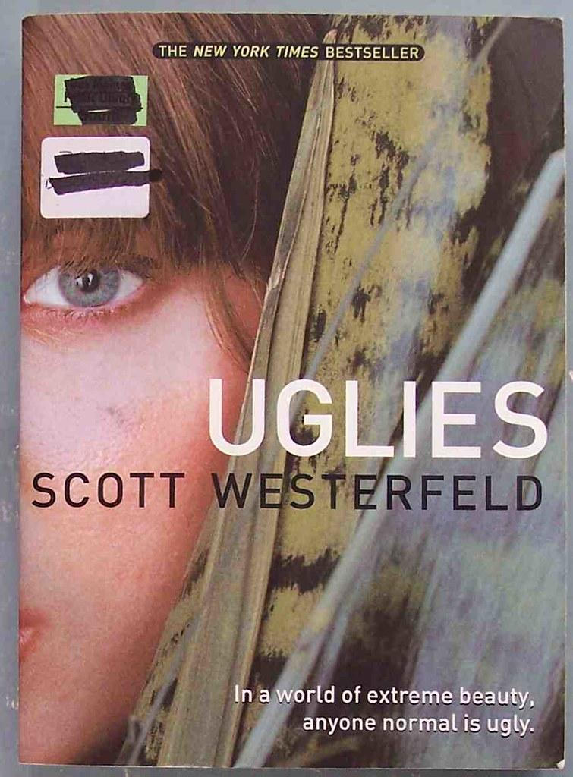
Westerfeld, Scott. The Uglies. Scholastic, 2005. Read.
This is set in a time after we have destroyed the planet and the ecosystem and now the government has full control of everything. Tally believes she is ugly, because her society tells her so.In fact, everyone is ugly, until they become “pretty” once they turn sixteen from plastic surgery. However, there is a society of people who don’t want to become pretty and they want to live off the land, the way humans used to. Tally makes a new friend shortly before her turn to become pretty, who then disappears. Now Tally is faced with a decision, become pretty (and be happy), or turn in her friend, whom she hasn’t known for very long.
This book has become one of the few dystopian novels in the YA cannon and is therefore my “centerpiece”. It is an important book because it highlights the difficult choices that Tally, as a main character, has to make. Does she stay loyal to her friend? Is there betrayal? Does the love that Tally finds help her make rational decisions, or worse ones? The answer to all of these equates to her becoming a stronger character, just from the consequences of her actions. I really enjoyed this series, even though I did not agree with some of the decisions that Tally made (though, that might be because I am a bit older than she is.). This story is not only well crafted, but also checks almost all of the Exeter Qualities.
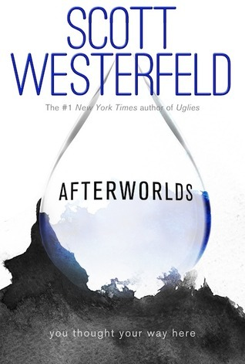
Westerfeld, Scott. Afterworlds. Simon Pulse, 2014. Read.
Afterworlds is not technically dystopian. Westerners brilliantly weaves these two stories together though, to highlight my position on love influencing bad or selfish decisions. Darcy just graduated high school and has already landed a huge two book deal with a popular YA publishing company. This story alternates between Darcy, trying to convince her parents that writing is a career, love, and priorities, and her main character, Lizzie, in a supernatural setting, surviving a terrorist attack and trying to overcome the trauma and new abilities that come with it. Darcy’s story may not be dystopian, but it plays into the themes of becoming stronger due to the consequences of the main characters actions of not thinking things through, or listening to the advice that was given to her.
I highly recommend this book for many reasons. It teaches about creative writing, it shows the importance of setting priorities when becoming an adult and the expectations that accompany it, it is LQBTQ+ friendly, and Westerfeld, again, covers so many of the Exeter Qualities. I literally read this book in one night, all six hundred pages. It challenges the readers on so many levels and in so many places; It’s no wonder Scott Westerfeld is one of the top names in YA literature.

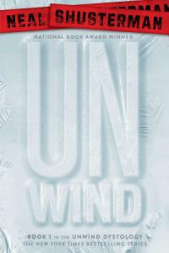
Shusterman, Neal. Unwind. Simon & Schuster, 2007. Read.
In this dystopian world, the idea of abortions are taken to a new level. Between the ages of 13 to 18, your parents can decide to do what they call “unwind” you and essentially hand you over to the government, in which you are used for all sorts of things, but mostly replacing rich people’s bodies and/or organs. This story follows three different kids, Conner, Lev, and Risa from different walks of life inside the “unwinding” system and how they fight together to survive. Connor has an explosive temper that often got him in trouble growing up, which is why his parents are choosing to unwind him, but he decides to run away before he can get snatched. This results in a literal collision where the three of them find themselves intertwined in trying to hide until they are old enough (19) to no longer be “unwound”. Of course there is romance in this series as well, one compliments the other in attitude, however the decisions made in this book are pretty well thought out. I would like to think because the main character is an already somewhat strong of a character, making dumb decisions only when it comes to his temper, and not necessarily to his lover.
This book is helpful, because similar to all dystopian novels, it helps put ethics into perspective. Just what is the best method to deal with overpopulation, reproductive rights, etc.? Neal Shusterman is a brilliant YA dystopian author and everything he writes holds a majority of the Exeter Qualities, and he does it in a way that makes the book hard to put down; I think Exeter Quality 6 (Themes that inform truthfully about the wider world so as to allow readers to engage with difficult and challenging issues relating to immediate interests and global concerns) is a great example of this.
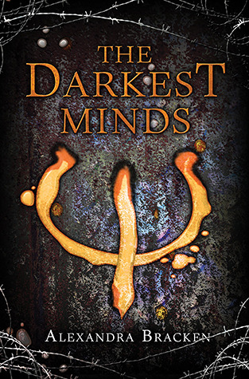
Bracken, Alexandra. The Darkest Minds. Hyperion, 2012. Read.
There is a terrible disease and this disease kills off almost all children between the ages of 8 and 14. The very, very few that survive (>2%) adapt special abilities. The government then decides to turn to the age old answer to fixing problems they don’t know how to solve with: concentration camps. For kids. These kids are ripped away from their families and forced to do manual labor. They are separated into different groups, depending on the types of their powers, from simply being super smart, to being able to use fire, or control someone. This story follows Ruby who, like most, is ripped from her family, though she accidentally uses her powers on them and erases herself from their memories. After discovering that her powers can be a threat, she makes the smart move to keep her head down and tries not to be noticed. However, things are changing and it’s only a matter of time before she is found out and is rescued from a rebel group, just in time. Once she gets out of the camp, her life begins to change, as the choices she starts to make, will change her course forever.
This is one book where we start off with a weak-willed character, who slowly becomes stronger on her own and from the connections she makes with the people she decides to surround herself with. Because her powers are used by touch, she knows to keep her physical distance, in which she also forces herself to keep an emotional one, too. However, when she meets someone who has similar powers to hers, she lets down her guard, and that’s when she starts making all of the wrong decisions, putting everyone, not just her new family, in danger. The way Alexandra Bracken tells this story is so vivid, it’s eerie. This story also meets most, if not all of the Exeter Qualities, as do the volumes that follow it.

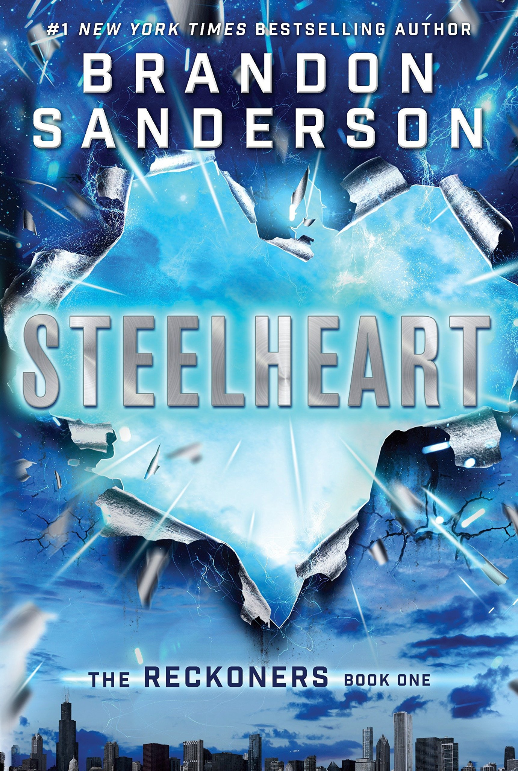
Sanderson, Brandon. Steelheart. Dragonsteel Entertainment, LLC., 2013. Read.
Steelheart is more of a post-apocalyptic, than a dystopian, but instead of being ruled by a controlling government, it is being put in a balance by “Epics”, people who were given special powers after an object started orbiting earth (known as the calamity). The story follows David, an orphan, who grows up with hate in his heart. When he was a child, an Epic that was supposed to be a hero killed his father in front of him, seemingly because they say him bleed, showing his weakness.David is now obsessed with studying the Epics, finding their weaknesses, and killing Steelheart. He comes across a rebel group called “the reckoners” and though they were skeptical at first, they let him join after David reveals that he saw Steelheart bleed. He also convinces them that he has a plan to kill Steelheart and they work together to accomplish this goal.
Sanderson tells a brilliant “super hero” story that plays with the concept of good and evil, and what having power can do to you. David is a character that is already strong-willed from his father’s death and continues to stay strong through the book. The difference in this book is that he is blinded by love, not necessarily making dumb decisions, just avoiding obvious ones. Because of the strong themes of moral ambiguity in power and good/evil, as well as the depth of the characters, this is another novel that covers most if not all of the Exeter Qualities.
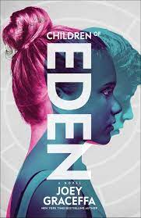
Graceffa, Joey. Children of Eden. Atria Books, 2016. Read.
In a world where humans have completely destroyed the earth, a new synthetic world was created, where families could only have one child. To ensure that this rule was followed, lens implants are placed in the eyes. Everyone eats synthetic food, everyone is taught the destructive past of how the humans killed everything, and everyone is expected to follow the rules. This story follows Rowan, a secret twin, who has been kept in hiding for twenty years of her life. Her parents are big shots in the governments and her time has come to finally get some false lens implants of her own so she can finally be free, but this is very illegal. Rowan, in a bout of rebellion one night, decides to walk the streets of Eden, and runs into a friend of her brother’s, whom she’s heard so much about. These two become friends immediately, but the authorities get tipped off that Rowan’s family might be holding a second child and she has to be rushed immediately to get the lenses. What follows is an adventure where Rowan learns what it’s like to fit in and what it means to fight for something you believe in.
This story is important because not only does it play into the themes of the consequences of making dumb decisions based on love, but it also grapples with emotions stemming from more than one love, feeling torn between worlds, and the destruction of family. Overall, the story was not the best, but I did like the themes that Graceffa played with and I think it is well done,
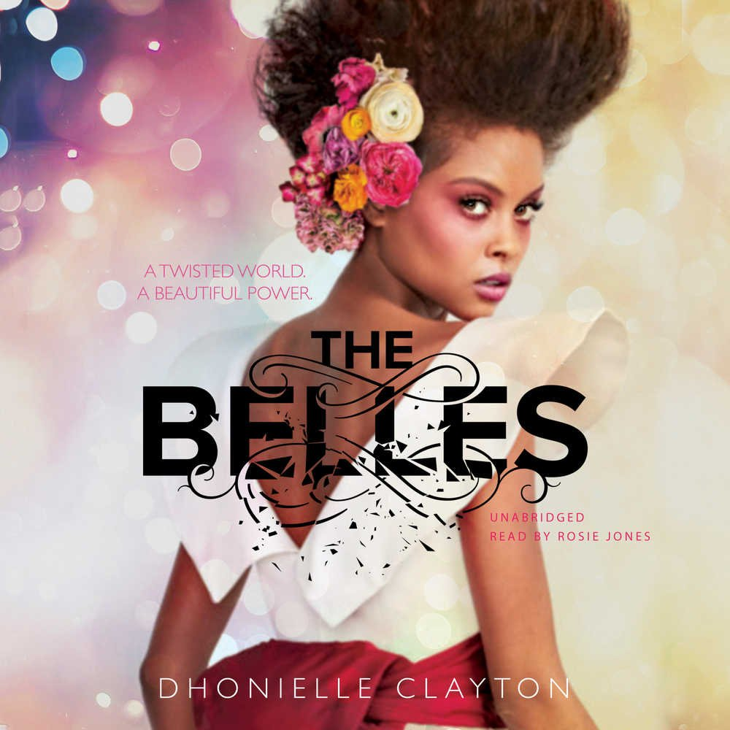
Clayton, Dhonielle. The Belles. Freeform, 2018. Read.
The Belles is half fantasy - half dystopian as there are small amounts of magic that grace this world. But only for those who are deemed Belles. Belles are women who “have magic in their blood” and they are used by those in high society to change the outer (sometimes inner) appearance of a person. They are stationed at tea houses where people who live in the area come and make appointments, spending a lot of money to keep up with the latest fashion trends. However, magic is not the only thing that makes them different. They are to never marry or have children. And there are secrets, secrets that should never be uncovered, especially if you are a Belle. The story starts in the beginning of a competition where Camellia, and her sisters have to compete by using their “magic” to make the prettiest girl. This competition decides their placements and who the “favorite” is, placing them at court with the King, Queen, and Princess. Camellia wants to follow in the footsteps of her mother and does her best to win favorite, but her nature is a bit rebellious. She is strong-willed, which always makes for a great protagonist, but she is also naive. Camellia tries hard to follow the rules that are placed on her by the “Belle code”, but the more secrets she uncovers, the harder it is for her.
Dhonielle Clayton weaves a wonderful, thrilling narrative, that similar to Steelheart shows a different side to blind love. This story also covers a lot of the Exeter Qualities, especially the second one, however, I wish there was more substance to it overall. The story does highlight important morals and how important it is to stay true to yourself.
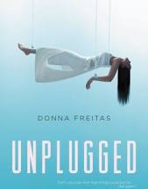
Freitas, Donna. Unplugged. HarperTeen, 2016. Not Read.
“Skyler “Skye” Cruz lives her life in a constant countdown, waiting for the day where she can unplug from the App World to be with her mother and sister in the Real World. The family she was placed with (known as her surrogate family) were Mr. and Mrs. Sachs and their daughter Inara. Growing up with Inara, they were best friends, sharing thoughts and matching opinion about everything except unplugging. Inara (living in the world with both her biological parents) could never understand why Skye, a Single (meaning no blood relation in the App world), would even want her real body back. After all, in class they learned about how terrible the Real World was, how their bodies grow weak with age, can be damaged so easily, and how long for their very short life they have to spend eating, drinking and sleeping. At age seventeen, it is your choice, to be unplugged from the App World, or stay there forever. Most singles do choose to go back to the real world, where love[d] one[s] who have already unplugged, or the ones that have been left behind. Surprises can happen, as the president’s only child, and the App World’s media favorite target, Rain Holt, decided to unplug, leaving his fan based, and everyone he knew behind. When the “cure” was discovered the App world went nuts, as finally they could be disconnected from their bodies entirely, no longer relying on the Keepers (the people left behind in the real world) to keep them alive. Skye was horrified, as because of the cure, voluntary unplugging was banned, meaning that she was stuck in the App World forever. Or so she thought, as a message came to her asking how much Skye would risk to go to the Real World, she made a deal with the devil, as Skye finds herself in the real world with two jobs: to find her family, and bring Rain Holt back.”
Summary taken from:
https://www.teenink.com/reviews/book_reviews/article/980082/Unplugged-by-Donna-Freitas
Like The Darkest Minds and Steelheart, once you find someone who you believe to be an ally and you connect with them on an emotional level, it’s not hard to be fooled by love; Though I have not read this myself, the reviews and summaries I have read, leads me to believe that she falls into the same sad story of so many others. I do look forward to reading it, as the summary on it’s on follows Exeter Quality 2.
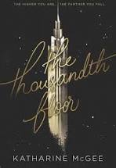
McGee, Katharine. The Thousandth Floor. Harper Collins, 2017. Not Read.
“WELCOME TO MANHATTAN, 2118. A hundred years in the future, New York is a city of innovation and dreams. Everyone there wants something…and everyone has something to lose. LEDA COLE’s flawless exterior belies a secret addiction—to a drug she never should have tried and a boy she never should have touched. ERIS DODD-RADSON’s beautiful, carefree life falls to pieces when a heartbreaking betrayal tears her family apart. RYLIN MYERS’s job on one of the highest floors sweeps her into a world—and a romance—she never imagined…but will this new life cost Rylin her old one? WATT BAKRADI is a tech genius with a secret: he knows everything about everyone. But when he’s hired to spy for an upper-floor girl, he finds himself caught up in a complicated web of lies. And living above everyone else on the thousandth floor is AVERY FULLER, the girl genetically designed to be perfect. The girl who seems to have it all—yet is tormented by the one thing she can never have. Amid breathtaking advancement and high-tech luxury, five teenagers struggle to find their place at the top of the world. But when you're this high up, there's nowhere to go but down....”
Summary taken from:
https://www.goodreads.com/book/show/24921954-the-thousandth-floor
In a story with so many main characters, there are bound to be love filled mistakes that lead to the biggest of consequences. As the summary hints, you can only go down when you are up as high as Avery Fuller, and the other characters seem to also be pretty high up in the building. Using so many many characters could be tricky as a writer, but it also could be helpful in order to connect with a larger audience, the more you have, the higher the chance you have of representing everyone.

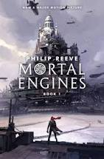
Reeve, Philip. Mortal Engines. Scholastic, 2018. Not Read.
“London is hunting again. Emerging from its hiding place in the hills, the great Traction City is chasing a terrified little town across the wastelands. Soon London will feed.In the attack, Tom Natsworthy is flung from the speeding city with a murderous scar-faced girl. They must run for their lives through the wreckage -- and face a terrifying new weapon that threatens the future of the world.”
Summary taken from:
https://www.amazon.com/Mortal-Engines-Book/dp/1338201123
I didn’t want to spoil too much of this book, because I was really interested in reading it, and all of the reviews says it’s promising (plus I have a lot of friends who loved it), there isn’t much I can say to my theme of mistakes made from love and the consequences that ensue. However, there are always consequences from your actions, and there’s another cliche that goes “what doesn’t kill you makes you stronger”.

Works Cited
Bracken, Alexandra. The Darkest Minds. Hyperion, 2012. Read.
Clayton, Dhonielle. The Belles. Freeform, 2018. Read.
Freitas, Donna. Unplugged. HarperTeen, 2016. Not Read.
(Summary:https://www.teenink.com/reviews/book_reviews/article/980082/
Unplugged-by-Donna-Freitas)
Graceffa, Joey. Children of Eden. Atria Books, 2016. Read.
McGee, Katharine. The Thousandth Floor. Harper Collins, 2017. Not Read.
(Summary: https://www.goodreads.com/book/show/24921954-the-thousandth-floor)
Reeve, Philip. Mortal Engines. Scholastic, 2018. Not Read.
(Summary: https://www.amazon.com/Mortal-Engines-Book/dp/1338201123)
Sanderson, Brandon. Steelheart. Dragonsteel Entertainment, LLC., 2013. Read.
Shusterman, Neal. Unwind. Simon & Schuster, 2007. Read.
Westerfeld, Scott. Afterworlds. Simon Pulse, 2014. Read.
Westerfeld, Scott. The Uglies. Scholastic, 2005. Read.

