The Book Thief
Book Talk by Hayley Behnke

About the author
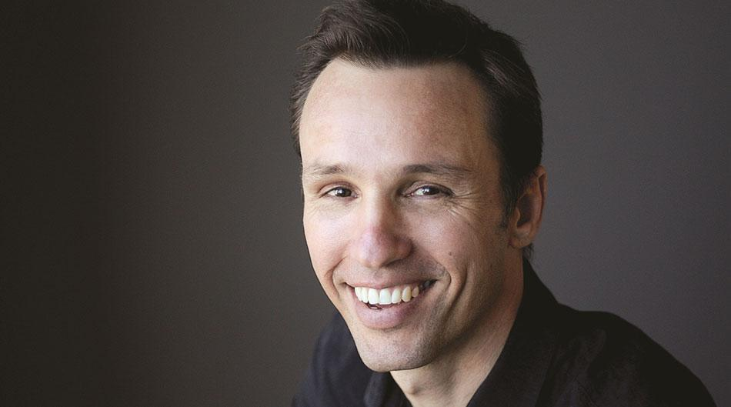
https://www.prhspeakers.com/speaker/markus-zusak

Author’s website: http://www.zusakbooks.com/

The Book Thief was written by Markus Zusak, who was born June 23, 1975 in Sydney, Australia. His mother is from Germany and his father is from Austria, and the inspiration for The Book Thief were the stories they would tell Zusak of their time during the World War II era. Early in his career, Zusak taught high school level English and Writing. He eventually went on to study English and History at the University of New South Wales where he graduated with a Bachelor of Arts and Diploma of Education. Zusak is best known for his two books The Book Thief & The Messenger, and has written four other books: Bridge of Clay, The Underdog, Fighting Ruben Wolfe and its sequel, When Dogs Cry.

Book Synopsis
In a small town called Molching in 1939 -- the peak time for the German Nazi regime -- a young girl named Liesel Meminger loses her brother, her father is taken away for being a communist, and her sick mother has her live with her new foster parents, Hans and Rosa Hubermann. Throughout the story, Liesel falls in love with books, despite not knowing how to read; she knows they’re important and even begins to steal books from various places, including a Book Burning. Liesel’s foster father, Hans, eventually discovers her love of books and begins to teach her how to read. Eventually, Hans and Rosa come to hid a Jewish boy, named Max, in their basement as their way to privately fight against the Nazi regime. Liesel and Max begin to bond and form a close friendship, but the secret of keeping Max in the basement is a ticking time bomb for Liesel’s foster family -- for if their anti-Nazi sentiments become known then they’ll receive a punishment possibly even worse than death.

Text Complexity
Lexile Level: 730L
ATOS® Reading Level: 5.1
Overall Grade Levels: 6-12
The Book Thief, being set during World War II, Nazi Germany, contains a lot of heavy, sensitive material that I personally believe are not age appropriate for younger audiences. A student reading this would also have to have an understanding of the U.S. history of that time. Therefore, my suggested grade level for this book would definitely be grades 8-12 instead of 6-12, as 8th-12th graders would be a bit more emotionally mature and understanding of the material presented in this book.

Quotes

“*** AN OBSERVATION *** … When it came down to it, one of them called the shots. The other did what he was told. The question is, what if the other is a lot more than one?” (22-23)
  - In this quote, from the beginning of the book, Liesel’s brother has just died and two pairs of people have come; one pair to take Liesel and her mother off the train they were riding, and the other pair to bury her brother’s body by the train tracks. The way the pairs blindly follow orders is a bigger parallel to the people blindly going along with the Holocaust and Nazi Regime. When the quote asks what would happen if “a lot more than one” simply followed orders, it is making a reference to the many Germans who just did as they were told and didn’t question their instructions. This quote implies that the Holocaust happened because of complacency and unquestioning obedience.
- “You could argue that Liesel Meminger had it easy… But anything was better than being a Jew.” (158-159, 161)
  - In this quote, after Max has made his escape from Stuttgart to Molching, we begin to see the Jewish perspective of the story. The quote acts to show the concerns of the main characters in a broader context, and to remind the readers that no matter how hard things got for Liesel and any of the other characters, their lives were much safer and easier than those of many others during this point in time. Instead Death, the narrator, tells us that Liesel was not the only one who suffered under Hitler, and that hundreds of thousands of others suffered so much more because they were Jewish.
- “The Jew: ‘What do you see?’
The girl: ‘A train, and my dead brother.’ The Jew: ‘Your brother?’ …” (219)
- In this quote, we see the start of Max and Liesel’s friendship — as they both show compassion and empathy towards each other. They’re shared nightmares, Liesel’s about her brother that she lost, and Max’s about the family he left behind to seek asylum in The Hubermann’s basement, show their humanity.

Adolescents in the search for meaning & The book thief
- Chapter 5: Books about Facing Death and Loss
  - From the very beginning of the book, Liesel Meminger is surrounded by death. She loses her brother while riding the train with him and her mother, World War II is happening and unfolding right before her very eyes, as the Jewish population are marched towards their death, and her foster father decides to hid Max, a Jewish boy, despite putting him, Liesel, and his wife at risk. Death is even the narrator for this novel -- which shows just how centered the novel is around this concept.
- Chapter 6: Books about Identity, Discrimination, and Struggles with Decisions
  - Max is the main focus of this chapter. His Jewish heritage is his death sentence should he be caught by the Nazis, and his struggle to make that decision to leave his family and loved ones to go into hiding is an incredibly hard choice, but it’s a choice he must make to save his life.
- Chapter 7: Books about Courage and Survival
  - Both Liesel and Max show tremendous courage in this book. With Liesel as “The Book Thief” going to various places, like a Book Burning, to steal and recover books, and with Max just living during this time and trying to survive the Holocaust, showing incredible bravery and strength while trapped in a horrible reality.

Teaching Ideas
- Ask your students why they think Zusak made Death the narrator of the story. How different do they think the story would be if it was told through Liesel or Max’s point of view? Do they think Death is an unreliable or a reliable narrator?
- Have your students do a Sustained Silent Writing (SSW) and have them write: if they were “The Book Thief”, what books would they steal and keep safe? And why?
- Have your students get into groups and discuss the potential themes of The Book Thief -- this can range from the responsibility of the living to the dead (the survivor’s guilt many of the characters feel), to the power of words (how books and stories keep people connected to one another).

Rationale: Why should teens read this?
The Holocaust is an incredibly massive dark spot on the world’s history. Despite this book being a work of fiction, it is still historical fiction, and teens should read The Book Thief to gain an understanding of what life was like during that horrendous time. Students of Jewish descent and students who have gone through/are going through the grieving process may be able to understand certain characters and aspects of the novel. The Book Thief, in the end, is a novel where the reader instantly roots for Liesel and Max and wants things to go well for them -- with all the trials and tribulations they face the two of them deserve a happy ending.

