Raul Romero
24Oct22
Like a Love Story
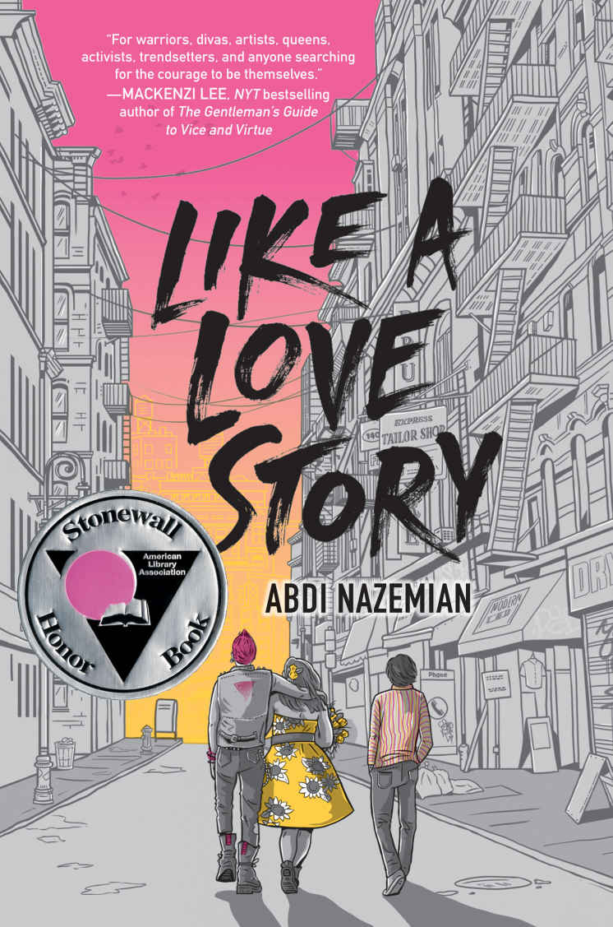
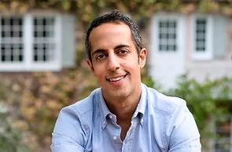
(Photo from https://www.abdinazemian.com/ )
About the Author
Abdi Nazemian has written for three television shows: NBC's ORDINARY JOE, Fox’s ALMOST FAMILY, and NBC’s THE VILLAGE. Abdi’s first novel, THE WALK-IN CLOSET, was awarded Best Debut at the Lambda Literary Awards. He has written three young adult novels, all published by Balzer + Bray / HarperCollins: THE AUTHENTICS (2017), LIKE A LOVE STORY (2019), and THE CHANDLER LEGACIES (2022). Time Magazine has said LIKE A LOVE STORY is one of the 100 best young adult books of all time and the book has also won a Stonewall Honor. Nazemian lives in Los Angeles with his two children and husband and holds dual citizenship between the United States and Canada. Madonna has written a children’s book called the adventures of Abdi however Nazemian is not the inspiration, but he will forever insist that he is.
Summary
Like a Love Story by Abdi Nazemian is a story from start to finish, 413 pages. It is told in first person by three teenagers navigating the hardships of the late 80's and the AIDS epidemic. Reza, an Iranian, new to the city has to learn to get along with his new step dad and sibling all while unsure of his own sexuality , Art, an openly gay teen documenting the activist’s life through his camera lens, Judy, an aspiring fashion designer and best friends with Art. Judy has a gay uncle named Stephen who is dying of AIDS and is an activist for equal health rights for the LGBTQ and people of color who plays a critical road of acceptance for the trio of teens. These three stories intertwine with each other so well and draw you in with each chapter and its characters perspective.
Quotes
“I quickly closed the book, overwhelmed by his image, but his face haunts me. I cannot stop thinking about him, and his shaved scalp, and his open studded ear, and his devilish lips. I need to stop thinking about him, and I know there's only one way to do that. I lie back on my bed, close my eyes, and then unzip my pants. I see Bartholomew Emerson grant the 6th come to life, enter my room, climb into bed with me. He kisses me, and dresses me, tells me not to be scared. But then he's gone, and all I can see are images of dying men with lesions. I hate myself. I hate these thoughts. I hate Bartholomew Emerson grant the 6th. I close my eyes tighter, and my breath quickens. When it's over, I breathe out all the air inside me, hoping that with the last bit of oxygen leaving my body, this sickness will leave me too. I know this is a phase. It must be. I grew out of needing my stuffed rabbit with me all the time. I grew out of hating eggplant, and of putting McDonald's French fries on every Persian stew my mom made. I will grow out of this. I must, because I cannot ruin my mom's new marriage. And because even though my mom can handle anything, I don't know if she can handle me dying. I need to live, and to live, I can't ever be what I know that I am” Reza pg 14
One of the hard things about being a teenager is believing you must know who you are. In this quote we see Reza go from questioning his sexuality to disliking what his own mind produces. It's tough enough Losing a father, then to join a new family in a new city with the Aids epidemic Causing ignorance to brew fear. Reza struggles with cultural norms from Iran but understands that he is no longer in the war-torn country. Even more unfortunate when his mother believes, and Iranian men cannot be gay. The author can use the opening chapter with Reza to show the raw emotions that come from such confusion.
“…it's not my first time in church, and most of the memories it brings to mind are bad ones. But this time, something about the choir moves me. The sound of all those voices harmonizing together and undeniably beautiful, and the acoustics of the space make it sound like the voices are surrounding me. Angels do exist, I suppose this is what they sound like. And the voices remind me of the choir in like a prayer, and I think that if it weren’t for all the bullshit rules of Catholicism then there would be no Madonna, because what is she if not rebellion against all of this? I guess I need to be grateful for that. I hear her song playing in my head, and I imagine Reza’s face when he listened to it for the first time… I could feel him come alive, forming into something new in front of my eyes, and then he pulled away from me… and I imagine myself kissing Reza’s lips, his eyelids, his nose, his chest, his thighs. Imagine everything that would discuss the church on the cardinal, all set to their holy music. I guess that's the thing. I don't want to burn this place to the ground. What I want is to make them see that I AM HOLY. Well, except for that part about him being my best friend's boyfriend now. That's a sinful detail… when it comes time to take communion, we decide to head out. But I'm not ready to leave. Now when I turn and see the prayer candles waiting to be lit. There is a suggested donation to light a candle, but I know that God isn't about money exchanging hands to make wishes come true. And I know that I don't believe in that God can grant wishes, but if there's even a chance that such a God exists, and I have some wishes that I like granted. I figure making a wish is like an insurance policy, and so I close my eyes and light a candle. I want to wish for Reza to come back to me but that will be next. that can't be my first wish, not when I'm surrounded by death. Not when Stephen looks so weak…” ART pg 151-153
Art is one of my favorite characters in this novel. Even though he faces the hardships of being gay in the late 80s and at the height of the aids pandemic, he does his best to be true to himself. During this scene Art joins the activist group Act Up in the Catholic Church to plan their next protest. The author uses the church and their conservatives’ ways to give a reason for the way Madonna portrays herself in society, or better yet being the driving force that causes some to want to be different
“Judy…,” he whispers from beneath his fingers, barely audible. “I can't do this.”
“I'm sorry,” I say quickly. “I'm so sorry. I pushed you too far. I'm sorry”. I know how pathetic I sound. And now he's rejecting me, and I think I know why. But I want to keep him. I need to hold on to him as long as I can.
“Judy…,” he whispers again, and now he takes his hands off his face and holds mine with them. His eyes are welling, no tears yet, but the formation of them, like a looming threat of what's to come. “I am the one who is sorry… I can't do this to you anymore,” he says. His eyes are fuller now. The wave is coming to the surface of his face about to explode…” Judy, you know what I'm about to say" he says, with kindness that arranges me. If there's one thing, I don't want from him right now, it's kindness. I want passionate, animalistic lust, or the promise of future passionate, animalistic lust. Instead, I get kindness, and worse, pity.
“I don't know, and I don't want to know” Judy and Reza p211-214
One of the toughest things for me in high school was coming out of my shell and attempting to connect with my peers. There were plenty of times that I were questioned everything that came out of my mouth or everything that I did. I believe most teenagers go through the same thing. Now in this specific situation in this scene I cannot relate to Judy, I can't relate to Reza, but what I can help students understand is the similarity and struggles that we share with one another.
“You didn't even have a camera if it weren't for my money” my dad says curtly.
“Why does it always have to come back to money for you?” I ask, enraged. “I don't want your money. I want--- I don't know, maybe your love and respect.”
“Then earn them," my dad says.
“I shouldn't have to earn your love and respect,” I say incredulous " I'm your son. That part should be unconditional.”
I can feel my mom trembling “art, sweetie, we do love you. We do,” she says.
“And by the way, dad, the camera was a gift from Stephen,” I say. “You don't even know that. You don't even know what he's given me.”
“Given you? “My dad snaps
“Yeah, he's giving me a community,” I say.
my dad shakes his head. “You're too young to have a community. At your age, all you have is family.”
“QUEERS!” I yell at him.” We are queers, dad, and we have a community. We're there for each other.”
ART PG 243-245
This scene, this set of quotes hit incredibly hard and incredibly close to home. To share a personal story my brother came out in the town of sadness and anger that can be reflected in this passage. The feeling of just wanting to be loved by those closest to you. The author uses words like trembling to show the level of emotions, or curtly to show the level of rudeness. The feeling of pain behind the word queers when Art yells it out can be felt by the reader. The reader can relate even if not being queer, the feeling can translate do you having something you love, and it not being understood.

Classroom Usage and YA LIT category
The book Like a Love Story by Abdi Nazemian can be used in a classroom primarily by seniors because near the end of the story there is a sex scene. Using the book during pride month would be a great way to have students look into LGBTQ+ history and the activism that has taken place to push for equal rights. At any age group, some people struggle to accept who they are because of the stigma that old societies have set in our family dynamics. Being able to use my own life experience can help in my connection with the students.
Regarding this book and its place in “Adolescents in the Search for Meaning: Tapping the Powerful Resource of Story”, it falls into chapter 4, 5, 6, 7. Chapter 4 and the real-life experiences is something that resonates throughout the whole book, from the love complications, the loss of loved ones, the AIDS phobia that took place. Chapter 5, 6, and 7 tie together the struggles of the LGTBQ+ community has had to endure from the lack of health care, the discrimination, the fear mongering because of the condition’s symptoms.

