Alma Hernandez
ENGL 122B Sec 01
Dr. Warner
24 October 2022
Anna and the Swallow Man
By Gavriel Savit
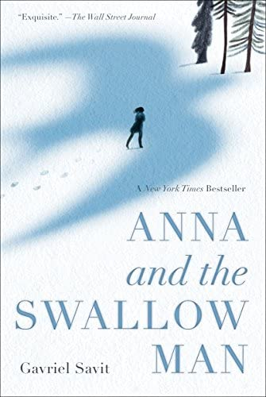
About the Author:
https://www.gavrielsavit.com/
Source: https://www.nationalbook.org/people/gavriel-savit/
Savit grew up in Ann Arbor, Michigan, where he attended the University of Michigan and obtained his BFA in musical theater. He is an actor and singer who has performed in Broadway shows across three different continents. Anna and the Swallow is Savit’s debut novel, he has two other fantasy novels.
- He comes from a Jewish background.
- Interest in fantasy elements with historical events.
- The novel received the Odyssey Award and the Sydney Taylor Book Award
Summary:
Anna and the Swallow Man is set during the Nazi German invasion in 1939 Kraków. It is about a seven-year-old girl named Anna Łania who is raised by a single parent and taught the beauty of multiple languages. In November of that year, her world changes and she loses her father, a professor of linguistics who is taken during the Great Purge. Anna becomes an orphan in the span of a day when a mysterious, tall “thin” man appears in her life becoming a father figure for her. Despite never knowing his real name, Anna travels along with the Swallow man who teaches her the ways of the road and how to give up her identity and innocence to survive in a cruel world that is constantly changing. She grows from a child into a young woman and learns lessons about trust, love, morality, and womanhood.
Quote #1:
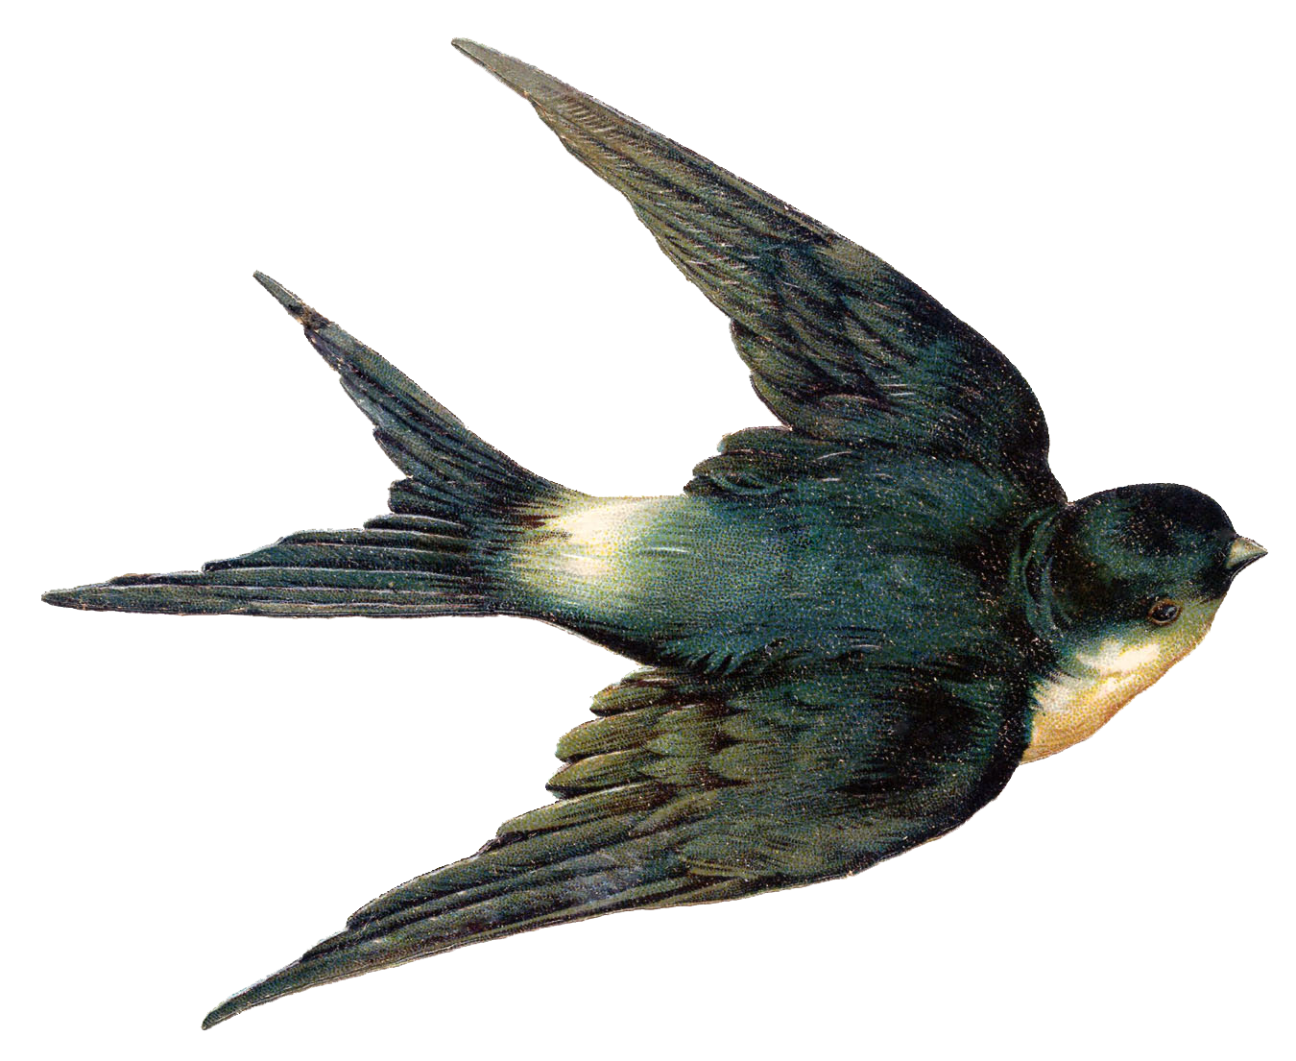
“‘The tall man sighed. ‘Was your father a nice man?’… She held it” (46-50).
As a seven-year-old girl, who has no idea of the massacre that is occurring in the world, she has many questions regarding their secrecy and fleeing. Anna has nothing that belongs to her, therefore giving up her name is a hard decision for a child to do. This quote shows us the childlike nature of Anna who entrusts her life to a man of whom she barely has any knowledge. It is one of the many times that Anna is forced to give up something of hers to protect the Swallow man and herself. She is concerned with the act of lying and wants a sense of normalcy, yet she is aware that it is risky to be seen. The Swallow man explains to Anna as direct as he can the gravity of their situation, treating her like an adult at times but acknowledging that she is still a child. She is asked to do something perplexing but knows that being nameless or rather changing names when the time comes is the best way to keep safe.
Quote #2:
“Generally, this demand— a bare word or two … tamed wild beasts with wild fruit” (70-74).
The Swallow Man teaches Anna how to read the world and people. He uses the metaphor of the wolves and bears to explain the dangers of encountering German or Russian soldiers that they met between border lines. This quote is an example of the deceitful acts that the Swallow Man performs and shows the skills he uses which Anna picks up on. It is during these checkpoints that Anna memorizes the social code that exists between different men. She becomes accustomed to taking on different identities to appease the wolf or the bear. Anna is the “watcher” and the assistant in this performance which highlights the fairytale aspect of the story.
Quote #3:
“The Swallow Man sighed. “Hirschl, you heard what he said … it was nearly a week later that they found Reb Hirschl’s body” (170-174).
The first time the duo decides to make a friend, the Swallow Man’s ethics are shaken. He begins to display more acts of kindness, but ultimately his beliefs and Hirschl’s identity come into conflict. Hirschl’s religious identity clashes with the Swallow Man’s decisions and actions. After the Swallow Man kills a peddler who desires Anna and offers his goods in trade for her, the Swallow Man has no choice but to go after him. Hirschl’s confrontation puts Anna in a tough spot as she has an affinity towards Reb Hirschl but knows that she cannot leave the Swallow Man either. Hirschl believes that all lives are precious and is like Anna who wishes to see the best in people even though death is everywhere. The Swallow Man’s common sense and sternness had never been affected but Hirschl makes him reflect and feel something that he never has.
Classroom Use
I would use this book during a longer unit to teach about the Holocaust and have classroom discussions about different people’s experiences during the war. I would pair this novel with the Book Thief because it depicts the cruelty of humans to a young character in an analogous way that it does to Anna. During this unit, I would have my students also read The Pianist and Night to provide different perspectives of the war and how it affects the character’s faith and sense of identity. Afterward, I would have them watch the respective films to those books. To foster critical thinking, as a class we would work on a timeline project to map out the location of the character as their story progresses. This would help students view the relationship between the Nazi policy, WWII, and the individual experience during the Holocaust.
As a writing activity, students can write a one to two-page ending to Anna and The Swallow Man as the novel has an ominous and ambiguous ending. This book would also be paired with another book in an essay that explores the co-dependence and relationship between adults and children. Another possibility could also discuss the characters' faith and how is it that they manage to hold onto their beliefs.
Why should you give this book to teens?
Teens should read this book because of its fairytale-like setting and plot, which they will find intriguing. The book will also leave students asking questions as the story progresses such as Why does the Swallow Man choose to help Anna? Who is the Swallow Man? Teenagers can also identify with Anna who poses questions that are never fully answered as she would like. Young readers may relate to her quickness and curiosity or “precociousness.” The novel is historical fiction with a narrative that is easy to follow but has layers that teenagers can appreciate because of its emotional impact, character development, and anecdotal plot.
Other Reasons:
- Because religion is never an excuse to inflict violence on others.
- Because teenagers like Anna may have fallen in love with someone that they were discouraged from growing a relationship with because of their identity.
- Because they may have “parents” or adult figures in their life whom they try to understand and who may suffer from medical conditions that limit their perception of the world.
How it fits best in Chapters 4-8 in Adolescents in the Search for Meaning:
Chapter 4: Books about Real-Life Experiences:
- Anna is a child when war breaks and is left an orphan without a proper explanation of what is going on in Poland. Young people are the most confused when change occurs that affects every aspect of their lives.
- WWII included every part of the world, and wars at home and in other countries are still an issue that teenagers should learn about.
- Students in the class may have relatives who had to migrate because of racism, religious, or political persecution. They may even have a family connection to this period in history.
- The sense of being lost and having to make personal sacrifices to protect loved ones.
Chapter 5: Books about Facing Death and Loss:
- Anna sees death along her journey, finding body after body and learning how to cope with such hate. Teens who experience the death of others at an early age can relate to her exasperating sentiments.
- Teenagers who may not have both parents in their lives or were raised by a single parent can empathize with Anna’s vulnerability and need for affection.
Chapter 6: Books about Identity, Discrimination, and Struggles with Decisions:
- Anna does not know what “group” she fits into, or why her ethnic identity matters. Teens can understand Anna’s confusion and frustration to fit in somewhere.
- Students can reflect on how prejudice and discrimination exist in their communities and question bodies of power in the world.
- Regardless of their cultural experience, students can learn about the discrimination against Jews and other groups. They can reflect on the anti-Semitic sentiments that the media portrays.
Chapter 7: Books about Courage and Survival:
- Anna is a courageous character that endures hunger, pain, and extreme living conditions to survive.
- Students can understand how Hitler came into power and consider how other political leaders are indifferent towards social causes.
- Anna asks for help from men whom she was never supposed to come near.
- Anna’s willingness to remain kind while others are vicious.
Chapter 8: Books on Allegory, Fantasy, Myth, and Parable
- Taken as an allegory, imaginary friends can help teenagers such as the Swallow Man’s magic helps Anna.
- Anna learns that not all authority figures can be trusted.
- The folklore and mythical essence of the story may interest students.
- The story is not just for middle or high school students but for adults who may find themselves being challenged.

Quantitative
Lexile: Age: N/A, 1160L
AR: ATOS Book level 7.1, Interest level: UG 9-12, AR points: 10.0
Readability: 4-5 graders, ages 8-9
Dale-Chall: 5-6 grade
Flesch-Kincaid: 6th grade
I would recommend this book to 9-10th grade students.
Qualitative
- Structure
  - Third-person omniscient POV
  - Not a linear plot, but it describes the habitual patterns of the protagonists.
    - There are moments when the characters go back and forth between the present and the past.
      - I.e., When Anna thinks about her dad, or the Swallow Man thinks about his little girl.
  - Anna’s feelings are the main focus of the story, the perspective of the Swallow Man or other characters is not revealed.
2. Language Conventions and Clarity
  - Word choice and vocabulary are relatively simple.
  - Anna’s speech captures the feelings of a small child.
    - The audience can hear the child’s POV, innocence, and unawareness of the bigger context yet her quickness to notice everything that is changing is clear.
  - Imagery, metaphor, allegory, archetype, personification, simile, and ambiguity are the main literary devices used in the book.
3. Knowledge Demands
  - The text requires that students have background knowledge of the story's historical context.
    - Invasion of Poland, and Intelligenzaktion.
    - Contextualization of WWI and the consequences of the war that led to a second war.
    - The Nazi regime, Hitler’s agenda, and his ideologies.
      - Requires a lesson plan to discuss WWII and how Hitler rose to power.
  - The reader understands the dynamics between the orphan and the caregiver or magician.
    - The obscure adult figure and the impressionable child.
    - The reader understands that mental illness can prevent an adult from functioning “properly” or showing affection.
4. Levels of Meaning
  - Two levels of meaning
    - The surface level-meaning: A young girl and an adult as they embark on a dangerous journey that requires them to be cautious of the rules of the world.
    - A young girl emerges into womanhood during a dark place in time where she is forced to give up parts of herself.
    - The purpose is for its readers to ask questions and want to learn more about people like Anna and the Swallow Man.
      - The allegory of the swallow and its relation to maintaining faith and love when it seems like an illusion.

