Scythe
by Neal Shusterman
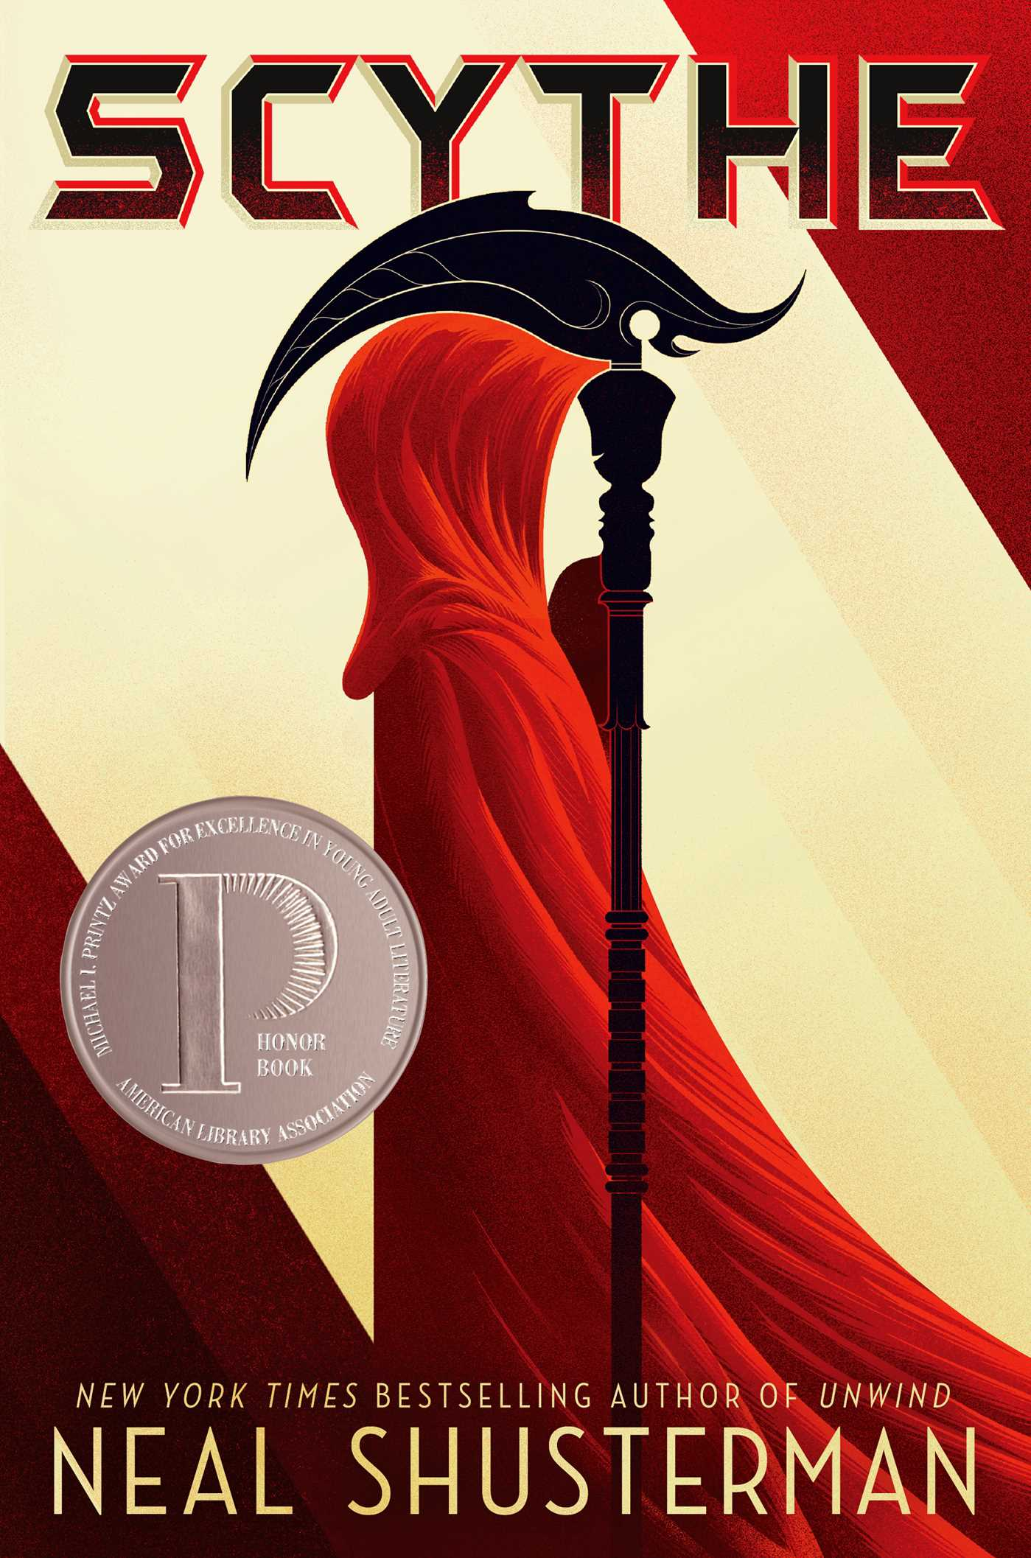
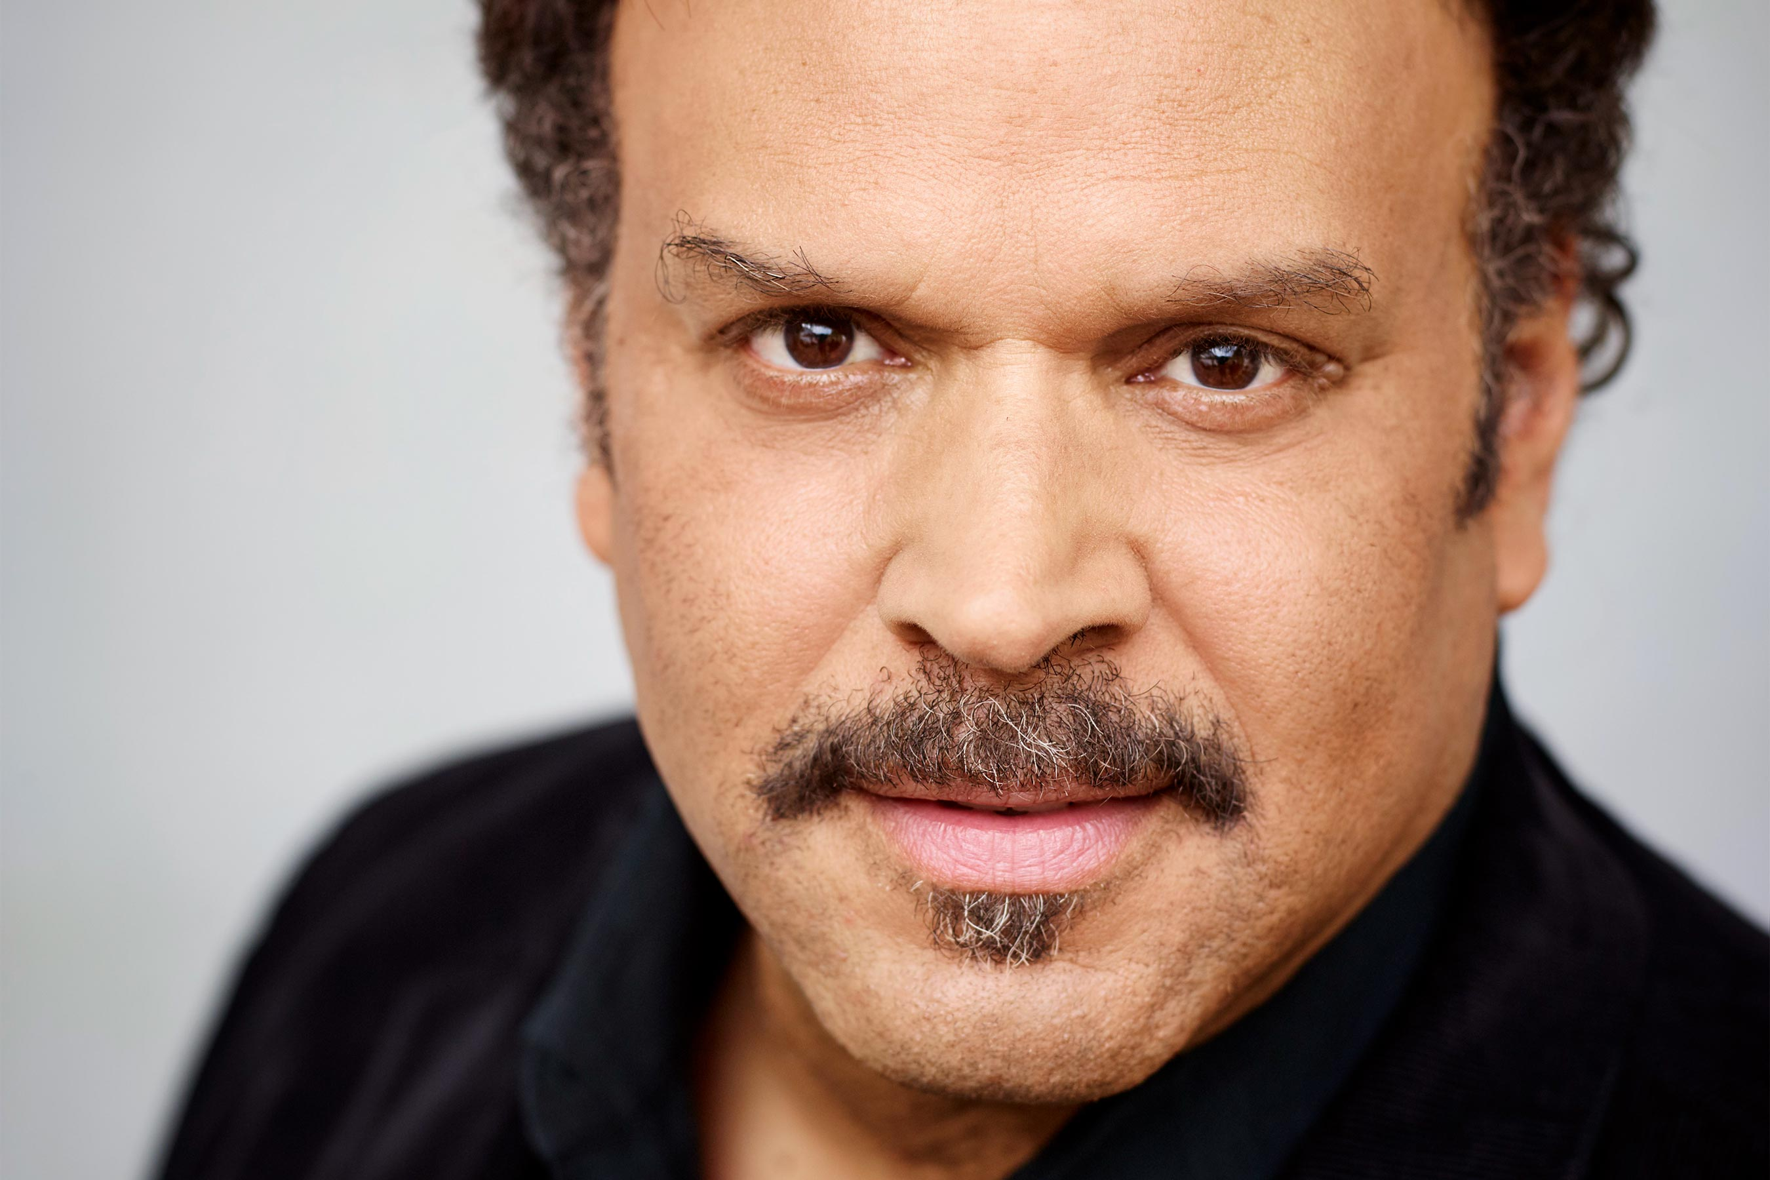
https://ew.com/books/2019/05/17/neal-shusterman-arc-scythe-the-toll-preview/
Neal Shusterman spent his early years of life in Brooklyn, New York. He loved writing even when he was younger. As a child, Shusterman claimed he wanted to be a writer, a film director, an artist, a rock star, an architect, an actor, and a doctor. Eventually he would go on to attend UC Irvine, and would find himself with his first book deal as well as writing a movie script within his first year after graduation. Shusterman has become a novelist, a screenwriter, and a television writer, having written for television show such as Animorphs and Goosebumps. He also wrote a few murder mystery games. Shusterman has a unique story telling style due to his degrees in psychology and drama.

Scythe is set in a seemingly utopian world where death has been permanently circumvented due to scientific advancements. Humanity, however, decided that death was still necessary, and created scythes, tasked with ending a certain amount of lives each season. The story is told from the perspective of two teens, Citra and Rowan, both of whom are suddenly and unwillingly thrust into acting as apprentices to a scythe while learning the trade. Throughout the course of their training, they are introduced to several different ideologies and ideas about life and death and what the right approach is to “gleaning” (the term used for permanently taking someone’s life). These ideals are often presented throughout the book in the form of journals written by various scythes, a requirement of the trade. If the concept of becoming scythes wasn’t enough of a surprise, many more challenges arise for Citra and Rowan.

“My greatest wish for humanity is not for peace or comfort or joy. It is that we all still die a little inside every time we witness the death of another. For only the pain of empathy will keep us human. There’s no version of God that can help us if we ever lose that.” From page 388 | This quote comes from the gleaning journal of Faraday, one of the prominent scythes in the book. One of the primary focuses of Scythe is on the morality of gleaning, especially in regard to how the scythe treats the person they are gleaning, and how they feel about it. Faraday is a great example of the view known as the “old guard,” preferring humility and compassion, along with mourning for those who have been gleaned.
“I am not a man easily brought to fury, but how dare the old-guard scythes presume to dictate my behavior? Let every last one of them glean themselves, and we can be done with their self-loathing, sanctimonious ways. I am a man who chooses to glean with pride, not shame. I choose to embrace life, even as I deal death. Make no mistake—we scythes are above the law because we deserve to be. I see a day when new scythes will be chosen not because of some esoteric moral high ground, but because they enjoy the taking of life. After all, this is a perfect world—and in a perfect world, don’t we all have the right to love what we do?” From page 162 | Here we see the new way of thinking, in the words of Goddard, a prominent “new order” scythe. Goddard and his followers believe that a life of sadness and self-hatred is not at all what the scythes should live, and instead embrace the idea that they should enjoy their work. They believe that as the killing is a necessity they have been tasked with, there is no reason they should feel remorse. These opposing viewpoints become the center of the book, and Citra and Rowan find themselves tangled within this conflict of ideologies.
“Citra grimaced at the thought. Scythe Curie was right—he didn’t sound like the same Rowan she used to know. What had he been through to turn him so cold? She didn’t dare imagine.” From page 414 | This last quote is the perfect summation of the divide created between Citra and Rowan, without giving away what it is that caused this divide. Citra and Rowans paths start on the same track, but due to unexpected circumstances they quickly find themselves in very different situations. This is highlighted even more given how they had become close before being torn apart. Eventually the things they have heard about each other leave them lost when dealing with each other, hoping in their hearts that the other hasn’t become something horrible due to what they’ve been through, but cautious given their complete lack of interaction in a long time.

How I would teach Scythe: Much like the apprentice scythe journals of both Citra and Rowan, I would have my class write their own gleaning journals, encouraging them to talk about how some aspect of the book make them feel, or voice some opinion they had about the ideas given in the book. Journals would not have to be shared with each other, but could be if desired. All “journal entries” will be turned in after discussion. These journal entries could happen at least a couple times throughout the reading of the book.
Teens should read Scythe because it presents the reader with an exciting and intriguing world, while tackling complex concepts like life and death, the importance of compassion, and the dangers of human nature. I would recommend this book for teens 15 and up as the story focuses a lot on philosophical beliefs, and can be very dark at times. Scythe would fit into Chapters 5 “Books about Facing Death and Loss,” Chapter 6 “Books about Identity, Discrimination, and Struggles with Decisions,” and Chapter 7 “Books about Courage and Survival” of Adolescents in the Search for Meaning: Tapping the Powerful Resource of Story.

Text Complexity:
Lexile: Age Range: 12 – 17
Dale-Chall: Grades 7 – 8
Scythe includes Exeter qualities 1, 2, 3, 4, 5, 7, and 8. The only Exeter quality left out is 6, as Scythe’s world is so vastly different from ours, that the global dilemmas they face are typically far from what we face, only really crossing that threshold when it comes to corruption. Scythe has a great plot, with many different viewpoints and perspectives. The plot is also very exciting, with several twists and turns that most teens will try to guess at but most likely still be surprised. Scythe also does a great job of giving teen readers someone to identify with, with both a strong male and female lead, who seem like real teenagers who react to their lives in believable ways. That being said, Rowan and Citra certainly undergo change brought on by a myriad of exciting and unexpected situations, that go way beyond what we experience on a day to day basis. The language also works well to provide some harder words, while for the most part focusing on easily understood but not patronizing language. Finally, and most of all, Scythe’s strongest Exeter quality might be 7, where the several issues, moral dilemmas, and ideas presented by the characters and the world provide for emotional and intellectual growth of teens, who can find what they believe and what they think within this complicated world.

