GATHERING BLUE
by Lois Lowry

Lois Lowry is an American novelist who was born in Honolulu Hawaii in the year 1937. She received a bachelor degree in English literature at the University of Southern Maine. Her two most well-known novels are The Giver and Number the Stars. The first book she got published in 1977 was called a Summer to Die. Lowry was awarded the Newberry Award twice, one in 1990 and one in 1994. She has also won the Margaret Edwards Award in 2007. Lowry has experienced trauma such as losing her son but uses writing for personal healing.

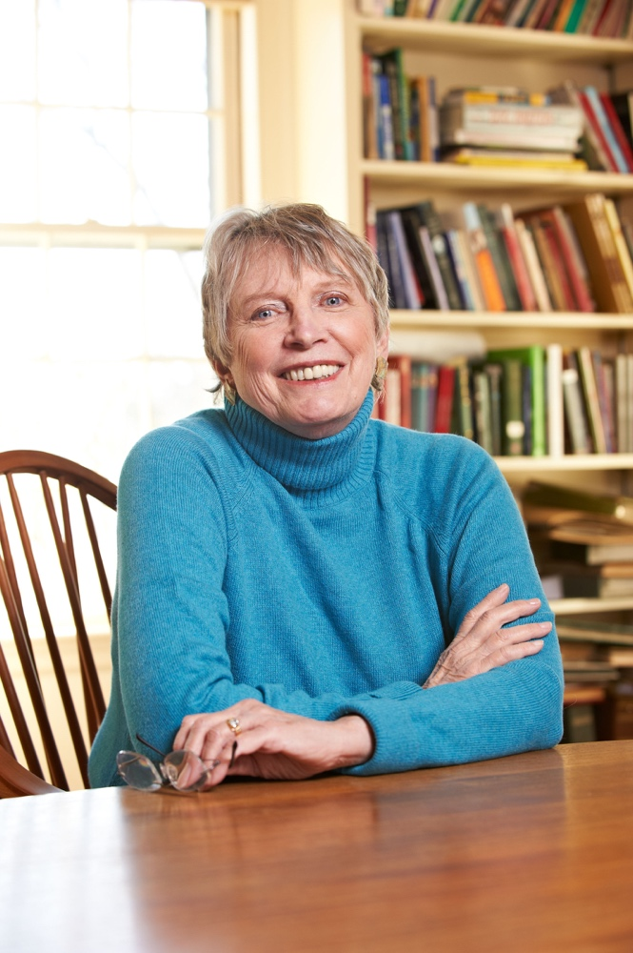

Photo taken from Flickr website: https://www.flickr.com/photos/ala_members/14152761743
http://www.ipl.org/div/askauthor/Lowry.html

Gathering Blue follows a young girl named Kira who has just lost her mother to a strange illness that affected only her. In this world, the sick and “damaged” people are disregarded and shunned away from society. Kira was born with a limp leg and was only allowed to remain alive because her mother begged and argued that her father was someone notable. Kira never met her father and is under the impression that he died by being attacked by vicious beasts. A woman named Vandara seeks to claim Kira’s mom’s land but fails to do so when the Council of Guardians says Kira should be saved because of her great talent with threading. They need her to fix a gown that is thought to hold all of the history of the world. Kira is trained by an old woman named Annabella who knows how to dye threads in color taken from leaves and other mixes. Kira finds her new living situation to be constraining which also leads to her discovering the dark truth behind the reality of the society she lives in.

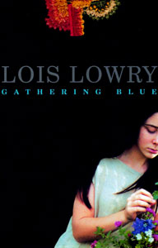

QUOTES | RELEVANCE
“It was the job that Kira usually did, the tidying up. She was not permitted to weave yet, though she had always watched carefully how it was done and thought that she could have, if they needed her. She had not been at the weaving shed in many days, not since her mother’s illness and death. So much had happened. So much had changed” (53).  “And maybe she would ask Matt too. Wild little thing that he was, Kira had no doubt that Matt had crossed the boundaries often and had gone to places tykes were not supposed to go. She laughed quietly, thinking of Matt and his mischief. He spied on everything, knew everything. Had she and Thomas not stopped him, he would have tagged along with the men on the hunt and put himself in danger. Perhaps he had done it before” (116).  “As she watched, he touched his own face. He ran his hand over the scars, feeling the edges; then he followed the jagged skin down the side of his own cheek, along his neck. Finally, he reached into his blue shirt and pulled forward the leather thong that hung there. As he held it in his hand, she saw the polished half-rock that matched her own. ‘Kira’ he said, but he did not need to tell her now, because she knew, ‘my name is Christopher. I’m your father” (198). | This is a scene in which Kira returns to the territory she once lived in with her mother, before her passing. It is a scene in which she is seen finally absorbing how different her life has become and how she will never be able to return to the way things used to be. I think this quote highlights the strains of being forced to grow up very quickly, a situation many kids find themselves in.  Matt plays a very important role in Kira’s life. He is an innocent soul who guides Kira and is able to bring her joy in such a dark time in her life. Matt also assists Kira throughout the book because he keeps an eye out for her. Matt is ultimately the reason she discovers the truth about the Council of Guardians.  This is one of the last scenes in the book when a huge plot twist happens. Kira believed her father was dead for most of the novel but Matt is brave enough to go outside of the town’s boundaries where he discovers her father is alive. He wasn’t attacked by beasts after all. This changes Kira’s outlook on everything and the novel ends shortly thereafter but suggests that she is going to change society and reveal the truth to everyone.

Text Complexity

Lexile level 680L

This falls under a 3rd grade reading level. The text is limited in complexity and uses simple sentence structure. However, I do feel this would be better suited for a student who is 10-12 years old. The content is appropriate for a younger child. There is no mention of profanity or sexual content. The focus is on family and strengthened friendships.

ATOS level 5.0

I do believe the ATOS score is more appropriate for this text. It means that it is intended for fifth graders. I do think students in this grade would enjoy and fully comprehend the text itself. Gathering Blue would be too easy of a read for students whose reading levels are higher.

Within the Classroom

-In order to teach this novel, I would definitely begin by having my students participate in popcorn reading whole pages of the novel aloud. Considering the students would likely be in fifth grade, having them participate in reading aloud would ensure their full attention and also make sure they are reading the book since life outside of the classroom can be hectic.

-Once we made it to the middle of the book, where Kira’s talent is fully divulged, I pass out blank sheets of paper and have students draw a map of the city Kira lives in. This would help them to see that this is a novel centered around a dystopian society. I feel that drawing the map itself would also encourage students to use their imagination while reading so that they are able to picture Kira and her surroundings in their mind.

-Before beginning our reading for the day, I would have students do a quick-write in which they say what they hope will happen next in the novel or what their favorite scene was. This would ensure their full attention.

-Another fun quick-write I would have them do at the end of the novel is writing which character they would be if they could be and why. I would also ask them to write whether or not they liked the ending and if they didn’t I would ask them to write how they would have written it if they were the author.

Why Students Should Read Gathering Blue

-This book deals with the loss of family (i.e. Kira losing her mother). I think this is a topic many students have faced or will face in the future. It would be helpful for them to read this novel in order to see perseverance is the only form of coping necessary.

-This is a good read for students who are artistically inclined. Kira herself is a weaver and she has two friends with her at the house of the Guardians who are singers and wood carvers. Art plays a huge role in this novel and can fuel the hearts and inspire students to delve further with their art.

-Kira is a character who has a deformity but still manages to strive for the best and always think positive. I think many students face insecurities with their own appearance and this novel might help them to see that the world is not limited to that.

Kelsey Mullins
ENGL 112B
Book Talk

