Miguel Lomeli
Dr. Warner
ENGL 112 B
3 April 2018
Other Side of the Picket White Fence

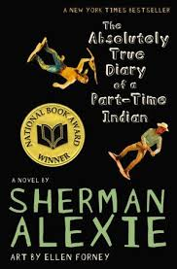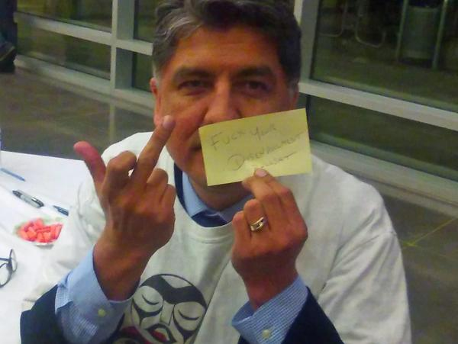

Biography

Winner of the PEN/Faulkner Award for Fiction, the PEN/Malamud Award for Short Fiction, a PEN/Hemingway Citation for Best First Fiction, and the National Book Award for Young People's Literature, Sherman Alexie is a poet, short story writer, novelist, and performer.

He has published 26 books including his recently released memoir, You Don't Have to Say You Love Me, his first picture book, Thunder Boy Jr, and young adult novel, The Absolutely True Diary of a Part-Time Indian, all from Little, Brown Books; What I've Stolen, What I've Earned, a book of poetry, from Hanging Loose Press; and Blasphemy: New and Selected Stories, from Grove Press.

He has also published the 20th Anniversary edition of his classic book of stories, The Lone Ranger and Tonto Fistfight in Heaven.

Smoke Signals, the movie he wrote and co-produced, won the Audience Award and Filmmakers Trophy at the 1998 Sundance Film Festival.

A Spokane/Coeur d'Alene Indian, Alexie grew up in Wellpinit, Washington, on the Spokane Indian Reservation.

Alexie has been an urban Indian since 1994 and lives in Seattle with his family.

http://fallsapart.com/press/
Synopsis
Imagine living in a world perceived to be outside of civilization, from a place were ones group used to be considered savages. Now are is stereotyped for what the colonizers brought to their culture with views of the poverished life on the reservation. Then acknowledging that the only way one can better the chances of living a better future is by stepping out of the comfort of your community, and culture. Sherman Alexie capture’s the feeling of what it means to be split between two worlds, to have that self conflicting battle with identity. The double consciousness of having one foot in one assimilated society and one foot in your roots. When Junior decides to leave the rez for a chance to become somebody in a society that already discriminates anything from his culture, he puts himself in a state of vulnerability. Having to not only battle the outsiders for trying to fit in, but his own kind for leaving.

Quotes

“Let me repeat that: MR. P SOMETIMES FORGETS TO COME TO SCHOOL!... It was like some kind of prison-work farm for our liberal, white, vegetarian do-gooders and conservative, white missionary saviors (29-30).”
This quote says a lot about both parties. One side the teachers are underpaid and feel as if they should be teaching somewhere else. To them this is seen as charity work they do not want to do. Living behind the school in an old compound isn’t a great way to build a positive environment where teachers can thrive in. Second, even though they were placed on the reservation, they are still teachers and have to believe in their students. The teachers have already given up and don’t expect much of his students. Showing up in your pajamas and slippers to teach? I can see if it was a school spirit day but just because shows he has no interest or passion for teaching these reservation kids. Adding more fuel to the statistical flame of these Rez kids not becoming anything. An example of our US Government doing all they can to ensure the positive outcome of the lives and cultures they are continuing to destroy.

This pic is just a powerful message. I believe it might have been either Langston Hughes or W.E.B. During Bois that discussed the identity issue of double consciousness. Having one foot in white, assimilated America and one foot in your own ethnical roots and culture. Where one that tries to assimilate is seen as the traitor and someone who is denying their heritage and one who doesn’t assimilate can see all the missed opportunities that lie ahead. Here junior has the struggle that many of us have within ourselves when with various groups. There are two people trapped inside one to be a chameleon in the colonizers world.

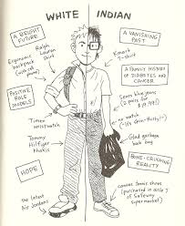-p.57
“And I was making the attempt, too… We were supposed to disappear (216).”
Junior speaks his heart out when he is talking about life on the Rez. He knew how addicted his people were to alcohol and all the problems the white man brought onto his land. What he is talking about here is genocide that is happening to his people. Everyone on the Rez drinks alcohol because the liquor stores and bars are what’s on every corner. At a young age he was able to see this and his only way out was to leave the place where he called home and is comfortable within his own and go out to white America where he would be harassed and discriminated for being born the way he was. Native American. An ethnicity the government wants to eradicate as quickly as possible.

How I would teach this book
The way I would teach this book is under the theme of American Dream. I imagine it being a companion to The Great Gatsby by F. Scott. Fitzgerald and incorporating other types of American Dreams. In order to show the students that the dream is different for many of us based on different backgrounds. Along with the risk that many of us have to take in order to achieve whatever the dream may be but also to understand how hard it is for those outside the privileged realm. I had the luxury of seeing how well it worked with middle schools in an impoverished area because they were able to connect with the text. It all depends on the area and knowing your audience to get a grasp of what will stick and what will not. Sherman Alexie talked about how he wrote a book about his life so if white people didn’t feel anything for his stories or life, they would feel something for his character.

Reading level recommended
Ages 12 and up
Grades 9-12

