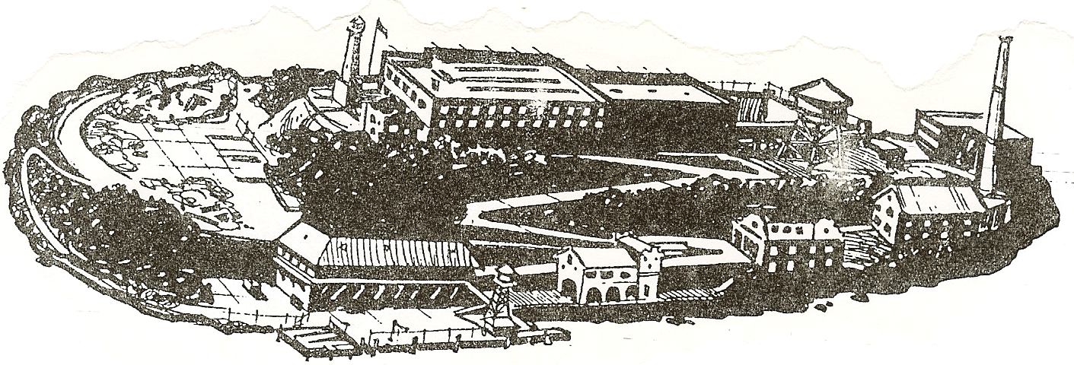
Alcatraz Tour
Saturday, November 18, 2006
9:15 – 2:00 PM

Wear warm clothing and comfortable walking shoes, because we will be hiking up
and down some steep rocky trails on the island.

We will meet at Pier 41 at 9:15 AM on Saturday!!
- I will be in front of the Pre-paid/Will Call ticket window at Pier 41 with your tickets. The boat boards at 9:45, and leaves promptly at 10:15.
- Once on the boat, we will meet up on the top deck for photos and to plan the tour.
- The tour itself will take about three hours. When we get back to shore, you are free to enjoy the rest of your afternoon in beautiful San Francisco!

To get there:

Take 280 North into San Francisco. Get off at King Street (the exit after 6th Street), and continue straight down King, past PacBell Park. King turns into Embarcadero. Follow Embarcadero along the waterfront to Pier 41/Fisherman’s Wharf.
(Note: When you first get off at King, as you pass PacBell Park you may notice there is a Pier 40 toward the right. That is not the one we want – Pier 41 is several miles down the Embarcadero beyond PacBell Park.)

Getting to Pier 41 is the easy part; the hard part is parking. It is very expensive and/or hard to find. The lot across from Pier 41 is the easiest, but it costs up to $35.00 for the day. I would suggest you arrive early enough to find a more reasonable lot! The lot at Bay and Embarcadero (across from Pier 35) is supposed to be pretty cheap, and only a couple of blocks from Pier 41. Since we are going on a late boat, IT WILL BE CROWDED!!! It would be smart for you to arrive early!!!!

See you Saturday, no later than 9:30, please!!!

IMPORTANT!!!
- DO NOT BE LATE!!! I WILL NOT WAIT LONGER THAN 10:00!!
If you have purchased tickets, and find out you cannot make it, let me know immediately! I will have already paid for the tickets, and I cannot get your money back unless we can sell the tickets to someone.
Home: 408-779-4229/Car: 408-710-8519

