Instructions: Write your name on the back page, top right corner. This is a closed-book exam. You are allowed to use the FORMULAS and TABLES for Moore (provided) and your calculator. Point values are indicated in [square brackets].

1. A website ranks hospitals based on their quality. Below are several variables that contribute to this ranking. Indicate whether the variable is categorical or quantitative.

(a) Percent of patients who experience infections following surgery. [1 pt]

(b) Hospital type: community hospital, not for profit, for profit. [1 pt]

2. Assume that T4-helper cell counts in a non-HIV population follows approximately a Normal distribution with mean 10,000 and standard deviation 1,600 cells per deciliter.

(a) According to the 68-95-99.7 rule, what range of T4-helper cell counts covers the center 95% of counts? [1 pt]

(b) What percentage of counts are less than 6800? [1 pt]

(c) Counts less than 5,000 are classified as immuno-deficient. What percent of this population is classified as immuno-deficient? [2 pts]

(d) People with counts over 14,500 are classified as hyper-sensitive. What percent of this population are hypersensitive by this criterion? [2 pts]

3. Data on water fluoridation levels and dental cavity rates per 100 children from 9 cities are:

Fluoride level | 0 | 0 | 0.1 | 0.2 | 0.2 | 0.3 | 0.4 | 0.5 | 0.6
Cavities per 100 | 825 | 710 | 706 | 703 | 733 | 652 | 556 | 444 | 412

(a) What is the explanatory variable in this analysis?

(b) What is the response variable?

Here is the scatter plot of these data.

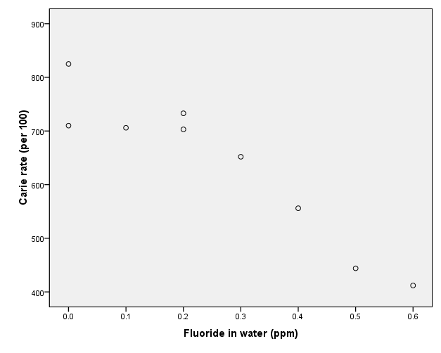

(c) Describe the form the observed relationship.

(d) Describe the direction of the relationship.

(e) Describe the strength of the relationship. (Hint: the correlation coefficient is reported on the next page. This will help you objectively describe the strength of the relationship.)

(f) Are there any outliers or influential observations in these data? (If so, identify.)

-- This problem is continued on the next page --

A computer program calculates the following statistics for the data
$\bar{x}$= 0.256, s_{x} = .2128, $\bar{y}$ = 637.89, s_{y} = 138.591, r = −.942.
.
(g) Using the statistics calculated on the prior page, find the slope of the regression line for predicting the cavity rate from the fluoride level. Show your work. (Yes, you may check your results with your calculator.)

(h) Find the intercept of the regression line.

(i) Write the regression equation.

(j) According to your regression line, how much does cavity rates decline per unit of fluoride added to the water, on the average.

(k) What percentage of the cavity rate can be explained by the relationship between fluoride levels and cavity rates?

4. Stress levels may be related to the risk of heart attacks in some populations. Stress levels were determined in a sample of 8,562 heart disease-free individuals. Individuals were followed for 5 years and the number of heart attacks was noted. Cross-tabulated data are as follows:
(a) What percent of the sample was classified has high stress level? (Report your results professionally in the form “x.x%” for all parts of this question.)
 | Low stress | Intermed. stress | High stress | Total
Heart attack | 103 | 205 | 54 | 362
No heart attack | 3024 | 4561 | 615 | 8200
Total | 3127 | 4766 | 669 | 8562

(b) What percent of the sample experienced heart attacks?

(c) Calculate the conditional percents that compare heart attack rates among the groups defined by their stress level. [3 pts]

(d) Is there an association between stress level and heart attacks? How so?
5. A recent HW exercise (ex. 6.25) had you compare the admission rates of male and female applicants to professional schools. Data are as follows:

 | Business |  |  |  | Law
 | Admit | Deny |  |  | Admit | Deny
Male | 480 | 120 |  | Male | 10 | 90
Female | 180 | 20 |  | Female | 100 | 200

(a) Combine the data from the two schools to form a single table gender by decision for the two professional schools together by summing entries in these tables.

 | Both schools combined
 | Admit | Deny
Male
Female

(b) From the two-way table for both schools combined, calculate the percent of male applicants who are admitted

(c) From the two-way table for both schools combined, calculate the percent of female applicants who are admitted.

(d) Note that the school admits a higher percent of male applicants. However, when you compute separately the percent of males and female applicants admitted by the business school females outpace males (480 / 600 = 80.0% for males vs. 180 / 200 = 90.0% for females). The same is true within the law school (10 / 100 = 10.0% for males vs. 100 / 300 = 33.3% for females). This is Simpson’s paradox: both schools admit a higher percent of women, but overall, a lower percent of female applicants than male applicants are admitted. Explain as if speaking to a skeptical reporter, how it can happen that the university appears to favor males, when each school individually favors females. [2 pts]

