Computational Public Health Statistics (HS267)

Lab Workbook

San Jose State University
Department of Health Science

B. Gerstman
Version: December 2005

Table of contents

Introduction (Rules and Suggestions)
- Means and variances
- ANOVA
- ANOVA topics (post hoc comparisons, conditions, non-parametrics)
- Correlation and regression
- Cross-tabulated counts
- Relative risks and odds ratios
- Stratified analysis (introduction to confounding and interaction)
- Data management
- Power and sample size

Introduction (Rules and Suggestions)

Labs. The lab is an important part of the course. You should complete each lab each week unless otherwise specified by the instructor. Lab Workbooks will be checked periodically for neatness and completeness.

Premise of the Lab. The premise of this lab is to analyze data from different studies to reveal relations between variables. The object is for you to learn methods and principles applicable to a broad range of public health studies.

College Computer Accounts. During the first session of the semester you must procure a College of Applied Sciences and Arts (CASA) computer account. You need a new account each semester -- your HS 167 account will not longer work. Once you get your account, write down your ID and password and bring this information to lab. You (not the instructor) are responsible for maintaining your computer account. If you have difficulties with your account, contact the technical staff via email tech@casa.sjsu.edu.

The course assumes you are familiar with Windows computers. We do not teach file management and computing basics in this course. If you do not know how to manage files on a Windows computer, please learn how to do so before entering HS 267.

Software. We rely on three computer programs in this course. These are: (1) SPSS (version 11 or higher), (2) EpiData (version 3 or higher), and (3) WinPepi. Although the student version of SPSS is adequate for many of the labs, you will occasionally need the full version of the program. The full version of the program is installed in lab. You can also purchase the SPSS Graduate pack which is the full version in the campus store. EpiData and WinPepi are freeware and can be downloaded via links on our website. All programs are installed in the computer lab.

Lab 1: Variances and means

Lab 1, Part 1 (Basic stuff)

Comparison A. Group 1 has values of {10, 30, 50, 70, 90}. Group 2 has values of {30, 40, 50, 60, 70}. We plot these data as leaves on a common stem:

Group 1 Group 2
0|1|
|2|
0|3|0
|4|0
0|5|0
|6|0
0|7|0
|8|
0|9|
(x10)

This side-by-side plot helps us compare group:

- shapes
- locations
- spreads

Because data are small (n₁ = n₂ =5), we can not make reliable statements about shape. It is clear, however, that groups have identical central locations. It is also clear that group 1 has much greater spread than group 2.

Differences is location and spread can be summarized numerically with means and standard deviations.

Calculate the mean of group one, 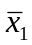 =

Calculate the mean of group two, 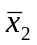 =

These means should be identical (since central locations are identical).
Recall that:
- the sum of squares is the sum of the deviations around the mean, squared: 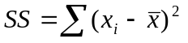
- the variance is the sum of squares divided by n minus 1: 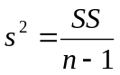
- the standard deviation is the square root of the variance: 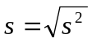

The standard deviation of group 1 is calculated:

Obs | Values | Deviations | Squared Deviation
1 | 10 | 10 - 50 = -40 | -40² = 1600
2 | 30 | 30 - 50 = -20 | -20² = 400
3 | 50 | 50 - 50 = 0 | 0² = 0
4 | 70 | 70 - 50 = 20 | 20² = 400
5 | 90 | 90 - 50 = 40 | 40² = 1600
Sums: | 250 | 0 | SS₁ = 4000
= 250 / 5 = 50
s²₁ = SS₁ / (n₁ - 1) = 4000 / 4 = 1000
s₁ = √s²₁ = √1000 = 31.6228
Calculate the standard deviation of group 2.

Obs | Values | Deviations | Squared Deviation
1 | 30
2 | 40
3 | 50
4 | 60
5 | 70
Sums  | 250 | 0 | SS₂ =
= 50

s²₂ =

s₂ = √s²₂ =
Notice that the standard deviation of group 2 is much smaller than the standard deviation of group 1, reflecting less variability in this group.
Rounding

Students often have questions about rounding. The first rule of rounding is to apply judgment so your final statistic reflects the precision of the measurement. To report too many decimal places is pseudo-precision. To report too few places losses information.

The second rule is to keep tabs on significant digits. Significant digits convey information. When counting significant digits, start at the first non-zero digit and end at the last digit in the number. For example, 1237 has four significant digits. So does 1.237. So does 0.00001237. On the other hand, 12.3700 has six significant digits because the zeroes at the end of the number presumably reflect confidence up to one in ten-thousand.

Consider weights of 1.237 kilograms and 1.2 kilograms. Based on this information, we would assume the first measurement is more precise than the second. The first measurement is accurate to the nearest thousandth of a kilogram. The second is accurate to the nearest tenth of a kilogram.

When we present a result of 1.2 kilograms, we are really saying that we think the item weights is between 1.15 kgs. and 1.25 kgs. When we present a result of 1.237 kg., we are saying it weights between 1.2365 kgs. and 1.2375 kgs.

Questions:

How many significant digits does 4.8 have? ANS: 4.8 has two significant digits.
How many significant digits does .0000067 have? ANS: This also has two significant digits since leading zeroes are merely place holders for the order of magnitude of the measurement.

There may be some ambiguity with trailing zeroes in a large whole number. For instance, the average distance from earth to sun is about 93 million miles. In this form, the number has two significant digits and means we think the average distance from the earth to the sun is somewhere between 92½ to 93½ million miles. Suppose we write the distance as 93,000,000. Surely this distance is not accurate to the nearest mile. You must use judgment when interpreting significant digits. You must use judgment in all aspects of your life.

When you see a large round whole number, the zeroes may merely be place-keepers. To get around this problem, express the value in scientific notation. For instance, express 93 million miles as 9.310⁷ miles. On your calculator, this is displayed as 9.3E7.

Questions:

How many significant digits are in 4800? ANS: We are uncertain. The 4 and 8 are significant, but we can not tell whether the 0s in the tens and ones places are significant. “4800 ”may represent two or four significant digits.
How many significant digits are in 4800.0? ANS: 4800.0 has five significant digits. With 4800.0, the last zero is not needed as a place holder so all the digits must be significant.

Rounding Calculations - What is 16 divided by 6? The answer is 2b but your calculator says 2.666666667. At what point do you round the decimals when performing calculations? One solution to this problem is not to round at all. Store the result in the memory of your calculator for future use. This will maintain 16 or 32 significant digits.

The other solution is to think ahead, determine how many digits will be reported in your final answer and carry two additional significant digits beyond that throughout all calculations. For instance, if I wanted an answer with two-decimal place accuracy, I’d carry 2.666666667 as 2.6667.

Once an calculation is rounded, it cannot be un-rounded. Consider 1.2  1.2  1.5. To get an accurate answer, carry along extra significant digits in your intermediate calculations. This is because 1.2  1.2 = 1.44 and 1.44  1.5 = 2.16  2.2. If you had rounded 1.44 to 1.4 mid-stream, you would have calculated 1.4  1.5 = 2.1, which is off by nearly 5%. Wait until the end to round, if you can.

When working with your calculator, try not to re-enter an intermediate result you see on your screen. Instead, chain later calculations to earlier ones. For example, in calculating 2.00  6.000, these factors have three and four significant digits. Your final answer should have three significant digits. Finding 2 on your calculator gets you something like 1.414213562. Do not re-enter this number. Instead, press the [] key and then press 6. Your calculator will display an answer of 8.485281374, which you can then round to 8.49. If you had rounded earlier, entering 1.41  6, you would get an answer 8.46, which is too far off from the correct answer. Letting the calculator or computer carry full precision will avoid rounding error.

Scientific Notation

Scientific notation was developed to express very large and very small numbers. To write a large number in scientific notation, move the decimal point to the left until it is between the first and second significant digits; the number of places moved is the exponent. For example, 167 becomes 1.67  10² or 1.67E2.

Scientific notation removes the guesswork about how significant a large number is. 9.3E7 miles has two significant digits; it is accurate to the nearest million miles. 9.30000E7 has five significant digits, and it is accurate to the nearest hundred miles (0.0000110⁷ = 100 miles).

To write a small number in scientific notation, move the decimal point right until it has just passed the first non-zero digit. Write the number of places moved as a negative number in the exponent. Example: 0.0000894 must move the decimal point five places right to become 8.9410^{–5} or 8.94E–5.

To convert a number from scientific notation to ordinary decimals, reverse the process. A positive exponent indicates a big number: move the decimal point to the right. A negative exponent indicates a small number: move the decimal point to the left. For example, if the probability of an event is 6.014E–4, you must move the decimal point four places left to convert it to 0.0006014. If the population of the earth is 6.110⁹ people, you move the decimal point right nine places to convert to 6,100,000,000.

Lab 1, Part 2: Linoleic acid lowers LDL cholesterol without a proportionate displacement of saturated fatty acid (rassias.sav).

References

- Stemplots—HS167 lecture notes, unit 2
- Mean and standard deviation—HS167 lecture notes, unit 3
- F ratio test—Current HS 267 lecture and Rosner, 2006, pp. 310 - 317
- Unequal variance t test—Current HS 267 lecture and Rosner, 2006, pp. 317 - 322

A study by Rassias et al. (1990) tested the plasma cholesterol-lowering effect of dietary linoleic acid in twelve mildly hypercholesterolemia men and women. Plasma cholesterol levels at baseline (mmol/m³) in the 12 study subjects were:

6.0 6.4 7.0 5.8 6.0 5.8 5.9 6.7 6.1 6.5 6.3 5.8

A different (fictitious) group of individuals had the following plasma cholesterol levels:

6.4 5.4 5.6 5.0 4.0 4.5 6.0

Stemplot exploration

Show the data as leaves on a common stem. Use split-stem values and an axis-multiplier of ×1. Data for group 1 is already plotted.

Group 1 Group 2
|4|
|4|
|5|
9888|5|
43100|6|
75|6|
0|7|
(×1)
(mmol/m³)

How do the groups compare?

Mean and standard deviation
The mean group 1 is 6.192 mmol/m³. The standard deviation is 0.392 mmol/m³. Calculate the mean and standard deviation of group 2. Show all work! Put the final results in this table:
Group | n | (mmol/m³) | s (mmol/m³)
1 (Rassias data) | 12 | 6.192 | 0.3919
2 (Fictitious) | 7

Test of the variances

We want to test whether group variance differ significantly. The null hypothesis is that the variance in population 1 is equal to the variance in population 2. In statistical notation this is H₀: σ²₁ = σ²₂. (Statistical hypothesis always refer to population parameters and not to sample statistics!) Two different procedures may be used to test this hypothesis. These are:

- The F ratio test for unequal variance
- Levene’s test for unequal variance

We will do the F ratio test by hand and Levene’s test with SPSS.

The F statistic is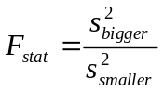 . Calculate this statistic for the data.

The F statistics has numerator df and denominator df. The numerator df is the sample size of the group with the bigger variance minus 1.

df_{numerator} = n_{numerator} - 1 =

The denominator df is the sample size of the group with the smaller variance minus 1.

df_{denominator} = n_{denominator} - 1 =

The F statistic is converted to a P value with an F table or computer program. Go to our website and download the F table. Print the tables and keep it in a safe place near your other statistical tables for future reference. Use the table to convert the F_{stat} to an approximate p value.

______ < P < _______

Is the difference significant? Y/ N

Test of the means, unequal variance t test

In the prerequisite course we covered the equal variance t test. That test assumed populations had equal variances, allowing us to pool sample variance to come up with a single estimate of variance. This approach makes little sense when population variances are non-uniform. When population variances are non-uniform, we use the following formula to calculate the standard error of the mean difference: 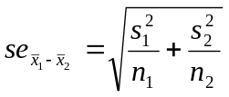. Calculate the standard error of the mean difference of our data using this formula:

The standard error of the mean difference is used to test whether population means differ significantly. In statistical notation, the null hypothesis is H₀: µ₁ = µ₂. The t_{stat} is the familiar 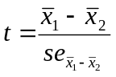. Calculate the t statistic:

This degrees of freedom for this t statistic is complex. When working by hand it is acceptable to use the smaller of df₁ = n₁ - 1 or df₂ = n₂ - 1 as a conservative estimate of the actual degrees of freedom. Calculate

df₁ = n₁ - 1 =

df₂ = n₂ - 1 =

Use the smaller of the above at the df for your the test when working by hand. Determine the P value based on this information.

Do means differ significantly?

SPSS computations

- Open SPSS.
- Create the variable CHOL for cholesterol
- Create the variable GROUP for the group indicator (1 or 2).
- Enter the data into SPSS.
- Click Analyze > Compare Means > Independent samples T test. Select CHOL as the Test variable and GROUP as the Grouping variable.
- Click the Define Groups button and enter the codes 1 and 2. Click “OK.”
- Your output should look like this:
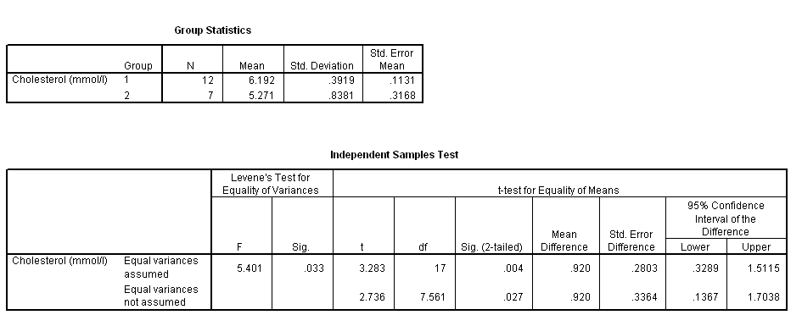

Review your output. Notice that SPSS does not perform a F ratio test but does perform Levene's test for equality of variances. Like the F ratio test, Levene’s procedure tests H₀: σ²₁ = σ²₂. However, Levene’s F statistic will NOT match the F ratio statistics you calculated by hand—it is an entirely different procedure. Although you do not yet have the ability to calculate Levene’s statistic, you do have the ability to interpret its P value, which is .033. Does Levene’s test suggest variances differ significantly? Y/N

Both the equal variance t test and unequal variance t test are reported by SPSS. Results for the “equal variances assumed” line were covered last semester. The “equal variances not assumed” statistics should match the statistic you calculated by hand for this lab. In this analysis, the results of the equal variance t test and unequal variance t test differ a little. The equal variance t procedure derives a smaller P value (0.004) and a narrower confidence interval (0.3289, 1.5115) than the unequal variance procedure (P = 0.027, 95% CI for µ₁−µ₂ = 0.1367, 1.7038). It is therefore more prudent to go with the unequal variance t procedure results in this instance.

Lab 2: ANOVA

Analysis of variance is a method of comparing the means from multiple groups. In conducting ANOVA, it is useful to establish the following notation. Let:

- the mean of each group be denoted 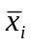
- the standard deviation of each group be denoted s_{i}
- the mean of all data combined be denoted (no subscript). This is the “grand mean.”
- k represent the number of group being compared
- n_{i} represent the size of group i
- N denotes the total sample size: N = n₁ + n₂ + … + n_{k}

Data: Weight gain and junk food (deermice.sav)

One theory suggests that the ubiquitous availability of junk food contributes to the high prevalence of obesity in our society. To shed light on the viability of this theory, fifteen lab mice were randomly assigned to one of three treatment groups. Group 1 received a standard lab animal diet, group 2 received a diet of junk food, and group 3 received a diet of health food. Weight gains (grams) over a 5 week period were:

Group 1 (standard diet): 11.8 12.0 10.7 9.1 12.1
Group 2 (junk food): 13.6 14.4 12.8 13.0 13.4
Group 3 (health food): 9.2 9.6 8.6 8.5 9.8

This type of design is a completely random ANOVA with fixed effects. The design is completely randomized because individuals in the study are randomly assigned to treatment groups. This allows us to assume that the variation in individual within each treatment group estimates the usual amount of variation in the population. The design is a fixed effects design (also referred to as “model I”) because the treatment was assigned as part of the experimental protocol.

The study considers two variables: a dependent variable and an independent variable. The dependent variable is the response variable or study outcome, which in this instance is weight gain. The independent variable is the explanatory variable, which in this instance “type of diet.”

Side-by-side boxplot

We use a side-by-side boxplot to explore group differences. Boxplot construction starts with the 5-number summary. Since n = 5 for each group, the 5-number summary is the data itself. Determine if there are outside values in any of these groups.

Group 1 five-number summary: 9.1 10.7 11.8 12.0 12.1

IQR = Q3 - Q1 =

Fence(upper) = Q3 + 1.5(IQR) =

Fence(lower) = Q1 - 1.5(IQR) =

Any outside?

Group 2 five-number summary: 12.8 13.0 13.4 13.6 14.4

IQR = Q3 - Q1 =

Fence(upper) =

Fence(lower) =

Any outside?

Group 3 five-number summary: _____ _____ _____ _____ _____

IQR = Q3 - Q1 =

Fence(upper) =

Fence(lower) =

Any outside?

Construct side-by-side boxplots on these axes:
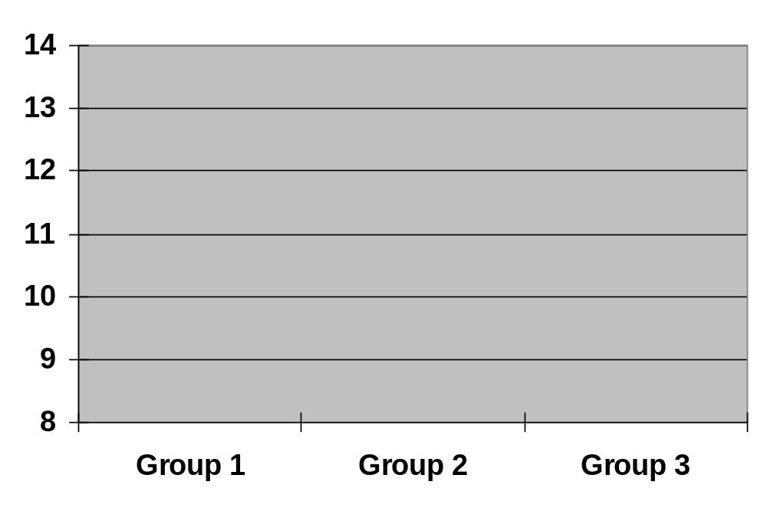

Discuss your findings. How do groups compare?

SPSS explore command

It is tedious to do many calculations by hand, so in practice, we rely on technology for most computations. Let us use SPSS to calculate routine summary statistics for the current dataset.

- Start SPSS and create variables for WTGAIN and GROUP.
- The data should be entered as follows:

Weight gain (gms.) | Group
11.8 | 1
12.0 | 1
10.7 | 1
9.1 | 1
12.1 | 1
13.6 | 2
14.4 | 2
12.8 | 2
13.0 | 2
13.4 | 2
9.2 | 3
9.6 | 3
8.6 | 3
8.5 | 3
9.8 | 3

- Save your data as lab_experiment.sav.
- Click Analyze > Descriptive Statistics > Explore. A dialogue box will appear. Move WTGAIN into the Dependent variable box and the GROUP into the Factor list.
- Go to the output window. Do your boxplots look like those produced by SPSS?
- Click Analyze > Compare means > MEANS.
- Enter WTGAIN as your dependent variable and GROUP as your independent variable and run this procedure.
- Label your output with to show 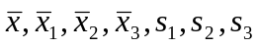.

Analysis of variance (ANOVA)

One-way analysis of variance (ANOVA) tests the null hypothesis “all the populations being considered have equal means. For our purpose, the null and hypotheses are:

H₀: µ₁ = µ₂ = … = µ_{k}
H₁: at least one of the µ_{i}s is different

where µ_{i} is the mean in population i. We are considering k populations. Notice that H₁ is neither one-sided nor two-sided. It does not state which population means differ, or how so. It states merely that the null hypothesis is false.

The type of ANOVA we are currently pursing is called “one-way ANOVA.” The “one-way” refers to the fact that the effect of one explanatory factor are being considered. In this instance, the single explanatory factor is “diet type.”

For one-way ANOVA, we divide the variability of the data set into between group variability and within group variability. The variability between groups signals group differences. The variability within groups is a measure of the “diversity” (variability) of the dependent variable.

Between group statistics

We quantify the “between group with the sum of squares between, which is given by this formula:

where is the grand mean (i.e., the mean for observations from all the groups). When considering three groups, .

Calculate the sum of squares between for the data set we have been considering.

The degree of freedom between (df_{B}) is the number of groups minus 1.

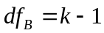 =

The variance between (also called Mean Square Between) is equal to the sum of squares between divided by the degrees of freedom between.

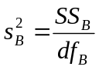=

Within group statistics

When working with three groups, the sum of square within is

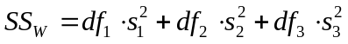

where df_{i} = n_{i} – 1 and s²_{i} is the variance in group i.

Calculate the sum of squares within for the data set we have been considering.

The “degrees of freedom between” is equal to the total number of individuals (N) minus the number of groups (k).

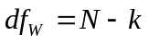 =

The within-group variance (s²_{W}) is the sum of squares within (SS_{W}) divided by the degrees of freedom within (df_{W}).

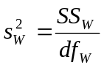 =

ANOVA Table

Elements of the ANOVA are organized to form an ANOVA table. Fill in values for the data set we’ve been considering in this ANOVA table:

Source | Sum of Squares | Degrees of freedom | Mean Squares
Between | SS_{B} = _______ | df_{B} = _______ | s²_{B} = _______
Within | SS_{W} = _______ | df_{W} = _______ | s²_{W} = _______

The F statistics is the Mean Square Between (s²_{B}) divided by the Mean Square Within (s²_{W}).

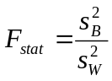 =

Use your F table to determine the approximate P value for the problem.

P < _________

Is the difference between groups significant?

What does this suggest about the effect of diet?

ANOVA in SPSS

- Open deermice.sav
- Click Analyze > Compare Means > One-way ANOVA.
- Run the program and print the output.
- Label s²_{B}
- Label s²_{W}
- Label the F_{stat}, the numerator df, denominator df, and p value.
- Make certain your hand calculations match SPSS’s.
- You instructor may ask you to turn in the labeled output.

.

Conditions for inference

All statistical methods require “conditions” or, as statisticians like to say, “assumptions.” Some conditions address the distribution of the population, while others address validity.

The distributional assumptions for ANOVA are “Normality” and “equal variance.” In you own words (in note form), define what each of these mean.

Description of the Normality assumption:

Description of the equal variance assumption:

Validity assumptions are even more important that distributional assumptions. The validity assumptions address sampling, data quality, and confounding. In note form, define what each of these conditions means.

No selection (sampling) bias:

No information bias:

No confounding:

Lab 3: ANOVA-related topics

Purpose: To conduct post hoc comparisons of means (Rosner, 2006, pp. 564 - 576), assess the equal variance assumption with Levene’s test (www.itl.nist.gov/div898/handbook/eda/section3/eda35a.htm), and conduct a non-parametric Kruskal-Wallis comparison of groups (Rosner, 2006, pp. 600 - 606).

Data (Weight gain and junk food)

Last week's analysis of weight gain revealed a significant difference in groups (p  0.0000). The greatest average gain occurred in group 1 and the smallest occurred in group 3. Data showed

Group | n | mean | standard deviation
1 (standard) | 5 | 11.140 | 1.270
2 (junk) | 5 | 13.440 | 0.623
3 (health) | 5 | 9.140 | 0.581

The ANOVA results were:

Source | Sum of Squares | Degrees of freedom | Mean Squares
Between | 46.30 | 2 | 23.15
Within | 9.37 | 12 | 0.78

F_{stat} = 29.69 with 2 df and 12 df, P ≈.0000.

This told us groups differed significantly but did not tell us which groups differed. Although it is safe to say that group 2 is significantly different than group 3 (the largest difference), it is conceivable that group 1 and group 2 do not differ significantly and groups 1 and 3 differ significantly. A detailed follow-up analysis to decide which of the population means differ is needed. These take the form of post-hoc comparisons.

Three post hoc tests are considered:

- Group 1 versus group 2 (H₀: µ₁ = µ₂)
- Group 1 versus group 3 (H₀: µ₁ = µ₃)
- Group 2 versus group 3 (H₀: µ₂ = µ₃)

Post-hoc comparisons by the LSD method

The simplest way to perform post hoc comparisons is by the least squares difference (LSD) method. The LSD method uses the Mean Square Within as a pooled estimate of variance within groups (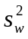). We get this value from the ANOVA table. For the current data, = _________ .
The variance within groups is used to calculate the standard error of mean difference (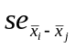) according to this formula 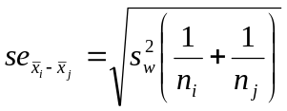. When n is the same for the three groups, the standard error of the difference is the same for all comparisons. Calculate the standard error of the difference:

The t_{stat} is equal to the observed mean difference divided by the standard error: 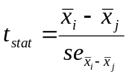. Calculate the t statistic for testing H₀: µ₁ = µ₂

Calculate the t statistic for testing H₀: µ₁ = µ₃:

Calculate the t statistic for testing H₀: µ₂ = µ₃:

These t statistics have df_{w} = N - k degrees of freedom. This is because the pooled estimate of variance within groups is based on all N observations. We loose k degrees of freedom because k means were estimated as part of the variance calculation. Calculate the df_{w} for this problem.

df_{w} = N - k =

The t statistics are converted to p values. For post hoc comparisons, it is helpful to get a precise p values. Technology is needed for this purpose. We have several technologies for this purpose. These are:

- StaTable > Students t (Web, Windows, or Palm version)
- WinPepi > WhatIs > P value (Windows)
- SPSS (Windows and Mac)

Use one of these technologies to determine the p value for each post hoc comparison. The degrees of freedom = df_{w} = N - k = 15 - 3 = 12 in each instance.

H₀: µ₁ = µ₂ | t_{stat} = | P =
H₀: µ₁ = µ₃ | t_{stat} = | P =
H₀: µ₂ = µ₃ | t_{stat} = | P =

Interpret your results:

Bonferroni’s adjustment

As discussed in lecture, post-hoc multiple comparisons increase the likelihood of a family-wise type I error. This can be a problem when many comparisons are made.

The simplest approach for limiting the number of family-wise errors is to apply Bonferroni’s adjustment. SPSS applies Bonferroni’s adjustment by multiplying the p values from LSD tests by the total number of comparisons (in this instance, three).

For H₀: ₁ = ₂, p_{Bonf} = p × 3 =

For H₀: ₁ = ₃, p_{Bonf} = p × 3 =

For H₀: ₂ = ₃, p_{Bonf} = p × 3 =

At a family-wise  of 0.05, which of the above comparisons are significant?

At a family-wise  of 0.01, which comparisons are significant?

SPSS: Replicate computations in SPSS by open the dataset deermice.sav and selecting Analyze > Comparison of Means > One-way ANOVA > Post Hoc button > LSD and Bonferroni. Print the output and label it extensively so that you can connect each column and entry with notation used in class.

Levene’s test

Recall that the ANOVA combines group variances to derive a pooled estimate of variance within group. This assumes variances in the k populations are homogeneous.

Earlier this semester, Levene’s test was introduced as an alternative to the F ratio test as a way to test variances for homogeneity. Levene’s test can also be used to compare k independent groups.

The null hypothesis for Levene’s test is that the “variances in the k populations are equal.” In statistical notation this is H₀: σ²₁ = σ²₂ = … = σ²_{k}. The alternative hypothesis is that the at least one of the populations has a different variance.

Open the data set you used last week (deermice.sav) in SPSS and run the Compare means > one-way ANOVA procedure. click the Options button. Check the homogeneity of variance box. Run the program and then go to the output window. Then report:

Levene’s F_{stat} =

df₁ =

df₂ =

P =

Is the evidence the variances differ significantly at alpha = .05? Yes or No (circle)

Non-parametric tests

The methods for inference about quantitative response variables we have used so far have assumed the sampling distributions are means are approximately Normal. The methods are robust—resistant to violations in Normality—when samples are at least moderate in size (and the Central Limit Theorem kicks in). But what can we do if the population is highly skewed or contains outliers and the data set is small? What can we do when the variances of group are very unequal and we want to pursue an ANOVA? Here are some options:

- If there are outliers, you have choices to make. To decide what to do, you must find the cause of the outlier. If the outlier represents an incorrect measurement or data entry problem, you should either correct the error or remove the outlier and analyze the remaining data. If the outlier appears to come from a different population, it should be removed. On the other hand, if the outlier appears to belong with the data, it should be left in and analyzed as part of the data.

- You can mathematically transform the data. Transformations, such logarithms, inverses, and square roots, can “pull in” long tails of distributions and make the results more nearly Normal. Mathematical transforms can also be used to make data more linear when necessary. We will introduce mathematical transformation methods in the next chapter.

- You can use non-Normal parametric models. These methods replace Normal distributions with more complex probability models. These methods are generally beyond the scope of this book.

- There are inferential procedures that do not assume any specific distributional form. These are called distribution-free or nonparametric methods. This brief section concerns one type of nonparametric procedure based on the ranks of observations in the data set. The rank tests we consider address the central location of the populations.

When a population is Normal (or at least symmetrical) we summarize its location with the mean. “Normal tests” (z tests, t tests, and ANOVA) address population means.

When distributions are skewed, we prefer use median as the measure central location. Non-parametric tests based on ranks can address population medians.

The following table compares the tests based on the Normal distribution with their non-parametric “equivalent:”

Setting | Normal test | Non-parametric test  (based on ranks)
One sample | One-sample t | Wilcoxon signed rank test
Matched samples | Paired t test / one-sample t applied to within-pair differences (delta)
Two independent samples | Independent t test (equal variance or unequal variance) | Mann-Whitney, Wilcoxon rank sum test, Kruskal-Wallis for two samples
Multiple independent samples | One-way ANOVA | Kruskal-Wallis test

Non-parametric tests are available through SPSS’S Analyze > Nonparametric Tests menu.

One-way ANOVA compares multiple groups when populations are approximately Normal and population variances are equal. When these distributional requirements are violated, we can no longer use regular ANOVA and use the non-parametric Kruskal-Wallis test instead. The Kruskal-Wallis test no longer requires Normality or equal variance. It still does require the validity assumptions like sampling independence. Only the Normality and equal variance conditions can be relaxed.

Recall that the ANOVA hypotheses are H₀: µ₁ = µ₂ = … = µ_{k} versus H₁: not all k population means are equal. The hypotheses tested by the Kruskal-Wallis procedure are:

H₀: all k populations have the same central location
H₁: the distribution of one or more of the populations is higher than the others

If all of population distributions have the same shape (not necessarily Normal), the Kruskal-Wallis hypotheses can be restated as:

H₀: all k populations have the same median
H₁: one or more of the population medians is higher than an other

We will rely on SPSS software to do the arithmetic for the Kruskal-Wallis test.

Data set 2: Alcohol consumption and socio-economic status

A survey looked at alcohol consumption according to socioeconomic status (Monder, 1987). Alcohol consumption was scored on a twelve-point ordinal scale with 12 indicating high alcohol consumption and 0 indicating no alcohol consumption (variable ALCS). The distribution of the data is asymmetrical:

Frequency Stem & Leaf

137.00 0 . 0000000000000000000000000000000000000000000000
114.00 1 . 00000000000000000000000000000000000000
55.00 2 . 000000000000000000
134.00 3 . 000000000000000000000000000000000000000000000
59.00 4 . 00000000000000000000
55.00 5 . 000000000000000000
23.00 6 . 00000000
23.00 7 . 00000000
19.00 8 . 000000
10.00 9 . 000
5.00 10 . 00
79.00 Extremes (>=11)

Stem width: 1
Each leaf: 3 case(s)

The independent variable is income graded on a 5 point scale with 5 indicating the highest income group (variable INC). Analysis of mean alcohol scores by income reveals:
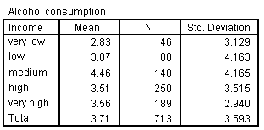

Levene’s test of H₀: σ²₁ = σ²₂ = σ²₃ = σ²₄ = σ²₅ shows significant differences in variances:

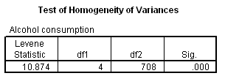

We want to test whether the populations have significantly difference central location and might consider using a one-way ANOVA for this purpose. However, conditions for ANOVA have been violated. What two conditions have been violated?

1. ____________________________________________________________

2. ____________________________________________________________

Because conditions suitable for ANOVA do not exist, a Kruskal-Wallis test is performed. The null hypothesis is H0: all k populations have the same central location. What is the alternative hypothesis?

H1: _________________________________________________________________

- Download the data set alcohol.sav from www.sjsu.edu/faculty/gerstman/datasets/.
- Open the data set in SPSS and run Analyze > Nonparametric Tests > K Independent samples.
- Use [ALCS] as the dependent variable and [INC] as the grouping variable.
- Click the Define range button and define the range for the grouping variable as 1 to 5.
- Click “continue,” and run the procedure.

The procedure compares mean ranks among the k groups. Whereas some software reports the Kruskal-Wallis H statistic for the test, SPSS converts the score to a chi-square to obtain a P value. Although we have not yet covered chi-square statistics, you can still interpret the p value. Report the p value:

P = _______________

Do the central locations of the populations differ significantly?

Lab 4: Correlation and Regression

Correlation and regression are used to study the relationship between two quantitative variables. One variable, X, is the independent (explanatory) variable. The other variable Y, is the dependent (response) variable.

To illustrate correlation and regression, let us look at the classical ecological study of smoking and lung cancer by Richard Doll (Doll, R. (1955). Etiology of lung cancer. Advances in cancer research, 3, 1-50.). Data consisting of national per capita cigarette consumption in 1930 (variable CIG) and lung cancer mortality in 1950 (variable LUNGCA):

Observation | Country | CIG | LUNGCA
1 | USA | 1300 | 20
2 | Great Britain | 1100 | 46
3 | Finland | 1100 | 35
4 | Switzerland | 510 | 25
5 | Canada | 500 | 15
6 | Holland | 490 | 24
7 | Australia | 480 | 18
8 | Denmark | 380 | 17
9 | Sweden | 300 | 11
10 | Norway | 250 | 9
11 | Iceland | 230 | 6

Which of these variables is the independent variable?

Which variable is the dependent variable?

Scatterplot

The first step in analyzing bivariate quantitative data is to create a scatter plot of data points. Plot the data below. Points for the U.S., Great Britain, and Iceland are already plotted.
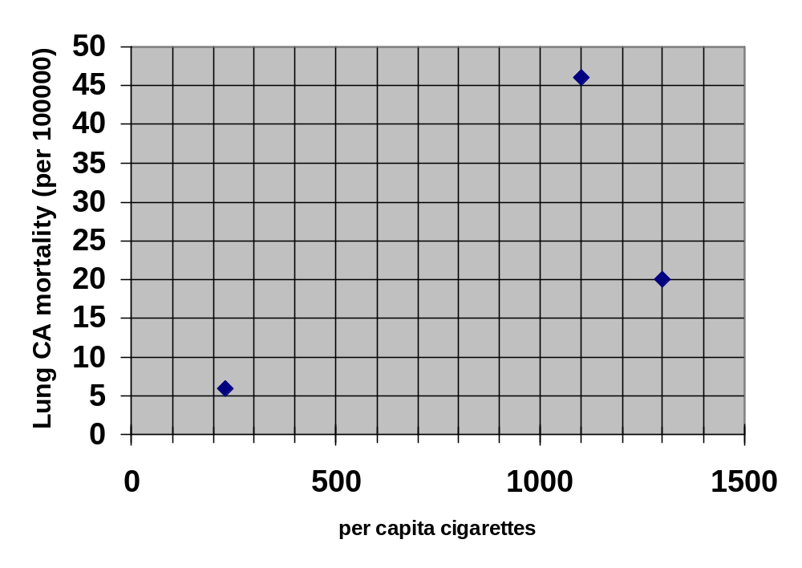
Can the relation between per capita cigarette consumption (X) and lung cancer mortality (Y) be described by a straight line?

Does the relation appear to be positive, negative, or “nil”?

Are there any outliers in the data? If yes, which country / countries?

Pearson’s Correlation Coefficient

Pearson’s correlation coefficient (r) is a statistic that provides a unit-free measure of the strength of the linear association between X and Y. (It is not appropriate for describing non-linear associations.) An r of 0 indicates no linear association. An r of +1 indicates all data points fall perfectly on a positive trend line. An r of −1 indicates all points fall perfectly on a line with a negative slope.

Calculating r. There are several ways to calculate the correlation coefficient. The easiest way is to let the computer or calculator do it for you. It can also be calculated by hand using various sums of squares and cross-products. For the current data (n = 11), we note = 603.64 and = 20.55. Sums of squares and sums of cross-products are calculated as follows:

- The sum of squares of the independent variable 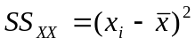= 1,432,255. This is just the numerator of the variance of X. Note that SS_{XX} = (n -1)s²_{x}
- The sum of squares of the dependent variable 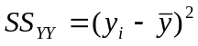= 1375. This is just the numerator of the variance of Y. Note that SS_{YY} = (n -1)s²_{Y.}
- The sum of the cross-products 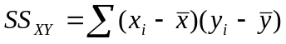. This quantifies the covariance of the two variables, showing the extent to which X and Y go together. When both the X value and Y value of a point are above average, the cross-product is positive. When both the X value and Y value of a data point are below average, the cross-product is also positive. On the other hand, when the values of the coordinates go in opposite directions, the cross-product component will have a negative sign. Here is how we calculate the sum of cross-products for these data:

x_{i} |  | x_{i} − | y_{i} |  | y_{i} − | (x_{i}- − )(y_{i} − )
1300 | 603.64 | 696.36 | 20 | 20.55 | -0.55 | -382.998
1100 | 603.64 | 496.36 | 46 | 20.55 | 25.45 | 12632.362
1100 | 603.64 | 496.36 | 35 | 20.55 | 14.45 | 7172.402
510 | 603.64 | -93.64 | 25 | 20.55 | 4.45 | -416.698
500 | 603.64 | -103.64 | 15 | 20.55 | -5.55 | 575.202
490 | 603.64 | -113.64 | 24 | 20.55 | 3.45 | -392.058
480 | 603.64 | -123.64 | 18 | 20.55 | -2.55 | 315.282
380 | 603.64 | -223.64 | 17 | 20.55 | -3.55 | 793.922
300 | 603.64 | -303.64 | 11 | 20.55 | -9.55 | 2899.762
250 | 603.64 | -353.64 | 9 | 20.55 | -11.55 | 4084.542
230 | 603.64 | -373.64 | 6 | 20.55 | -14.55 | 5436.462
 |  |  | 32718.182

The sum of the last column is the sum of the cross-products 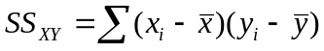= 32,717.
Calculate the correlation coefficient according to this formula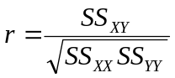.

r =

The correlation coefficient quantifies the direction and strength of the association between the variables. The sign of the coefficient indicates the direction of the association. Is the correlation positive, negative, or about zero?

The magnitude of the coefficient determines the strength of the association. The closer r is to 1 or −1, the stronger the association. If |r| > .7, the association is said to be strong. If |r| > .3, the association is said to be weak. Describe the strength of the association for the data.

Because of random variation, the correlation in the sample will differ from the correlation in the population. The correlation in the population is denoted ρ (“rho”). We often test whether the sample correlation coefficient is significantly different than 0. Under the null hypothesis, ρ = 0. Write the null hypothesis using statistical notation. Remember that the hypothesis statement should refer to the parameter ρ and not to the statistic r.

H₀:

The test statistic is t_{stat} = 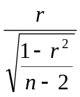 with df = n − 2. Calculate these statistics.

Use your t table to determine the P value: _______ < P < _______

Is the correlation significant at alpha = .05? Y/N

Is it significant at alpha = .01? Y/N

The test of H₀: ρ = 0 assumes the sample is a simple random sample of the population (sampling independence) and the population has a bivariate Normal distribution.

SPSS correlation

Replicate your analyses in SPSS.

- Enter or download the data set doll-ecol.sav. Open the data set in SPSS.
- Click Graph > Scatter > Define > etc.
- Click Analyze > Correlate > Bivariate
- Click the Options button on the Bivariate dialogue box and check the Cross-product deviations and Covariances box.
- Your output should look like this:

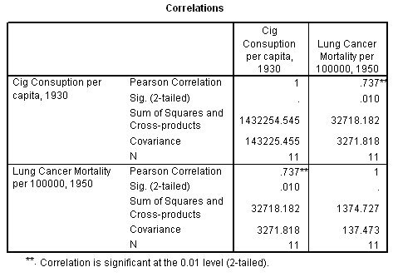

- On your copy of the output, label the following statistics: r, SS_{XX,} SS_{YY}, SS_{XY,} s²_{X}, s²_{Y}, the P value for testing H₀: ρ = 0.
- In addition, label the covariance. This is 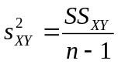 and is analogous to a variance. The covariance statistic quantifies the extent to which X and Y co-vary together.

Regression Model

Like correlation, regression is used to quantify the extent to which two quantitative variables go together. However, unlike correlation, regression quantifies the predicted change in Y per unit X (e.g., change in lung cancer mortality per unit change in per capita cigarette consumption).

Regression models are based on two parameters: the intercept (α) and the slope (β). The estimates for these parameters, a and b, are fit according to a least squares method that minimizes the squared residuals of the model. Formulas for calculating the intercept and slope estimate are given below.

Calculate the slope estimate b according to this formula 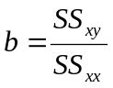=

Calculate the intercept estimate a according to this formula 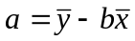 =

The parameters are used to define the regression model via this equation 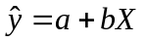 where is a predicted value for Y. Complete the regression model by filling in these blanks:

= ______ + ______X

With a straight edge, draw the regression line on the scatter plot you created earlier this lab. You can do this by noting that the regression line must go through the mean of each variable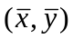. The point for these data is (603.64, 20.55). Mark this point with an “X” on your scatter plot in this Lab Workbook. Put your straight-edge ruler on the point you just marked and on the intercept, which is point (0, a) = (0, 6.76) Draw a straight line that goes through these points in the range of X from 230 to 1300. This is your regression model.

Use your regression model to predict the lung cancer mortality in a country with annual cigarette consumption level of 800 cigarettes per capita.

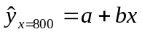 =

The most pertinent element of the regression model is the slope coefficient. The slope coefficient describes “the predicted change in Y per unit X.” Therefore, an increase of one cigarette per capita predicts an increase of _____ lung cancer cases per 100,000 [fill in the blank].

An increase of 100 cigarettes per capita predicts an increase of _____ lung cancer cases per 100,000 [fill in the blank].

Regression Analysis of Variance

The variance in the regression model is divided into two components: residual components and regression components.

The residual component of a data point is 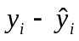, where 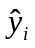 is the predicted value for that point based on the regression model 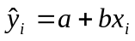. For example, the data point for the U.S. has an X value of 1300 and 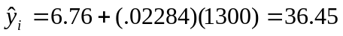. The actual value of Y is 20, so the residual = = 20 − 36.45 = −16.45. This means the predicted value was 16.45 units too low: the residual is negative 16.45. On your scatterplot, draw this residual as a vertical line from the data point for the U.S. to the regression line.

The point always falls on the regression line. Earlier in the lab you marked this point with an “X” on your scatter plot. Draw a line parallel to the X axis going through ( = 20.55). The regression component of a data point is defined as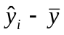. For the U.S. data point, = 20 − 20.55 = − 0.55. This is a very short distance on the plot. Still, draw a line from the data point to y-bar to identify the regression component for the U.S. data point.

You can now partition the variance in the data into the following components:

- The total sum of square (Total SS) is the sum of squared deviations of individual points of Y from the sample mean of Y: 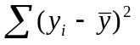

- The regression sum of square (Reg SS) is the sum of the squares of the regression components: 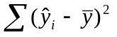

- The residual sum of square (Res SS) is the sum of squared deviations of residual components: 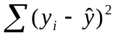

These sums of squares and associated statistics form a regression ANOVA table as follows:

Source | Sum of Squares | Degrees of freedom | Mean Squares
Regression | Reg SS | df₁ = 1 | 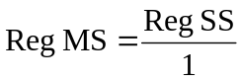
Residual | Res SS | df₂ = n - 2 | 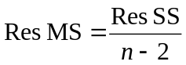
Total | Tot SS | df = n - 1 | Tot SS / df

This table is analogous to the regular ANOVA table with the exception that

- the “Between” component is now expressed in terms of the “Regression”
- the “Within” component is captured by the “Residuals”

The df for the regression is 1 for a simple regression model is df₁ = 1. The term simple regression model means that the model has a single independent variable. Multiple regression model have multiple independent variables.

The regression mean square (Reg MS) is the Reg SS divided by its degree of freedom:

.

The df for the residuals for simple regression models is df₂ = n – 2.

The residual mean square (Res MS) is the Res SS divided by its degrees of freedom:

Complete the ANOVA table for the current data:

Source | Sum of Squares | Degrees of freedom | Mean Squares
Regression | 747.409 | df₁ = 1 | _______
Residual | 627.319 | df₂ = ______ | _______
Total | 1374.727

An F statistic can be used to test H₀: β = 0 versus H: β ≠ 0. Calculate this statistic:

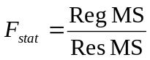 =

This statistic is converted to a p value in the usual manner. Use your F table to determine the p value for the test: ______ < P < ______

Confidence interval for the slope

The sample slope b is the estimator of population slope β. To derive a confidence interval for β, first determine the variance of Y at a given level of X: s²_{y·x}. This is a measure of scatter around the regression line. This variance is estimate by the Residual Sum of Squares divided by the residual df. The residual SS is described on p. 35 (we let the computer calculate this for us) and df = n – 2 for simple regression models. Therefore:

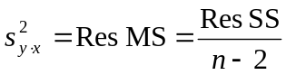

We pick-up these statistic from the ANOVA table created by SPSS.

For our data,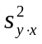= _________.
The standard error of the slope estimate is given by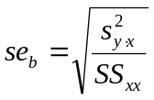. Calculate this standard error:

The 95% confidence interval for the slope is equal to 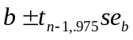. Calculate the confidence interval for the slope:

As with all confidence intervals, this is used to make statements about the parameter, in this instance β. We can be 95% confident that population slope β lies in this interval.

SPSS Regression

Replicate the analysis in SPSS.

- Open doll-ecol.sav (if not already opened).
- Click Analyze > Regression > Linear.
- Select LUNGCA as the dependent variable and CIG1930 as the independent variable.
- Click the statistics button and check the confidence interval box.
- Run the program.
- Review the output, which should look something like this:

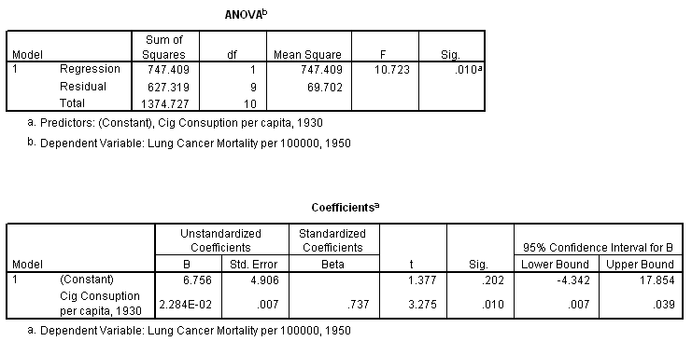

- Print the output.
- The computer identifies these statistics in a way that I do not want you to overlook. Therefore, on your copy of the output, label the following statistics:
- s²_{y·x} , which is equal to the Res MS)
- The intercept estimate (a), which is labeled as the unstandardized coefficient for the (constant)
- The slope estimate (b), which is labeled as the unstandardized coefficient for the variable X, in this case CIG
- The p value for H₀: β = 0, which is the “Sig.” for the X variable
- The confidence limits for β, which is the Lower Bound and Upper Bound for the X variable CIG

Dataset 2: Domestic water and dental caries (water.sav)

Raw data

Dean et al. (1942; via Pagano & Gauvreau, 1993, pp. 377–378) studied domestic water FLUORIDE levels (parts per million) and rates of dental CARIES (per 100 children) in 21 cities. Data were:

OBS FLUORIDE CARIES
1 1.9 236
2 2.6 246
3 1.8 252
4 1.2 258
5 1.2 281
6 1.2 303
7 1.3 323
8 0.9 343
9 0.6 412
10 0.5 444
11 0.4 556
12 0.3 652
13 0.0 673
14 0.2 703
15 0.1 706
16 0.0 722
17 0.2 733
18 0.1 772
19 0.0 810
20 0.1 823
21 0.1 37

- Enter the data into an SPSS file or download the data set water.sav from the data directory
- Plot the data with Graph > Scatter > Define (the dependent variable is CARIES and the independent variable is FLUORIDE).
- Review the output.
- Although there is a relation between caries and fluoride, the relation is not linear. How would you describe the relation in words?

- Are there outliers? Y / N
- Would unmodified linear regression be warranted under these circumstances? Y/N

Logarithmic transform

Although unmodified regression should not be used because the condition of linearity does not exist and there is an outlier, you may build a valid model using one of a number of methods. One method is to exclude the outlier and straighten-out the relation with an algebraic transform. Here’s a way to accomplish this:

- Make a copy of the data file water.sav. Call the new file water2.sav. (Save As > water2.sav)
- Delete the outlier (observation 21).
- From the SPSS menu, click Transform > Compute.
- A dialogue box will appear. Fill in the Target Variable field with the new variable lncaries
- Fill the Numeric Expression field with ln(caries). Click OK.
- A new column appears in the Data View. This column called lncaries will appear and will contain the logarithmic transform of CARIES.
- Perform a similar logarithmic transform on the FLUORIDE variable by creating a variable called LNFLUOR.
- Plot the ln-ln transformed data (Graph > Scatter > Define…).
- Look at the graph.
- Is the transformed relation linear? (circle) Y / N
- Run a regression on the transformed data with the (Analyze > Regression > Linear) command. Provide the values for:

r² =

The statistic r² is called the coefficient of variation. This is merely the square of the correlation coefficient and is a measure of the model’s fit to the data. This statistic is printed with the regression output.

b =

Range restriction

Another way to analyze these data is to eliminate the outlier and then restrict the analysis to the range that appears to be linear.

- Make a copy of the data file. Call the new file water3.sav. Open water3.sav.
- Sort the data on FLUORIDE (Data > Sort Case -- select FLUORIDE > OK.)
- In the FLUORIDE and CARIES columns, delete cases with FLUORIDE values greater than 1 part per million.
- Plot the data (Graph > Scatter > Define)
- Look at the graph.
- Is the relation linear? (circle) Y / N
- Run a regression on transformed data (Analyze > Regression > Linear).

r² =

b =

Which model, the ln-ln transformed model or the range-restricted model, has a better fit as determined by r²?

Which model do you prefer?

Lab 5: Cross-tabulated counts

So far this semester we have covered statistical relations in which the response variable is quantitative. Now we consider categorical response variables.

Categorical variables may occur naturally (e.g., diseased/non-diseases) or can be created by grouping a quantitative variable into classes (e.g., grouping age into “old” and “young,” for instance). Whereas quantitative responses are analyzed with sums and averages, categorical responses are analyzed with counts and proportions.

The data we will consider is a survey on socio-economic status (SES) and smoking (SMOKE). SES is classified into 5 categories with 1 indicating low SES and 5 indicating high SES (source: UC Berkeley lecture notes, circa 1983). SMOKE is classified as 1 = current smoker and 2 = non-smoker. Data are stored in sessmoke.sav. Here is a screen shot of the first 5 records in SPSS:

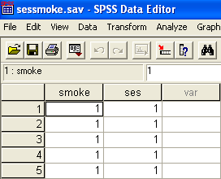

Download sessmoke.sav from the datasets directory. Open the file and cross-tabulate SMOKE by SES by clicking Analyze > Descriptive stats > Crosstabs. Put ses in the row field and SMOKE in the column field. Then click OK.

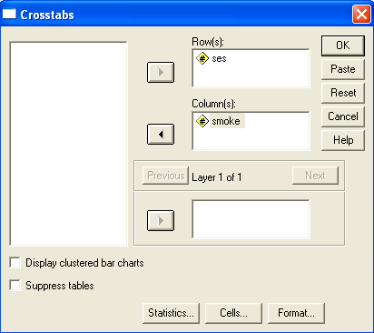

R-by-C table

Fill in this table with the counts you just cross-tabulated:

 | SMOKE |  | Total
SES | 1 | 2
1 |  |  | _______
2 |  |  | _______
3 |  |  | _______
4 |  |  | _______
5 |  |  | _______
Total | _______ | _______ | _______

This table has 5 rows and 2 columns, so it is a “5-by-2” table. We refer to an R-by-C cross-table, where R indicates the number of rows and C indicates the number of columns. In this instance, R = 5 and C = 2. The table has margins for the row variable and column variable totals. These totals represent the marginal distribution of SES. The Total row at the bottom of the table gives the marginal distribution of the column variable, SMOKE. The Total row on the right gives the marginal distribution for SES.

Before the marginal distributions can be easily interpreted you must convert them to percentages. The marginal percents for SMOKE are derived by dividing each column total by the table total and converting the proportion to a percents by multiplying it by 100%. For instance, the percentage of people in the sample who smoke is 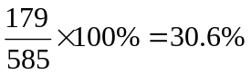. The percentage of people who do not smoke is 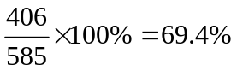. These sum to 100% because all the individuals in the study fall into one of these two categories.

We now want to calculate marginal percents for the row variable. This is accomplished by dividing each row total by the table total and multiplying by 100%.

Percent in SES class 1 = 50 / 585 × 100% = 8.5%.

Percent in SES class 2 =

Percent in SES class 3 =

Percent in SES class 4 =

Percent in SES class 5 =

We can use a bar chart or pie chart to display the marginal distribution for each of the variables that comprises the cross-tabulation. Here’s the marginal distribution for the SES variable:
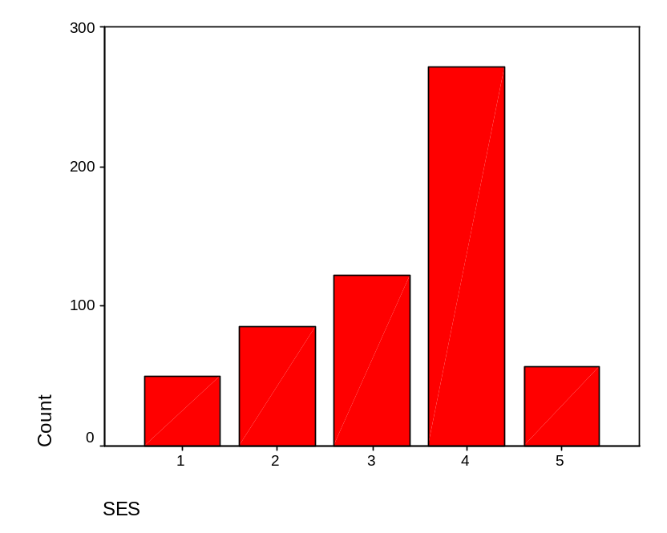

Replicate this chart by clicking Graphs > Bar > Define. Print this chart and then write by hand the marginal row percents on top of each bar.

It should be noted that marginal percents represent population prevalences only where data are derived by a simple random sample of the population. In many instances, however, we will intentionally select a set number of observations per group in order to maximize the power of comparisons. Under such circumstances, the marginal percents will not represent population prevalences.

Relationship between the row variable and column variable

Marginal distributions describe the individual variables that comprise the table. They do not, however, provide information about the relationship between the variables. To derive information about relationships, you must calculate conditional percents. There are two types of conditional percents:

- Row percents =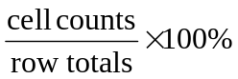. These are cell counts conditioned on the row totals.
- Column percents =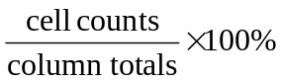. These are cell counts conditioned on column totals.

To calculate the proper conditional percents you must ask yourself “Which groups do I want to compare?” For example, if you want to compare smoking by SES status you would calculate row percents (since the SES comprises rows). If you wanted to compare SES in smokers and non-smokers, you would calculate column percents.

Here is our cross-tabulated data:

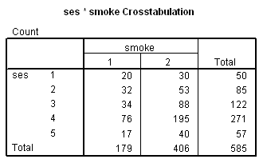

We want to compare the prevalence of smoking by SES status. Therefore, we will calculate proportions in which the numerator is the number of smokers and the denominator is the number of people in the group. These correspond to the row percents in column 1. For example, the percent of smokers in SES group 1 = 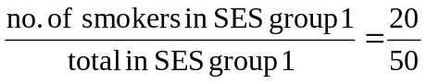= .400 = 40.0%. Now calculate the following prevalences:

Prevalence of smoking in SES 2 =

Prevalence of smoking in SES 3 =

Prevalence of smoking in SES 4 =

Prevalence of smoking in SES 5 =

Describe the relationships.

Note: Depending on how the table is set up, it might be more relevant to calculate column percents or row percents. Here is the same data as a 2-by-5 cross-tabulation:

 | SES
SMOKE | 1 | 2 | 3 | 4 | 5 | Total
1 | 20 | 32 | 34 | 76 | 17 | 179
2 | 30 | 53 | 88 | 195 | 40 | 406
Total | 50 | 85 | 122 | 271 | 57 | 585

Setting up the table this way requires us to calculate column percents to determine smoking prevalence. This does not materially effect the conclusions to follow. Remember to ask “What groups do I want to compare?” In this instance, column percents for row 1 represent the proportions (prevalences) of smoking within socio-economic classes.

Row and Column Percents in SPSS

Click Analyze > Descriptive statistics > Crosstabs > Cells button. Then check the Row percentage box in the dialogue box and continue.

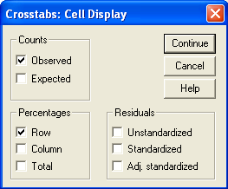

Output will include row percents for all cells in the table. Here’s the output:

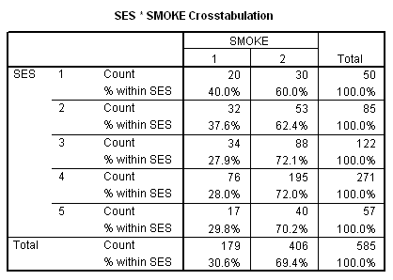

Notice that the row percents in column 1 represent the prevalence of smoking in that group. Print this output and circle prevalences by SES.

Chi-square test

We have found that the prevalence of smoking varies among the five SES groups from a low of 27.9% (group 3) to a high of 40.0% (group 1). Although these differences are evident in the sample, our interest extends beyond the sample to the population. We want to know whether the association in the sample is strong enough to make conclusions about the population.

In the pre-req. course we used a z procedure to test two independent proportions. We now want to test independent proportions from more than two groups. A chi-square test is used.

The null hypothesis of the chi-square test is that there is no difference in the prevalence of smoking by SES. This is the same as saying that there is no association between the row variables (SES) and column variable (SMOKE). The alternative hypothesis is that there is an association between these variables. In other words,

H₀: there no association between the row variable and column variable in the population
H₁: the is an association between the row variable and column variable in the population

Notice that the alternative does not specify the direction of the association. It could be a positive association (high SES associated with a high occurrence of smoking), negative association (high SES associated with a low occurrence of smoking), or otherwise e.g., highest prevalences in the middle groups, for instance). In this sense, the alternative it is neither one-sided nor two-sided -- it is “many sided” (like an ANOVA). The chi-square test will provide a single P value to test the overall association, but will not specify the form of the association.

Expected counts

The chi-square test statistic compares observed counts in the table to what we would expect except for random variation if H₀ were true. The strength of the evidence against H₀ is based on how far observed counts deviate from expected.

Expected counts are calculated with this formula:

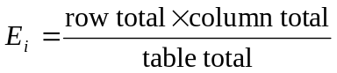

where E_{i} is the expected count in table cell i.

This formula if easy to use and has an intuitive explanation. Consider single proportion p. If we have n independent trials of a binary event, each with probability of success p, we expect np successes to occur on the average. For example, if we define “heads” as a success in tossing a fair coin 10 times, we expect np = 10 × .5 = 5 successes.

Let us apply this thinking to our data. Our cross-tabulated data is:

 | SMOKE |  | Total
SES | 1 | 2
1 | 20 | 30 | 50
2 | 32 | 53 | 85
3 | 34 | 88 | 122
4 | 76 | 195 | 271
5 | 17 | 40 | 57
Total | 179 | 406 | 585

The proportion of all 585 people in the sample who smoke = 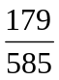. Think of this as overall proportion p. If H₀ were true, this proportion would apply to each sub-category, notwithstanding random variation. Therefore, the expected number of successes in SES category 1 is equal to 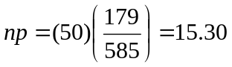. This is the same result obtained by the expected value formula: 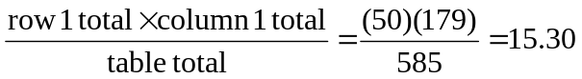.

Calculate the expected values for the sessmoke.sav data:

 | SMOKE |  | Total
SES | 1 | 2
1 |  |  | 50
2 |  |  | 85
3 |  |  | 122
4 |  |  | 271
5 |  |  | 57
Total | 179 | 406 | 585

Chi-square statistic

We are ready to calculate the chi-square statistic. The chi-square statistic compares observed counts to expected values. The discrepancies between observed and expected are squared and summed according to the formula:

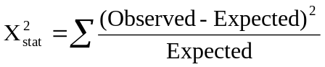

The summation sign in this formula means “add the elements for all cells in the cross-tabulation.”

For the current data, 20 individuals in socio-economic group 1 were classified as smokers. The expected count for this category is 15.30. Therefore the chi-square contribution from this cell is 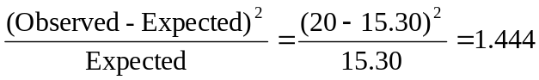.

Now determine chi-square contributions from the other cells in the table:

 | SMOKE
SES | 1 | 2
1 | 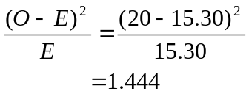
2
3
4
5

Each chi-square elements is a measure of the “distance” of the observed count to the expected value. When the observed count is equal to the expected value, this distance is zero. Large distances indicate the observed counts is far from expected value. Therefore, large X² statistics provide evidence against H₀. Sum the elements from the prior table to derive the chi-square statistic:

=

This chi-square statistics has (R - 1)(C - 1) degrees of freedom, where R ≡ the number of rows in the table and C ≡ the number of columns. Calculate the df for the current data:

df = (R - 1)(C - 1) =

The chi-square statistic is converted to a p value with a chi-square table or statistical software. Go to our website and print the chi-square table. Permanently affix this table to a page in your Procedure Notebook near your other tables. Use the table to determine the approximate P value of your chi-square statistic.

_______ < P < _______

State your conclusion to the test.

Interpret the findings as a whole. Consider the observed prevalences and chi-square test result.

Chi-square in SPSS

- Open sessmoke.sav (if not already opened).
- Click Analyze > Descriptive Statistics > Crosstabs > select variables
- Click the Cells button and check the Expected option
- 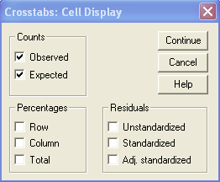
- Click the Statistics button and check the Chi-square option
- 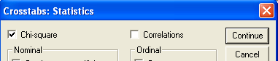
- Carefully review the output
- Notice that the output has a statement that reads “0 cells (.0%) have expected count less than 5. The minimum expected count is 15.30.” This is because the chi-square statistic requires that most (80%) of the cells have an expected value of 5 or greater. When a table cell has an expectation of less than 5, additional Fisher’s exact test will be reported. Use Fisher’s test when an expected value is less than 5.
- The chi-square statistic we’ve calculated is Pearson’s chi-square statistic. It is also called the uncorrected chi-square statistic. Karl Pearson (1857-1936) discovered this statistic circa 1900. The test is “uncorrected” because the observed counts in the table are discrete, yet the chi-square distribution and its Normal distribution basis are continuous. This creates a mathematical conundrum in fitting the sampling distribution model, since a partial “case” cannot occur. To “correct” for this conundrum, there is a test called the Yates’ continuity-corrected chi-square. Frank Yates (1902 - 1994) came up with a method to split the difference of non-continuous nature of the discrete data by correcting the Pearson statistic. The modification of the chi-square statistic is 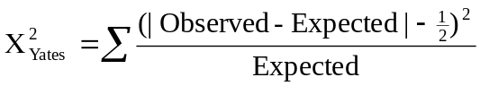. The Yates corrected chi-square statistic is no better or no worse than the Pearson’s uncorrected statistic -- statisticians are split on their preferences. When n is large, they produce almost identical results.

Lab 6: Relative risks and odds ratios

Introduction

We are going to compare the frequency of a binary outcome in two groups of individuals. This can be done in various ways. The most common way is in the form of a ratio of prevalences or incidences.

Data (HIV and IVDU)

A study by Smith and co-workers investigated HIV infection in a New York state women’s correctional facility. The study was a cross-sectional serological survey. Data for HIV sero-positivity by intravenous drug use (IVDU) revealed:

 | HIV+ | HIV | Total
Group 1 (IVDU+) | 61 | 75 | 136
Group 2 (IVDU-) | 27 | 312 | 339
Total | 88 | 387 | 475

In this 2-by-2 cross-tabulation, the prevalence in the IVDU+ group is the row proportion in the first cell of row 1. This sample proportion (prevalence) in group 1, denoted “p-hat₁,” is:

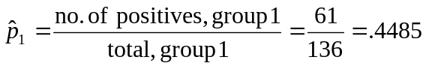

The prevalence in the IVDU- group is the row proportion in the first cell of the second row. Calculate this prevalence:

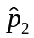 =

Notes on prevalence and incidence:
- Both incidence and prevalence have a numerator and denominator. Both are “measures of occurrence,” or “measures of disease frequency.” Both are called “rates,” although neither is a rate in the mathematical sense.
- Prevalence is cross-sectional. Its numerator consists of current cases. Its denominator is the total number of people in the group.
- Incidence can be measured as a rate or proportion. This unit considers incidence as a proportion. Incidence proportions are longitudinal and are called “incidence risks,” “average risks,” or just “risks.” The numerator of an incidence proportion consists of number of onsets. The denominator consists of those at risk as of the beginning of follow-up.
- Although prevalence and incidence proportion are distinct measures of occurrence, calculations and numerical manipulations are identical.
- Use at least 4 significant digits during calculations.
- The APA preferred method of reporting proportions is to convert them to percents with one decimal. For example, 0.028654 should be reported as 2.87%. When the incidence is very low, the proportion should be reported with a multiplier. For example, 0.00002864 is reported as 2.86 per 100,000.

Relative Risk (prevalence ratio)

The ratio of two proportions provides a measure of the relative effect of the exposure. The exposure in this instance is intravenous drug use. The ratio of the two prevalences is the prevalence ratio or relative risk:

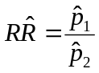

Calculate the relative risk for the prison data:

Notes on the RR estimate:
- The prevalence ratio is equal to the risk ratio when the following conditions hold:
  - The disease does not affect the likelihood of exposure.
  - The duration of disease is the same in the two groups.
  - Conditions of inflow and outflow in the population are steady-state.
  - The disease is rare, affecting less than 5% of the population at a given time.
- APA style manual does not list guidelines for reporting relative risks, but it is common to report two decimal places (e.g., RR = 5.63).
- When the prevalences are the same in the two groups, the RR will equal 1. The current prevalence ratio of 5.63 indicates that prevalence in the IVDU+ group is more than 5 times that of the IVDU- group.
- The RR provides a measure of the direction (positive, negative, nil) and strength of the association (e.g., doubles risk, triples risk, and so on).

95% confidence interval for the RR

We label table cells as follows:

 | Disease + | Disease - | Total
Exposure + | a | b | n₁
Exposure - | c | d | n₂
 | m₁ | m₂

Note that 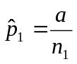 , 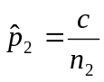, and

To calculate a confidence interval for the RR, convert the RR estimate to a natural logarithmic scale. Take the natural logarithm of your relative risk estimate. The natural log is the LN key on your calculator:

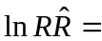

The standard error of the natural logarithm of the RR estimate is given by :

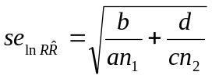

Calculate this standard error:

The 95% confidence interval for the ln(RR) is equal to 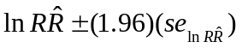. Calculate these limits.

Take the anti-logs of the limits you just calculated to derive the 95% confidence interval for the RR. The anti-log key on your calculator is the second function on the LN key, labeled e^{x}

Interpret your confidence interval.

Notes:

- The 95% confidence interval seeks to capture prevalence ratio parameter RR.
- Confidence interval width provides a measure of the estimate’s precision. Wide confidence intervals indicate relative imprecision; narrow confidence intervals indicate precision of the estimate. There are no benchmarks for what constitutes a precise or imprecise estimate. Precision is a relative thing.

SPSS Computations

- Download prison.sav from the data directory.
- Open the data file in SPSS.
- Click Analyze > Descriptive Statistics > CrossTabs. Select IVDU as the row (exposure) variable and HIV as the column (disease) variable.
- Click the statistics button and check the box labeled Risk.

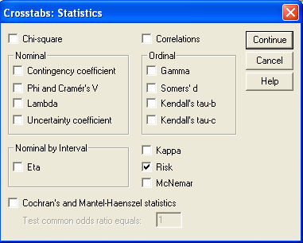

- Click Continue > OK.
- Review the output. Navigate to the Risk Estimates. The line labeled “For cohort HIV = yes” provides the relative risk of HIV for the IVDU+ group (not really a cohort, but the computer program doesn’t know any better).

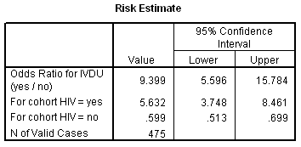
- Please label the output with the statistics you calculated in this lab.

Odds Ratios (Case-Control Studies)

Introduction

The relative risk is an estimate of the ratio of the probability of disease in exposed individuals divided by the probability of disease in the non-exposed individuals. This is the most common measure of effect used in public health. However, the RR is constrained by design -- it can only be used in longitudinal studies and in cross-sectional studies. Case-control studies cannot derive relative risks directly. This is because case-control studies select individuals based on their disease status and cannot derive incidences or prevalences.

Fortunately, case-control studies can calculate a measure of effect called the odds ratio. The odds ratio (OR) is a estimate of relative risk if certain conditions hold. The primary conditions are:

- Exposure status of cases in the study must reflect the exposure status of cases in the population
- Exposure status of controls in the study must reflect the exposure status of non-diseased individuals in the population.

The statistical basis of the odds ratio is covered in Epidemiology Kept Simple pp. 210 - 212.

Recall the labeling of the 2-by-2 cross-tabulation:

 | Disease + | Disease - | Total
Exposure + | a | b | n₁
Exposure - | c | d | n₂
 | m₁ | m₂

The short formula for the odds ratio is:

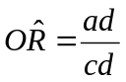

Data set 2: Esophageal cancer and tobacco consumption

A case-control study by Tuyns et al. (1977) reported in Breslow & Day (1980) studied the effects of tobacco consumption on esophageal cancer risk. Cross-tabulation of case status with tobacco use dichotomized at 20 grams per day is:

Tobacco | Cases | Controls
Exposure + | 64 | 150
Exposure - | 136 | 625

Calculate the odds ratio for these data.

The odds ratio is interpreted as a relative risk. Based on your results, how much does tobacco exposure at this level increase the risk of esophageal cancer?

We convert the OR to a logarithmic scale.

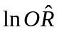 =

The standard error of the logarithm of the odds ratio is 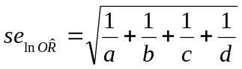. Calculate this standard error.

Calculate the 95% confidence interval for the ln(OR) which is equal to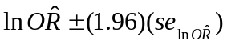.

Take the anti-logs of these limits to determine the 95% confidence interval for the OR:

Interpret your results:

SPSS computation

- Download bd1.sav from the datasets directory.
- Open the file in SPSS
- Click File > Display Data Info> bd1.sav > OK. This will produce a code book for the data. The codebook contains variable names, variable formats, variable labels, value labels, and other identifying information. Here is pertinent information from the codebook:

N of Cases: 975
# of Named Variables: 6
Variable Information:
Name Position

CASE Esophageal cancer 1
Measurement level: Nominal
Format: F8 Column Width: 8 Alignment: Right

Value Label

1 case
2 control

AGEGRP Age Group 2
Measurement level: Ordinal
Format: F8 Column Width: 8 Alignment: Right

Value Label

1 25-34
2 35-44
3 45-55
4 55-64
5 65-74
6 75+

ALC Alcohol consumption 3
Measurement level: Ordinal
Format: F8 Column Width: 8 Alignment: Right

Value Label

1 0 - 39 gm/day
2 40 - 79 gm/day
3 80 - 119 gm/day
4 120+ gm/day

TOB Tobacco consumption 4
Measurement level: Ordinal
Format: F8 Column Width: 8 Alignment: Right

Value Label

1 0-9 gms/day
2 10-19 gms/day
3 20-29 gms/day
4 30+ gms/day

ALC2 Alcohol dichotomized 5
Measurement level: Scale
Format: F8 Column Width: 8 Alignment: Right

Value Label

1 80+ gms/day
2 0-79 gms/day

TOB2 Tobacco dichotomized 6
Measurement level: Scale
Format: F8 Column Width: 8 Alignment: Right

Value Label

1 20+ gms/day
2 1-19 gms/day

- Click Analyze > Descriptive Statistics > CrossTabs.
- Select TOB2 as the row variable and CASE as the column variable.
- Click the statistics button and check the Risk box. Click Continue > OK.
- Print the output and label the OR and its confidence limits.
- If any discrepancies exist between your results and SPSS’s, reconcile the difference.

Matched Pairs

The techniques presented so far in this lab considered independent groups. Some studies match individuals as part of their design -- groups are not independent. Different analytic techniques are required for matched-pair data.

A case-control study by Witte et al. (1996) used matched-pairs to study adenomatous polyps of the colon and diet (Rothman & Greenland, 1998, p. 287). Cases and controls had undergone sigmoidoscopic screening. Controls were matched to cases on time of screening, clinic, age, and sex. One of the study’s analyses considered the effects of low fruit and vegetable consumption on colon polyp risk. There were 45 pairs in which the case but not the control reported low fruit/veggie consumption. There were 24 pairs in which the control but not the case reported low fruit/veggie consumption.

The analysis of matched pairs is based on the distribution of discordant pairs in the sample. A discordant pair is a matched set that has differing exposure-disease status. There are two types of discordant pairs:

- n_{A} ≡ the number of discordant pairs in which the cases is exposed and the non-case is non-exposed.
- n_{B} ≡ the number of discordant pairs in which the case is non-exposed and the control is exposed.
- The odds ratio in this situation is:

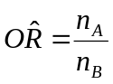
Calculate the odds ratio associated with low fruit/veggie exposure: 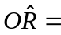

Calculate the natural logarithm of this odds ratio: =

The 95% confidence interval for the ln(OR) = 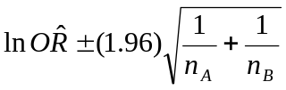. Calculate these limits and then convert them to a regular scale by taking their anti-log.

Do data support a connection between low fruit/veggie consumption and colon cancer? Y / N

Lab 7: Stratified analysis: confounding and interaction

Confounding is a distortion of an association between an explanatory variable (X) and response variable (Y) brought about by an extraneous factor (Z). This is a common problem in public research.

Confounding occurs when the groups being compared have unbalances extraneous factors. Here are the conditions for confounding:

- Z and X are associated in the data and
- Z is a causal factor for Y

For example, smoking (Z) confounds the relationship between alcohol consumption (X) and lung cancer risk (Y) because smoking and alcohol consumption are associated, and smoking (Z) is an independent risk factor for lung cancer (Y). In comparing alcohol consumers and non-consumers, we would find a higher rate of lung cancer in the alcohol consumers. However, it would be foolish to conclude alcohol causes lung cancer. The more reasonable explanation is that alcohol (X) is associated smoking (Z), and smoking (Z) causes lung cancer (Y). In other words, Z confounds the relation between X and Y.

There are many statistical techniques that are used to control for confounding. Examples of such techniques include:

- within strata analysis (subgroup analysis)
- matching (see above)
- indirect and direct standardization (e.g., age-adjustment)
- multiple regression (quantitative response variable)
- logistic regression (binary response variable)
- Poisson regression (rate analysis)
- Cox proportional hazards models (survival analysis)
- Stratification with summary risk estimation (Mantel-Haenszel)

We will cover stratification with summary risk estimation in this chapter.

Statistical interaction is distinct from confounding. Statistical interaction occurs when we see different statistics according to the level of the extraneous variable. Statistical interaction is distinct from biological interaction.

Stratification

Confounding and interaction can be addressed by stratify data according to levels of the extraneous factor. Here are three scenarios that illustrate this point.

Start by considering the data in a two-by-two cross-tabulation from a cohort study. The cross-tabulation is:

 | Disease + | Disease - | Total
1 (E+) | 200 | 800 | 1000
2 (E−) | 50 | 950 | 1000

In these data
- 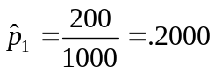
- 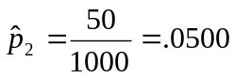
- 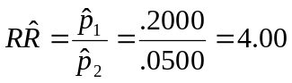

These are “crude” statistics because we have not stratified or adjusted the results. In these crude data, the exposed group has 4 times the risk of the non-exposed group.

We will now stratify the data into subgroups for men and women. Three hypothetical potential scenarios are presented to demonstrate confounding and interaction.

No confounding, no interaction

Here’s our data again:

 | Disease + | Disease - | Total
1 (E+) | 200 | 800 | 1000
2 (E−) | 50 | 950 | 1000

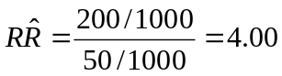

Suppose the data stratify as follows:

Men |  |  |  |  | Women
 | D+ | D+ | Total |  |  | D+ | D+ | Total
1 (E+) | 160 | 240 | 400 |  | 1 (E+) | 40 | 560 | 600
2 (E−) | 40 | 360 | 400 |  | 2 (E−) | 10 | 590 | 600

Notice that the data from the strata-specific tables can be combined to form the data in the crude 2-by-2 cross-tabulation.

The RR in men is 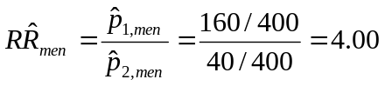

Calculate the RR in women:

Because the RR is the same in both groups and the strata-specific RRs are the same as the crude RR, there is no confounding and no interaction. Subgroup analysis and adjustment are unnecessary.

Confounding, no interaction

The same data in the 2-by-2 data are considered.

 | Disease + | Disease - | Total
Exposure + | 200 | 800 | 1000
Exposure - | 50 | 950 | 1000

It is possible data for men and women could produce these results:

Men |  |  |  |  | Women
 | D+ | D+ | Total |  |  | D+ | D+ | Total
E+ | 194 | 606 | 800 |  | E+ | 6 | 194 | 200
E- | 24 | 76 | 100 |  | E- | 26 | 874 | 900

Calculate the RR in men:

Calculate the RR in women:

Because the RRs is the subgroups differs from the crude RR, the crude data are shown to be confounded. Since the RRs in the subgroups are about the same we assume they are estimating the same underlying effect of the exposure. This allows us to average of the strata specific RRs as a summary RR adjusted for the confounder. There are several method to calculate this average. One population method is the Mantel-Haenszel method. The instructor may or may not cover the Mantel-Haenszel technique this semester.

Interaction

Crude 2-by-2 data:

 | Disease + | Disease - | Total
Exposure + | 200 | 800 | 1000
Exposure - | 50 | 950 | 1000

The crude data could conceivably reveal:

Men |  |  |  |  | Women
 | D+ | D+ | Total |  |  | D+ | D+ | Total
E+ | 188 | 612 | 800 |  | E+ | 12 | 188 | 200
E- | 5 | 195 | 200 |  | E- | 45 | 755 | 800

Calculate the RR in men:

Calculate the RR in women:

Because the RRs are different, the exposure seems to be having a different effect in the subgroups. When this is the case, we say statistical interaction is present. We do not adjust for interaction since this would obscure the differences in the sub-groups. Instead, we report the RRs for each group separately.

Data: Sex bias in graduate school admissions?

This data set is a subset of the data reported by Bickel et al. in 1975. Data are applicants to Graduate schools at the University of California Berkeley in 1973. During the study period, 8,442 men and 4,321 women applied for admission to various graduate programs on campus. Assuming that the men and women who applied for admissions were equally well-qualified, one would expect equal acceptance proportions by gender.

There were over a hundred graduate programs at UC Berkeley at the time. Freedman et al. used data from the six largest majors to demonstrate principles of confounding in their excellent text (1991, pp. 16 - 19) . I use the experience of two of these majors to illustrate principles. Data are stored in the data directory as sexbias2.sav.

- Download sexbias2.sav
- Open the file in SPSS.
- Cross-tabulate acceptance to graduate school (variable ACCEPT) and gender (SEX). In this case, SEX is the explanatory variable, so put it in the rows of the table.
- The output will reveal:

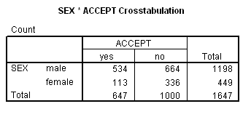
Calculate the incidence of acceptance for males:

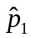 =

Calculate the incidence of acceptance for females:

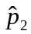 =

Does there appear to be a gender bias? How so?

Stratification

To explore potential confounding and interaction, stratify the data by the extraneous factor of MAJOR. To accomplish this, add MAJOR as a layer in the CROSSTAB dialogue box:

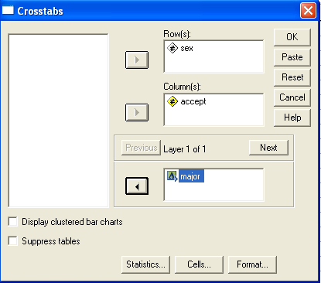

This produces the following tables:

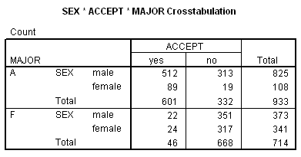

The incidence proportion of acceptance for males who applied to major A is 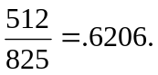 The incidence proportion of acceptance for females who applied to major A is 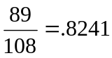. The RR of acceptance for males is .6206 / .8241 = 0.75. Therefore, males were 25% less likely to be accepted into Major A.

Calculate the incidence proportion of acceptance for males who applied to major F:

Calculate the incidence proportion of acceptance for females who applied to major F:

The RR of acceptance for males to major F:

Does there appear to be any gender bias? How so?

This stratified analysis reveals a paradox. Overall, males had higher acceptance rates. However, within majors, females had higher acceptance rates. This an example of Simpson’s paradox. Simpson’s paradox occurs when an extraneous factor changes or reverses the relationship between two categorical variables. Simpson’s paradox is nothing more than an extreme case of confounding. In the current example, the bias in preference of males was reversed when we considered the extraneous variable MAJOR.

What is the explanation for Simpson’s paradox in this example? It turns out males tended to apply to the graduate program with higher acceptance rates. The fact that men had a higher acceptance rate overall merely reflects the fact that they applied to majors that were easier to get in to. When controlling for MAJOR, in fact the opposite occurred. Men had a more difficult time getting into the graduate program. This is shown in our relative risk analysis. The relative risk of acceptance in major A for men was 0.75, reflecting 25% lower acceptance rates for men. The relative risk of acceptance in major F for men was 0.84, reflecting 16% lower acceptance rates for men. We could combine these two relative risk estimates to get a summary relative risk estimate. Unfortunately, SPSS does not compute a summary relative risk estimate. (It does do a summary odds ratios, but we are not using odds ratios as our measure of association in this illustration, and the method for odds ratio is slightly different than for risk ratios.)

The instructor may choose to show you how to combine the strata-specific relative risk estimates to get a summary risk ratio.

Lab 8: Data Management

Purpose: To create a data set with controlled data entry and then export the data to SPSS.

Reference: Bennett, S., Myatt, M., Jolley, D., & Radalowicz, A. (2001). Data Management for Surveys and Trials. A Practical Primer Using EpiData, available www.epidata.dk/downloads/dmepidata.pdf

Introduction to EpiData

We will use EpiData for data entry, data documentation, and data management. EpiData is an open source Windows program that can be freely copied and modified according to the terms of the GNU Software Foundation (www.gnu.org). The program is based on the DOS version of EpiInfo, a program introduced in the late 1970s by CDC. EpiInfo was used by tens of thousands of users worldwide (Harbage & Dean, 1999) before it went down hill in its Windows version.

A little history: In the mid-1990s, as Windows replaced DOS, EpiInfo began to loose popularity. In response, CDC released EpiInfo200x to replace EpiInfo. EpiInfo200x is based on Microsoft Access data engine and is similar to the original EpiInfo in name only. It proved slow and unreliable. To correct these shortcomings, a group of volunteers created EpiData. EpiData is a small, fast, and reliable and can be downloaded from www.epidata.dk.

EpiData allows for controlled data entry. This means it will accept only data that meets certain criteria. EpiData allows you to attach value labels and range checks to data elements. It has very good documentation features and provide a complete data base management system (DBMS).

Although this lab focuses on EpiData for, the concepts and techniques learned using EpiData are valid when you work on other platforms.

Start EpiData

The method of starting EpiData depends on how it was installed on your computer. In the SJSU computer lab, the program appears on the Windows Start bar. Some installations may have icons for the program on the desktop. Some installations require you to click Start > All Programs to find the program.

EpiData works with three basic file types. These are:

- .QES files (QuEStionnaire files)
- .REC files (RECord files)
- .CHK files (CHecK files)

It uses Windows pull-down menus and also has a Work Process Toolbar which looks like this:

Briefly,

1. Define Data is used to create QES files
2. Make Data File is used to convert QES files to REC files
3. Checks allows you to create and modify CHK files
4. Enter Data opens REC files for date entry
5. Document creates supplemental files for DBMS documentation
6. Export Data allows you to export REC data to different formats

Create QES File

QES files are used to define variables and create data entry screens. The QES file is an ASCII text file with special codes. Use a text editor to create and edit QES files. EpiData has a built-in text editor. You may also use Windows NOTEPAD but do not use Microsoft Word since Word does not by default produce plain ASCII text.

Variable names in EpiData must conform to certain standards. They must

- begin with a letter (not a number)
- contain no spaces or punctuation marks
- be 10 or fewer characters long

Example of illegal variable names are 1ID (begins with a number), DRUG DOSE (contains a space), and AGE_AT_TIME_OF_DEATH (longer than ten characters).

By default, EpiData will take the first ten [non-blank] characters in a line of a QES file as the variable name. For example, typing:

AGE What is your age? ##

will create a variable called AGEWHATISY.

This convention can be over-ridden by changing programs defaults or by enclosing the variable name in {curly brackets}. For example,

What is your {AGE}? ##

will create a variable called AGE.

EpiData variables are defined with special indicator codes. Here are the main indicator codes:

Variable Type | Examples
TEXT variables (either mixed-case or upper-case only) are used to hold text and numbers. Use an underscore (_) for mixed-case and <A> for upper-case text. The length of the variable is determined by the number of underscores or As in the variable indicator. For example,  will hold two mixed-case text characters while <AAA> will contain three upper-case text characters.  Mathematical operations cannot be performed on non-numeric text. | _  _________  <A>  <A >  <AAAAA>
NUMERIC variables hold integers (whole) numbers or real (fractional) numbers. The number of # characters determines the variable’s length. For example, # will hold a single integer (0–9) while ## will hold integers 9 to 99. Use a decimal point to hold real numbers. For example, use ##.# to hold values of 9.9 to 99.9. | #  ###  ##.##
LOGICAL (“BOOLEAN”) variable are used to hold binary (dichotomous) data. | <Y>
DATE variables hold dates in either American <mm/dd/yyyy> or European <dd/mm/yyyy> format. Only valid dates (allowing for differing month length) are permitted with this variable type. This variable type allows calculation of time-spans.  EpiData also has special date functions and formats that are updated every time a record is changed. | <mm/dd/yyyy>  <dd/mm/yyyy>
The AUTO ID NUMBER variable are incremented automatically for every new record added. Once a value is assigned for an AUTO ID NUMBER it cannot be altered. | <IDNUM>
SOUNDEX variables apply SOUNDEX coding rules to text data. This is used to make record anonymous as required in some circumstances. For example, you may want to anonymize the names of subjects in a surveillance system for sexually transmitted disease. | <S >

You are ready to create your first QES file:

- Click on the Work Process Toolbar.
- Click New .QES file.
- A blank screen will appear. Type questions with variable names and indicators as follows:

TOX-SAMP - Sample of the TOXICITY data set
{ID} ##
{Age} in years ##
{Sex}: 1 = male 2 = female #
{Manuf}acturer: J = Jones, S = Smith <A>
{Diag}nosis: 1 = leukemia 2 = lymphoma #
{Stage}: 1 = relapse 2 = remission #
{TOX}icity: 1 = yes 2 = no #
{Dose} gms/M2 ##.#
{SCR} creatinine in mg/dl #.#
{weight} kilograms ###

- When you have created your QES file, click File > Save As > A:\tox-samp-yourname (e.g., A:\tox-samp-bud). Do not let EpiData save your file to the default folder. Save your file to either A:\ or H:\
- Check for the presence of tox-samp.qes on your floppy or LAN drive. Right-click the Windows Start Bar. Selecting Explore. Navigate to the A: drive Check to see that your file is present where you think it is. (If you loose your files you will have to start the process from scratch.)

Create REC File

- Click on the Work Process Toolbar.
- A dialogue box will appear. Enter A:\tox-samp-yourname.qes into the field labeled QES file and A:\tox-samp-yourname.rec into the field labeled REC file.
- You will be prompted for a data file label. Enter “The first 20 records from the Jolson et al., 1992.”
- The REC file should now be in the root directory on the floppy drive. Check to make sure it is where you expect it to be.

Create CHK File

You want to create a CHK file containing range restrictions, value labels, and other controlled data entry functions.

- Click on the Work Process Toolbar.
- A dialogue box will appear. Enter A:\tox-samp-yourname.rec into the file name field.
- Place the cursor in the AGE data-entry field. A dialogue box will appear on screen. Since we know no one in our study is less than 15 or greater than 80, select Range, Legal, and type 15-80 (no quotes).

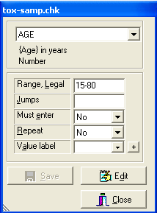

- Click “Save” and “Close”
- Place the cursor in the SEX data entry field. In Range, Legal field enter “1,2” (no quotes; you get the idea). Then, next to the Value Label field, click the + button. Fill in the widow as follows:

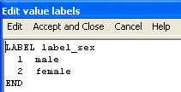

- Click “Accept and Close.”
- At your option, apply additional range restrictions and value labels to the other variables in the dataset.

Enter Data

- Click on the Work Process Toolbar .
- Open your data file.
- Enter the data shown below into your REC file. Working with a partner will cut down on data entry errors. One partner can recite the data while the other enters data at the keyboard.

ID AGE SEX MANUF DIAG STAGE TOX DOSE SCR WEIGHT
1 50 1 J 1 1 1 36.0 0.8 66
2 21 1 J 1 2 2 29.0 1.1 68
3 35 1 J 2 2 2 16.2 0.7 97
4 49 2 S 1 1 2 29.0 0.8 83
5 38 1 J 2 2 1 16.2 1.4 97
6 42 1 S 2 2 2 18.0 1.0 82
7 17 1 J 1 2 2 17.4 1.0 64
8 20 1 S 2 2 2 17.4 1.0 73
9 49 2 J 1 1 2 37.2 0.7 103
10 41 2 J 1 2 2 18.6 1.0 58
11 20 1 S 2 2 2 18.0 1.1 113
12 55 1 S 1 1 2 36.0 0.8 87
13 44 2 J 1 1 1 22.4 1.2 59
14 23 1 S 2 2 2 39.6 0.8 83
15 64 2 S 1 1 2 30.0 0.9 69
16 65 1 S 1 1 1 23.2 1.7 106
17 23 2 S 1 2 2 16.8 0.9 66
18 44 1 S 1 2 2 17.4 1.0 84
19 29 2 S 2 1 2 18.0 0.7 56
20 32 1 S 1 2 2 18.0 1.0 84

Validate

Double entry is the most reliable way to ensure data have been entered properly. The procedure requires you to enter the data into two parallel files followed by a side-by-side comparison of the files.

- Select a data partner.
- Copy your data file and your partners data file to your H:\ LAN drive.
- Click and then select Validate Duplicate files.
- A dialogue box will appear. Enter the names of the two data files into the fields

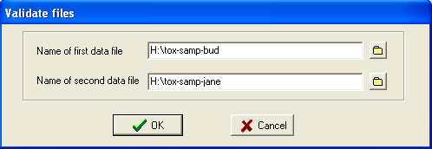

- Click OK. A report will appear on the screen. Read the report. Did it note any discrepancies between the files?
- If a discrepancy is reported, go back to the original data listing and determine which entry is correct. Correct errors in problematic REC files.
- Rerun the Validate program to make certain files contain no errors.
- Print the final validation report to document file integrity.

Data Documentation

EpiData does an excellent job creating data code books. Data codebooks contain information that allow people who are unfamiliar with the file to understand its structure and content. A good code book will contain the filename, file location, variable names, variable codes, and other pertinent information. EpiData includes a powerful codebook generator.

- Click and then select Codebook.
- Select your data file.
- You will be presented with a dialogue box. Review the content of this dialogue box. Retain the defaults and click  OK.
- A codebook will appear on screen. Review its content.
- Notice that descriptive statistics are reported for each variable in the codebook.
- Save the codebook (File > Save) as a:\tox-samp.not (EpiData uses the .not extension to denote “note”.)
- Print a hard copy of your code book (File > Print).

Export the data from EpiData

We will convert the EpiData .REC file to an SPS .SAV file. To complete this process, you must appreciate the fact that the .REC file is first converted to a flat data (.TXT) file and is then imported into SPSS via the SPSS command processor. It also helps to know a little about the structure of the flat text data (.TXT) file and SPSS command syntax.

- Return to the main Work Process Toolbar and click .
- Select your data set
- A dialogue box will appear. Review this dialogue box, accept the defaults, and click OK.
- This will create two files: An .sps command syntax file and a flat .txt data file.
- On the Windows Start bar, select All Programs > Accessories > Notepad. (Notepad is the Windows ASCII text editor.) In Notepad, open A:\tox-samp.txt (File > Open). Review the content of this flat file. Notice that the flat file lacks variable names, variables labels, and database file structure information. A data manager would need detailed information concerning the length, type, and coding of each variable before he or she could decipher this information. Close this file. Do NOT save any changes! The file must be left exactly as it was found.
- In SPSS or Windows NOTEPAD, open A:\tox-samp.sps This is an SPSS syntax file. Lines starting with asterisks (*) are comments. Other lines are commands. SPSS programmers will recognize many of these commands. We can infer command meanings through context. (This is a good way to introduce yourself to the SPSS “work process.”) Let us take note of DATA LIST commands, for instance:

DATA LIST
FILE = "A:\tox-samp.txt"
RECORDS=1
/ ID 1-2 AGE 3-4
SEX 5 MANUF 6(A) DIAG 7 STAGE 8
TOX 9 DOSE 10-13(1) SCR 14-16(1)
WEIGHT 17-19.

- The FILE = "A:\tox-samp.txt" command directs SPSS toward the flat file tox-samp.txt in the root directory of the A drive. The RECORDS = 1 command lets SPSS know that each line represents one record (observation). Commands after the / indicate variable names, columns, and types. For instance, MANUF 6(A) indicates the MANUF variable is alphanumeric with data in column 6. Similarly, DOSE 10-13(1) indicates that DOSE is a numeric variable with one decimal place, staring in column 10 and ending in column 13. Toward the bottom of the screen you will notice the command

* SAVE OUTFILE="A:\tox-samp.sav".

Remove the leading asterisk from the SAVE command so that it will be activated and then save this changes. Close the file.

Import the data into SPSS

- Start the full (non-student) version SPSS. Student SPSS does not have the syntax interpreter needed to run the syntax .sps file.
- Select File > Open > Syntax
- A dialogue box will appear. Type A:\samp-tox.sps in the File name filed and click Open. On the top menu select Run > All.
- After the procedure runs, an SPSS output window will appear.
- Review the output and check for errors
- Navigate to the Data View window.
- Make certain data were imported properly
- Click the Variable View tab. Make certain value labels were imported properly.

Lab 9: Power and sample size (DRAFT)

- Measuring an attitude. This exercise will demonstrate the relationship between sample size, the standard deviation of (error) the sample mean , and the margin of error for 95% confidence. Juan makes a measurement on a survey and records the results in his database. The standard deviation of the measurement is known to be σ = 10. Juan repeats the measurement 3 times and calculates the mean of his 3 measurements.
  - What is the standard deviation (error) of Juan’s mean result? That is, if Juan kept on making 3 measurements and averaging them, what would be the standard deviation (error) of all his ’s. (Recall the square root law: 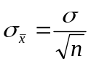 . Also note that σ_{x-bar} and SE_{xbar} are synonyms.)
  - Explain to someone who knows no statistics the advantage of reporting the average of several measurements rather than the results of single measurement.
  - How many times must Juan repeat the measurement to reduce the standard deviation of to 5? (Hint: Solve for n.)
  - The idea of a 95% confidence interval is that the interval captures the true parameter value in 95% of all samples. That is 95% hits and 5% misses. Because means tend to be Normally distributed (central limit theorem), we can say that for 95% confidence we must establish a margin of error m of about 2 standard errors (recall the 68–95–99.7 rule). In other words, m ≈ 2 σ /√n for 95% confidence. To obtain the margin of error m, solve for the sample size n. (If you need help, ask the lab instructor!) So how large a sample does Juan need to reduce his margin of error down to 5 units?

- Comparing risk-taking behavior in boys and girls. This exercise will identify the factors you need to understand in order to test a difference in means for significance. A questionnaire uses an index of risk-taking in which scores are standardizes so that μ = 100 and σ = 15. We suspect that boys will exhibit a score that is 10 points higher on average than girls.

  - What additional information do we need before we are able to calculate the required sample size to test the difference for significance?
  - Suppose we want a significance level of 0.01 (two-sided), power of 90%, and will use an equal number of boys and girls in our sample. How many subjects do we need to study?
You may use a utility (e.g., WinPepi or OpenEpi.com) or formula for computations. The formula is 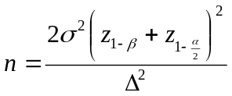 per group, where 1 – β = the desired power, α = the significance-level, σ = the within group standard deviation, and Δ = a difference worth detecting.
  - Suppose it was twice as easy to survey girls as boys. How many subjects do you need to study? What was the influence of changing the ratio of the sample sizes?
  - Return to the conditions as part (b) but that you are now willing to settle for an alpha level of 0.05 (two-sided) (Δ = 10, power = 0.90, σ = 15). What was the influence of increasing the alpha level?
  - Return to the conditions specified in part (b) except you now what to find a difference of 5 units (Δ = 5, alpha = 0.05, power = 0.90, σ = 15). What was the influence of decreasing the difference worth detecting?

- In planning a study with a binary outcome, you want to choose a sample size that allows estimation of parameter population proportion p with “plus or minus” stated margin of error m. We saw earlier how to do this when estimating μ (i.e., for a quantitative outcome). The method is similar when estimating p.
The margin of error for 95% confidence in a large sample confidence interval for p is 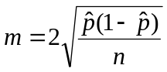. Notice that the margin of error involves the sample proportion 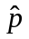. We therefore need an educated guess for the value of when determining the sample size. Let’s call this educated guess p*. We can get p* from previous studies, pilot studies, and “Gestalt”. When no such information is available, use p* = 0.5 as your guess to ensure adequate precision.
  - You want to calculate a proportion so that the margin of error of plus or minus 5%. How large a sample is needed?
  - Now we want a margin of error of plus or minus 2%. How large a sample is needed? What was the “cost” of decreasing the margin of error?

- We now want to compare two proportions.

The exact distribution of the Kruskal-Wallis statistic H under the null hypothesis depends is necessary only when samples are very small.
? I prefer the range restricted model because it is easy to interpretation and has biological relevance. Some statisticians might prefer the ln-ln model because it provides a better model fit.
Smith, P. F., Mikl, J., Truman, B. I., Lessner, L., Lehman, J. S., Stevens, R. W., et al. (1991). HIV infection among women entering the New York State correctional system. Am J Public Health, 81 Suppl, 35-40.
? If your computer does not have EpiData, download the program from www.epidata.dk and install it now. The installation method is described on the EpiData website.
OK…you twisted my arm: 

