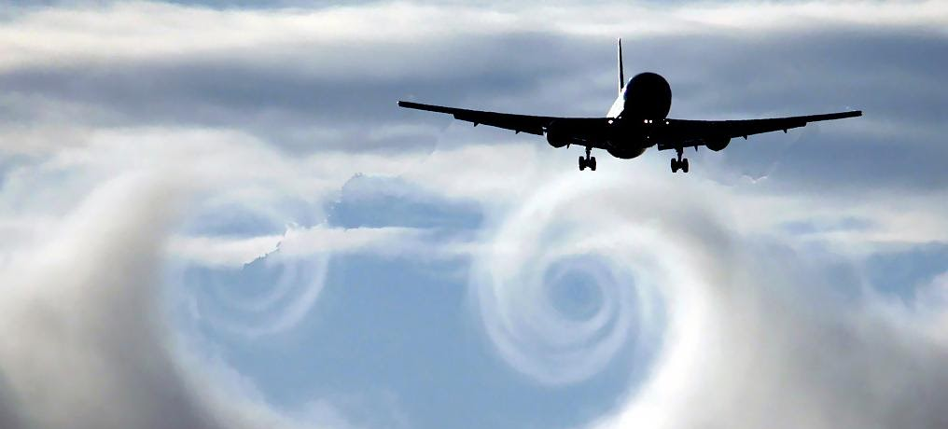
Instructor |  | Brian Andrade  Brian.Andrade@sjsu.edu  Office Hours: TR 0745-0845 & by appt., in Engr 272
Credit |  | 3 units
Class Time |  | TR 0900-1015
Final Exam |  | Tuesday, May 19th 2020, 0715-0930
Classroom |  | Engr 331
Prerequisites |  | “C-” or better in Math133A, AE160, and Engr100W
Textbook |  | Fundamentals of Aerodynamics 5th Edition by John D. Anderson Jr. plus Instructor Notes to be posted on CANVAS

Description

Airfoil and wing theory. Modeling of inviscid flows around aerodynamic bodies using 2D and 3-D potential flow theory. Problem solving, computer simulations, wind tunnel experiments and team project.

Goals Introduce students to:

- Low speed airfoil theory.
- Low speed wing theory.
- Aerodynamic simulations.
- Aerodynamic design of airfoils and wings.

Learning Objectives

Students completing AE162 should be able to:

- Define the vorticity of a flow field and distinguish between rotational and irrotational flows.
- Define circulation and calculate it around various paths.
- Define the stream function and the potential function for a flow and calculate each, if they exist.
- Analyze the elementary flows (uniform, source / sink, doublet, vortex, corner) as well as combinations of them.
- Explain Kelvin's theorem and its implications for the vortex system of an airfoil.
- Use and interpret airfoil nomenclature.
- Describe the aerodynamic characteristics of an airfoil and their importance in airplane design.
- Explain the design and the performance improvements of modern airfoils (LS, MS, and supercritical).
- Use experimental data, thin airfoil theory results, and computer programs to predict aerodynamic characteristics of airfoils (e.g. lift and drag at various angles of attack, pitching moment about various points, ac location, etc.)
- Use the Biot-Savart law to calculate induced velocities in the vicinity of line vortices.
- Explain how rectangular, swept, and delta wings differ in terms of maximum lift, lift slope, stall angle of attack, induced drag, skin friction drag, L/D at low speeds, and L/D at high speeds.
- Describe the horseshoe vortex model for a wing and its limitations.
- Apply Prandtl's lifting-line theory to calculate the aerodynamic characteristics of airplane wings.
- Use the method of images to discuss and calculate aerodynamic interference for (a) wings flying in the vicinity of each other (i.e., wing/tail/canard combination, biplanes, etc.), (b) wind-tunnel boundaries, and (c) ground effects.
- Work effectively in a team to:
  - Define and solve open-ended problems in aerodynamics
  - Design and perform wind tunnel experiments
  - Analyze and interpret the results from these experiments, compare them with analytical / computational predictions and other published data, and explain any discrepancies.

Approximate Weekly Schedule

Week Lecture Topic(s)

- Introduction to potential flow theory.
- Vorticity. Rotational and irrotational flows.
- Velocity potential and stream function. Quiz 1
Wind tunnel experiment 1: Boundary layer studies.
- Elementary flows: uniform, source / sink, doublet, vortex.
Wind tunnel experiment 2: Pressure distribution around a circular cylinder.
- Circulation and lift. Kutta – Jukowski theorem. Quiz 2
- Airfoils: Kutta condition, nomenclature, characteristics, design and performance.
Wind tunnel experiment 3: Airfoil lift, drag, and pitching moment. 07 Modern airfoils for low and high speed. Quiz 3
- High lift devices.
Wind tunnel experiment 4: Airfoil high-lift devices.
- Wings: Induced drag, Biot-Savart law. Quiz 4 Spring Break
- Wings: twist, horseshoe vortex model.
- Prandtl’s lifting-line theory; elliptical lift distribution.
- General lift distribution.
- Wings for high speeds.
- Aerodynamic interference; method of images.
- Wind tunnel corrections; ground effect.
- Review.

Grading
Assignments (20%
Quizzes (30%)
Final Exam (25%)
Lab Reports (25%)

95% < A+ 67% < C+
90% < A 65% < C
85% < A- 62.5% < C-
80% < B+ 60% < D
75% < B <60 <F 70% < B-

Exams

- You must average at least 65% on your tests (quizzes and final) to receive a passing grade in the course (“C –”, “C” or “C +”). If you average 60% - 69% on your tests you can only earn a “C –”, “C” or “C +” in the course, regardless of the total number of points you may have earned.
- You must average at least 70% on your tests (quizzes and final) to receive an A or a B in the course.

Workouts

- Workout problems are a great opportunity for developing problem solving skills during class, when I am available to coach you. However, you need to come to class prepared by reading the relevant material beforehand to benefit from these problems.
- Workout problems are solved in teams during class. Teams may change in composition from class meeting to class meeting.
- You must come to class, solve each problem correctly, and present the solution following any guidelines given in class, to receive workout points.
- In some cases, you may be allowed to finish these problems outside of class. In such cases you must turn them in at the beginning of the following class meeting.
- If your name appears on a workout solution sheet you should be able to come up to the board and present this solution to the rest of the class.
- It is everyone’s responsibility to ensure that everyone else in their team understands the solution of the problem. If a student is asked to present the solution to a problem and he/she is not able to do so, the team will not receive any points for this problem, even if their written solution is correct.
- No workout solutions will be accepted after a workout problem is solved on the boar

Laboratory

- You will design and perform in teams, 4 wind tunnel experiments in the aerodynamics lab (Engr. 107).
- Each experiment takes approximately 30 min to 1 hour to perform.
- A lab report is due for each experiment, following the posted guidelines, 2 weeks after you complete the experiment.
- You must average a minimum of 70% in your lab reports to receive a passing grade in the course.

Course Contribution to Curriculum (Criterion 5)
- College level mathematics and science 0 unit
- Engineering topics 3 units
- General education 0 unit

Course Relationship to Program Outcomes
 | A | B | C | D | E | F | G | H | I
Learning Objectives
1 – 14 | B |  |  |  |  |  |  | B
15 | C | C |  | C | C |  |  | B | C

Late Policy
All assignments submitted late shall be penalized by 20% of the assignment score. No assignments shall be accepted 2 weeks after the due date has passed.

Communications
Important communications shall be conveyed through Canvas. It is advised to check back regularly for any announcements and information regarding assignments. If there is any deviation from the regular class or office hours schedule there will be an announcement posted to that effect.

Group Work
A peer evaluation shall be due with each lab report and the project report. This peer evaluation shall be completed on an individual basis, evaluating the contributions of all people in the group including yourself. Consistently seriously underperforming relative to the rest of the group may result in score adjustments being applied.

______________________________________________________________________________________ For issues related to Canvas, please contact the eCampus Help Desk.
Phone: (408) 924-2337
Submit a help ticket using the following
URL: https://isupport.sjsu.edu/ecampus/ContentPages/Incident.aspx.
While logged into Canvas, click on the word Help on the upper right corner of the screen.
______________________________________________________________________________________

